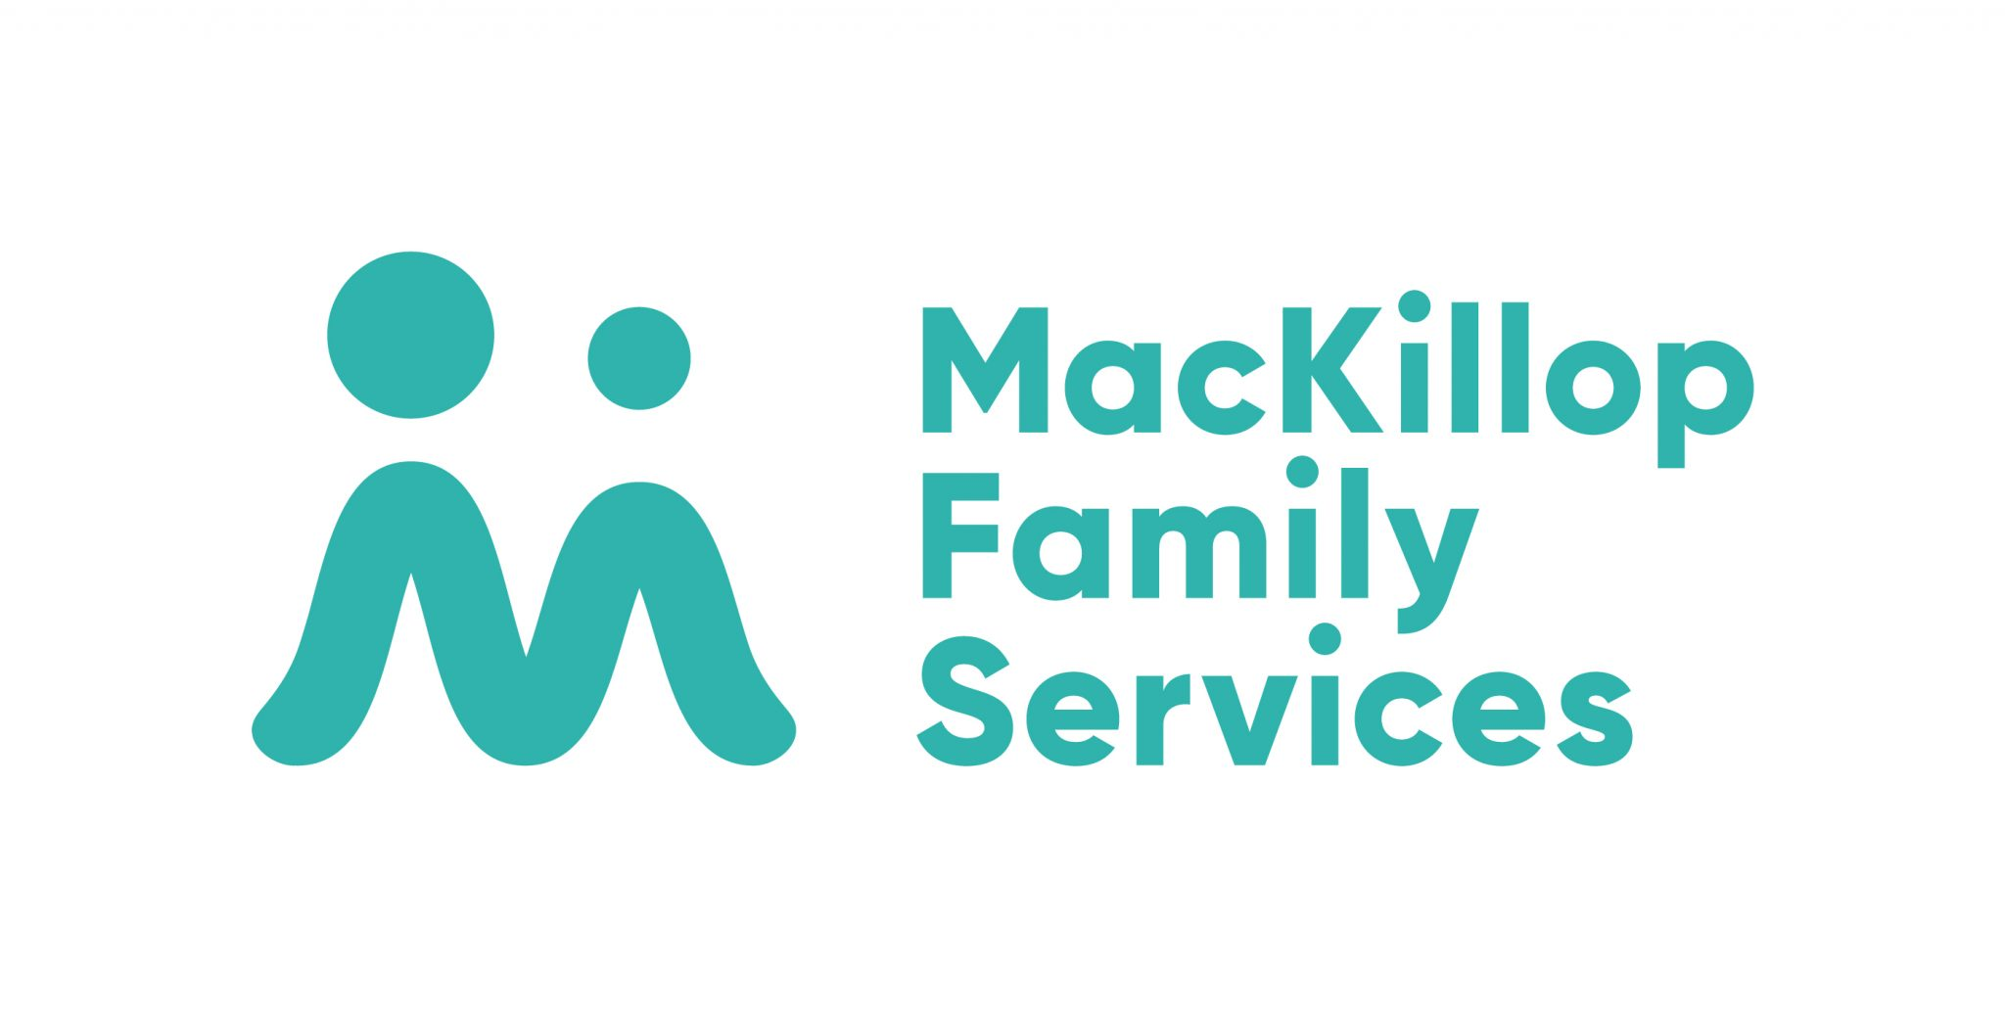

**Relationship:** Sheen Fleet

**Accident Management:** Internally run by MacKillop Fleet department

**Insurer:** Self-insured up to $5,000 / Zurich over excess

**Excess:** $5,000

**Sheen Excess Reduction Offer:** $300 per claim

**Pricing:** under excess – Sheen Fleet Pricing Schedule / Over excess – no pricing arrangement

**Decals / Signwriting:** No specific requirement for decal supplier

**Replacement Vehicle:** Generally don’t accept loan vehicles due to high risk of damage on their sites – will only provide if requested by MacKillop Fleet team

**Communications:** All store communication directly with MacKillop vehicle driver or site manager regarding vehicle updates – no centralised reporting required

**Escalation Point:** Contact Sheen Fleet

**Process:**

1. Inspect vehicle & take images - ensure name of customer of estimate is: MacKillop Family Services 237 Cecil St, South Melbourne VIC 3205
2. Submit your estimate & images to [fleetinsurance@mackillop.org.au](mailto:fleetinsurance@mackillop.org.au) & cc [fleet@sheengroup.com.au](mailto:fleet@sheengroup.com.au)
3. MacKillop Fleet will respond with either authorisation for a direct payment or will lodge the claim number

**Notes:**

Even if the damage appears to be certainly over $5,000 MacKillop have a process where they will have an estimate & images submitted prior to their lodgement of the claim