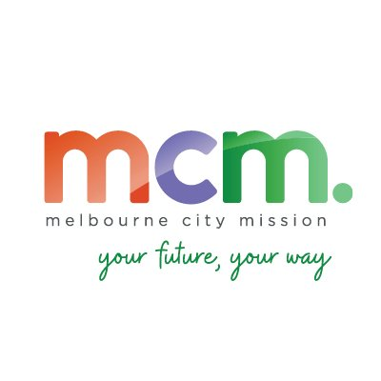

**Relationship:** Sheen Fleet – Sheen Panel Service Kensington & Brooklyn

**Accident Management:** Custom Fleet Accident Management

**Insurer:** Vero

**Excess:** $500

**Sheen Excess Reduction Offer:** no excess reduction – Custom Fleet % of total invoice referral fee

**Decals / Signwriting:** No specific requirement for decal supplier

**Replacement Vehicle:** Accept Sheen Accident Replacement Vehicles

**Communications:** All store communication directly with MCM vehicle driver

**Escalation Point:** Please contact Mark Salvadori at Sheen Fleet

**Process:**

1. Inspect vehicle & take images
2. If vehicle driveable – driver to keep driving until assessment date / if vehicle not driveable or unroadworthy provide Sheen replacement vehicle
3. Driver to contact Custom Fleet Driver Support number to lodge their claim
4. Claim will be allocated by Driver Support to the insurer & your store will be emailed the details