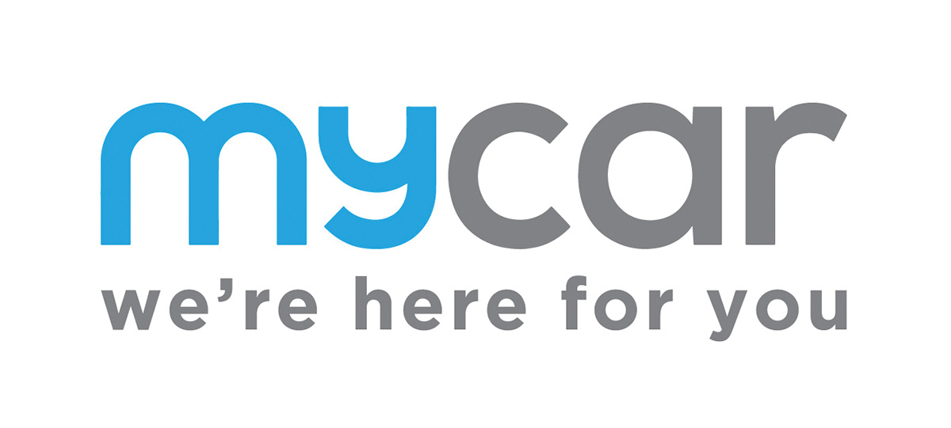

**Relationship:** Sheen Fleet

**Accident Management:** Innovation Managed

**Insurer:** Self Insured

**Excess:** $25,000

**Excess Reduction:** n/a

**Pricing:** Sheen Fleet pricing Schedule

**Sheen Excess Reduction Offer:** n/a

**Decals / Signwriting:** No specific requirement for decal supplier

**Replacement Vehicle:** mycar accept Sheen accident replacement vehicles

**Communications:** All store communication directly with local mycar branch or client of mycar

**Escalation Point:** Alex Laughton – mycar head office, details:

|  |  |  |  |  |
| --- | --- | --- | --- | --- |
| **Alexandria Laughton** | | | | |
| Care Team | | | | |
|  |  |  |  |  |
| **T** | 02 9680 6500 | **F** | (02) 9680 8170 |
|  |  | **W** | mycar.com.au |
|  |  |  |  |

[alexandria.laughton@mycar.com.au](mailto:alexandria.laughton@mycar.com.au)

**Process:**

1. Inspect vehicle & take images
2. You may offer the mycar customer a Sheen accident replacement vehicle if required
3. Submit your estimate & images to [alexandria.laughton@mycar.com.au](mailto:alexandria.laughton@mycar.com.au) – she will either allocate vehicle to Innovation to be managed or provide authorisation for direct payment

**Notes:**

Sheen are a partner of mycar in Victoria where we repair vehicles of mycar customers that have been damaged whilst on a mycar site.