Who We Are Youtube Video

What We Do Youtube Video

There are multiple ways you can share a YouTube Video.
- The easiest way on desktop is to copy the URL at the top of the page and paste it directly.
  - Most social media platforms like LinkedIn, Twitter, and Facebook will automatically embed the video when done this way.
- You can also click on the Share Button under the video.

- This will pull up a dialogue box where you can choose a platform to share it on or copy the URL directly here.
  - If you are using the mobile YouTube app this is the only way to copy the URL.

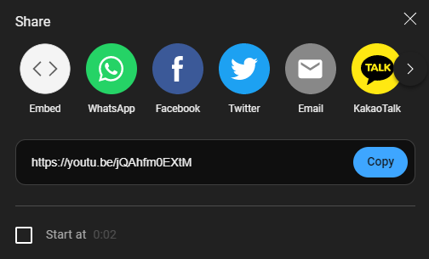
- Embedded videos in emails can be marked as spam, but you can add a clickable image that leads directly to the YouTube video!
  - Download the corresponding YouTube thumbnail image attached to this post.
  - In a new email select 'Insert' - 'Pictures' - 'This Device'
  - 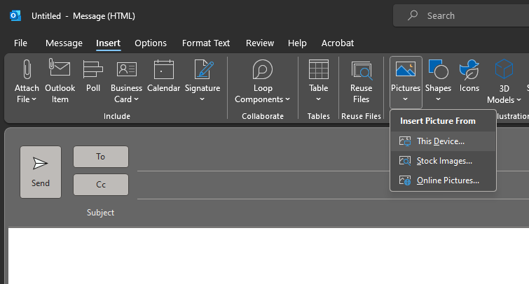
  - Select the image and resize.
  - Right-click on the image and select 'link' - 'existing file or web page' - and then paste the YouTube URL in 'Address' and click 'Ok'
  - 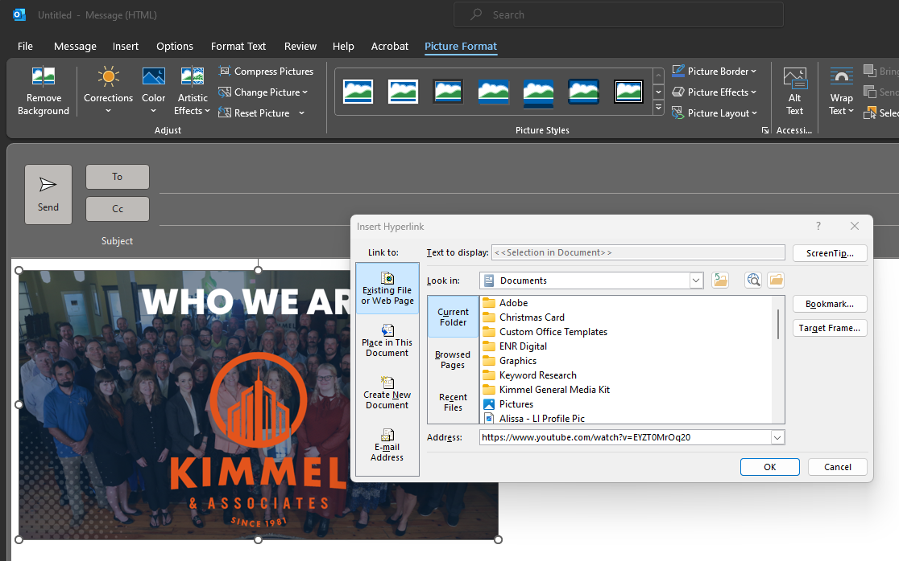
  - You can hover over the image to see the URL pop up.
    - It is also recommended to include a simply pasted URL above or below the image in case the recipient decides not to download images when they open the email.

Who We Are LinkedIn Video

What We Do LinkedIn Video

On LinkedIn, you also have the option to Repost the videos from our company’s LinkedIn Page.
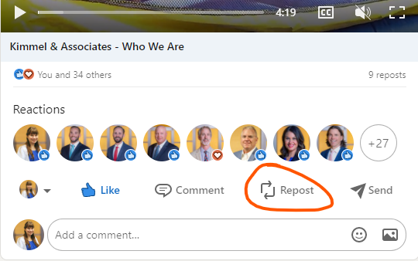
You have the option to add your own words above the post, select Repost with your thoughts, or simply share the video, select Repost.
What We Do Video Thumbnail.png
Who We Are Video Thumbnail.png

