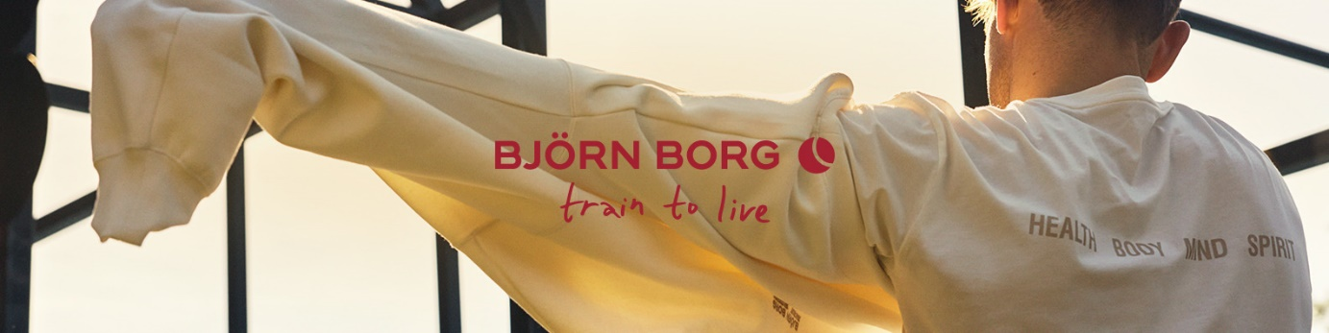

Brand Activation Manager Germany | Hamburg
Remote Setup – Full-time or halftime (minimum 50%)
We are on an exciting journey, and our ambition is bold: to become the number one sports fashion brand. At Björn Borg, our culture is defined by high ambition, relentless drive, and a deep passion for what we do.
As Brand Activation Manager Germany, you are the beating heart of our brand in the market. Your mission is to drive brand growth in Germany – strategically and tactically. You will increase awareness and preference, build strong local partnerships, and turn ideas into high-impact activations that fuel both brand and business.
You are a people person — social, fearless, and full of energy. You know how to connect with communities, gyms, studios, and influencers, and you’re not afraid to roll up your sleeves to make things happen. Whether you’re hosting an event, partnering with a fitness studio, or seeding products to the right people, you bring our brand to life in the real world.
You feel at home in a training environment — you work out, you move, and you understand the mindset of the active community. You live the lifestyle our brand represents.
This is a 100% remote position based in the Hamburg area. As we do not have a local office, you will work fully remotely and independently, while being closely connected to our Global Marketing team in Stockholm.

Your tasks & responsibilities
- Develop and execute brand activations that drive awareness and brand heat in Germany
- Build partnerships with gyms, fitness studios, sports clubs, and cultural communities
- Organize and host events that make people feel — and remember — Björn Borg
- Lead product seeding to create organic visibility
- Identify and nurture key brand ambassadors and local heroes
- Collaborate with the Global Marketing team in Stockholm to create alignment across all markets
- Oversee activation budgets and planning

Your profile
- 2+ years of experience in brand activation, PR, marketing, events or training environment — ideally within sports, fashion, or lifestyle
- Fluent in English and German
- Highly self-driven and structured, with the ability to work independently in a fully remote setup
- A true connector: confident, social, and naturally building relationships wherever you go
- Hands-on, proactive, and not afraid to take ownership from idea to execution
- Skilled in planning, project management, and event execution
- A sense of style and understanding of youth and fitness culture in Germany
- You live an active lifestyle and feel energized in a gym or sports environment

Who you are
You’re bold, energetic, and love being out there — not behind a desk. You are a true doer who thrive in a fast-paced environment where no two days are the same. You are curious, independent, and solution-oriented, with a natural drive to make an impact.

What we offer
- A competitive salary and great benefits — including phone, laptop, and 40% employee discount
- A 100% remote position based in the Hamburg area
- Twice-yearly travel to Stockholm, Sweden, for our Global Brand Summit
- A energetic, and sporty team that values ambition, humor, and drive

How to apply
Send your CV and cover letter to beatrice.lindenhall@bjornborg.com
We review applications and conduct interviews on a rolling basis, and encourage you to apply early as the position may be filled during the recruitment process.
You’ll receive an email confirmation once your application has been processed. Shortlisted candidates will be invited to an in-person interview. We usually make our decision after two to three rounds

