
Retired
Officers Club
-

Queensland

Newsletter No. 498
–

February
The Annual General Meeting

Where did it happen?
 | Contacts
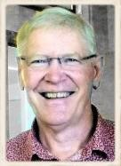 | President  David McGregor  0409 890 019  cmc62075@bigpond.net.au
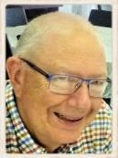 | Secretary  Greg Hooke the Younger  0418 180 557  30 Panoramic Drive, Preston Qld. 4352 ghooke@internode.on.net
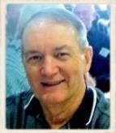 | Treasurer  John Tudhope V3   3341 9197  5 Brad Street  Eight Mile Plains, Qld. 4113 tudhope@bigpond.net.au
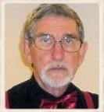 | Newsletter Editor  The Weird Guy  62 South Street  Thornlands, Qld. 4164 gkrobb01@gmail.com.au
Gold Coast Coordinator
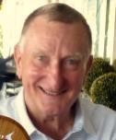 | Glen Robertson  5537 3230  glenrobertson1@optusnet.c om.au
The Club's email address is anzrocq@outlook.com
Please use this address for all general and newsletter emails to the Club Account details
Payments to the Club should be made to:
ANZ Retired Officers Qld. BSB 014002
Account No. 3611 32367
What happened?
Reports and Things
The March Edition
The business was conducted in pleasant and comfortable surroundings in ANZ Bank 20th Floor Eagle Street.
We are again grateful to the Bank for providing this facility, with a special thank you to Jenny Barry, (Qld. Co-ordinator, Institutional Banking) who makes it all happen.

When the dust settled, this is what you got.
The incoming President is actually the same old David McGregor but with a new haircut.
Secretary Greg Hooke the Elder has been replaced with a rejuvenated Greg Hooke the Younger, but his tenure is uncertain. More on that in the March newsletter
The new man in the counting house is a reincarnated John Tudhope, Version 3.
The Auditor might be Bill Elder. He is away at the moment and can’t be asked if he wants to continue in that role.
The new Newsletter Editor looks a lot like the old one, but the 2020 version seems a bit strange…. Time will tell. For the moment we will just refer to him as The Weird Guy.

The AGM only finished a couple of hours ago so it’s expecting a bit much to have reports and things ready for this edition. They will get done soon. You can look forward to getting them in the March edition.

It might be mid-March by the time you get that one. The Weird Guy is heading off to Tasmania next week. He will be back in time to see what is in the mailbox in early March.
Actually he arrived home from the AGM to find a letter from Denis Volter with material that will be included in that newsletter.
And the Queen and Creek Street staff photo, which you will find towards the end of this newsletter, was circulated at the AGM and a
good number of the group has already been identified. That will also
Be a Contributor

be included.
All in all it looks hopeful that we will have a respectable quantity of material.

We know from past experience that you won’t write in and tell us about yourself. So write in and tell us about someone else.

Sightseeing in High Places
In the previous newsletter, you were invited to tell us what edifices you had climbed in your travels.
The then editor called that suggestion, an initiative. What was he thinking? He only received one response.
I won’t be pestering you with silly ideas. If you want to send something for the newsletter it will be welcome. If you don’t, (insert shoulder shrug here). I will still sleep well at night and will still sit up the front of the plane.

The lone climber
Of the list of edifices that were included in the December newsletter, Greg had climbed the Eureka Tower in Melbourne and the Eiffel Tower. He also offered another he had climbed as a candidate for the list.
That was the Fernschturn Berlin. Greg translated that for us. It means Television Tower and it tallest structure in Germany and 3rd in the EU.
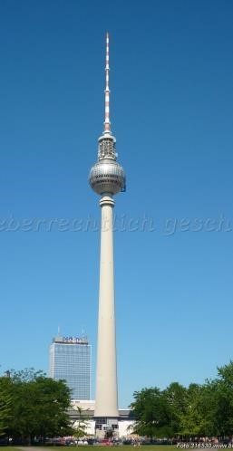

Gone missing
Postal mail sent by Julie Whitmee to Col Yates has been returned without explanation.
Can anyone enlighten us?

Identified heads

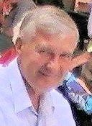
This bloke was identified by Peter Young as ‘Bob Beaumont, Ex-Esanda, who now lives in Toowoomba.’
And Graeme Drew who said ‘my money is on Bob Beaumont ‘.

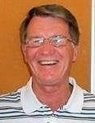
This fellow is Les Henderson and we have that on the authority of Les Henderson.
By way of confirmation he was also identified by Ted Denford.
Peter Lenton also identified Les from his Esanda days.
And yes, both have made it to the Head Shots Gallery.

Nice things said

Mark Downey
Thanks for the newsletter and all the newsletters during the year. I must say the images in the newsletter are first class. Regards and Merry Christmas

Graeme Drew
Thanks for the newsletter. Great production as usual. Congratulations on repeated top efforts which are much appreciated by all of we members. Happy Christmas and all the best for the New Year.

Peter Young
Merry Christmas to you & the family. Just enjoyed reading another great Newsletter.

Robin Kelly
Thanks for the great newsletters. Keep up the good work.

Peter Lenton
Thought the December newsletter was a beauty, as was the Christmas Luncheon at the Stamford Plaza. Best wishes for Christmas and 2020.

Mayling Liu
……. a good newsletter worth reading.
Please extend my appreciation to the organising Committee for the enjoyable Christmas Lunch last Thursday. It is refreshing to reminisce about our former happy days – in some cases spanning many decades – when friendships were made, and were made to last, during and long after our careers ended.
Best wishes to all for an enjoyable Christmas and New Year filled with family harmony and the sustaining warmth of close friends.

John Alcorn
Well done guys, what a great newsletter. Really did round off the year. Some great stories and Xmas functions. Cheers.

Innisfail Reunion
The reunion of ex-Innisfail Staff is to be held on 2nd. May 2020 at the show grounds building in Innisfail.
It will be an afternoon and evening affair.

Contacts
Jo-anne bm.mac@bigpond.com or
Ken Kitson kitson3@bigpond.com
The get together has been arranged by the staff from the 1980"s era (Tour-deInnisfail team) but includes all and any of the workers from Innisfail from any period.
 Ken’s commentary is included later in the newsletter.

Ted Brown |  | Rob Kelly
 This biography of Ted Brown was compiled by Ted’s family with a little editing by Greg Hooke.

From the beginning
Ted was born on 3rd October 1930.
He joined the ANZ Bank in Chinchilla in 1952 but prior to that he had a series of jobs.
That included working for a Stock &
Station Agent and as a Cinema
Operator. He also worked for the Main Roads Dept. toting a pick and shovel and then trained with them to be a Cost Clerk.

After he married
Ted married Rose in 1954 and it was fortunate they enjoyed life in country towns as Ted was transferred to Miles, Nambour, Chinchilla, Caboolture and Bundaberg.

Becoming a Manager
Ted’s first managerial appointment was opening Moura Branch on 7th March 1968. In his 4 years as Manager the branch grew from 4 to 9 staff and he won the respect of the locals for his service to the community.

Off to the big smoke
Rose and Ted’s family had grown to eight children, so a transfer to Brisbane was fortuitous for their education.
Ted was initially Manager at Acacia Ridge and then Cleveland.
After many years’ service as Branch
Manager, Ted finished his career as Manager Lending Inspection. This role took him all over Queensland.

Retirement
After 35 years’ service, Ted retired in 1987 at the age of 57.
Rose and Ted enjoyed an active retirement, playing bowls, travelling and spending time with the evergrowing extended family.
Looking for new challenges, they worked as relief managers of private hotels/units.
Ted also volunteered for AESOP
(Australian Executive Service Overseas Program). His role was to promote the Chamber of Commerce in developing communities.
This led to Rose and Ted having memorable stays in Tonga and Nauru, where his guidance was greatly appreciated.

Village life
In 2008, they moved to Renaissance Retirement Village at Victoria Point, where they enjoyed socializing and making new friends.

At the end
Sadly Ted passed away at the age of 89 surrounded by his loving wife and family.
In addition to Rose and their eight children, Ted is survived by 22 grandchildren, 15 great grandchildren plus two about to come into this world.

In summary
We can truthfully say that Ted lived a good life and, with Rose, made the world a better place.

It continued
To extend the ANZ connection, Rose and Ted’s daughter Kathy, worked for ANZ for nearly 17 years and is married to Peter Herbert who also had a long career in the company.

With thanks
Rose and the family would like to extend their thanks to the many folk who wrote or called with messages of support and comfort.
It has been a sad time but the goodwill and fond remembrances have buoyed their spirits.

Late tribute
Secretary Greg received a message of tribute to Ted from Tony Butler, but too late for inclusion in the December newsletter.
Tony worked with Ted for about six months at Moura Branch in 1970 before Tony was transferred to Brisbane. Tony recalled Ted was a good bloke to work with and got on well with his team.

It was good to hear from Rob Kelly recently. It must be 25 years since I saw him last.
Rob is coping with prostate cancer. He says he is doing well but the bladder side effects have restricted him some.
To quote Rob; When you have to go, you have to go.
He had to give up travelling on the train to the Geebung gatherings. However the courtesy bus from the Caboolture Sports Club picks Rob up at his gate and drops him back at home, so that is still on the agenda.
Rob and Jannette have done a few short cruises, mainly with P& O. Most recently they took a 12 day cruise over Christmas on the Pacific Aria to Fiji.

New Members

Betty Richter
Betty left the Bank after 34 yrs.’ service.
She was introduced by Greg Hooke and is well known to Darling Downs members as long term senior staffer at Oakey.

Jenny Drummond
Jenny completed 17+ yrs. service as a Financial Planner with ANZ and had previous banking experience with NAB.
Jenny was introduced by Greg Hooke and is well known to Darling Downs members.

Kathy Herbert
Kathy had a couple of stints in the Bank, finally leaving in 2002 after 17yrs service.
Kathy was introduced by Greg Hooke and is well known to Toowoomba staffers. She is also the wife of former staff member and the daughter of the late Ted Brown.

 Greetings ladies and a very warm welcome to the Club.

When Greg Hooke arrived at the Stamford for the Xmas luncheon he came with an armful of old house journals. They were copies of ‘World’, the magazine that replaced Newslink.
The collection that Greg brought comprised random editions from 1998 to 2002. One of them was quite special in that it included a full page featuring Mayling Liu. It came from the May 1999 edition.
The subject matter of the article was the connection between ANZ and the Broncos and Mayling’s involvement.
Mayling’s involvement was substantial as most of you would already know. And that was not just with the sponsorship of the Broncos and the naming rights to ANZ Stadium, but also fostering the business opportunities from the connection.
Let me use an extract from the caption that accompanied the picture, to illustrate the regard in which Mayling was held.
Mayling Liu was presented with a Broncos Gold Pass in recognition of her unstinting work and support in her capacity as ANZ’s Public Affairs Manager in Queensland.
The caption also advised that only eight people had received the honour and that included Alan Border. It referred to the recipients as ‘this elite club’.
It really was well deserved recognition.
Mayling features in World |  | In the same World |  | In another World

The same edition that featured Mayling In This clip appeared in one of the also carried references to two other World magazines that Greg brought to Queenslanders, Dennis Coolee and lunch. Gordon Nicholson.
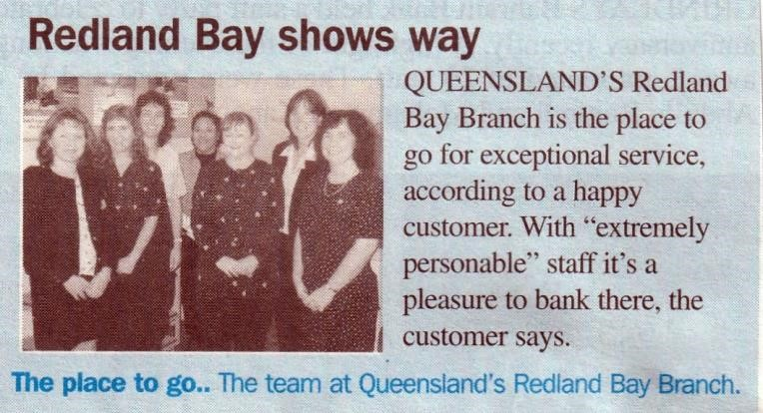
In the case of Dennis and Gordon it was in reference to their sales efforts.
Gordon Nicholson of Woodridge Branch was the number one sales achieving Senior Sales Consultant.
Dennis Coolee, based at Springwood was the leading
It says in the caption. “The place to go.”
Manager Investment Lending sales
achiever. If there are any readers who know of
the Redland Bay Branch and its Dennis is a current Club member.
whereabouts, would they please share Gordon never joined us. that with the rest of us.

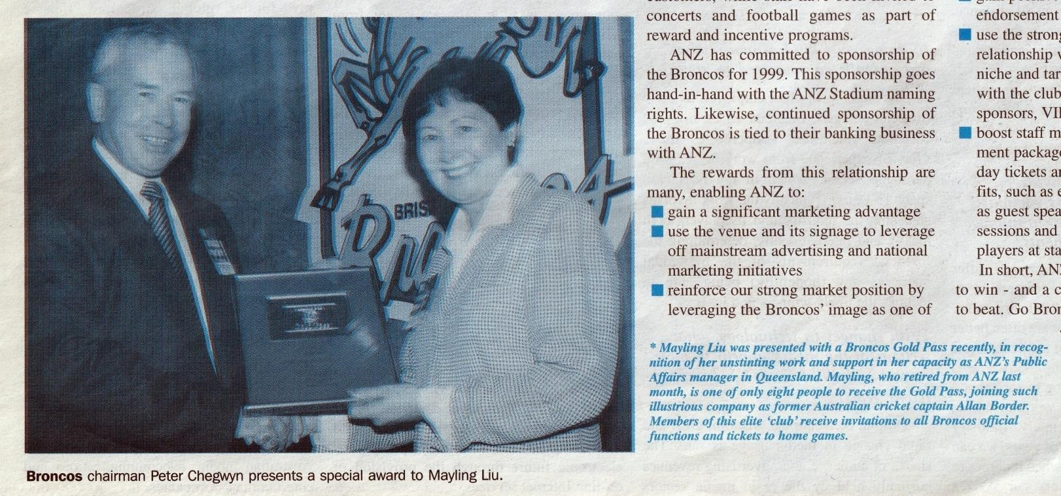

Innisfail and NQ
• By Ken Kitson
I had a very interesting time in Innisfail.
I took over as Manager from Don Grant in 1985 and experienced cyclone Winifred in '86.
In 1987 I opened the new branch premises and opened Mission Beach in the following year.
When I left in 1989 we had a staff of 20 odd.
They were a terrific bunch of young women and a couple of blokes. Their enthusiasm lasts up to today and thereby the impetus for their reunion.
For me the opportunity of working with such as them made my career in the Bank all worthwhile.
Nambour Branch opening & some more Sunshine Coast trivia
• A contribution by Noel Gilvarry

There is more to the Nambour story
I suggest that there is quite a bit more that can be read into the article about Arthur Bennett, the first Manager at
Nambour which was contributed by Ken Burrell in the November newsletter.

Coincidence
By pure chance I stumbled over the newspaper article the day before the newsletter arrived and I shared it with Senior Citizen Member, Geoff Taylor , only hours before the newsletter arrived.
Some members may wish to revisit the article which includes five photos a couple of which I suggest are historically significant.
(If Editor Graham can find the space they might to be included in his archives.)
Either click on or cut and paste the following link https://www.pressreader.com/australia /sunshine-coastdaily/20191102/282196537753811
The article

Pioneer Bank Manager Big
on Business was the headline.
When retired in 1924, 18 years after opening the branch, there was a staff of 10.
Question - Can anybody
The 1924 staff photo –  Question – Is this the oldest branch staff photo that could be in the ANZROC Members ‘Gallery? (See next page for the answer) | Palmwoods and the 'fine large residence' was a strong projection of the bank's status in the small town. The ES&A Bank was a prominent banking institution in the Council area, opening branches in Palmwoods, Landsborough, Maleny, Yandina, Nambour, Kenilworth,
Names in that photo
I recall Fred Steggall who came to Cooroy as a relieving Manager in about 1960.  Question – Is H S Baildon, Bevan Baildon’s father? He is certainly the same stature as Bevan?  I recall the names Fred Larkin, a Tony Dyason and a Bill Wild but cannot recall in what context. Maybe some of our Senior members may enlighten us. | Beerwah.  YANDINA – I found a heritage trail brochure, a couple of excerpts of which read – “Before the ES&A Bank erected this building in 1920” and also “The ES&A moved into the original building in  1909 and shared space with the Post Office until 1914”  The branch/agency appears to have closed, possibly during the depression or during WW2 but I recall that in the
More history
I digress into a bit more history – I decided that I would endeavour to ascertain the opening dates of branches in the area. My search of ES&A Bank Kenilworth found nothing but there were several other references including the following.  PALMWOODS - The town was greatly improved in the 1910s. A general store and hotel were constructed in 1912 and the English, Scottish & Australian (ES&A) bank and residence were built in 1915. At the time, the local newspaper noted that the bank had 'shown its confidence by erecting a commodious building with a fine large residence | 60s the agency used to be conducted by Col Berrill (agency officer Nambour) in the Ladies lounge of the pub owned by Paddy Rafter who is Grandfather of Pat  Rafter the tennis player. Pat’s father Jim worked for the Scottie but later resigned and I believe worked for MIM in Mt Isa.  Summary – This additional information indicates that Arthur Bennett’s success at Nambour and surrounds was the catalyst for the  Scottie’s rapid expansion on the  Sunshine Coast, much more so than the  author of the Historical Society’s article depicts.
Eumundi, Caloundra, Eudlo and
adjoining' (Chronicle and North Coast
Advertiser, 1 October 1915: 3). It is This picture will be captioned and added to
name a branch that had a staff of 10 just 18 years after opening and had been the catalyst for the opening of several other branches and agencies in the vicinity.
Wot a goer this bloke must have been. Bennett’s flag - It appears that he travelled the hinterland on a regular schedule gathering business but also dropping in to cash cheques or collect deposits from rural customers who displayed “Bennett’s Flag”.
Question - “Was he the first mobile banker?
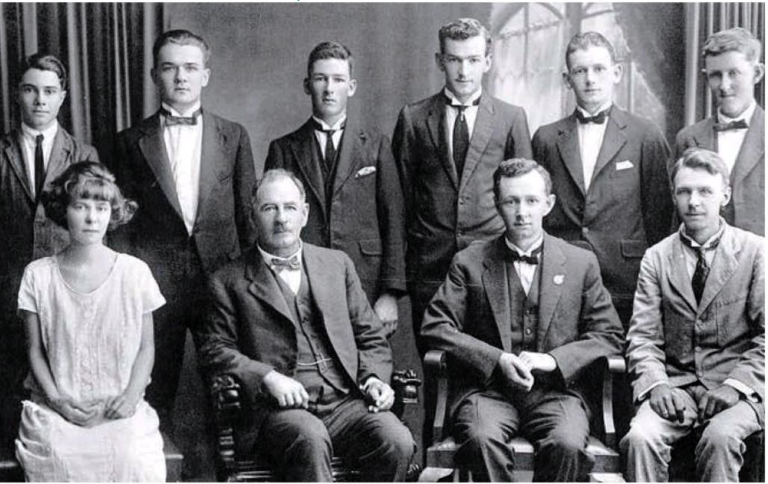
Groups in the Members Gallery the first purpose-built bank in
Here are the names of the people who are pictured in the 1924 ES&A Nambour group from the previous page.
Standing L-R
 F. Steggall (Junior)
 N.I. Wild (Ledger keeper)
 H.S. Baildon (Ledger keeper)
 F. Larkin (Teller)
 H. McDougall (Ledger keeper)
 H. Harris (Junior)
Seated L-R
 M.E. Small (Typist)
 Arthur Bennett (Manager)
 R.J. Lindsay (Accountant)
 C.M. Dyason (Agency Officer)
 Three Ledger keepers, two Juniors and one teller. This needs explanation!

That question
Who are those people? |  | The Editor has no problem filling empty spaces
Question – Is this the oldest branch staff photo that could be in the ANZROC Members ‘Gallery?
Answer – No, it is not.
The photograph below predates the
Bennett group photo published in the Sunshine Coast newspaper article. The caption tells the story

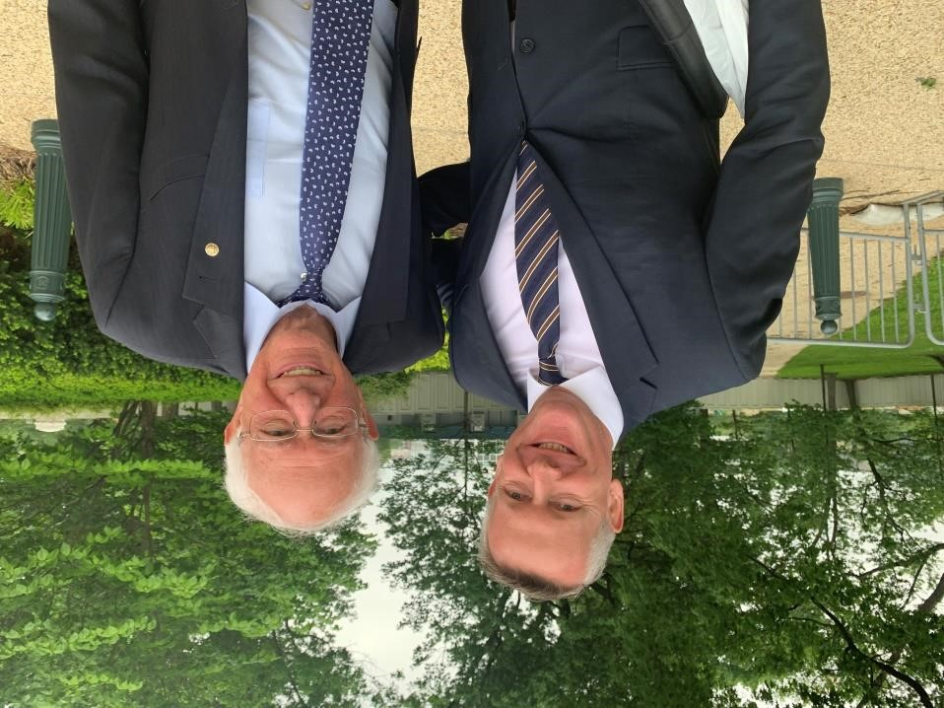
This photo was taken in Washington D.C. around October last year. The
fellow on the left is Mark, one of the Editor’s sons in law.
You will very likely recognise the chap on the right, but if you do need a clue; He has an aspiration to become the next President of the United States.
This has absolutely nothing to do with Club news, but it does help to fill up the blank spots.
Why not send in in your happy snaps of family with Presidential candidates. If there is space in the next newsletter we will print them.
Bonus pages
Everything from this point forward arrived after I had resigned myself to a six pager. So, thank Graham Kernovske, Greg Hooke, Cheryl Judd and Bert Higgins for what you see from here on.
Report from Bert Higgins
• Bert had occasion to write to the Club and he included a brief personal update.
Gloria and I are now in our nineties and reasonably well and active. After decades of ballroom dancing we gave it away about 12 months ago as it is not compatible with declining balance and strength faculties.
We enjoy the monthly newsletter and pleased to know that many of my ex-colleagues are still well and active.
Health report
Dudley Fisher has recently visited Tim Butler. He tells us that Tim is much the same as previously reported.
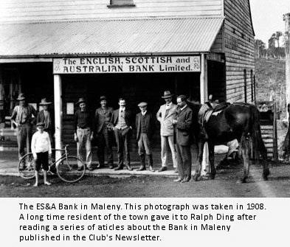
Graham Kernovske’s contribution
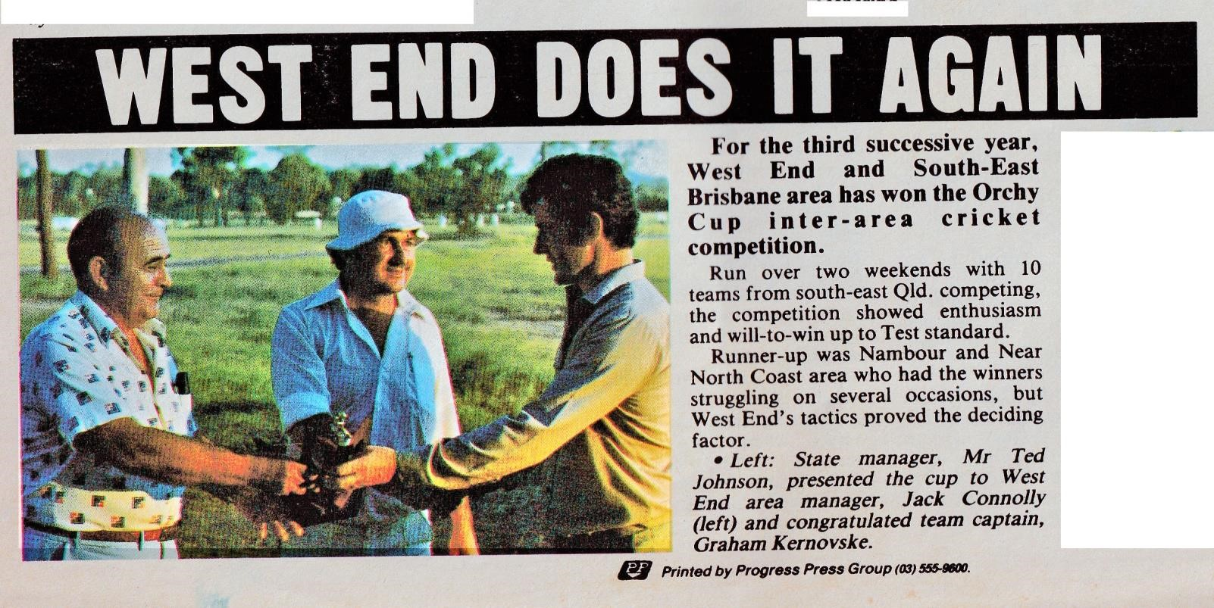
Graham sent the entire Newslink edition from June 1982. The primary purpose was to support his story on the Orchy Cup, but there is quite a lot of other interesting stuff in there and you can bet your life that a lot of it will turn up in future editions of our newsletter.

Graham’s Orchy Cup story
This is a follow up to our discussion on the Orchy Cup Cricket Competition.
It was an in-house competition played between the various Areas, State
Administration, Esanda and the North and South Coasts in the seventies and early eighties.
It is understood that the competition started B(Q&C) and B(Q&W) Street Branches and later spread because of outside challenges.
The trophy was put up by Bob Blair, who a Test cricketer from New Zealand and the “Boss Fella” of Orchy soft drinks in Queensland. He just happened to be on a marketing drive.
The competition was strong for a number of reasons. Inter-area rivalry
Ratio of male staff &
The teams contained players who had represented the State and players like Kev Maher and John Bell, who were bordering on State selection.
Retired Officers mantra Respect your elders. They graduated from school without the internet.
The standard set by West End & South East Brisbane Team resulted from strong leadership imposed by coach Jack Connolly. This coupled with
tactical sessions at the
Same Newslink
– Different Sport
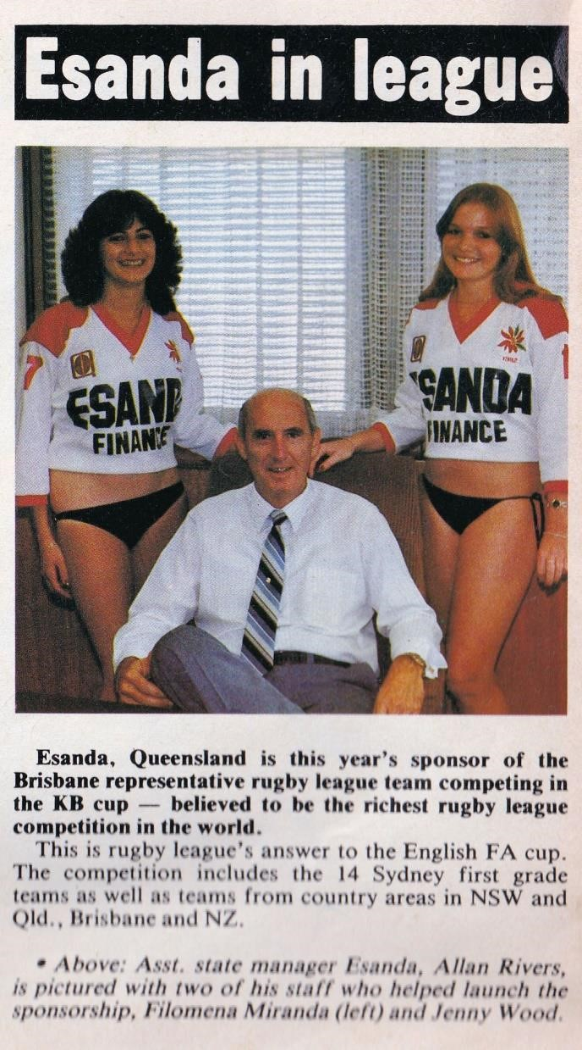
Melbourne Hotel proved to be the correct formula for a record three successive team wins.

Stacked/loaded opposition sides led by Noel Wyeth fell short of beating this solid Connolly outfit.
 Graham is hoping to get a rise out of his old mate, Noel Wyeth with that one.

Queensland got a second mention in the sports page of the Newslink that Graham sent. It was this clip featuring Allan Rivers flanked by a couple of Esanda staff in their work uniform.
 Our congratulations go to the Esanda Recruitment Manager of the day.

Cheryl Judd’s contribution
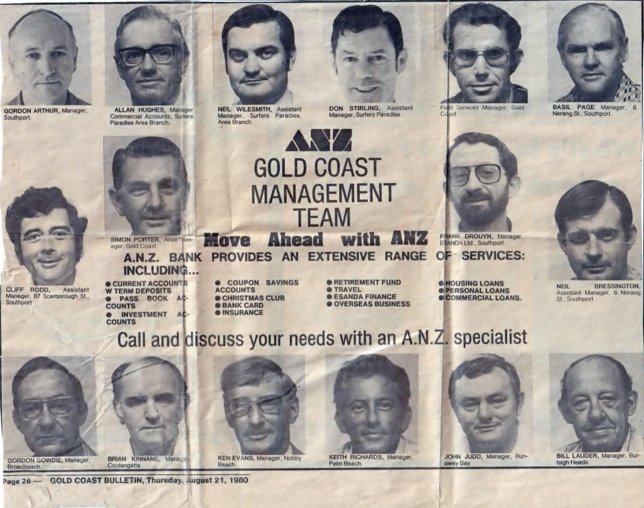
Cheryl had been sorting out some cupboards when she came across this old clipping from the Gold Coast Bulletin from August 1980.
Knowing that it would be of interest to many of you, she has shared it with us.
Cheryl’s late husband, John Judd, is one of those pictured in the clipping.
For some reason they did not identify Harley Kropp and they got thoroughly confused about “Bresso”.
Bet there are stories that are stirred by these faces.
 Thank you for sending the clipping to us Cheryl.

Greg Hooke’s contribution
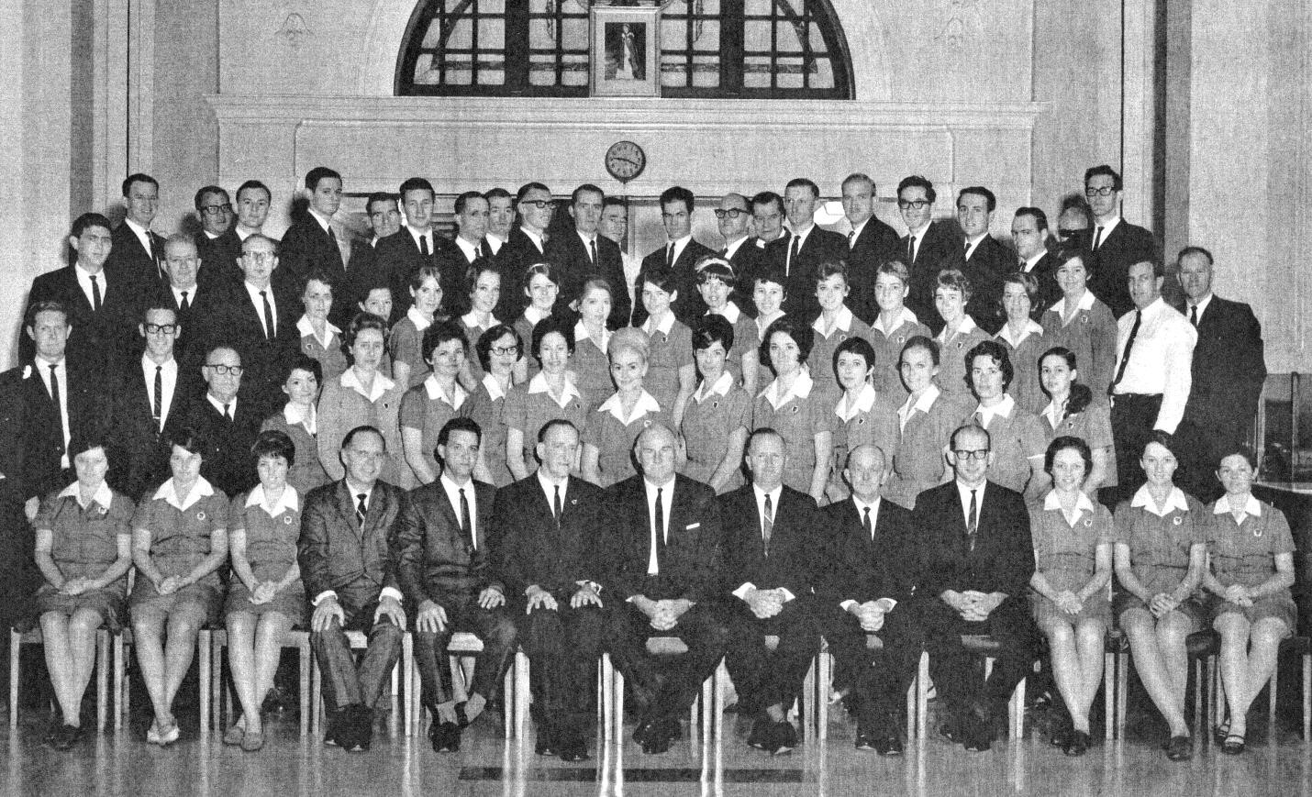
More on this photo in the next issue. We already have material, including
commentary from Col Yates.
While this photo of the staff of B(Q&C) came to us from Greg, it is from the album of Col Yates. Greg said he recognised few and said “(Doug Cox & Heather Stephenson for starters) and there are some that seem familiar but it’ll take a while for the little grey cells to do their work.” As to the date, “I would guess it must have been mid 1960s?” Add your commentary.

