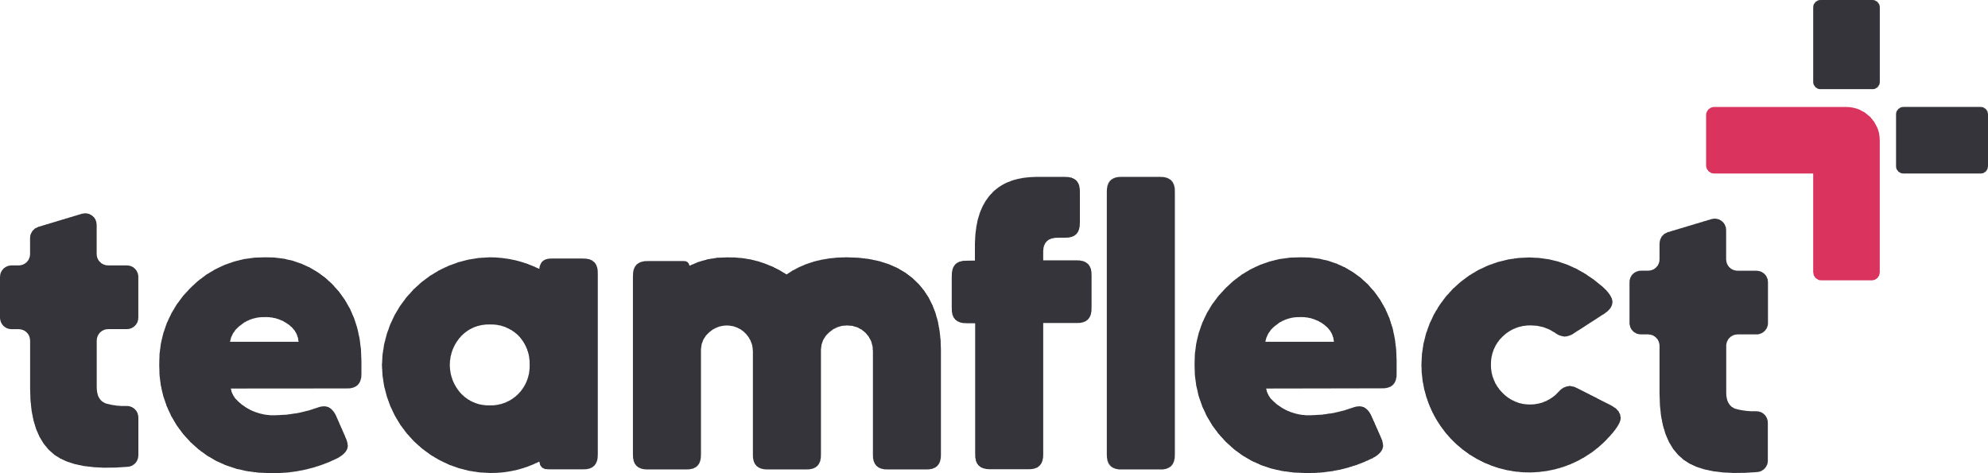

Manager Evaluation
Audit Worksheet
A practical HR tool for identifying which managers need a development conversation — before problems compound.
  Organization name
  HR lead / reviewer name
  Review period (e.g. Q2 2026)
  Number of managers being evaluated

01 BENCHMARK SCORECARD — SCORE EACH MANAGER TEAM

Enter your current data for each manager's team. Flag any metric that crosses the warning signal threshold.
$10 trillion  lost to disengagement globally in 2025 | 79% vs 22%  best-practice vs global manager engagement | 49%  of employees globally are genuinely faring well at work

Metric | Benchmark | Warning signal | Your data + flag
Team Engagement Score  Source: Gallup 2026 | Benchmark  Best-practice organizations: 79% of managers engaged. Global average: 22%. US average: 31%. | ⚠ Warning signal  Team scores below company average for two consecutive survey cycles. | Your team's score  _______________  Flag? ☐ Yes ☐ No
1-on-1 Frequency  Source: Lattice 2026 | Benchmark  Weekly or biweekly is the research-supported minimum. | ⚠ Warning signal  Monthly cadence or less for two or more consecutive months. | Your team's score  _______________  Flag? ☐ Yes ☐ No
Turnover by Team  Source: Gallup 2024 | Benchmark  US voluntary turnover benchmark: ~13% annually. 42% of exits are preventable, with management quality among the leading drivers. | ⚠ Warning signal  Team running above 20% annually, or 1.5× the company average, for two consecutive quarters. | Your team's score  _______________  Flag? ☐ Yes ☐ No
Team Wellbeing  Source: WEF / McKinsey | Benchmark  Global average: 49% of employees faring well. Only 2.2% of companies measure wellbeing systematically. | ⚠ Warning signal  No structured wellbeing survey completed for this team in the past six months. | Your team's score  _______________  Flag? ☐ Yes ☐ No

02 FLAG SUMMARY

List every manager team that triggered at least one warning signal above.
Manager / team | Metric(s) flagged | No. of flags | Priority (High / Med / Low)

03 DEVELOPMENT CONVERSATION PLANNER

For each flagged manager, complete one block. Schedule the conversation within two weeks of identifying the flag.
MANAGER / TEAM ____________________________________ DATE ________________
Metrics flagged (circle)
Engagement score 1-on-1 frequency Turnover rate Team wellbeing
Key patterns identified

Agreed development goal (specific and measurable)

Next check-in date _______________ Owner _______________
Duplicate this block for each flagged manager.

04 PRE-REVIEW READINESS CHECKLIST

Complete before running your next manager evaluation cycle.
- Engagement survey data pulled for all manager teams
- 1-on-1 frequency report exported from calendar or HR system
- Voluntary turnover by team calculated for the review period
- Team wellbeing survey completed or scheduled within the last six months
- Competency framework reviewed and confirmed current
- 360-degree feedback collected with minimum three raters per manager
- Calibration session scheduled with senior leadership
- Development conversation template prepared for flagged managers

05 POST-REVIEW ACTION TRACKER

Action | Owner | Due date | Done ☐
Schedule development conversations for all flagged managers
Share aggregated feedback themes with each manager
Assign training or coaching resources
Update individual development plans in HR system
Set next evaluation cycle date

Teamflect • teamflect.com | Sources: Gallup 2026, Gallup 2024, Lattice 2026, WEF / McKinsey Health Institute

