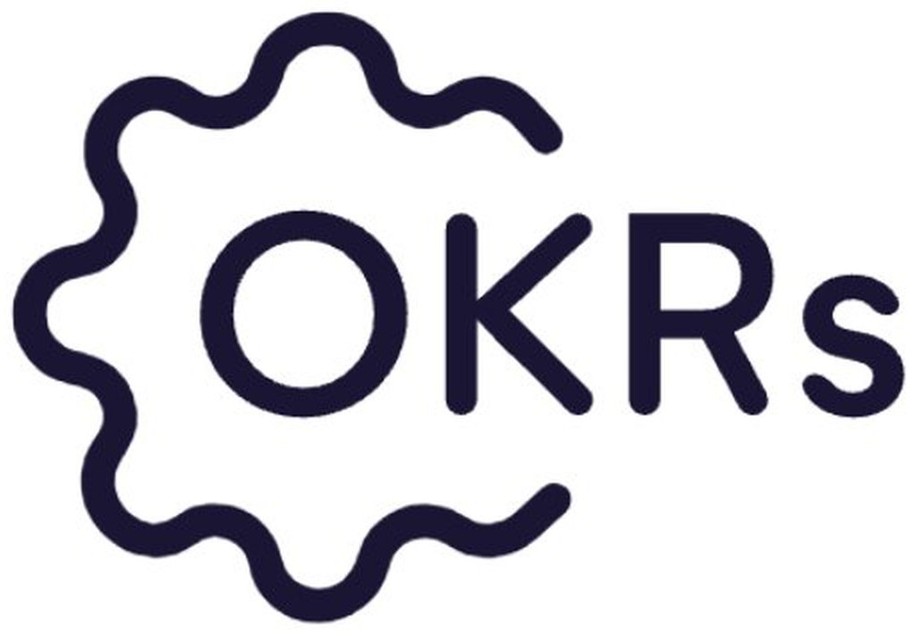
OKR Program Update
[Q1 2027] · Prepared by [Your name], [Date]
Replace the bracketed values with yours. This one-pager is built to go straight to your sponsor, or onto a slide in the leadership meeting. Delete this line before you send it.
At a glance
Weekly adoption  [68]% | KRs on track  [14] of [20] | At risk  [3] | Cycle  Week [6] of 13
Company objectives
Company objective | Owner | Status | Grade to date
[Grow into the enterprise segment] | [Dana] | [On track] | [0.6]
[Make onboarding effortless] | [Sam] | [At risk] | [0.4]
[Build a repeatable demand engine] | [Priya] | [On track] | [0.7]
[ … ] | [ ] | [ ] | [ ]
What moved this period
- [A key result or two that advanced — name the concrete progress]
- [A team that hit a milestone worth calling out]
What's at risk — and what I need from you
- [The objective that's slipping, and why in one line]
- [The specific decision, resource or unblock you need from leadership]
Focus next period
- [The one or two things the program will push on next]
- [Any change to cadence or scope]

Built with OKRs Tool · okrstool.com — your live dashboard produces these numbers for you, so this update takes minutes, not an afternoon of chasing.

