National College of Business
Administration & Economics
Lahore



Inequality, Social Cohesion and Economic Growth: A Multi-Level Estimation

BY

SHAHLA AKRAM

doctor OF Philosophy
in
ECONOMICS

AUGUST, 2020
national college of business administration & economics

Inequality, Social Cohesion and Economic Growth: A Multi-Level Estimation

BY

SHAHLA AKRAM

A dissertation submitted to
School of Social Sciences

In Partial Fulfilment of the

Requirements for the Degree of

DOCTOR OF PHILOSOPHY
IN
ECONOMICS

August, 2020



IN THE NAME OF ALLAH
THE MOST BENEFICENT
AND THE MERCIFUL
National College of Business
Administration & Economics
Lahore

Inequality, Social Cohesion and Economic Growth: A Multi-Level Estimation

by

A dissertation submitted to School of Social Sciences, in partial fulfilment of the requirements for the degree of

DOCTOR OF PHILOSOPHY IN
ECONOMICS

Dissertation Committee:

_____________________
Chairman

_____________________
Member

_____________________
Member

___________________
Rector
National College of Business
Administration & Economics

DECLARATION

This is to certify that this research work has not been submitted for obtaining a similar degree from any other university/college.

SHAHLA AKRAM
August, 2020

DEDICATED

DEDICATED
TO

My Parents, Teachers
And
Family

ACKNOWLEDGEMENT

All praise and thanks are due to Allah Almighty, who enabled me to accomplish the task of writing this thesis. I owe a debt of gratitude to different personalities who have been very helpful and supportive during writing this thesis. First and foremost, thanks to my esteemed supervisor Dr. Zahid Pervaiz for his valuable guidance and affectionate encouragement. His encouraging behavior has given me the confidence to succeed. Formal words of thanks will never be sufficient to express my heartfelt gratitude for his sympathetic and compassionate attitude.

My foreign supervisor Dr. Irene van Staveren, Professor of pluralist Development Economics at International Institute of Social Studies (ISS), The Hague, deserves my special thanks for her invaluable suggestions and encouragement. Her gracious behavior during my stay at ISS was greatly helpful in improving the quality of my thesis.

This work would never have been completed without the priceless prayers, compassionate care, and unconditional support of my parents. Formal words of thanks seem to be quite insufficient in expressing my heartfelt gratitude to them. I extend my deepest regards from the core of my heart for their selfless affection and care. Thanks to my brothers, sisters, and all family members for being very cooperative, helpful, and supportive. The financial support provided by the Higher Education Commission of Pakistan is also greatly acknowledged.

RESEARCH COMPLETION CERTIFICATE

Certified that the research work in this thesis entitled “Inequality, Social Cohesion and Economic Growth: A Multi-Level Estimation” has been carried out and completed by Shahla Akram under my supervision during her PhD. in Economics Program.

(Dr. Zahid Pervaiz)
Supervisor

SUMMARY

The purpose of this study is to explore the relationship among inequality of income, inequality of opportunities at micro, meso, and macro level, and economic growth through different channels, for example, direct social cohesion and indirect social cohesion through investment. This study is novel because it uses inequality as a whole and decomposes inequality into circumstances and effort based on different identities. These identities include socioeconomic conditions, gender, geography, political, social association, and parents’ background. Decomposition of income inequality aims to explore which part of inequality is harmful to social cohesion and indirectly for economic growth.
In the first stage, income inequality has been decomposed into six different inequalities of circumstances and effort indices. These indices are gender, intergenerational mobility, socioeconomic conditions, geographic conditions, social and political affinities. We used a set of cirumstances such as institutions (formal and informal), fractionalization, economic background of a birth country, intergenerational mobility, and different type of exclusion ( socioeconomic conditions, geographic conditions, social and political affinities ) we have been used for this purpose. We ran a regression using this set of circumstances and estimated values used as circumstance indicess while residual values were used as efforts.
While on the second stage, we explore the relationship of these indices with social cohesion. The findings show that circumstances' inequality has adverse but significant effects on social cohesion, while effort has an insignificant effect. We have also found that political stability is firmly, positively, and significantly related to social cohesion. However, ethnic diversity does not remain significant when we control different inequalities of circumstances and political stability; even then, it changed the direction that is converted from negative to positive. So, we conclude that if we control inequality, diversity may not be harmful to social inclusion.
In the third stage, we explore the indirect effects of inequality on economic growth using social cohesion as a mediator. Findings show the inequality of circumstances, whatever base of the group, has a significant but negative effect on economic growth, as inequality of circumstances retards social cohesion.
In the fourth stage, we explore social cohesion as a channel to increase economic growth through investment activities. We concluded that inequality of circumstances and socio-economic issues are harmful to economic growth. So, compensatory policies should be introduced to cope with the inequality of circumstances that is the root of social and economic deterioration. Equal opportunities regardless of group identity (geography, political, social, gender-based, and socio-economic) should be provided. Open merit should be applied. Only in this way efficient use of resources will be possible. Efficient use of resources can enhance the economic growth rate that is the next stage to accelerate society's economic effect.

ACRONYMS/ABBREVIATIONS

3SLS | Three Stage Least Squares
CIneq | Inequality of Circumstance
EIneq | Inequality of Efforts
GCR | Global Competitiveness Report
GDIM | Global Database on Intergenerational Mobility
GDPPC | Gross Domestic Product Per Capita
ICRG | International Country Risk Guide
IGP | Intergenerational Persistence
IOP | Inequality of Opportunities
ISD | Indices of Social Development
ISS | Institute of Social Studies
LIS | Luxembourg Income Study
SWIID | Standardized World Income Inequality Database
UCM | Unobserved Components Model
V-Dem | Variety of Democracy Institute
WIF | World Economic Forum

Table of contents

DECLARATION v
DEDICATED vi
ACKNOWLEDGEMENT vii
RESEARCH COMPLETION CERTIFICATE viii
SUMMARY ix
ACRONYMS/ABBREVIATIONS xi
LIST OF TABLES xiv
LIST OF FIGURES xv
CHAPTER 1 1
INTRODUCTION 1
1.1 BACKGROUND OF THE STUDY 1
1.2 RESEARCH QUESTIONS OF THE STUDY 5
1.3 OBJECTIVES OF THE STUDY 5
1.4 HYPOTHESES OF THE STUDY 6
1.5 SIGNIFICANCE AND CONTRIBUTION OF THE STUDY 6
1.6 ORGANIZATION OF THE STUDY 7
CHAPTER 2 8
LITERATURE REVIEW 8
2.1-INCOME INEQUALITY AND CIRCUMSTANCE 8
2.2-SOCIAL COHESION AND INEQUALITY OF OPPORTUNITIES 15
3.3-SOCIAL COHESION AND ECONOMIC GROWTH 23
CHAPTER 3 28
THEORETICAL FRAME WORK AND METHODOLOGY 28
3.1-THEORETICAL BACKGROUND 29
3.2-JUSTIFICATION OF CHOICE OF CIRCUMSTANCES 30
3.3- METHODOLOGY 31
3.4-BRIEF SPECIFICATION OF VARIABLES AND DATA SOURCES 36
CHAPTER 4 43
Empirical Results and Discussion 43
CHAPTER 5 68
CONCLUSION AND POLICY SUGGESTIONS 69
5.1 CONCLUSION 69
5.2 POLICY SUGGESTIONS 70
5.3 FUTURE RESEARCH PROSPECTS OF THE STUDY 70
5.4 LIMITATIONS OF STUDY 70
REFERENCES 71
APPENDICES 89
Appendix A 89
Appendix B 99
Appendix C 105
Appendix D 109

LIST OF TABLES

Table 4. 1 Descriptive statistics table 44
Table 4. 2 Matrix of correlations 45
Table 4. 3 Decomposition of Inequality of Income 46
Table 4. 4 Five More Unequal and Equal Country Ranking According Inequality of Opportunities in 1995 and 2015 52
Table 4. 5 Descriptive statistic 55
Table 4. 6 Correlation 56
Table 4. 7 Inequality of opportunities and Social Cohesion 56
Table 4. 8 Descriptive statistic 60
Table 4. 9 Correlation 61
Table 4. 10 Social Cohesion and Economic Growth (2SLS) 62
Table 4. 11 Social Cohesion and Economic Growth (3SLS) 64

Table A- 1 Exclusion by Socio-Economic Group 90
Table A- 2 Exclusion by Gender index 91
Table A- 3 Exclusion Urban-Rural Location index 91
Table A- 4 Exclusion by Political Group index 92
Table A- 5 Exclusion by Social Group index 92
Table A- 6 Military index 93
Table A- 7 Indicators Used in the Construction of Membership of Clubs and Voluntary Associations Index (Social Capital) 94
Table A- 8 Other Variables 95
Table A- 9 Intergroup Cohesion 96
Table A- 10 Political Stability 96
Table A- 11 Economic Globalization index 99

Table B- 1 Ranks and values of countries 102

Table C- 1 List of Countries Studied in Different Models 110

LIST OF FIGURES

Figure 3. 2 Theoretical Frame 29

Figure 4. 1 Trend of inequality indices over time 49
Figure 4. 2 Trend of inequality indices among regions 50
Figure 4. 3 Trend of inequality indices among income group 51

Figure D- 1 Scatter Plot for Inequality of Income and Favouritism (Average for Year 1988-2017) 119
Figure D- 2 Scatter Plot for Inequality of Income and Military interference in Politics (Average for Year 1988-2017) 120
Figure D- 3 Scatter Plot for Inequality of Income and Social Capital (Average for Year 1988-2017) 121
Figure D- 4 Scatter Plot for Inequality of Income and Religious Tension (Average for Year 1988-2017) 122
Figure D- 5 Scatter Plot for Inequality of Income and Ethnic Tension (Average for Year 1988-2017) 123
Figure D- 6 Scatter Plot for Inequality of Income and Economic Background 20-year lag of GDPpc (Average for Year 1988-2017) 124
Figure D- 7 Scatter Plot for Inequality of Income and Intergenwrational Mobility Persistence (Average for Year 1988-2017) 125
Figure D- 8 Scatter Plot for Inequality of Income and Socio-Economic Exclusion (Average for Year 1988-2017) 126
Figure D- 9 Scatter Plot for Inequality of Income and Gender Exclusion (Average for Year 1988-2017) 127
Figure D- 10 Scatter Plot for Inequality of Income and Geographic Exclusion (Average for Year 1988-2017) 128
Figure D- 11 Scatter Plot for Inequality of Income and Political Exclusion (Average for Year 1988-2017) 129
Figure D- 12 Scatter Plot for Inequality of Income and Social Exclusion (Average for Year 1988-2017) 130
Figure D- 13 Scatter Plot for Social Cohesion and Ethnic Diversity (Average for Year 1988-2017) 131
Figure D- 14 Scatter Plot for Social Cohesion and Political Stability (Average for Year 1988-2017) 132
Figure D- 15 Scatter Plot for Social Cohesion and Inequality of Income (Average for Year 1988-2017) 133
Figure D- 16 Scatter Plot for Social Cohesion and Inequality of Circumstances based on Intergenerational Mobility Persistence (Average for Year 1988-2017) 134
Figure D- 17 Scatter Plot for Social Cohesion and Inequality of Circumstances based on Socioeconomic Group (Average for Year 1988-2017) 135
Figure D- 18 Scatter Plot for Social Cohesion and Inequality of Circumstances based on Gender (Average for Year 1988-2017) 136
Figure D- 19 Scatter Plot for Social Cohesion and Inequality of Circumstances based on Geographic (Average for Year 1988-2017) 137
Figure D- 20 Scatter Plot for Social Cohesion and Inequality of Circumstances based on Political Affiliation (Average for Year 1988-2017) 138
Figure D- 21 Scatter Plot for Social Cohesion and Inequality of Circumstances based on Social Group (Average for Year 1988-2017) 139
Figure D- 22 Scatter Plot for Social Cohesion and Inequality of Efforts based on Intergenerational Mobility Persistence (Average for Year 1988-2017) 140
Figure D- 23 Scatter Plot for Social Cohesion and Inequality of Efforts based on Socioeconomic Group (Average for Year 1988-2017) 141
Figure D- 24 Scatter Plot for Social Cohesion and Inequality of Efforts based on Gender (Average for Year 1988-2017) 142
Figure D- 25 Scatter Plot for Social Cohesion and Inequality of Efforts based on Geographic (Average for Year 1988-2017) 143
Figure D- 26 Scatter Plot for Social Cohesion and Inequality of Efforts based on Political Affiliation (Average for Year 1988-2017) 144
Figure D- 27 Scatter Plot for Social Cohesion and Inequality of Efforts based on Social Group (Average for Year 1988-2017) 145
Figure D- 28 Scatter Plot for Real GDPpc Growth Rate and Social Cohesion (Average for Year 1988-2017) 146
Figure D- 29 Scatter Plot for Real GDPpc Growth Rate and Investment (Gross Fixed Capital) (Average for Year 1988-2017) 147
Figure D- 30 Scatter Plot for Real GDPpc Growth Rate and Intial of (20-year lag) GDPpc (Average for Year 1988-2017) 148
Figure D- 31 Scatter Plot for Real GDPpc Growth Rate and Percentage of Complete Primary Schooling Attained in Population (Average for Year 1988-2017) 149
Figure D- 32 Scatter Plot for Real GDPpc Growth Rate and KOF Globalization Index (Average for Year 1988-2017) 150
Figure D- 33 Scatter Plot for Investment (Gross Fixed Capital) and Social Cohesion (Average for Year 1988-2017) 151

CHAPTER 1

INTRODUCTION

1.1 BACKGROUND OF THE STUDY

There are enormous gaps in economic performance among the countries of the world. GDP and GDP per capita are the most widely used measures to compare such performance across the globe. An overview of global data depicts huge diversity among countries regarding their GDP and GDP per capita. Countries like Rwanda and Burundi are far below as compared to developed countries of the world. Real GDP per capita of developed countries, for example, Luxembourg ($107865) is 508 times higher than that of Burundi ($213) (Bank, 2017). The economists' primary concern has been to explore the factors responsible for the gaps in GDP and GDP per capita in different countries. Some possible factors accountable for the gaps can be: capital-output ratio, saving ratio (Domar, 1946; Harrod, 1939), the availability of physical capital per capita, technological progress (Solow, 1956), investment in human capital (Lucas Jr, 1988), institutional quality (Andrei & Crăciun, 2015; North, 1990), cultural constraints, (De Jong, 2011b), social norms (Bethencourt & Kunze, 2019, 2020; Keefer & Knack, 2008b), values (de Jong, 2011a) and geography (Bourguignon et al., 2009).
A paradigm shift has been seen in the literature of economic growth. Economists' focus has shifted from core economic determinants of differences of income per capita among countries to social, political, and cultural determinants. A surge in this type of literature has been particularly noted after the work of North (North, 1990). Different non-economic variables under the term of missing links have been introduced, for example, institutions (Daron Acemoglu & Robinson, 2012) and social capital (Putnam, 1995). Institutions are rules that may be formal or informal. Social capital is introduced under the informal rule, but social capital's conceptualization is very difficult because it is a broader term than social capital measure. It is measured that individuals trust other people, but this measure of trust spreads and is considered trust on institutions. Social capital is further divided into bonding and bridging social capital, although it is difficult to draw a clear line. However, social capital is termed as bonding when individuals' relations with family or friends are considered, but bridging social capital is a relationship between groups, regardless of group identity (race and region).
A critical aspect of this discourse is identifying social cohesion as a determinant of the countries' economic performance. Social cohesion is defined as a phenomenon of togetherness among individuals, depicting societies' ability to bridge cross-group differences. It can be considered an allied social capital concept, which is generally defined in social relations and community participation. However, it is distinct from social capital because it focuses more on intergroup relations and harmony among society groups (Pervaiz et al., 2013; Pervaiz & Chaudhary, 2015). The literature on the relationship of social cohesion with economic growth is rare. A study by Easterly et al. (2006) has found that social cohesion is an essential determinant of institutions' quality, and it affects economic growth through its effects on the quality of institutions. They have defined social cohesion in terms of income share going to the middle class (second, third and fourth quintile of income) and ethnolinguistic diversity (probability that two randomly selected persons do not belong to the same ethnolinguistic group). A higher share of middle-class income and lower ethnolinguistic diversity, according to their definition, represent higher social cohesion.
However, this definition seems to be a narrow definition that does not consider the actual division or cooperation. Another study by Pervaiz and Chaudhary (2015) has used a more direct social cohesion measure and concluded that Intergroup Cohesion is positively and significantly related to economic growth. There is no consensus on measuring social cohesion, but its relation with economic growth is found positive by researchers.
For example, more cohesive societies increase economic growth (Pervaiz & Chaudhary, 2015) by lowering the conflicts. In earlier literature, social cohesion is found direct (Majeed, 2017; Pervaiz & Chaudhary, 2015). However, both of the studies mentioned above have treated social cohesion as an exogenous variable that does not seem plausible. The availability of equal opportunities to all groups of society can be an essential determinant of social cohesion (van Staveren & Pervaiz, 2017). Some studies also find a channel through social cohesion effect on economic growth (Knack & Keefer, 1997). Social cohesion is also an essential factor in enhancing investment activities (Stanley & Smeltzer, 2003). Social cohesion affects economic growth through the institution (Easterly et al., 2006). Contrary to this, some studies theorise that social cohesion is also affected by vertical (Pervaiz et al., 2013) and horizontal inequalities (van Staveren & Pervaiz, 2017) and affects economic growth. Exclusion of opportunities related to a specific group, for example, Muslims in India or the blacks in the United States, creates a sense of deprivation (Stewart, 2014).
The relationship of inequality with social cohesion and economic growth is inconsistent in previous literature. That issue is addressed in the inequality of opportunities (IOP) literature. In IOP, inequality of income has been decomposed into inequalities of efforts and circumstances. However, the concept of unequal opportunities is more of an umbrella term explored in social cohesion literature. Knowing these unequal opportunities, efforts, or circumstances is important because the effects of both types of inequalities are different. Inequality of efforts positively, but the inequality of circumstances negatively affects economic growth (Roemer, 1998). He disentangles inequality of opportunities into the efforts (an individual is responsible, for example, for a choice of working hours and leisure) and circumstances (for this individuals are not responsible such as parents’ education and status, gender, race, birth, region and unobservable circumstance for example luck). At the same time, the efforts are also endogenously determined by circumstances. However, all circumstances are not equally responsible for reinforcing inequalities in different societies.
For example, race (Marrero & Rodriguez, 2013) is an essential factor in the USA and caste in India (Singh, 2012). Countries' background also affects the severity of inequality, such as the severity of inequality in assets holding countries than educated and skill-holding societies (Spilimbergo et al., 1999). Political factors can also be considered circumstances; for example, institutions' political instability and inefficiency are also responsible for creating power and wealth inequalities (Ferreira & Walton, 2006), not controlled by individuals. Most previous empirical studies have used cross-section analysis (D. Acemoglu, 2011; Belhaj Hassine, 2011; Bjorklund et al., 2012; Bourguignon et al., 2007; Pervaiz & Akram, 2018; Pistolesi, 2009; Singh, 2012) and regional analysis (Abras et al., 2013; Checchi et al., 2016; Marrero & Rodriguez, 2012). Few studies address inequality of opportunity across countries and time (Ferreira et al., 2018; Marrero & Rodriguez, 2016). Both studies constructed indices of inequality of circumstance and efforts. The first study's issue is that set of circumstances is not equal for all countries, while the second study addresses all countries equally by considering political, ethnic, and religious tension and parents’ background on 20-years data. However, both studies only focused on how these factors affect the outcome without considering that group identities also restrict groups from getting opportunities. It implies that it may not matter among countries which circumstance is worse for it. One study may focus on the micro-level while other bends towards macro level. Both studies may ignore group base inequality of opportunities.
Previous studies treated fractionalization as tension among groups based on religion and ethnicity. Nevertheless, if and to what extent these groups are excluded from opportunities, it is not addressed. Fractionalization only tells about the tension among groups, irrespective of whether these groups live on equal footing or not. However, the indices that we develop inform how individuals belonging to a specific group are excluded from equal opportunities to education, health, nutrition, civil liberties (justice), political power, jobs, and business. Our study, therefore, elaborates how groups are treated unequally by developing six types of indices of inequality of opportunities such as inequality of opportunities based on intergenerational mobility persistence (IOP-IGM index), Inequality of opportunities based on Socioeconomic group (IOP- Socioeconomic index), Inequality of opportunities based on Gender (IOP-Gender index), Inequality of opportunities based on Geography (IOP- Geographic index), Inequality of opportunities based on Political affiliation (IOP-Political index), Inequality of opportunities based on Social group affiliation (IOP-Social index). However, empirical backward and forward links of social cohesion may not analyze it frequently. All previous literature uses social cohesion as an exogenous variable, but it may be used endogenously in the growth model when determined by the level of inequality of opportunities in any society. If opportunities are equally distributed in society, it may decrease the conflicts and make society more cohesive. Moreover, a cohesive society may enhance investment activities.
Our study investigated inequality as an instrument for social cohesion and social cohesion as instrument an investment in the economic growth model. The study is novel because it explored the relationship between inequality and economic growth using a direct and indirect social instrument. It used structural equation modeling (two-stage least square and three-stages least square) to correct the earlier studies' methodological issues. Moreover, income inequality is disaggregated into inequality of the efforts and inequality of circumstances. The inequality of circumstances labeled as inequality of opportunities is unlike efforts. Circumstances are assumed to be beyond the control of individuals. New measures of inequality of opportunities indices are contributed in a previous study by decomposing inequality of income. The study explored the relationship of inequalities of efforts, circumstances, and economic growth through its effects on social cohesion.
Furthermore, it explores the channel where social cohesion plays a more influential role in economic growth through investment. For the measurement of social cohesion, the Intergroup Cohesion index of ISS will be utilized. Cross-country analysis will be conducted for different countries of the world for which all variables' comprehensive data are available.
To address the gap mentioned above empirically, we used data of 30 years with 3 points of time with the methodology of country fixed effect to capture the difference across countries. Finding shows it is not inequality, but the part of inequality of opportunities called circumstances that have negatively affected social cohesion. We also found that inequality of opportunities does not change abruptly. We found evidence that different countries have a severity of inequality of opportunity in different identities. It helps to develop compensatory social and economic policies for policymakers because it covers economic, geographic, political, and social dimensions of inequalities of opportunities. Our finding shows the inequality erodes social cohesion, but a socially cohesive society enhances investment five times more when we used social cohesion as a mediator variable of investment in the growth model.

1.2 RESEARCH QUESTIONS OF THE STUDY

The study has tried to explore the gap that is found in previous literature
- What is the degree of inequality of opportunities in different countries of the world?
- How does inequality of opportunities affect social cohesion?
- How does inequality of opportunities affect the economic performance of the countries through its effects on social cohesion?
- How does social cohesion affect the economic performance of the countries through its effects on investment?

1.3 OBJECTIVES OF THE STUDY

This study has the following objectives:
- To decompose income inequality into inequality of opportunities and inequality of efforts for a large set of countries of the world.
- To examine the effects of inequality of opportunities on social cohesion.
- To examine the effects of inequality of opportunities for economic performance through its effects on social cohesion.
- To examine the effects of social cohesion for economic performance through its effects on investment.

1.4 HYPOTHESES OF THE STUDY

- Intergenerational mobility does not affect income inequality.
- Group-based exclusion does not affect income inequality .
- Overall inequality of income does not affect social cohesion.
- Inequality of circumstances does not affect social cohesion.
- Inequality of efforts does not affect social cohesion.
- Ethnic diversity does not affect social cohesion.
- Social cohesion does not have a direct effect on economic growth.
- Social cohesion does not have an indirect effect on economic growth through investment.

1.5 CONTRIBUTION OF THE STUDY

The study is unique in different aspects. Firstly, it has decomposed income inequality into inequality of the efforts and inequality of circumstances in different world countries. Income inequality has been decomposed in different ways to find the effects of inequality of opportunities in depth. Inequality of circumstances and efforts has been decomposed differently, for example, socioeconomic, gender, geographic, political, and social indices. These indices show how a specific group's affiliation affects an individual’s opportunities to get basic needs (education, health), job, and business. The indices also show that different countries have different types of inequality of opportunities.
Secondly, it also explores inequality of opportunities slowly changed as we used data of 30 years with 3-times decade wise. No variation has been seen among decades.
Thirdly, it explores ethnic diversity and inequality of opportunities, especially the part of inequality of opportunities related to circumstance, instead of inequality of opportunities that deteriorate social cohesion.
Fourthly, unlike some previous studies (Easterly et al., 2006; Pervaiz & Chaudhary, 2015)this study treats social cohesion as an endogenous variable that seems to be more plausible (van Staveren & Pervaiz, 2017). Inequality of opportunities is an essential factor that may be responsible for differences in social cohesion. The role of inequality of opportunities in the determination of income at a micro and macro level (Bourguignon et al., 2007; Checchi & Peragine, 2010; Ferreira et al., 2018; Marrero & Rodriguez, 2016) wealth (Ferreira, 2001), health (Deaton, 2003) and education (Golley & Kong, 2018) has been studied in the context of different countries. However, there is hardly any study investigating the role of inequality of opportunities for the countries' economic growth through social cohesion. For this purpose, we used the two-stage least square (2SLS) method in the literature of social cohesion and economic growth.
Fifthly, this study finds that the investment channel through social cohesion affects economic growth using the three-stage least square (3SLS) method.

1.6 ORGANIZATION OF THE STUDY

Besides the first chapter, which consists of the introduction, a literature review is presented in chapter two. Chapter three consists of a theoretical framework and methodology. Chapter four discusses the results. Chapter five consists of a conclusion, policy implications, limitations, and future research questions of our study.

CHAPTER 2

LITERATURE REVIEW

This study is going to find the relationship between inequality and economic growth by using the channel. A literature review consists of three subsections. Firstly, we review the literature on the inequality of income and inequality of opportunities. Secondly, the relationship of inequality of opportunities and social cohesion and the channel of inequality of opportunities and social cohesion affect economic growth.

2.1-INCOME INEQUALITY AND CIRCUMSTANCE

The literature on equality of opportunities (EOP) is discussed in theories of justice and welfare economics. In economics, the debate emphasizes the concept of EOP, the operationalization of EOP, and decomposition of factors into circumstances and efforts, and the measurement of EOP.
According to Rawls (1971), individuals are not responsible for their circumstances under the original position concept. Other philosophers emphasize access to basic needs regardless of their social status. For example, Dworkin (1981) introduces the term availability of resources, while Sen (1985) proposes the notion of capability, and Cohen (1989) makes a plea for access to the basic needs for all. Kranich (1996) and Herrero et al. (1998) conclude the linear and inverse relationship of outcomes and circumstances. These theories have been tested empirically by Roemer (1998). Efforts are considered an Individual’s responsibility while circumstances are not. He shows that the Equality of Opportunities theory works under two principles: reward and compensation.
Under reward, the difference in outcome is due to efforts, while inequality of circumstance leads to differences for which a person is not responsible, so compensatory policies are necessary to eradicate social background factors. Both principles are analysed under two approaches, ex-ante and ex-post. The ex-ante approach assumes that equality of opportunities is the same for all, regardless of their circumstances, while the ex-post approach focuses on equality of efforts (Fleurbaey & Peragine, 2013). The ex-post approach requires more data to measure fairness, so the ex-ante approach mostly uses opportunity analysis (Peragine & Biagi, 2019). The concept of equality of opportunities is also discussed with intergenerational mobility, meritocracy, intergenerational equity, and human opportunities. Firstly, meritocracy defines equality of opportunity of efforts regardless of the circumstances. It focuses on inequality of outcome, whether based on good luck or bad luck.
In contrast, intergenerational mobility considers only the parents’ income and social position and ignores the other set of circumstances. Intergenerational equity, according to the World Bank (2005), is defined as “By equity, we mean that individuals should have equal opportunities to pursue a life of their choosing and be spared from extreme deprivation in outcomes” (Bank, 2005). However, the human opportunities index focuses on access to children's basic needs, such as education, health, nutrition, and basic services (Peragine & Biagi, 2019). Hence, both conceptualizations of equal opportunity refer to the family background and other dimensions such as gender and ethnicity. A girl may have fewer opportunities than her brother, even though growing up in the same family. Similarly, a migrant may face more constraints than non-migrant, even if their parents have the same income level.
Empirically, equality of opportunities as intergenerational mobility (IGM) has been analyzed by different research contexts. Intergenerational mobility through a regression model, the higher value of beta shows lower mobility and higher inequality of education or income. The literature of intergenerational mobility is divided into educational (human capital) and income (occupational as a proxy of status) mobility among father and son. Using annual income and year of schooling of son and father, IGM is measured in different countries at different time points (Checchi et al., 1999; Gregg et al., 2015; Monsen, 2018; Pekkarinen et al., 2009; Raitano & Vona, 2015). Different studies show different trends of IGM in a different context, for example, increasing IGM trend in UK (Nicoletti & Ermisch, 2007) Finland (Pekkala & Lucas, 2007) while no evidence in the case of France (Lefranc & Trannoy, 2005) and slight IGM trend change in case of US (C.-I. Lee & Solon, 2009). These studies show higher family background effects in the case of US and lower in UK and Norway. Nevertheless, some studies extended by using education government expenditures and conclude that government expenditure on education increases IGM (Ichino et al., 2011). Educational intergenerational mobility is lower in France (Ben-Halima et al., 2014). In Germany's case, IGM remains almost the same (Heineck & Riphahn, 2009), while in UK, IGM shows an increasing trend (Machin, 2007). Ben-Halima et al. (2014) used government expenditure on education and concludes that it is useful to lower the role of parent background and increase social mobility. However, IGM is different from EOP because EOP considers the parent’s status and other social characteristics, such as ethnicity, regions, etc. But EOP concept is closer to the intergenerational mobility and equity approach, according to definition, access of basic need decreases the inequality and poverty (Peragine & Biagi, 2019).
Meritocratic society means people get a reward for their efforts regardless of their socioeconomic background. However, Elford (2016) emphasizes the difference between meritocracy and equal opportunities. As he says, meritocracy deals with an egalitarian point of view; each effort gets a reward, while the theory of justice justifies the provision of equal opportunities by the government as a fundamental right of everyone, irrespective of efforts. While Teklu (2018) perceived meritocracy as subjectively determined, belief in merits and religion maybe work as mediators to achieve a deeper understanding of poverty and inequality. However, Reynolds and Xian (2014) distinguish between meritocratic and non-meritocratic. Meritocratic features are related to personal preferences, like hard work and educational level, while non-meritocratic is defined as family background and family relations. Talib and Fitzgerald (2015) emphasize that meritocracy works with equal opportunities and under fair and transparent institutions. As Roemer (1998) analysis after equalization circumstance, the difference within the same category inequality describes the efforts or meritocratic difference that do not need compensation, and it is also said to be fair inequality under the theory of reward. Shehzadi et al. (2012) explore meritocracy in Pakistan by equalizing circumstances and conclude that meritocracy is important when opportunities are the same, and differences are only due to efforts. Bjorklund et al. (2012) conclude in the context of Sweden, after equalizing a large set of circumstances, efforts play a crucial role in enhancing inequality. Brown (2001) argues that meritocracy would be introduced to tackle the problem of economic inequality. For this purpose, the intervention of government in economic market is obligatory. He also emphasizes the inequality of influence by individual social background such as circumstances that are needed to addressed by government by providing equal opportunities and introducing merit (individual gets which they deserve). However , meritocracy is influenced by non-meritocratic element indirectly due to different starting points by limited access to social capital and resource (Kim & Choi, 2017).
Contrary to meritocracy, different researchers have conducted different studies under the concept of inequality of opportunities. Different sets of circumstances have been studied; for example, schooling, household head’s occupation, fathers’ age, family size, and parents' existence (both or single) were used as circumstances in Brazil. The results showed that earning inequality among individuals was mainly due to differences in circumstances (Nunez & Tartakowsky, 2007). In Europe, Checchi and Peragine (2010) measured difference in income by using a set of circumstances ( Individual income with parental education, parental occupation, gender, nationality, geographical location), and Calo-Blanco and García-Pérez (2014) used a slightly different set of circumstances (gender, parental education, and labour status). Findings of both studies showed that differences in income among European countries were due to circumstances. It also seems to be the case outside of Europe.
By using income as an outcome variable in India and varying set of circumstances (father’s education, father’s occupation, caste, religion, geographical area of residence) (Singh, 2012), US (age, parental education, father's occupation, ethnicity, a region of birth) (Pistolesi, 2009) and South Africa (race, father's education) (Piraino, 2015), researchers conclude that circumstance plays a vital role in enhancing inequalities of outcome. For this purpose, labour market policies may play an important role, but there is also the role of enhancing educational opportunities (Checchi et al., 2015).
Inequality of opportunities indirectly affects outcomes through different channels, for example, education (Bourguignon et al., 2007; Palomino et al., 2019; Zhou & Zhao, 2019), occupation (Lefranc et al., 2008; Marrero & Rodriguez, 2012; Palomino et al., 2019; Pérez, 2019; Zhang & Eriksson, 2010) and social capital (Verhaeghe et al., 2015). These studies conclude that education and occupation are affected by socioeconomic background, immigration status, gender, and caste (Singh, 2012). These factors significantly influence the chances of having temporary employment associated with lower rewards, and labour market allocation and salary are affected by parental connections (social capital) when looking for a job. Also, the relationship between independent variables seems to matter. The relationship between income inequality, educational inequality, and career opportunities is surveyed by Torraco (2018), who concludes that all elements are like a cycle with positive feedback effects, resulting in a self-perpetuating process. The cause of self-perpetuating is defined by different researchers such as race, social class, and political system (Massey, 2007) and inequality of education access and achievement (Dickert-Conlin & Rubenstien, 2007). Parents also built social capital for their children, which provides them opportunities (Verhaeghe et al., 2015). To compensate for lack of financial means, governments may help increase education access, but the opportunities grabbed through social networks may result in a redistribution of an initial endowment. Increasing inequality with lowering social mobility may create social unrest via an unstable political environment (Jerrim & Macmillan, 2015). While in a survey of Piketty, who concludes that capitalism is a cause of inequality Stiglitz (2015) states that it is the market model and the inclusion of political power and government policies that create inequalities. This argument is reinforced by Reich (2016), who argues for that reason, inequality may be a choice and not destiny. The inequality of income, therefore, requires a revision of economic, social, and public policies.
Moreover, the inclusion of institutions that provide opportunities is also essential. In particular, two types of institutions seem relevant: educational institutions (measured by government expenditure on education and teacher-student ratio in different levels of schooling) and labour market institutions (measured as unions' presence, the generosity of welfare policies, and inter-household redistribution). Findings of such empirical studies show that both types of institutions are essential for determining the inequality of opportunities and income (Checchi et al., 2016).
The literature discussed so far has focused on the regional level (Checchi et al., 2016; Ferreira & Gignoux, 2014; Ferreira et al., 2018; Ferreira et al., 2015; Lefranc et al., 2008) or concerned cross-sectional analyses (Bourguignon et al., 2007; Checchi et al., 1999; Checchi & Peragine, 2010; Ferreira & Walton, 2006; Marrero & Rodriguez, 2012; Nunez & Tartakowsky, 2007; Pervaiz & Akram, 2018; Shaheen et al., 2016; Shehzadi et al., 2012; Singh, 2012). However, only a few studies cover data across time (Ferreira et al., 2018; Marrero & Rodriguez, 2016; Moramarco et al., 2019; Pistolesi, 2009). Over time and extensive cross-section studies show a richer picture to policymakers about a trend in the inequality of opportunities. A study in the European Union before and after the 2009 crisis depicts an increase in the offspring’s dependency on parents (Álvarez & Menéndez, 2018). Contrary, parental investment expenditure on offspring education was reduced when effective educational policies were implemented (Torche, 2015). Nevertheless, private investment in education also poses a big hurdle for policymakers to enhance the equality of opportunities (Roemer & Ünveren, 2017). Education may matter on the primary and secondary level (World Bank, 2005) to contribute to equal opportunities for basic needs and to mitigate poverty in Asia (Son, 2013), Latin American (Molinas Vega et al., 2011), Europe and Central Asia (Abras et al., 2013). The authors listed here show how the accessibility of basic needs, education, and childhood health are essential factors over time. Inequality between groups matters more in terms of gender, minority groups, and parents than the perception of inequality. Perceived inequality enhances the demand for redistribution (Alesina & La Ferrara, 2005). While Carneiro (2008) argues that higher educational inequality in Portugal is due to family background.
Another issue with cross-sectional is that it shows the degree of inequality of opportunities but not the trends (Ramos & Van de Gaer, 2016). Knowing the lower bound and upper bound of inequality of opportunities requires more data and inclusion of more variables for circumstances. For this purpose, panel data analysis is better. Ferreira et al. (2018) construct indices of inequality of opportunities by using different income or expenditure household surveys (IES) for 42 countries, and 134 Demographic and Health Surveys (DHS) for 42 countries for five points in time between 1985 and 2005. However, the set of circumstances used for each country is different due to the availability of data. In the case of the DHS, it includes a region of birth, number of siblings, religion, ethnicity, and mother tongue, while for IES, mother’s and father’s education are included, and immigrant status, citizenship, and disability are used as circumstances. Another study conducted by Marrero and Rodriguez (2016) with an expanded set of circumstances across countries, for example, level of nepotism and rent-seeking (corruption, military in power, democratic accountability ), ethnic and religious fractionalization (ethnic-linguistic tensions, religious tensions), accumulation of human capital (fertility rate) and parents background (20-year lag of human capital), by using ordinary least square(OLS) decompose inequality of income into circumstance and efforts.
Nevertheless, both studies' problem is that the first study lacks comparable circumstances, while the second study ignores group-based exclusion and only focuses on the macro-level set of circumstances. Above mention, studies only capture the lower bound inequality of opportunities index. However, this debate is advanced by Niehues and Peichl (2014), who handles lower and upper bound inequality opportunities. Using fixed-effects captures the effect for which a person is responsible, while OLS is used to capture the circumstance effects and uses both types of effects in the main income equation to obtain the upper bound inequality of opportunities. However, effort variables suffer from data constraints (Niehues & Peichl, 2014).
A different approach has been used to measure the inequality of opportunities in a nonparametric way. Most of these studies use income or consumption as outcome variables and one or two circumstances such as parent education and or residential origin as explanatory variables, using direct and indirect methods. These studies suffer from a limited selection of circumstances. Nonparametric analyses need a large sample size, so small sample results are biased, while the parametric technique uses the functional form and provides a partial role for each circumstance (Ramos & Van de Gaer, 2016). Another problem is the choice of circumstances, as more unobserved circumstances lead to low-bound analysis. However, this problem can be compensated using an extensive set of circumstances and effort variables, fixed effects using panel data to measure upper bound inequality of opportunities (Niehues & Peichl, 2014). These indices are used when the outcome variable is income or consumption, but a human opportunity index may be used and may be more useful to inform policy measures (Cuesta, 2014).
Nevertheless, these indices are generated from survey data, while on a macro level, some methodology exists to construct indices with principal component analysis, where the indicators take the auto weight (Decancq et al., 2009). There is also a social inequality measure based on the Theil index (Binelli et al., 2015) rather than using the mean of all dimensions (Pervaiz et al., 2013). An alternative way to develop an inclusion index is to calculate a group based index using rank-order information theory. It has been done, for example, for two separate indices: economic and racial inclusion for house ownership and home affordability, educational attainment, and poverty (Stacy et al., 2019)
Some studies have decomposed income inequality into circumstance and efforts at the micro-level, but few studies have done so at a macro level (Ferreira et al., 2018; Marrero & Rodriguez, 2016). Marrero and Rodriguez (2016), inequality of income decomposed into inequality of circumstance and inequality of efforts across counties using OLS and the same method (Checchi et al., 2016).
We discussed four concepts: intergenerational mobility (IGM), meritocracy (MER), human opportunities Index (HOI), and intergenerational equity (IGE) that are alternatively used for equality of opportunities (EOP). Intergenerational mobility may more bend toward parents' social background, how much their social background is different, or their parents. Simultaneously, meritocracy may focus on another extreme, where all people have faced the same merit without considering their early circumstances. The first approach may ignore gender or ethnicity, while meritocracy does not consider the social background factors that indirectly affect the merit. The human opportunities index may focus on how access to basic needs is necessary that later affects economic factors. However, the intergenerational equity approach may address equal childhood education opportunities and facilitate the adults' labour market. However, equality of opportunities (EOP) focuses on compensation as well as reward theory. So it addresses both concepts under two different approaches ex-ante (equalized circumstance) and ex-post (equalized efforts). So, EOP may be more general and comprehensive. Previous literature may have inconclusiveness due to the measurement of EOP opportunities. It mostly measures at the household level and constructs index by equalizing circumstance or efforts by using parametric and nonparametric techniques that may focus on within and between inequalities on a micro-level. We focus on our study EOP concept, which decomposes income inequality in the circumstances and efforts at the macro level by using the reduced form methodology introduced by Bourguignon et al. (2007). In this method, we run a regression of observed circumstance and residual consisting of unobserved circumstance and efforts considered as efforts. Because few studies have a focus on a macro level, however, all studies mentioned earlier on the macro-level only consider inequality of opportunities instead of how exclusion due to a specific group's affiliation has created inequalities of income. We fill the empirical gap on macro-level vertical (individual) and horizontal decomposition of income inequality.

2.2-SOCIAL COHESION AND INEQUALITY OF OPPORTUNITIES

Social cohesion may associate with social norms and economic status. People may trust individuals who share identical norms, such as language, region, or religion (Keefer & Knack, 2008a). Social norms may be informal ties, as Hirschi (1969) proposes in social control theory. In diverse societies, these informal ties may weaken the social capital. The chances of conflicts may enhance in diverse societies rather than those that are less diverse in social or economic status. Trust may be strengthened in those societies where the educated small number of groups live (Knack & Keefer, 1997).
Social cohesion is a latent variable and measures three steps: individual, group, and institutional. Most research on social cohesion is taken into account by individuals and communities but missed the institutional level. Nevertheless, all levels are interdependent with each other the demerits of one level can be covered by other levels (Fonseca et al., 2019). As social cohesion is a multidimensional phenomenon, and different proxies have been used to measure it. An integrated social cohesion model that considers both social and institutional features together in single-model liberty, equality, and solidarity collectively conclude that social cohesion is defined in individual levels such as social diversity, social inclusion, and social capital. Social Diversity may enhance tolerance, but inequality retard health (Chuang, 2013).
The relationship of social cohesion, diversity, and inequality is inconclusive. The reason behind this inconclusiveness is how to measure social cohesion as well as diversity and inequality. For example, Delhey and Newton (2005) find a negative relationship between trust and ethnic diversity by introducing the mediation role of a wealth of country, government, and income inequality. Using US and Canada data and trust and civic attitudes as a proxy of social cohesion, Stolle et al. (2008) reported a negative relationship between trust and diversity. However, the intensity is minor when diverse neighbours meet regularly rather than ethnic diverse people do not meet; they have few friends and social relationships and show less tendency in collective work. In the US, they argue that due to less collective work, the gain of immigration is being decreased, and this migration is a source of diversity and adverse effect on social cohesion. However, Alesina and Ferrara (2005) argue the negative effect of diversity in developing counties severe because these countries are missed the positive effect of production function while these benefits capture by developed countries due to sound policies. They also focus on distributing production that may bias toward groups' power when public goods are divided between groups. Despite the fact, Aberson and Gaffney (2009) argue that favorable contract among different groups reduces the negative effect of ethnic diversity.
Page (2007) argues that diversity positively affects when talent is used to solve the problem. This debate reinforces by Ashraf and Galor (2013). They conclude that diversity is negatively related to trust but positively related to innovations. In contrast, Zimdars and Tampubolon (2012) found a positive effect in Europe using the Eurobarometer survey. Findings show inconclusive when migration inclusion index used. This study concludes that the relationship between diversity and social capital depends on migration police adopted by any country.
Another study conducted in Canadian society also shows a positive relationship between diversity and trust (Kazemipur, 2006). This debate leads by Phan (2008), who found a positive relationship between diversity and social cohesion in the context of Canada on the city level but the friendship of diverse group cross country hostile. He concludes that diversity is not a problem but provides opportunities among groups, so government policy should concentrate on how structural inequality is removed and divided equally. Diversity may have positive effects on tolerance in more heterogeneous societies (Eric Oliver & Wong, 2003) when control inequality because economic exclusion erodes the tolerance in diverse groups, whatever base of the group. It also negatively relates to social cohesion. Economic deprivation may also deteriorate moral values between deprive and non-deprived groups. Economically excluded groups may forget tolerance that may create conflicts, and destroy social cohesion in society. So, introducing well-functioning institutions and policies can overcome the adverse effects of exclusion and make every person, regardless of their identity, be a valuable part of a community (Kesler & Bloemraad, 2010). Alesina et al. (1999) argue that public expenditures are negatively related to ethnic diversity in urban areas. So, income inequality and diversity both are lower the social cohesion that is measure in terms of organizational membership in US. Knack and Keefer (1997) argue that egalitarian societies can absorb diversity by increasing education and quality of institutions. Contrary, Gijsberts et al. (2012) suggest that a low social cohesion level is socioeconomic background instead of diversity. As Sokoloff and Engerman (2000) noted, instead of diversity, it is an elite class that excludes some people to get more advantage. Karnane and Quinn (2019) suggest the construction of strong institutions is necessarily that moderate the effect of diversity and established political stability for the engendering of economic growth.
In contrast, La Porta et al. (1999) found that ethnic diversity reduced institutions' quality. Using a different channel such as corruption, fertility, and conflicts concluded a more considerable variation in ethnic diversity than homogenous communities. Inclusion of some missing variables in analysis such as social and economic structure (segregation), the effect of diversity is insignificant (McKenna et al., 2018; Rothwell, 2012; van Staveren & Pervaiz, 2017).
Gasparini et al. (2008) explore the relationship of income polarization (it is different to Gini due to measuring of group "alienation" (y-x) and "identification” (fix the value of α) theorem. If value α=0 it is like Gini, but polarization measurement α value does not go down than 0.25, 0.50, 0.75 and 1 so it may differ when α value set) and social conflict by using Latin America and the Caribbean household surveys from 21 LAC countries in the period 1989–2004. In particular, countries with high-income polarization and inequality are more likely to have high social conflict levels due to an individual's gap in the base of ethnicity. Haller et al. (2016) explore the relationship of income inequality, diversity, and historical, ethnic exploitation across 133 countries. They conclude differences in income like in Africa countries are due to land inequality and historical, ethnic fractionalization and suggest ethic fractionalization can only reduce by redistribution political institutions. Gesthuizen et al. (2009) find that instead of diversity, income inequality and democracy are more critical factors to determine the social capital in Europe. Easterly (2007) finds that income inequality affects economic development through schooling and institutions.
In contrast, Green et al. (2010) explored, by controlling income inequality, the relationship between educational inequality and social cohesion and found impressive results. Instead of income inequality, educational inequalities significantly affect social cohesion. However, it may be a high correlation of income and educational inequalities.
Diversity negatively affects social cohesion, but it depends on which context this study is conducted. For example, King et al. (2010) used as education intervention effect to enhance social cohesion in Sun Saharan Africa while Laurence (2011) negative relation convert into positive when using bridging ties as a control variable in UK context. The author concludes that when equal opportunities are provided that enhance tolerance, and alternatively, social cohesion may upsurge. This concept is introduced by Letki (2008) in Britain, such as socioeconomic factors instead of diversity that erode social cohesion. Using socioeconomic factors such as poverty, unemployment, and neutral resources in Indonesia, Nazara et al. (2019) concluded that income inequality and ethnic fractionalization are responsible for enhancing conflict. The authors suggest these effects can be controlled by providing employment opportunities and basic needs by government.
However, this discussion turns when social scientists put forward the question; what is important? Is it ethnic diversity or discrimination due to ethnicity? This question was answered by Reed et al. (2004) as “it is not economic disparities as such that threaten the social fabric, but disparities that are perceived as unfair” (pp. 186). Algan et al. (2016) argue it is not ethnic diversity but differences in service provision between ethnic groups that erode social relations. Easterly and Levine (1997) suggest that specific group leads to rent-seeking behaviour reduced public group equal distribution.
Contrary to this, Kosec (2014) concludes, inequality of wealth strains, high quality of public good like education and health while Bhattacharya et al. (2016) extend this debate inequality of income demands high-quality private goods that generate clubs and resource. These clubs only serve specific groups benefits; groups may base on ethnic or wealth differences. Greif (2015) claims, instead of inequality, it is deprivation of housing or wealth accumulation in the hand of power group, that paly important role to retard the social relations. Vergolini (2011) analyses social inequality and social cohesion in Europe using the European Quality of Life Survey. He used social class and economic vulnerability as proxies of social inequality. The findings show that economic vulnerability is more influence, while social class slightly impacts social cohesion. Chong and Gradstein (2017) suggest that income inequality effect through political inequality on institutional quality and redistribution. The conclusion is inconclusive in favour of which form and type of inequality deteriorate society's social fabric.
Income inequalities increase investment and create rent-seeking activities favouring elites’ class and these activities. These activities also help accumulate wealth favouring a small group and negatively affect redistribution, quality of institutions, and social unrest. As Østby (2008) argues, conflicts have coincided with identity-based inequalities called horizontal instead of vertical. He builds his argument after empirical analysis based on Demographic and Health Surveys of 36 developing countries, horizontal inequalities are positively related to conflicts, and vertical inequalities are insignificant toward conflicts. Han et al. (2012) examine how inequality and perception of inequality are essential for determining societal social cohesion by focusing on different aspects such as the individual and societal perception of inequality. Both inequalities may erode social, psychological, and cognitive perception. Inequality of income has a negative and significant effect on social trust and well-being. Inequality of education has strongly affected societal cohesion when controlling income inequality. Inequality has a positive effect on crime flourish attitude while negative on political and civil liberties. Health inequality directly and indirectly, through education and income inequality, affects social relations.
Delhey et al. (2018) explore the relationship between social cohesion and income inequality among Western societies and Asian countries using two times (2004-08 and 2009-12). Findings show that inequality negatively affects social cohesion in western countries and is positively and insignificantly in Asian countries. They also found that income inequality has a quadratic relation in Asian society instead of a linear relation. This relation may be a tunnel effect, or the regime is the authoritative type of institution compared to Western countries. Another logic also presented about these societies; there may have substantial bonding social capital (family and friends) instead of different groups cohesion. Tammaru et al. (2018) explore the relationship between income inequality and socioeconomic segregation in European urban societies. They conclude that it is not one by one relation, but it is effective with some lag. For this purpose, they used ten-year lag, and findings show when inequality decrease after ten-year socioeconomic residential segregation between the top and bottom groups also decreases.
Casey and Owen (2014) explored fractionalization endogeneity. Ethnic fractionalization could be endogenous for many reasons: migration is more likely into richer countries; the ethnic identity is in part an individual choice, and country borders are not random.) that determine economic development. For example, contract theory suggests a favorable contract between groups can erode conflicts. Further, it is not fractionalization but the distribution of resources that make it harmful. So, less competition among groups on the identity of group wave out the negative effect of fractionalization. Good governance and public goods distribution without groups' identity can also remove tension due to fractionalization. Authors also suggested it is important to consider group inequality such as gender or class-based. Contrary, Turzi (2008) defines that inequality and poverty generate a sense of exclusion, enhancing social and political unrest.
In contrast, Passarelli and Tabellini (2017) find that political unrest is a reaction to unfairness. They find a collective act of group to get economic right to erode political and social relations. So, they suggest if government policies are fair and thorough, media-aware of the constraint of polices to the public, this makes the public less demanding and minimizes the exploitation of whole groups that only some leaders get at the price of group members and creates social unrest. Wietzke and McLeod (2013) explore that access to good jobs in the labour market is an important determinant of social cohesion in the middle- and low-income countries. Jobs are working two ways; first, it helps make better income distribution and enhance social relationships. However, jobs may also create discrimination according to the nature of the occupation, such as access to high professional jobs may enhance bridging while lower-class jobs may create bonding social capital. Another way to see the weakened social cohesion in developing countries is the lack of formal safety nets and social protection policies that increase the importance of family and community influence to get a job that may increase unemployment risk for people who do not have rich social capital: social trust and institutional help to reduce conflicts.
Hartmann, Lennards, and Reed (2004) note that “it is not economic disparities as
such that threaten the social fabric, but disparities that are perceived as unfair”
(pp. 186).
In assessing the state of Canada’s social fabric, Breton,
Hartmann, Lennards, and Reed (2004) note that “it is not economic disparities as
such that threaten the social fabric, but disparities that are perceived as unfair”
(pp. 186). Research studies should take into account the structure of inter-group
relations in a given normative context to properly understand the impacts that
racial diversity can have on social cohesion as manifest in individuals’ behaviors
and attitudes.
In assessing the state of Canada’s social fabric, Breton,
Hartmann, Lennards, and Reed (2004) note that “it is not economic disparities as
such that threaten the social fabric, but disparities that are perceived as unfair”
(pp. 186).
Winkler (2019) finds that inequality increases political polarization by using European data and concludes it can be handle by introducing transformation in labour market institutions. Gubler and Selway (2012) explore horizontal inequality based on ethnicity and class using data from 100 countries. They conclude it is easy to mobilize civil war and erode social relations when there were ethnic and class division. Gachet et al. (2017) calculate vertical inequality of income and consumption and horizontal inequalities based on gender, location, and language using Eduardo's survey data on five-time points. They found horizontal inequalities are among the group remain the same. Although vertical inequality is decreased, there is lack of sustainability. They suggest to handle the vertical and horizontal inequalities it is necessary to developed strong institutions. Dang (2019) calculate four type horizontal inequalities (education, health, assets and poverty) by using data set of Vietnams on two point of time. These indices are calculated based on gender, location, and ethnicity. They conclude that although the population is homogeneous on religion and ethnicity, horizontal poverty is worse in Vietnam.
Most of the studies concentrate on income inequality; what matters on a vertical or horizontal measure or regional are outcome inequalities. Nevertheless, the concept of inequality of opportunities is explicitly missed. As Stewart (2014) argues, income inequality affects economic development. However, horizontal inequalities erode social and political stability. It emphasizes inequality of opportunities instead of outcome are important how income distributed between groups may not matter when the access of resources are equally distributed of everyone without discrimination which group individuals belong. The concept of inclusion of minorities is empirically tested by van Staveren and Pervaiz (2017), and findings show that social inclusion is positively related to social cohesion. Waldorf (2019) reviewed literature and concluded political empowerment is negatively determined by week social contract, horizontal inequalities, and unemployment while positively related to human rights and information of rule of laws. He argues that political empowerment and social inclusion are two ways of inclusion of marginalized group in society. One side enhances the inclusion of government expenditures in favour of the poor while the other is inclusion in society by increase trust and fairness. Diprose (2009) explores the ethnic, religious, and political differences in Indonesia between two districts. He concludes instead of ethnic and religious division, political participation of these groups is critical. The district power-sharing is found there perceive horizontal inequalities and conflict are fewer than another district. The other cause of inclusiveness is the interaction of intergroup individuals through friendship. Contrary Buhaug et al. (2014) argue by using socio economic, ethnic and political power sharing political and socioeconomic inequalities are responsible for civil war when these are based on ethnic differences and erode social cohesion.
Leivas and dos Santos (2018) explore the role of diversity and horizontal inequality on the institution at three times points in Brazil. Horizontal inequality measures gender, ethnicity, religion, and locational. Results show both are a negative but significant effect on institutional. The concluded cultural and economic differences are eroded institutional quality and alternatively erode social trust. Kyriacou (2013) studied the relationship between governance and horizontal inequalities. Two types of horizontal inequality, economic inequalities (assets) social (education) based on ethnicity in developing countries, have been calculated using demographic health survey data. The author concluded that both types of horizontal inequalities are negatively related to the institutions. He suggests that the provision of equal opportunities can enhance the quality of institutions.
In contrast, Miodownik and Nir (2016) calculate objective economic and political horizontal inequalities and subjective perception-based status inequalities using Africa's survey data. They conclude that perception base inequalities create social unrest between groups. To perceive the government treats group unfairly is harmful to social cohesion, which can be handled to introduce transparency and accountability in the system. Langer et al. (2016) argue that the elite class power group ethnic is an important factor in the redistribution of jobs, but this may not be true in a marginalized class in Kenya's context. David et al. (2018)David et al. (2018) study the relationship of inequality and social cohesion in the context of South Africa by using South African Reconciliation Barometer Surveys eight rounds 2003 to 2007, 2010, 2012, and 2013 on individuals and province level. Social cohesion is measured on five dimensions: the feeling of belonging, cooperation, institutional trust, relationships, and identity geometric mean and vertical inequality as Gini and Theil index while horizontal inequality as group coefficient of variation within a province. Findings show vertical inequalities are negative and significant, while horizontal inequality is positive and insignificant with social cohesion.
Reproduction of culture is responsible for enhancing group-based inequalities is measured in the context of Germany from 1990 to 2009. Findings show that going abroad for higher education is disproportionally divided, generating social inequalities and persistent intergenerational group-based inequalities. These inequalities affect access to higher education for the poor and responsible for fewer opportunities in the labour market. The author concludes that microlevel decisions can affect the labour market (Netz & Finger, 2016). Because educational inequalities may limit job access, that may increase the sense of economics and social deprivation (Green et al., 2010). It may increase conflicts in society and erode social cohesion (Breton et al., 2004). A new curriculum development designed based on moral values should be introduced in schools and universities may enhance social cohesion and tolerance in society and eliminate social conflicts (King et al., 2010). While educational, ethnic inequalities are measure by Tesfay and Malmberg (2014) in Ethiopia. The socio-economic status of parents determines these vertical inequalities of education. In contrast, horizontal inequalities measure based on ethnic groups. They conclude that instead of horizontal inequalities, vertical inequalities increase the gap of education among individuals.
Panichella and Triventi (2014) study the phenomena of a cause of educational difference and conclude the individual or group-based inequality to get higher secondary education is more influenced by socio ecumenic factors instead of reform of education. The reform may not play a proper role in reducing vertical inequalities but widening class-based horizontal inequalities. Tolsma et al. (2009) suggested that education provision can be created in more cohesive societies.
Larsen (2013) studies the perception of the declining trends of social cohesion in developed countries. The reasons for this trend mostly recognize urbanization, nuclear family setup, and political institution. Four countries Denmark, Sweden, US, and UK compare and conclude the middle class may show a cheating attitude while the bottom class may be dishonest and broken the trustworthy environment. Social cohesion may be increased in society by increasing social mobility, politician narrative, and declining income inequality and poverty. Andrews and Jilke (2016) study the relationship between social cohesion and social services quality (child care, public employment, social housing, and social assistance) by using survey data with multi-level analysis in 27 European countries. Results show that social cohesion and quality of social services have a positive and significant relationship. This relation does not even affect after adding economic strain experience (vulnerability/poverty/tension/relative income deprivation/unemployment) in regression, although economic strain negatively affects social cohesion. Enderle (2018) argues that business ethics engender wealth, especially public wealth. Through the public wealth, business, ethics may strengthen social cohesion.
Previous literature considered vertical or horizontal income, education, or political equalities of the outcome. The inconclusiveness of the relation of social cohesion and inequalities may be of overall inequalities. While inequalities are decomposed, inequalities of circumstance and efforts have different effects on social cohesion. Circumstance may negative, but efforts may be positively related to social cohesion. In previous literature, there are different points of view existed. It is not diversity, but inequalities are more critical to erode social cohesion. However, which part of economic inequality erodes the social cohesion is missing here. The inclusive result of inequality social cohesion may be due to this missing link of which type of inequality is positively and which type of inequality is negatively related to social cohesion. We use inequality of opportunities with some control variables such as diversity, political stability, and how the circumstance and effort inequality play different opposite directional roles to determinant social cohesion.

3.3-SOCIAL COHESION AND ECONOMIC GROWTH

This section reviews the intensive literature on inequality and the channel from which inequality and inequality of opportunities affect economic growth. Income Inequality or inequality of opportunities is not only a direct effect on economic growth but also affects economic growth through some channels. These channels are subdivided into economic (initial wealth through imperfect credit market, fertility rate, size of the market), political (fiscal policy, political instability), and social (social cohesion, trust, and social networks).
The different economic growth models and inequality of initial wealth highlight the importance of an imperfect capital market. Imperfect credit markets negatively relate to economic growth and inequality of initial wealth. Capital market imperfection represented less access to capital for the poor because they cannot pay collateral. Due to finance's unavailability, economic activities shrink, and long-run economic growth shows a decreasing investment activity trend. The decreasing investment may enhance the fertility rate as people consider more hand more income. The increasing rate of fertility decreases the investment of human capital. This income inequality cycle is responsible for shrinking the domestic market and decreasing large-scale market and industrialization advantages. Initial wealth may enhance inequality due to unequal access of credit (Aghion & Bolton, 1997), investment in education (Galor & Zeira, 1993), relative return to physical and human capital (Galor & Moav, 2004), choice of profession (Banerjee & Newman, 1993) and fertility rate Galor and Zang (1997) size and structure of domestic demand (Murphy et al., 1989), product diversity through the increase of income per capita (Falkinger & Zweimüller, 1997), low demand of sophisticate goods (Mani, 2001) and inertia of poverty trap (Matsuyama, 2002). Theoretical studies showed that inequality negatively affects the imperfect credit market on human capital investment and provides unskilled human capital (Loury, 1981). so resources are not used efficiently (Galor & Zeira, 1993) while inequality positively affect growth via saving channel because rich people have the power to invest physical and human capital (Kaldor, 1955; Voitchovsky, 2005), product diversity via labour productivity (Falkinger & Zweimüller, 1997).
Another way to see the relationship between inequality and economic growth (political channel) is redistribution of tax and unstable socio-political environment that is harmful to the incentive of private investment and negatively affects future growth; in the redistribution approach, fiscal policy and median voter used as a mediator in inequality and economic growth to explain the negative relationship. The assumption behind this theory, the capital market is perfect, so the demand for redistribution increases the distortionary taxes that may destroy private investment and decrease economic growth. It describes current fiscal policy effects on future growth (Perotti, 1996). Political interference imposes the redistribution, and this redistribution negatively affects saving and investment incentive (Alesina & Perotti, 1996). However, it does not remain a straightforward relationship after introducing the concept of convergence. Two-way causality makes it more complicated, as Saint-Paul and Verdier (1993) argue that initial income inequality positively affects economic growth if public education depends on labour income taxes, than more public expenditure on education increases economic growth. However, more equality may decrease public spending on education and economic growth.
In contrast, Perotti (1993) expands the inequality of income and economic growth relationship from initial income inequality with the initial level of development and human capital in democratic countries. Due to indivisible investment in human capital, there are different relationships in different societies; in the poor, this relationship is more harmful, while in the rich, it may be more trend to equalization. Another point of view of political economy is that if the power is under the control of oligarchy, the inequality is negatively related to growth (Benabou, 1996). The power of politics is related to the affluent class of societies. This entry process in politics also worsens inequality; however, in the presence of vote power that the poor controls, it may be a social revolution hazard that forced to increase the tax rate and redistribution in favour of the poor class (Daron Acemoglu & Robinson, 2000b).
Another political approach lens, inequality, and growth relationship, political instability is used as a channel. Initial inequality of wealth and income also deteriorate economic growth through political instability. As inequality creates political instability, then political instability is reduced the investment and decreased growth in the second stage. Three types of political instability are introduced by Gupta (1990); violence against the regime, by the regime, and within the regime. Nevertheless, these three types of political instability are link with inequality and growth in different series of papers by (Daron Acemoglu & Robinson, 2000a, 2000b, 2001). Political transition theory introduced the concept of social unrest. It may be due to the difference in income. The higher level of inequality generates political instability. In the democratic regime, retribution may handle political instability through fiscal policy, while this relation may reverse in less democratic and near to democracy (Daron Acemoglu & Robinson, 2001).
However, another opposability in those societies where inequality is immense politic use repressive strategy to control the political situation and stop the demand of riots elect full democracy(Daron Acemoglu & Robinson, 2000a). Fiscal reform to handle the social unrest was also introduced, such as redistribution by increasing tax on wealthy and enhancing the poor's education level (Daron Acemoglu & Robinson, 2000b). It also depends on how many opportunities for the job are created and better-utilized technique of scarce resources. Better planning and implementation of planning are also important factors for institutions' working (Daron Acemoglu et al., 2002). The relationship between institutions and social capital is ambiguous such as social capital creates good institutions (Nooteboom, 2007) and good institutions cause social cohesion (Easterly et al., 2006).
Trust used to measure social capital helps economic transactions such as contracts of jobs and businesses are signed on trust, which payment is given in the future. As Easterly and Levine (1997) argue, economic transaction costs are less in those societies where institutions work good, and trust is high. It is also challenging to make the decision of investment and to save without it. Digital markets only work on trust. Societies where individuals trust institutions less spend on corrupt activities, so the resources are used efficiently and boost economic activities that boost economic growth and stability (Helliwell & Putnam, 1995). It may improve innovation's capacity by investing in human capital and earns a higher return on physical and human capital (Galor & Zeira, 1993).
In contrast, the debate of trust and civic participation is related to the government's formal institutions to provide basic needs, health, and education facilities (Coleman, 1988; Putnam et al., 1993). Educated people may develop social capital by contracting different school groups that may enhance community trust and lower the burden on bonding social capital. In less-educated societies, people do not trust the unknown and have trust only their relative due to a low level of social interaction with another individual that reduced efficient use of resources (Algan & Cahuc, 2010; Knack & Keefer, 1997; Tabellini, 2008). Another point of view about trust prevails in the literature that past life of any individual also important factors, for example, if people are face recession in their growing stage also have less trust than people who brought up in boom (Giuliano & Spilimbergo, 2014).
Inequality may also affect economic growth through formal and informal institutions. (Easterly et al., 2006). Sustainable institutional development through property rights is affected by social cohesion and enhanced investment (Daron Acemoglu et al., 2005). A positive social capital relationship with economic growth have been studied by Helliwell and Putnam (1995). Increasing social capital enhance economic performance, but Bourdieu (1986) argues that economic performance-enhanced social capital. Helliwell (1996a, 1996b) noted that social capital is negative associated with growth. Knack and Keefer (1997) note that trust is positively related in egalitarian societies, while Hicks and Kenworthy (1998) explore civic cooperation as worked better in developed democratic capitalism countries. However, Knack and Zak (2003) explain that trust endogenously determines economic growth. Formal institutions increase trust, and trust positively determines economic growth. Akçomak and Ter Weel (2009) also reinforce that social capital indirectly affects economic growth through innovations. Innovations are determined by higher education (Feinstein et al., 2004), and higher education is affected by educated people's social networking. Another study states trust effect through education and the rule of law on economic performance rather than directly, it positively but indirectly relates to economic performance (Bjornskov, 2012). A critical determinant of economic growth is economic inequality that affects economic performance through social cohesion when the economy's social and political background occurs (Kennedy et al., 1998). Inequality is endogenously affected by social cohesion, as noted by Rodrik (1999). Social cohesion indirectly affects economic growth through institutions and policy implementation (Easterly et al., 2006).
Due to inequality, social diversification may increase, and as a result, may erode the social fabric. This diversity in a race or economic exclusion may affect social cohesion and social cohesion reduced investment. Social cohesion may indirectly affect economic growth through credit constrain and conflict (Casey & Owen, 2014). Fractionalization affects economic growth through corruption because, due to sympathy, one group may worse than other groups. It lowers the efficacy of human and physical resource use and enhances favoritism that destroys the merits system and increases difference among groups, and decreases economic growth (Papyrakis & Mo, 2014). Inequality negatively affects social cohesion that later constrains the transform of information and credit availability (Durlauf & Fafchamps, 2005). Social cohesion may associate with social norms and economic status. People may trust individuals who share identical norms, such as language, region, or religion (Keefer & Knack, 2008a). So, diverse societies lower trust and organizational involvement (Alesina & La Ferrara, 2000; Park, 2012).
Diversity is a barrier to eradicate social exclusion in society. The severity of social exclusion may among immigrants belonging to different regions and ethnic groups (Costa & Kahn, 2003). Inclusion of some missing variables in analysis such as social and economic structure (segregation), the effect of diversity is insignificant (McKenna et al., 2018; Rothwell, 2012; van Staveren & Pervaiz, 2017). However, when the used fixed-effect method, the effect of diversity on social cohesion is positive and significant (van Staveren & Pervaiz, 2017). Tolerance, another social attitude, may positively handle diversity because diversity is good for creativity and innovations that, in the next stage, enhance economic progress. Tolerance also promotes inclusive social and economic growth (Buitrago et al., 2019).
By using cross section data set and ordinary least square (OLS), weighted least square and two stage least square (2SLS) of land income inequality (Alesina & Rodrik, 1994; Deininger & Squire, 1996), income (Clarke, 1995; Knowles, 2005; Perotti, 1994; Persson & Tabellini, 1994),income and human capital (Castelló & Doménech, 2002) income, land and human capital (Birdsall et al., 1995) findings show inequality have adverse effect (Halter et al., 2014)on economic growth while by using panel data set and random effect (RE), fixed effect (FE), generalized movement method (GMM) and GMM first differences of income inequality(Banerjee & Duflo, 2003; Barro, 2000; Berg et al., 2018; Forbes, 2000; Halter et al., 2014; Li & Zou, 1998; Ostry et al., 2014; Voitchovsky, 2005), income and land inequality (Deininger & Olinto, 2000), income and human capital (Castelló-Climent, 2010) and market and disposable income (Berg et al., 2018)find mixed result positive for whole sample or sample existed on rich countries, insignificant and negative when the sample is consist of developing countries. Some studies also used inequality channel as fiscal policy (Perotti, 1996; Persson & Tabellini, 1994), socio-political instability (Alesina & Perotti, 1996; Keefer & Knack, 2002; Sylwester, 2000), saving (Barro, 2000), innovation and entrepreneurship (Lazear & Rosen, 1981), physical and human capital (Galor et al., 2009) and credit market imperfection (Deininger & Squire, 1998). Nevertheless, inequality may indirectly affect income growth, so the different channels can be negatively affected, like human capital that may affect the imperfect credit market. Inequality is positively related to economic growth through political economy policies. Castelló and Doménech (2002) noted that equality endogenously determines economic growth through different channels, such as access to education and human capital. Inequality indirectly has negative economic growth via political economy interfaces (Alesina & Rodrik, 1994), while the positive relation of inequality and growth is expoled by Nahum (2005). Another study noted nonlinear relationship inequality and growth due to regional difference while nonlinear relationship decomposes the countries into poor and rich and positive relationships in the developed economy while in developing economies this relationship seems to be negative (Domnisoru, 2014). Andrei and Crăciun (2015) review inequality and economic growth literature and emphasize that inconclusive findings demanded more research on the inequality and economic growth relationship.
In empirical literature on social cohesion and economic growth, the issue is how to measure social cohesion is also important. It is bonding or bridging. Some studies measured it as a civic organization (Putnam et al., 1993), trust and civic norms (Knack & Keefer, 1997), middle class (Easterly et al., 2006), shared values (Kearns & Forrest, 2000), associational activity(Beugelsdijk & Van Schaik, 2005), five dimensions of social cohesion ‘belonging, participation, legitimacy, inclusion, and recognition (Jenson, 1998) and social cohesion index (Majeed, 2017; van Staveren & Pervaiz, 2017). Some studies used data cross-section (Putnam et al., 1993 while another used panel of African countries (Posner, 2004), Latin America (Ferroni et al., 2008), developing countries (Majeed, 2017), developing and developed countries (van Staveren & Pervaiz, 2017) show a positive and significant effect on economic growth. However, all these studies explore the direct effect of social cohesion on economic growth. While Easterly et al., 2006, social cohesion affects income growth through institutions and explores social exclusion effects on economic growth through social cohesion (van Staveren & Pervaiz, 2017). Social cohesion affects economic growth through investment (Ang et al., 2015). As a review mentioned above of literature may problem of measurement of inequality and social cohesion. Some studies used inequality, as Gini, a decrease of social cohesion it may meet the definition and measure of trust and different indices. Unit of analysis may also be a problem; it is cross-sectional and panel. Another problem inequality and social cohesion used to see direct relation or indirectly effect on growth.
Previous literature considered vertical or horizontal income, education, or political equalities of the outcome. The inconclusiveness of the relation of social cohesion and inequalities may be of overall inequalities. While inequalities are decomposed, inequalities of circumstances and efforts have different effects on social cohesion. Circumstance may negative, but efforts may be positively related to social cohesion. In previous literature, there are different points of view existed. There is diversity, economic performance, economic inequality, social inequality, and political stability, found instead of diverse socio-economic factors; it is more important to erode the social cohesion. However, which part of economic inequality erodes the social cohesion is missing here. The inclusive result of social cohesion inequality may be due to this missing link of which type of inequality is positively and which type of inequality is negatively related to social cohesion. We use inequality of opportunities with some control variables such as diversity, political stability and capture the negative and positive effects of income inequality by decomposing into the circumstances and effort inequality on social cohesion.

CHAPTER 3

THEORETICAL FRAMEWORK AND METHODOLOGY

In this chapter, we discussed the theoretical frame and methodology that has been used in our study.

3.1-THEORETICAL BACKGROUND

The relationship between income inequality and economic growth is inconsistent in previous literature. As some studies findings show, inequality has negative(Clarke, 1995; Knowles, 2005; Perotti, 1994; Persson & Tabellini, 1994), others show positive (Kaldor, 1955; Voitchovsky, 2005) relationship with economic growth while some remain insignificant (Berg et al., 2018). Another strand of literature finds some channels through the inequality effect on economic growth Castelló and Doménech (2002). Instead, the income inequality theory of justice focuses on decomposed income inequality into the inequality of circumstances and inequality of efforts. Our starting point is the hypothesis that both inequalities of circumstances and inequality of efforts may cause income differences among households (Roemer, 1998). Bourguignon et al. (2007); Niehues and Peichl (2014) have argued efforts, however, may be endogenous and lead to adaptive preferences. However, efforts largely depend upon individuals’ preferences regarding investment in human capital and choosing between work and leisure.
On the other hand, circumstances are beyond individuals' control and may depend upon their race, region, parental socioeconomic background, and gender. Both efforts and circumstances can play a crucial role in the determination of income. People put more effort, and having favorable circumstances may earn higher incomes. Some studies have decomposed income inequality into circumstances and efforts at a micro level, but few studies have done so at a macro level (Ferreira et al., 2018; Marrero & Rodriguez, 2016). By following this school that decomposes income inequality into circumstances and efforts, we find a channel through inequality of opportunities affecting economic growth. For this purpose, we consider two models: first, inequality of opportunities effect on economic growth (Ferreira et al., 2018; Marrero & Rodriguez, 2016) and second, social exclusion effect on income growth through social cohesion (van Staveren & Pervaiz, 2017) we reinvestigate these models by using hypothesis inequality of circumstances are negatively, but efforts are positively effecting in economic growth. We treated overall inequality, inequality of circumstances, and efforts separately on an individual and group-based. Instead of diversity, social exclusion is an important factor in explaining the variation in social cohesion (van Staveren & Pervaiz, 2017). By using this model, we focus on inequality circumstances and efforts as micro and macro level based on different identities instead only social exclusion. These models explained a better way the negative and positive role of inequality on social cohesion. However, another model is represented social cohesion's effect on economic growth through investment (Knack & Keefer, 1997).

Theoretical Frame
From previous literature, we derived this model.
Figure 3. 2 Theoretical Frame

Income inequality
Inequality of Circumstances
(estimated value)
Inequality of Efforts
(Residual value)
Social cohesion
Economic Growth
Investment
-
+/-
+
+
+

Individual/household/micro level

Group/meso level

Institutions/macro level

Figure No 3.1

3.2-JUSTIFICATION OF CHOICE OF CIRCUMSTANCES

In previous literature, there are two types of studies found on a micro level and macro level. Different studies used different sets of circumstances on the micro-level, such as parents’ education, region, race, cast, parents’ wealth status. Macro-level country of birth, fractalization, institutions, rent-seeking activities, GDPpc, and intergenerational mobility is used. By using macro-level data, we used rent-seeking activities (Stiglitz, 2015), fractalization (ethnic and religion)(Alesina et al., 2003), GDPpc (Milanovic, 2015) and intergenerational mobility(Bradbury & Triest, 2016) and exclusion (group-based) (Stewart & Langer, 2014). The myth to choose this set of circumstances; individuals do not control these factors. As GDPpc is not controlled by an individual and quality of institution (favoritism and military in politics) that create rent-seeking attitude (social capital) may not be controlled by people. Third, fractionalization based on ethnic and religious is mostly predetermined. Individuals do not control that exclusion of opportunities based on parents and country status. We subdivide this set of circumstances individual (intergenerational immobility), meso level (exclusion, fractionalization) and institutional level (favoritism and military in politics) and country background (GDPpc).
Further, we also used exclusion based on different identities separately to research the hypothesis that each exclusion type has different severity in different regions and countries. We used five identities of exclusion socioeconomic, gender, geographic, political, and social. Exclusion on group-based that group considered exclude even if a one-person excludes any opportunities due to identity. Socioeconomic group identity is defined on a characteristic of owning wealth, belonging of occupation. Exclusion of socioeconomic groups is considered when a poor person cannot afford the fees of schooling and justice set in any country. Gender group identity defines individuals as getting more power and right because they are male and women, excluding them from gender discrimination. Geographic exclusion is defined on the base of rural and urban if an individual is excluded from getting any opportunity because he/she belongs to rural and prefer the identity of urban. Political groups are referred to based on political identity and get more advantage of a particle political group candidate or supporter. For example, a person gets a job because he/she is a candidate/ supporter of the ruling political group instead of merit, and another individual is denied. Social group exclusion is defined as identity case, race, language, religion, migration status, or some combination within a country by excluding socioeconomic and gender identity. This identity depends on the context of the time and community. It is also possible that sometimes more than one identity is considered.

3.3- METHODOLOGY

We used data of 30 years with a 10-year gap. Because the social factors may not change abruptly, these took time for a change and other reason availability of comprehensive data.
By using panel data, we assumed, income inequality is affected by country-specific characteristics. We ran ordinary least square (OLS) regression and used Breach and Pagan Varangian multiplier test (BPLM). This test favour a random effect model instead of pooled OLS. When we subsequently used random effects and the Housman test in favour of fixed effect. We used eight models in this study. The Hausman test suggested a fixed-effects model instead of random. We use the following model: by controlling all variable in equation 3.2, we change the Intergenerational mobility (IGM) with different exclusion indices (see detail below)
(3.1)
Here y is the dependent variable while x is the set of independent variables. Uit is the between error term while εit is the within cross-section error term. Our econometric models are as given below

(3.2)
(3.3)
(3.4)
(3.5)
(3.6)
(3.7)
INEQ= Inequality of Income
FAV= Favouritism
MILPOL= Military interference in politics
SOCAP= Social Capital
RELT= Religious Tension
ETHT= Ethnic Tension
L.20GDPPC= Parent’s Economic Background 20-year lag of GDPpc
IGM= Intergenerational Mobility
SECEXCL= Socio-economic Exclusion
GENEXCL= Gender Exclusion
GEOEXCL= Geographic Exclusion
POLEXCL= Political Exclusion
SOCEXCL= Social Exclusion
θ=period fixed effect
ε= within error term
= between error term
i=cross sectional units
t=time point t
α=intercept
and
α,β,δ,ξ,ϕ,φ,γ,η,λ and ρ are coefficients of and respectively democracy, favouritism, civil tension, religious tension, ethnic tension, lag20 of GDPPC, social capital, military in politics and Intergenerational Mobility and exclusion alternatively.
Next model, we found a relationship between inequality of opportunities and social cohesion. We also used diversity to capture the cultural effect and political stability for institutions as control variables. In our case, cultural norms are different for every country that may affect the social cohesion, so the fixed effect is more appropriate to find unbiased results and Hausman test in favor of it we also control endogeneity. However, if that unobserved factor that captures in a fixed effect is time-invariant as in our case diversity, its mean outcome variable is affected due to other time change factors (Stock & Watson, 2003). Nevertheless, the fixed effect does not work in the right way when the cross-section variation is minimum or zero. The least-square dummy variable method is the best way to measure, fixed effect when one variable is time-invariant, which controls unobserved heterogeneity within a cross-section. One county is dropping for analysis by generating a dummy due to multicollinearity, and all dummy capture country-specific effect (Kohler & Kreuter, 2012). We use inequality of income and inequality of circumstances and efforts indices alternative and run six models. Our econometric models are as given below

(3.8)
(3.9)
(3.10)
(3.11)
(3.12)
(3.13)
(3.14)
SOCOH= Social Cohesion
ETHDIV= Ethnic Diversity
POLSTAB= Political Stability
INEQ= Inequality of Income
IGM(C)= Intergenerational Mobility (Circumstances)
IGM(E)= Intergenerational Mobility (Efforts)
INEQSEC(C)= Inequality of opportunities based on Socioeconomic group (Circumstances)
INEQSEC(E)= Inequality of opportunities based on Socioeconomic group (Efforts)
INEQGEN(C)= Inequality of opportunities based on Gender (Circumstances)
INEQGEN(E)= Inequality of opportunities based on Gender (Efforts)
INEQGEO(C)= Inequality of opportunities based on Geographic (Circumstances)
INEQGEO(E)= Inequality of opportunities based on Geographic (Efforts)
INEQPOL(C)= Inequality of opportunities based on Political affiliation (Circumstances)
INEQPOL(E)= Inequality of opportunities based on Political affiliation (Efforts)
INEQSOC(C)= Inequality of opportunities based on Social group affiliation (Circumstances)
INEQSOC(E)= Inequality of opportunities based on Social group affiliation (Efforts)
ε=error term
i=cross sectional units
t=time point t
Zi= dummy of cross-section
α=intercept
and
α,β,λ,σ, and ρ are coefficients of and respectively, diversity, political stability, inequality of circumstance, and inequality of effort. This study also reinvestigates social cohesion and income inequality with economic growth by using panel data. In previous studies, social cohesion may investigate in a specific area due to the availability of data. However, some studies used panel data for developing and our al countries and European countries. Nevertheless, these studies focused on finding the relationship between social cohesion and economic growth directly. However, our study focuses on social cohesion's effect on economic growth through investment channels instead of directly, and it is endogenous determined by inequality of income and inequality of circumstances and efforts. We use two types of the model on the first stage we used Two-Stage least squares (2SLS). How social cohesion is endogenously used instead of exogenous variable. Secondly, we used three-Stage least squares (3SLS) to determine how social cohesion affects economic growth through investment channels with a cross-section dummy to find the country fixed effect results. By using this technique, we can cope with endogeneity and omitted variable biases. We used here economic growth, social cohesion, and investment as the dependent variable. Equations 3.15 to 3.21 showed the 2SLS models, while 3.22 to 3.28 used 3SLS models. Where overall inequality of income, inequality of circumstances, and efforts indices used alternative. Our econometric models are as given below

2SLS With Least Square Dummy Variable
(3.15)
(3.16)
(3.17)
(3.18)
(3.19)
(3.20)
(3.21)
3SLS With Least Square Dummy Variable
(3.22)
(3.23)
(3.24)
(3.25)

(3.26)

(3.27)
(3.28)
GDPgr = Real GDPPC growth rate
GFC =Investment (Gross Fixed Capital)
Edu=Percentage of Complete Primary Schooling Attained in Pop
L.20GDPPC= Initial of (20-year lag) of GDPpc
KOFG= KOF globalization index
SOCOH = Social Cohesion
POLSTAB = Political stability
INEQ= inequality of income
IGM(C)= Intergenerational Mobility (Circumstances)
IGM(E)= Intergenerational Mobility (Efforts)
INEQSEC(C)= Inequality of opportunities based on Socioeconomic Class (Circumstances)
INEQSEC(E)= Inequality of opportunities based on Socioeconomic Class (Efforts)
INEQGEN(C)= Inequality of opportunities based on Gender (Circumstances)
INEQGEN(E)= Inequality of opportunities based on Gender (Efforts)
INEQGEO(C)= Inequality of opportunities based on Geographic (Circumstances)
INEQGEO(E)= Inequality of opportunities based on Geographic (Efforts)
INEQPOL(C)= Inequality of opportunities based on Political affiliation (Circumstances)
INEQPOL(E)= Inequality of opportunities based on Political affiliation (Efforts)
INEQSOC(C)= Inequality of opportunities based on Social group affiliation (Circumstances)
INEQSOC(E)= Inequality of opportunities based on Social group affiliation (Efforts)
D=cross sections(country) dummy
θ=period fixed effect
ε=error term
i=cross sectional units
t=time point t
α=intercept
and
α, β, δ, ξ, ϕ, λ, ρ, φ, ψ and η are coefficients of respective investment, initial of GDPPC, Education, KOF globalization index, social cohesion, political stability, inequality of circumstance and effort.

3.4-BRIEF SPECIFICATION OF VARIABLES AND DATA SOURCES

Inequality of Income (INEQ)

Inequality of income is defined as unequal disposable income. A household accumulates income by different sources such as wages and salaries, capital income, and social benefits (but in-kind benefits are not included). Inequality of income is measured by the Standardized World Income Inequality Database (SWIID) database, which has maximized comparability and also comprehensive reporting of countries and time. This database follows the Luxembourg Income Study (LIS) standard (gold standard). This data provides data of gross (market) income inequality, net (disposable) income inequality, and absolute and relative redistribution, making possible alternative welfare indices due to data availability. We used here net disposable income by assuming disposable income may be responsible for generating unequal opportunities. The value ranges from 0 to 100 of the Gini market and net disposable income that we have converted into 0 to 1.

Favoritism/ Bribery (FAV)

Favoritism may be an unfair attitude that provides an advantage to one person or group over others without putting in more effort. It provides more opportunities for one group than others and generates a rent-seeking attitude. This rent-seeking attitude enhances the inefficiency of the allocation of limited resources in any society. Favoritism may be practiced for a specific class or group on an ethnic or race basis. Another form of rent-seeking is corruption or bribery, which may only relate to the wealthy class because only wealthy people can buy jobs and contracts by paying some money to relevant officials. Different questions (appendix A) have been used to construct an index of favouritism by World Economic Forum that we have been used. The value of this index is given 0 to 1. The high value means high favouritism.
Military interference in political (MILPOL)
Military interference in the political process is damaging the system of accountability. It also creates a fearful environment in a country that may contract national and international investment activities. Only those investors who pay a bribe to the army may see their business flourish. When the military interferes in politics, they may demand increases in salaries and other facilities for soldiers. In this way, limited resources will be shifted to army purposes. It may also result in wealth inequalities through corrupt activities. In our study, we have used a measure for a military role in government activities to dismiss and appointment in cabinet ministers, constructed by University of Gothenburg, a variety of democracy Institute (V-Dem), Sweden. The value of the index is from 0 to 1. Higher values show that the military role is increased in government activities.

Social Capital (SOCAP)

Social capital is used here as bonding relationships in the form of family and friends. It is defined as social networks, relationships, and associations in groups. It may help provide economic opportunities, such as finding a new job and getting credit to a group member. However, it also generates a rent-seeking and free riding attitude in society. Some people have more opportunities because they have much social capital. It may enhance inequality because rich people have more social capital and more job opportunities or business success. In this way, social capital may exclude some skilled individuals. We have used here membership of clubs and associations index, which has been constructed by the International Institute of Social Studies (ISS) in, The Hague. Indicators such as membership of local voluntary groups, community meetings, time spent on sociability with relatives and local clubs, and participation in development associations have been taken from various sources to construct the index (see Appendix). The value of the index ranges from 0 to 1. Higher value implies a high level of membership of voluntary associations.
Religious Tensions (RELT)

Religious tensions may have limited the opportunities and enhanced the inequalities dominance of one religious’ group on governance and civil law replacing religious law. Religious tensions are measured by International Country Risk Guide (ICRG) on 6 points. A higher value of index means low tension. So we used it inversely; it means higher values show high tensions. This index ranges from 0 to 1.
Ethnic Tensions (ETHT)
Ethnic tensions may affect the fairness system in society, and due to discrimination based on race, resources may shift to specific power group. It only shows tension in any country due to the race of ethnic-based. Ethnic tensions are measured by International Country Risk Guide (ICRG) on 6 points. A higher value of index means low tension. So, we used it for inversely. It means higher values show high tensions. This index ranges from 0 to 1.
Economic Background (L20GDPPC)

To capture the country's economic background at the macro level, we take a 20-year lag of gross domestic product per capita (L20GDPPC). We took data from the World Bank 2018.

Intergenerational Mobility (IGM)

The primary measure uses the regression coefficient of children’s years of education on their parents' education as this coefficient is considered intergenerational mobility (IGM). Higher values of the regression coefficient indicate more remarkable intergenerational persistence and, hence, lower relative mobility. IGM data is taken from the Global Database on Intergenerational Mobility (GDIM). Intergenerational persistence (IGP) is the primary measure of relative IGM in education used in the report. This measure is estimated from the highest years of schooling variables (parents’ and children’s) constructed from the microdata. The estimate is the beta coefficient from regressing (standard OLS) a child’s highest years of schooling on the highest years of schooling of his/her parents. It measures the estimated impact of one additional year of parents' schooling on respondents' years of schooling.
Exclusion (EXCL)

Exclusion is defined in terms of deprivation. It is a latent variable that may define different ways and more than a unidimensional measure of income as deprivation. Suppose a person or a group is denied various opportunities due to circumstances; they are not responsible for this. In that case, it may be termed as exclusion, for example, Socio-economic exclusion index (SECEXCL), Gender exclusion index (GENEXCL), Geographic exclusion index (GEOEXCL), Political exclusion index (POLEXCL), and Social exclusion index (SOCEXCL). Socio-economic exclusion is defined as a person who is denied public services and jobs due to the membership of a particular group of wealth, profession, or property ownership. Gender exclusion is defined based on male and female sex discrimination, while Exclusion of geographic groups is due to living in urban or rural areas. Political exclusion refers to a person associated with a particular political group and therefore excluded from getting a job due to this identity. Social groups' exclusion from public goods and services is based on specific groups such as caste, language, ethnicity, and religion. (see Appendix). We have used indices of exclusion that have been constructed by University of Gothenburg, variety of democracy Institute (V-Dem), Sweden. All indices of exclusion values lie between 0 to 1. Zero value represents no exclusion, while 1 is high exclusion.

Social cohesion (SOCOH)

Social cohesion is a phenomenon of togetherness within society. Social cohesion is measured in two extensive methods, such as shared norms and social relations. We followed here social relation approach, which highlighted intergroup cohesion. It may be helpful to measure relations among different social groups and handle conflicts. It also reduced business costs and conflicts behavior. We used social cohesion as intergroup cohesion constructed by International Institute of Social Studies (ISS), The Hague. Minority discrimination and rebellion (MAR), risk of terrorism (ICRG), and the number of reported assassinations per capita a strong indicator, while Civil disorder rating and Internal conflict rating (ICRG), and the number of guerrilla attacks per capita a weak indicator used in the calculation of social cohesion. Furthermore, some other indicators as Fund for Peace rating on the level of uneven economic development along group lines and Economic and political disparities between minorities in the country, aggregated by the group, have been taken from various sources for the construction of index (see Appendix). All component of indices is standardized by zero mean and standard deviation. Data used with the five-year gap on six times of point. All indicators combined by using matching percentile. The value of the index ranges from 0 to 1. Higher value implies a higher level of social cohesion (Foa, 2012).
Diversity (ETHDIV)
Ethnic and religious diversity may be good, but exclusion may harmful to the social and economic environment. Different types of diversity are also discussed under the umbrella of political economy. More diverse societies’ delivery of public goods and trust may be lesser than in less diverse societies. Individuals feel more comfortable with the individual who looks like them. Trust develops among the group that has the same identity instead of different groups. So, diversity is measured among groups probability to select randomly from the population. We used here diversity that has been measured by Alesina et al. (2003). The strength of that measure is that maximum countries include this dataset and deal with religious diversity, ethnic and language separately missing from other datasets. Due to this separation, it is possible to measure different diversity measures such as ethnic, religion, and language in different contexts. Different underline date sources (Barrett, 1982; Britannica, 2001; CIA, 2000; International, 1997; Levinson, 1998) were used to construct this data. For calculation of language diversity 1066 different languages in 201 countries and 294 different religion (1) Roman Catholic; (2) Protestant; and (3) Muslim and residual consider other) from 216 countries have been used. For ethnic diversity, measure relies not only on language but also on racial features and the underlying variable data source. These indices' value ranges from 0 to 1 where a value closer to 0 shows that country has less ethnic, linguistic, and religious diversity. A higher value of indices implies that country has higher diversity in terms of ethnicity, language, and religion (see Alesina et al., 2003 for further details).
Political Stability (POLSTAB)

Political stability is an important factor for determining the social, political, and economic conditions in any society. Political stability may enhance local and foreign investment. Increase investment affects employment that may be important to handle crime that may flourish in society due to poverty. We used the Political Stability and Absence of Violence/Terrorism dataset from the World bank. It measures perceptions of the likelihood of political instability and politically motivated violence, including terrorism. For the calculation of this index, many underlying variables were used: the risk of political instability, Civil conflict, Government stability, Protests and riots, and a business cast of conflicts etc. Data is rescaled 0 to 1 higher value mean high political stability. A statistical tool known as an Unobserved Components Model (UCM) is used to make the 0-1 rescaled data comparable across sources and construct a weighted average of the data from each source for each country. The composite measures of governance generated by the UCM are in standard normal distribution units, with mean zero, a standard deviation of one, and running from approximately -2.5 to 2.5, with higher values corresponding to better political stability.
Inequality of opportunities Indices
Inequality of income is decomposed into inequality of circumstance and efforts. Social, economic, and political literature has been discussed the effect of inequality on the different social, and the economic outcome is inclusive. This inconclusive may be due to the combined effect of income inequality efforts inequality. As efforts, inequality may good for social and economic relations while circumstances are harmful to society. Circumstances are described as these are not controlled by the individual. It may be accurate at the family and a country level where a person is born and live. Here we capture both types of circumstances. By following Marrero and Rodriguez (2016), income inequality will be decomposed into inequality of circumstance and inequality of efforts for our countries' sample. For this purpose, the variable related to circumstances at the macro level such as Favoritism, military in politic, social capital, religion, and ethnic tensions, initial GDPPC with 20-year lag, intergeneration mobility and social exclusion among groups on different identities (socioeconomic, gender, geographic, political and social) has been used as independent variables. The inequality of income has been treated as a dependent variable in the regression. The variation in the dependent variable explained by variation in independent variables will be considered inequality of circumstance, while the unexplained variation (residuals) will be considered inequality of efforts. Different opportunities indices have been calculated intergenerational mobility may represent individual-level opportunity index (vertical inequality) while socioeconomic, gender, geographic, political, and social inequality of opportunities index represent group level (horizontal inequality).

Economic Growth
GDP is measured all final goods and services without double counting by using the consumption and income method for a specific period that is one year. The GDP measures the economy's size, while the growth rate tells how the economy changes during the measure. Instead of a higher growth rate of GDP, GDPPC show the living standard of people. Change (Increase or decrease) in goods and services baskets without inflation is considered the growth of real GDPPC. We take data of economic growth from the World Bank (2018).
Investment (GFC)
Investment is a crucial determinant of economic growth. It is affected by interest rate and credit availability. However, here we include social cohesion that is an important factor to determine investment. Instead of direct social cohesion may affect through investment in economic growth. We use here Gross fixed capital formation (% of GDP) as a proxy of investment is taken from World Bank (2018).
Initial GDPPC (L.20GDPPC)
To capture the convergence theory in which developing countries get more catch up due to high marginal productivity of capital, we use initial GDPPC. For the initial GDPPC, we used a 20-year lag of GDPPC. We took data from the World Bank 2018.
KOF globalization index (KOFG)
The KOF Globalization Index measures the economic, social, and political dimensions of globalization. Globalization in the economic, social, and political fields has been included. It may provide a comprehensive picture of trade openness. Trade openness may enhance the specialization under comparative theory and enhance economic growth. Each country exports the goods in which it has a comparative advantage. Instead, trade openness, globalization covered economic, political, and social factors, both ex-post and ex-ante factors. For detailed variable (see Appendix). Here we used a KOF globalization index to capture the broader side of trade openness. We used data that Gygli et al. (2019) have constructed.
Schooling (EDU)
Schooling plays an essential role in social as well as economic and political matters. It has significantly affected economic growth. Schooling may increase the productivity of labour due to higher skills attainment. It also enhances technological skills in the industry. We use data the completion rate at the primary level is expressed as a ratio
of people who completed primary schooling but did not enter secondary
Schooling to people who entered primary school is taken from Barrow and Lee 2016 (J.-W. Lee & Lee, 2016).

CHAPTER 4

Empirical Results and Discussion

Table 4.1 summarizes descriptive statistics, While Table 4.2 shows the correlation between the dependent and independent variables. Findings show that all variables have moderates relationships. It means a low probability of multicollinearity in data. The empirical results of our model have been presented in Table 4.3. Six different regressions have been run, and first regression, we use intergenerational mobility while 2 to 6 in each regression, five exclusion indices have been used alternatively.

Table 4. 1 Descriptive statistics table
Variable | Obs | Mean | Std.Dev. | Min | Max
INEQ | 227 | .38 | .09 | .218 | .66
FAV | 228 | .556 | .212 | .204 | .999
MILPOL | 228 | .096 | .128 | 0 | .535
SOCAP | 228 | .512 | .089 | .202 | .785
RELT | 228 | .219 | .123 | .1 | .617
ETHT | 228 | .275 | .119 | .1 | .6
L.20GDPPC | 228 | 8.544 | 1.516 | 5.262 | 11.163
IGM | 183 | .538 | .219 | .097 | 1.247
SECEXCL | 228 | .316 | .248 | .009 | .943
GENEXCL | 228 | .271 | .213 | .021 | .891
GEOEXCL | 228 | .287 | .24 | .035 | .88
POLEXCL | 227 | .268 | .256 | .011 | .913
SOCEXCL | 228 | .283 | .24 | .012 | .891

Table 4. 2 Matrix of correlations

 | INEQ | FAV | CIVIT | SOCAP | RELT | ETHT | L.20GDPPC | IGM | SECEXCL | GENEXCL | GEOEXCL | POLEXCL | SOCEXCL
INEQ | 1
FAV | -0.53*** | 1
MILPOL | 0.47*** | -0.51*** | 1
SOCAP | 0.01 | 0.22** | -0.03 | 1
RELT | 0.25*** | -0.44*** | 0.44*** | 0.05 | 1
ETHT | 0.33*** | -0.40*** | 0.33*** | 0.11 | 0.48*** | 1
L.20GDPPC | -0.57*** | 0.75*** | -0.58*** | 0.05 | -0.49*** | -0.39*** | 1
IGM | 0.47*** | -0.41*** | 0.42*** | -0.17* | 0.24** | 0.18* | -0.51*** | 1
SECEXCL | 0.70*** | -0.64*** | 0.70*** | 0.01 | 0.45*** | 0.41*** | -0.73*** | 0.49*** | 1
GENEXCL | 0.63*** | -0.56*** | 0.61*** | 0.03 | 0.47*** | 0.35*** | -0.69*** | 0.48*** | 0.87*** | 1
GEOEXCL | 0.67*** | -0.62*** | 0.68*** | 0.1 | 0.42*** | 0.37*** | -0.76*** | 0.51*** | 0.92*** | 0.88*** | 1
POLEXCL | 0.50*** | -0.57*** | 0.61*** | -0.01 | 0.49*** | 0.36*** | -0.72*** | 0.40*** | 0.80*** | 0.86*** | 0.85*** | 1
SOCEXCL | 0.65*** | -0.58*** | 0.64*** | 0.03 | 0.47*** | 0.47*** | -0.69*** | 0.49*** | 0.92*** | 0.91*** | 0.88*** | 0.85*** | 1

Six types of indices have been estimated. First regression (1) represents micro inequality, and group-based inequalities characterize the remaining five regressions (2-6).
Table 4. 3 Decomposition of Inequality of Income
 | 1 | 2 | 3 | 4 | 5 | 6
FAV | 0.029** | 0.057*** | 0.054*** | 0.053*** | 0.054*** | 0.056***
FAV | (0.014) | (0.013) | (0.013) | (0.013) | (0.014) | (0.013)
MILPOL | 0.067** | 0.028 | 0.027 | 0.014 | 0.053* | 0.040
MILPOL | (0.029) | (0.027) | (0.027) | (0.028) | (0.028) | (0.027)
SOCAP | -0.010 | 0.006 | -0.005 | 0.009 | 0.002 | 0.003
SOCAP | (0.040) | (0.035) | (0.035) | (0.035) | (0.037) | (0.035)
RELT | 0.068* | 0.069** | 0.063** | 0.069** | 0.068** | 0.065**
RELT | (0.035) | (0.031) | (0.032) | (0.032) | (0.034) | (0.032)
ETHT | -0.025 | -0.026 | -0.017 | -0.032 | -0.021 | -0.020
ETHT | (0.026) | (0.025) | (0.025) | (0.026) | (0.027) | (0.026)
L.20GDPPC | 0.036*** | 0.022*** | 0.029*** | 0.025*** | 0.021*** | 0.025***
L.20GDPPC | (0.007) | (0.006) | (0.006) | (0.006) | (0.006) | (0.006)
IGM | 0.042***
IGM | (0.013)
SECEXCL |  | 0.147***
SECEXCL |  | (0.034)
GENEXCL |  |  | 0.136***
GENEXCL |  |  | (0.032)
GEOEXCL |  |  |  | 0.140***
GEOEXCL |  |  |  | (0.035)
POLEXCL |  |  |  |  | 0.017
POLEXCL |  |  |  |  | (0.019)
SOCEXCL |  |  |  |  |  | 0.098***
SOCEXCL |  |  |  |  |  | (0.028)
Constant | 0.011 | 0.096* | 0.056 | 0.083 | 0.150*** | 0.094*
Constant | (0.064) | (0.049) | (0.053) | (0.051) | (0.052) | (0.052)
R² | 0.41 | 0.38 | 0.37 | 0.37 | 0.28 | 0.35
N | 183 | 227 | 227 | 227 | 226 | 227
Hausman P | 0.00 | 0.00 | 0.00 | 0.00 | 0.00 | 0.00
Country FE | YES | YES | YES | YES | YES | YES
* p<0.1; ** p<0.05; *** p<0.01 standard errors in parenthesis
Table 4.3 shows that favouritism (FAV) is a positive and statistically significant effect on explaining inequality. One percent increase in favoritism increases from 0.02 to 0.05% inequality. The results are according to expectation. Favoritism increases the inequality of some individuals or groups at the cost of marginalized individuals or groups. For example, a person who belongs to the rich class may have more chances to get a contract and job than their poor class colleague. Because he has the power to buy official sympathy by given money. This attitude creates two types of effects: one decreases the efficacy of resources and increases inequality that lowers purchasing power. Results are in line with previous literature (Marrero & Rodriguez, 2016)
Military in politics (MILPOL) has a positive effect on determining inequality of income. It is a statistically significant effect in the IOP-IGM and IOP- political model on 10%. One percent increase role of the military in politic increase inequality of income range 0.02 to 0.06%. Military interference generates uncertainty in the economy. The limited resource goes in favour of the military. This inconsistency of the military in politics may be contextualized. Our finding with previous literature partially in line when positive and significant (Marrero & Rodriguez, 2016) while some models are finding remain neutral.
Social capital has statistically insignificant effects on inequality of income. While according to theory, social capital may provide more opportunities for individuals or groups with rich social networking in society. It may be strengthened where the imperfect market and social inequality practices compensate for missing market links (McPherson et al., 2001). In six models, it affects negatively in two models while remain four models positively affect income inequality. The inconclusiveness of findings due to complex measurement because this index does not differentiate between bonding social capital (relation family and friends) and bridging (between groups). According to the literature, bonding capital positive and bridging capital negatively related to income inequality (Bircan et al., 2017). But statistical, our results are neutral as it is going to previous literature also (Hoyman et al., 2016)
Religion tensions (RTHT) are a statistically significant effect on income inequality. One percent increase in religious tension increase income inequality ranging from 0.06 to 0.09%. Individuals find more opportunities that belong to the same religion are in line, while ethnic tension(ETHT) does not significantly affect income inequality (Alesina et al., 2003; Marrero & Rodriguez, 2016).
Economic background (L.20GDPPC) is a statistically significant effect to enhance the inequality of income. One percent change in the economic background increases 0.02 to 0.03% inequality of income. It means that inequality rises in particular in middle income and higher-income countries and less in low-income countries. The results are according to economic literature. So, globally, income inequality is increasing due to the GDPPC of that country have. Results are according to previous literature (Milanovic, 2015).
Intergenerational mobility (IGM) is a positive and statistically significant effect on income inequality. One percent change in Intergenerational mobility increases income inequality by 0.04%. The findings show the individuals, have more educated parents get more opportunities to achieve a high level of education and find a good job. So, income inequality is increasing. The persistence cycle of inequality of income may remain stable. The results are parallel to existing literature (Marrero & Rodriguez, 2016).
The socioeconomic exclusion index (SECEXCL) representing the class system's exclusion finds a positive and statistically significant income inequality effect. One present increase in socioeconomic exclusion of 0.15% income inequality. Individuals who belong to the affluent class have more opportunities to get a business contract and jobs than their poor counterparts. All exclusion based on gender, social, and geography has a statistically significant effect and increases income inequality. However, different size effects, for example, Gender exclusion index (GENEXCL) and Geographic exclusion index (GEOEXCL), are 0.14%. In comparison, the Social exclusion index (SOCEXCL) 0.10%, but the political exclusion index (POLEXCL) is positive, but the statistically insignificant effect on income inequality is not fulfilling our hypothesis. (Massey, 2007).
All circumstances mentioned above are favouritism, religious tension, initial GDPPC, and all types of exclusion create rent-seeking and kick out the marginalization groups, whatever base of discrimination and enhance income inequality. That is the next period to reinforce the unequal distribution of economic resources and the inefficacy of use resources to decrease the economic resource outcome. It may develop a vicious cycle of poverty that developed social unrest. The purpose of this regression to construct indices of inequality of opportunities. The estimated values of each regression are considered circumstance while residual is considered efforts inequalities indices. We have to construct six indices named intergenerational mobility (IOP-IGM index), Inequality of opportunities based on Socioeconomic Class (IOP- Socioeconomic index), Inequality of opportunities based on Gender (IOP-Gender index), Inequality of opportunities based on Geographic (IOP- Geographic index), Inequality of opportunities based on Political affiliation (IOP-Political index), Inequality of opportunities based on Social group affiliation (IOP-Social index). The aim to construct indices shows how different inequality types of opportunities are differed due to region, income, and time represented in graphs.
The trend of inequality of circumstances indices over time

The trend of inequality of opportunities indices is almost persistent all years. These results are in line with the argument in diversity Alesina et al. (2003) and parents' background Marrero and Rodriguez (2016).

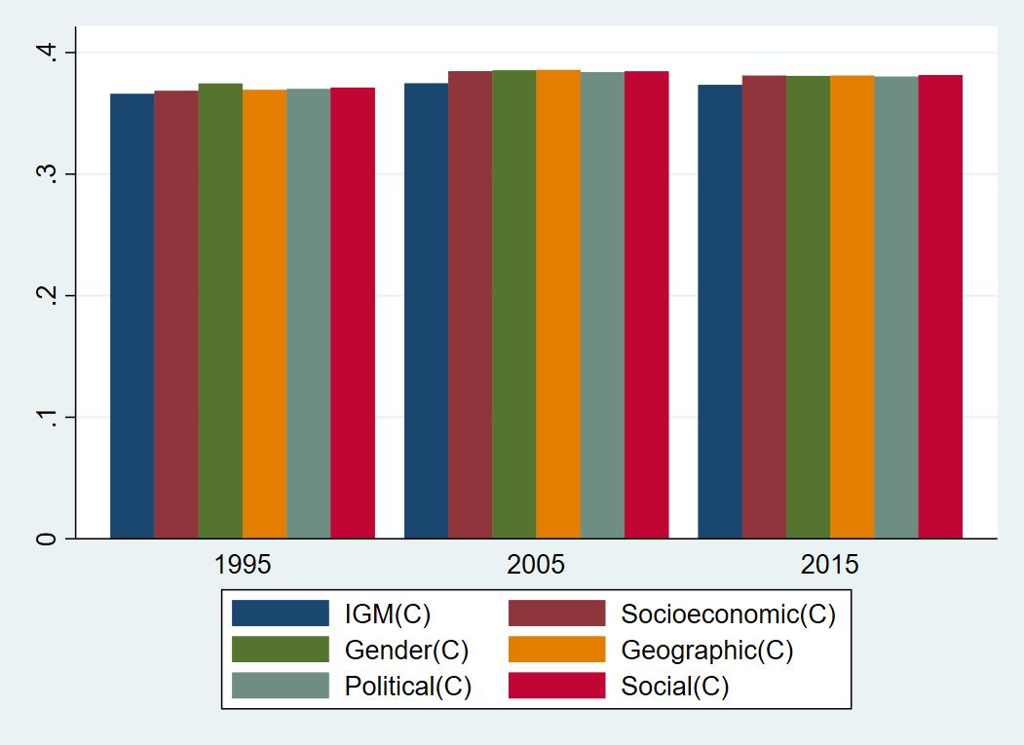

Figure 4. 1 Trend of inequality indices over time

The trend of Indices among Regions

According to the World bank, regions are divided into seven main categories (East Asia and Pacific (EAS), Europe and Central Asia (ECS), Latin America and Caribbean (LCN), Middle East and North Africa (MEA), North America (NAC), South Asia (SAS) and Sub-Saharan Africa (SSF)). According to the results, more equal regions are North America and Europe, and Central Asia in all indices. However, intergenerational mobility, socioeconomic, political, and social inequality opportunities are more pronounce in South Asia. In contrast, gender inequality of opportunities is more considerable in the Middle East and North Africa. Sub-Saharan Africa is more unequal based on geographic inequality of opportunities than other regions. Our argument is true because the different regions have different opportunities, so it needs different compensatory policies.
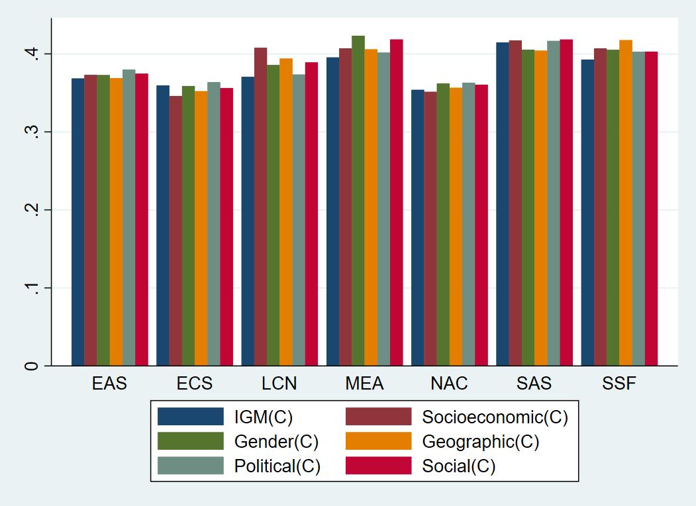

Figure 4. 2 Trend of inequality indices among regions

The trend of Inequality Indies among Income Groups

According to the World Bank, counties are dividing four income groups (High-income economies (HIC), Low-income economies (LIC), Lower-middle-income economies (LMC), and Upper-middle-income economies (UMC). The graph shows lower-income countries' geography and socioeconomic factors more prevailing circumstances to enhance inequalities, followed by lower-middle-income countries. However, in the case of middle-income countries, all indices show almost the same trends. It means hypothesis overall opportunities indices may biased results also accurate.
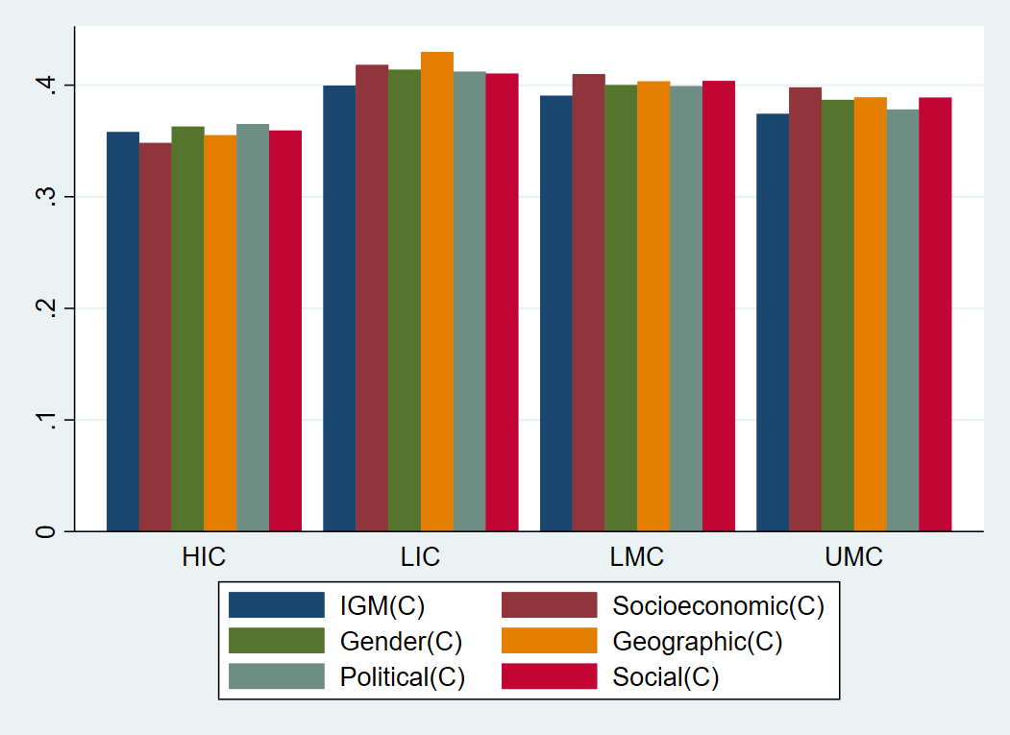

Figure 4. 3 Trend of inequality indices among income group

Table 4.4 shows the ranks of countries according to different inequality of opportunities index. Here rank 1 means higher inequality in under heading more unequal countries while rank1 means in less unequal countries are more equal countries. However, the issue is the inconsistency of ranking the country due to unbalanced panel data, not show an accurate picture of ranks for example if in 1995 data show only Pure rank was 2 in 36 counties, in 2005 58 countries rank was 23. In 2015, 90 countries rank was 67 is not representative of equality in the intergenerational mobility index. So, we discuss here the change in values instead of ranks. If we compare the intergenerational mobility index of 1995 with 2015, Egypt, Arab Rep rank remains persistent, but inequality increases 1%. Almost all inequality indices show higher inequality remain in the first two ranks, but values increase. This table at a country level instead of region and income also shows the different countries have different contexts. For example, some countries have worse inequality intergenerational mobility persistence as Pakistan in 2015 while others or groups base inequality of circumstances, such as Bangladesh.

Table 4. 4 Five More Unequal and Equal Country Ranking According Inequality of Opportunities in 1995 and 2015

 | More Unequal Countries (1995)
Ranks | Country | IGM(C) | Country | Income(C) | Country | Gender(C) | Country | Geographic(C) | Country | Political(C) | Country | Social(C) | Country | INEQ
1 | Egypt, Arab Rep. | 0.425 | Egypt, Arab Rep. | 0.468 | Egypt, Arab Rep. | 0.465 | South Africa | 0.478 | Egypt, Arab Rep. | 0.431 | Egypt, Arab Rep. | 0.466 | South Africa | 0.587
2 | Peru | 0.41 | Indonesia | 0.465 | Peru | 0.449 | Egypt, Arab Rep. | 0.476 | Indonesia | 0.414 | Peru | 0.451 | Brazil | 0.533
3 | Turkey | 0.404 | South Africa | 0.462 | South Africa | 0.435 | Peru | 0.453 | Peru | 0.403 | Indonesia | 0.45 | Peru | 0.528
4 | Philippines | 0.398 | Peru | 0.457 | Indonesia | 0.428 | Indonesia | 0.434 | Turkey | 0.4 | South Africa | 0.436 | Colombia | 0.512
5 | India | 0.397 | Mexico | 0.437 | Chile | 0.423 | Philippines | 0.413 | Philippines | 0.397 | Turkey | 0.418 | Chile | 0.481
 | More Unequal Countries (2015)
1 | Egypt, Arab Rep. | 0.438 | Egypt, Arab Rep. | 0.481 | Saudi Arabia | 0.493 | Egypt, Arab Rep. | 0.474 | Egypt, Arab Rep. | 0.446 | Bahrain | 0.486 | Namibia | 0.652
2 | Thailand | 0.431 | Yemen, Rep. | 0.48 | Iran, Islamic Rep. | 0.474 | Yemen, Rep. | 0.473 | Bangladesh | 0.432 | Egypt, Arab Rep. | 0.475 | South Africa | 0.594
3 | Pakistan | 0.431 | Haiti | 0.472 | Egypt, Arab Rep. | 0.467 | Bangladesh | 0.472 | Guinea | 0.43 | Ethiopia | 0.46 | Botswana | 0.581
4 | Cote d'Ivoire | 0.429 | Guatemala | 0.471 | Yemen, Rep. | 0.465 | Haiti | 0.46 | Thailand | 0.43 | Yemen, Rep. | 0.458 | Zambia | 0.555
5 | Guinea | 0.424 | Bangladesh | 0.466 | Bahrain | 0.457 | Nicaragua | 0.458 | Malawi | 0.428 | Bangladesh | 0.448 | Haiti | 0.527
 | More equal Countries (1995)
1 | Japan | 0.341 | Japan | 0.315 | Argentina | 0.334 | Japan | 0.329 | Japan | 0.341 | Italy | 0.33 | Finland | 0.218
2 | Italy | 0.348 | Italy | 0.316 | Greece | 0.338 | Italy | 0.329 | Argentina | 0.343 | Japan | 0.331 | Denmark | 0.223
3 | Greece | 0.349 | Korea, Rep. | 0.321 | Italy | 0.338 | Korea, Rep. | 0.334 | Italy | 0.343 | Greece | 0.333 | Sweden | 0.227
4 | China | 0.35 | Greece | 0.324 | Brazil | 0.344 | Greece | 0.335 | Greece | 0.348 | Argentina | 0.335 | Norway | 0.23
5 | Switzerland | 0.351 | Belgium | 0.33 | Belgium | 0.346 | Portugal | 0.336 | Portugal | 0.349 | Portugal | 0.338 | Belgium | 0.244
 | More equal Countries (2015)
1 | Korea, Rep. | 0.339 | Czech Republic | 0.309 | Argentina | 0.327 | Moldova | 0.32 | Argentina | 0.343 | Czech Republic | 0.329 | Slovenia | 0.248
2 | Italy | 0.344 | Latvia | 0.312 | Moldova | 0.33 | Czech Republic | 0.321 | Czech Republic | 0.344 | Lithuania | 0.333 | Norway | 0.249
3 | Czech Republic | 0.345 | Lithuania | 0.318 | Czech Republic | 0.331 | Lithuania | 0.327 | Italy | 0.345 | Italy | 0.334 | Slovak Republic | 0.25
4 | Moldova | 0.346 | Bulgaria | 0.321 | Lithuania | 0.333 | Latvia | 0.329 | Korea, Rep. | 0.351 | Argentina | 0.335 | Czech Republic | 0.251
5 | Australia | 0.348 | Italy | 0.324 | Hungary | 0.334 | Ukraine | 0.332 | Portugal | 0.352 | Korea, Rep. | 0.336 | Belgium | 0.253

The purpose of all indies of opportunities is to capture the difference due to a parent’s background or discrimination among different groups-based exclusion. These indices show the tendency of inequality due to different times and across countries. By determining a set of circumstances at a macro level by previous literature, we constructed six indices of inequality of circumstances and efforts. Using the country fixed effect, we decomposed the overall income inequality of income into circumstances and efforts indices. The estimated value of regression is used as a circumstance index, while residual values are used as an effort index. Effort index comprises unobserved circumstances that are not captured in regression due to unavailability of data and unobserved circumstance we cannot capture, for example, luck. Macro-level set of circumstance consists of institutions (formal (favouritism and military in politic) and informal (social capital)), economic background of the country (initial L.20 GDPPC) and fractionalization on based of religion and ethnic and exclusion on based on social, economic, political, geographic, and intergenerational mobility. Our findings are in line with institutions, economic background, fractionalization, and exclusion are important circumstances responsible for determining the individual’s income, and all these factors are beyond the control of him. Our findings are according to previous literature as circumstances are not abruptly over time as it takes a more time as figure 4.1 we used data of 3 decades with a ten-year gap, but there is no change on period, but variation has seen among region (figuree4.2) income groups(figure 4.3) and countries (table 4.4). Our results are also in line with previous literature. All countries and regions are not uniformly affected by the same circumstance; for example, some countries may find unequal intergenerational mobility like Pakistan and others in severe inequality of circumstance based on Geographic and political as Bangladesh. More unequal regions based on gender Middle East and North Africa while on socioeconomic Latin America and Caribbean and South Asia and based on geographic Sub-Saharan Africa.
All these findings show that our hypothesis difference among countries is due to different circumstances, so there is a need for different compensatory policies. In developing counties, geographic inequality is a more important factor but socioeconomic inequality in high-income countries.
Compensatory policies should be developed according to a circumstance for example for developing countries policies that provides more opportunities for the sake of people living in a village in all field of business, education and health sector while in case of a developed country is need to handle class system by providing opportunities to poor. Due to data availability, our panel only consists of limited countries that are different on all models.
Table 4.5 shows the descriptive statistics of all variables used in different inequities of opportunities and social cohesion models.

Table 4. 5 Descriptive statistic
Variable | Obs | Mean | Std.Dev. | Min | Max
SOCOH | 214 | .565 | .069 | .292 | .746
ETHDIV | 223 | .381 | .253 | .002 | .93
POLSTAB | 221 | .07 | .946 | -2.576 | 1.605
INEQ | 227 | .38 | .09 | .218 | .66
IGM(C) | 183 | .369 | .05 | .233 | .456
IGM(E) | 183 | 0 | .122 | -.215 | .302
INEQSEC(C) | 227 | .38 | .03 | .298 | .472
INEQSEC(E) | 227 | 0 | .093 | -.172 | .279
INEQGEN(C) | 227 | .38 | .039 | .275 | .517
INEQGEN(E) | 227 | 0 | .106 | -.193 | .284
INEQGEO(C) | 227 | .38 | .03 | .279 | .455
INEQGEO(E) | 227 | 0 | .098 | -.19 | .261
INEQPOL(C) | 226 | .379 | .033 | .29 | .444
INEQPOL(E) | 226 | 0 | .11 | -.204 | .296
INEQSOC(C) | 227 | .38 | .034 | .284 | .499
INEQSOC(E) | 227 | 0 | .104 | -.193 | .289

Table 4.6 shows the Pairwise correlation of all variables that are used in our models. Correlation of dependent and independent variable show, the models are a good fit for regression analysis. We used eight indices alternatively that show a high correlation.
Table 4. 6 Correlation
 | SOCOH | ETHDIV | POLSTAB | INEQ | IGM(C) | IGM(E) | INEQSEC(C) | INEQSEC(E) | INEQGEN(C) | INEQGEN(E) | INEQGEO(C) | INEQGEO(E) | INEQPOL(C) | INEQPOL(E) | INEQSOC(C) | INEQSOC(E)
SOCOH | 1
ETHDIV | -0.43*** | 1
POLSTAB | 0.82*** | -0.52*** | 1
INEQ | -0.40*** | 0.58*** | -0.55*** | 1
IGM(C) | 0.41*** | -0.47*** | 0.59*** | -0.47*** | 1
IGM(E) | -0.47*** | 0.62*** | -0.65*** | 0.93*** | -0.77*** | 1
INEQSEC(C) | -0.01 | -0.02 | -0.01 | 0.05 | 0.59*** | -0.21** | 1
INEQSEC(E) | -0.38*** | 0.57*** | -0.52*** | 0.94*** | -0.66*** | 0.96*** | -0.29*** | 1
INEQGEN(C) | 0.27*** | -0.30*** | 0.36*** | -0.26*** | 0.85*** | -0.55*** | 0.80*** | -0.53*** | 1
INEQGEN(E) | -0.44*** | 0.60*** | -0.60*** | 0.93*** | -0.72*** | 0.98*** | -0.26*** | 0.98*** | -0.59*** | 1
INEQGEO(C) | 0.20** | -0.15 | 0.28*** | -0.13 | 0.73*** | -0.40*** | 0.87*** | -0.42*** | 0.89*** | -0.44*** | 1
INEQGEO(E) | -0.43*** | 0.58*** | -0.59*** | 0.95*** | -0.67*** | 0.97*** | -0.24** | 0.99*** | -0.53*** | 0.99*** | -0.44*** | 1
INEQPOL(C) | 0.41*** | -0.45*** | 0.59*** | -0.50*** | 0.97*** | -0.78*** | 0.64*** | -0.70*** | 0.89*** | -0.75*** | 0.78*** | -0.71*** | 1
INEQPOL(E) | -0.45*** | 0.61*** | -0.63*** | 0.96*** | -0.69*** | 0.99*** | -0.16* | 0.98*** | -0.49*** | 0.99*** | -0.35*** | 0.98*** | -0.72*** | 1
INEQSOC(C) | 0.21** | -0.27*** | 0.31*** | -0.26*** | 0.86*** | -0.55*** | 0.84*** | -0.54*** | 0.95*** | -0.57*** | 0.89*** | -0.52*** | 0.90*** | -0.49*** | 1
INEQSOC(E) | -0.42*** | 0.59*** | -0.58*** | 0.94*** | -0.70*** | 0.98*** | -0.25** | 0.99*** | -0.55*** | 0.99*** | -0.41*** | 0.99*** | -0.74*** | 0.99*** | -0.56*** | 1

Table 4. 7 Inequality of opportunities and Social Cohesion
 | 1 | 2 | 3 | 4 | 5 | 6 | 7 | 8
ETHDIV | -0.396*** | -0.264 | -0.220 | 0.221 | 0.077 | 0.425 | -0.026 | 0.153
ETHDIV | (0.151) | (0.171) | (0.150) | (0.294) | (0.301) | (0.304) | (0.296) | (0.294)
POLSTAB |  | 0.073*** | 0.081*** | 0.082*** | 0.083*** | 0.082*** | 0.080*** | 0.080***
POLSTAB |  | (0.012) | (0.017) | (0.016) | (0.017) | (0.016) | (0.016) | (0.016)
INEQ |  | -0.338
INEQ |  | (0.225)
IGM(C) |  |  | -1.200***
IGM(C) |  |  | (0.430)
IGM(E) |  |  | 0.430
IGM(E) |  |  | (0.363)
INEQSECON(C) |  |  |  | -1.071***
INEQSECON(C) |  |  |  | (0.398)
INEQSECON(E) |  |  |  | 0.256
INEQSECON(E) |  |  |  | (0.310)
INEQGEN(C) |  |  |  |  | -0.816**
INEQGEN(C) |  |  |  |  | (0.406)
INEQGEN(E) |  |  |  |  | 0.093
INEQGEN(E) |  |  |  |  | (0.312)
INEQGEO(C) |  |  |  |  |  | -1.229***
INEQGEO(C) |  |  |  |  |  | (0.407)
INEQGEO(E) |  |  |  |  |  | 0.325
INEQGEO(E) |  |  |  |  |  | (0.307)
INEQPOL(C) |  |  |  |  |  |  | -1.441***
INEQPOL(C) |  |  |  |  |  |  | (0.467)
INEQPOL(E) |  |  |  |  |  |  | 0.204
INEQPOL(E) |  |  |  |  |  |  | (0.285)
INEQSOC(C) |  |  |  |  |  |  |  | -1.117***
INEQSOC(C) |  |  |  |  |  |  |  | (0.426)
INEQSOC(E) |  |  |  |  |  |  |  | 0.203
INEQSOC(E) |  |  |  |  |  |  |  | (0.304)
Constant | 0.649*** | 0.831*** | 0.977*** | 0.884*** | 0.831*** | 0.866*** | 1.073*** | 0.909***
 | (0.092) | (0.165) | (0.144) | (0.142) | (0.154) | (0.130) | (0.179) | (0.152)
N | 404 | 366 | 166 | 206 | 206 | 206 | 205 | 206
R² | 0.70 | 0.77 | 0.83 | 0.82 | 0.81 | 0.82 | 0.82 | 0.82
Hausman Test (P value) | 0.01 | 0.01 | 0.03 | 0.00 | 0.10 | 0.00 | 0.01 | 0.02
Country FE | NO | YES | YES | YES | YES | YES | YES | YES
* p<0.1; ** p<0.05; *** p<0.01

Table 4.7 shows the relationship between different types of inequality of circumstances and social cohesion. We used ethnic diversity and inequality of opportunities (measure on different bases) by controlling political stability(institution). In the first model, we used random effect as the Hausman test in favour of random effects. Ethnic diversity is a negative but significant effect on social cohesion. However, these results may be biased due to the omitted variable.
In the second model, we used income inequality by controlling political stability; ethnic diversity is still negative and significant. However, the point is noted that the size effect of negativity is smaller from 0.41 to 0.30. Political stability in all models persistent, highly significant, and positively related to social cohesion.
In model three, intergenerational mobility (IGM) shows that diversity plays a negative but insignificant role in determining social cohesion. This model's critical finding is the role of inequality of IGM is more to deteriorate the social cohesion while the inequality of IGM efforts effect on social cohesion is positive but insignificantly. The size effect of decomposed inequality (IGM) is more extensive than overall income inequality (INEQ) (-1.18- (-0.41). It means the inequality of opportunities is more harmful than inequality of income on social cohesion. We also used inequality of opportunities indices based on different group identities that decompose into circumstances and efforts.

We used the inequality of opportunities index based on socioeconomic (INEQSECON(C)) in model four. INEQSECON(C) is related to social cohesion negatively but significantly. It means a one per cent increases INEQSECON(C) deteriorate the social cohesion by 1.16%. In contrast, INEQSECON(E) affect positive but insignificantly.
We used the inequality of opportunities index based on socioeconomic (INEQGEN(C)) in model five. INEQGEN(C) has a negative but significant effect on social cohesion. One per cent increase in INEQGEN(C) decreases 0.89% in social cohesion.
We used inequality of opportunities index based on geographic (INEQGEO(C)) in model six. INEQGEO(C) have a negative but significant effect on social cohesion. One percent increase in INEQGEO(C) decreases 1.33% in social cohesion, while an increase in social cohesion increases by 0.24% when considering INEQGEO(E).
We used the inequality of opportunities index based on political (INEQPOL(C)) in model seven. INEQPOL(C) has a negative but significant effect on social cohesion. One percent increase in INEQPOL(C) decreases 1.44% in social cohesion while increasing social cohesion increases by 0.08% when considering INEQPOL(E).
We used the inequality of opportunities index based on social (INEQSOC(C)) in model eight. INEQSOC(C) has a negative but significant effect on social cohesion. One percent increase in INEQSOC(C) decreases 1.17% in social cohesion, while an increase in social cohesion increases by 0.10% when considering INEQSOC(E).
Next 4 to 8 model, we used indices of inequality of opportunities alternative. Here the point would be noted these inequalities are different because it decomposes income inequality into circumstances and efforts based on socio-economic, gender, geography, political, and social factors. The central hypothesis of these models that is a negative and positive relationship with social cohesion is dependent on how we deal with inequality; for example, we considered inequality as overall or decomposed into circumstances and efforts. Findings show the inequality of circumstances, whatever base of identity is harmful to social cohesion.
All model results are in the line of previous literature where instead of diversity, it is the division of opportunities that are more important to determine social cohesion. The second hypothesis also results in inline inequality of circumstance is harmful, but efforts are positively related to social cohesion.

Inequality of opportunities is a crucial factor to erode social cohesion. However, the critical point to be noted here is that part of inequalities of opportunities is negatively related that are considered circumstances while efforts inequalities are positive and insignificantly affect social cohesion and absorbed the effect of diversity. In egalitarians societies where the individual gets equal access to resources, the inequalities are bearable and do not damage social cohesion. In contrast, on the other side, where a rent-seeking attitude prevails, and opportunities are provided based on identity, these inequalities erode community social cohesion and tolerance. As inequality of circumstances on the base of ethnic or social when individuals are deprived of equal rights of basic need, job or business may erode society's tolerance. It has two effects on the community; it decreases the efficiency and accumulates the resource in a few hands. While when resources are given on the talent base. It means resources are used efficiently and create new opportunities as we used institutions (political stability) as strategy variables. Results show that good institutions can cope with group marginalization. One point to be considered group-based inequalities of circumstances are more harmful than others.

Table 4.8 show the descriptive statistic of all variables that are used in our models.

Table 4. 8 Descriptive statistic
Variable | Obs | Mean | Std.Dev. | Min | Max
GDPgr | 227 | 2.208 | 1.921 | -5.255 | 9.243
GFC | 224 | 22.788 | 4.926 | 8.547 | 44.101
L.20GDPPC | 228 | 8.544 | 1.516 | 5.262 | 11.163
KOFG | 225 | 66.323 | 13.859 | 35.356 | 90.292
EDU | 204 | 15.787 | 10.733 | .015 | 57.782
SOCOH | 214 | .565 | .069 | .292 | .746
POLSTAB | 221 | .07 | .946 | -2.576 | 1.605
INEQ | 227 | .38 | .09 | .218 | .66
IGM(C) | 183 | .369 | .05 | .233 | .456
IGM(E) | 183 | 0 | .122 | -.215 | .302
INEQSECON(C) | 227 | .38 | .03 | .298 | .472
INEQSECON(E) | 227 | 0 | .093 | -.172 | .279
INEQGEN(C) | 227 | .38 | .039 | .275 | .517
INEQGEN(E) | 227 | 0 | .106 | -.193 | .284
INEQGEO(C) | 227 | .38 | .03 | .279 | .455
INEQGEO(E) | 227 | 0 | .098 | -.19 | .261
INEQPOL(C) | 226 | .379 | .033 | .29 | .444
INEQPOL(E) | 226 | 0 | .11 | -.204 | .296
INEQSOC(C) | 227 | .38 | .034 | .284 | .499
INEQSOC(E) | 227 | 0 | .104 | -.193 | .289

Table 4.9 shows the Pairwise correlation of all variables that are used in our models. The correlation of dependent and independent variable shows the models are a good fit for regression analysis. We used nine indices alternatively that show a high correlation.
Table 4. 9 Correlation
 | GDPgr | GFC | L.20GDPPC | KOFG | EDU | SOCOH | POLSTAB | INEQ | IGM(C) | IGM(E) | INEQSECON(C) | INEQSECON(E) | INEQGEN(C) | INEQGEN(E) | INEQGEO(C) | INEQGEO(E) | INEQPOL(C) | INEQPOL(E) | INEQSOC(C) | INEQSOC(E)
GDPgr | 1.00
GFC | 0.62*** | 1.00
L.20GDPPC | -0.48*** | -0.16* | 1.00
KOFG | -0.34*** | -0.10 | 0.83*** | 1.00
EDU | 0.07 | 0.01 | -0.25** | -0.37*** | 1.00
SOCOH | 0.01 | 0.09 | 0.49*** | 0.40*** | -0.22** | 1.00
POLSTAB | -0.16 | 0.08 | 0.69*** | 0.66*** | -0.33*** | 0.81*** | 1.00
INEQ | 0.17* | 0.01 | -0.62*** | -0.74*** | 0.38*** | -0.51*** | -0.62*** | 1.00
IGM(C) | -0.52*** | -0.22** | 0.96*** | 0.76*** | -0.17* | 0.44*** | 0.60*** | -0.55*** | 1.00
IGM(E) | 0.34*** | 0.10 | -0.84*** | -0.84*** | 0.34*** | -0.55*** | -0.69*** | 0.94*** | -0.81*** | 1.00
INEQSECON(C) | -0.43*** | -0.29*** | 0.46*** | 0.23** | 0.11 | 0.03 | 0.02 | 0.00 | 0.59*** | -0.25** | 1.00
INEQSECON(E) | 0.31*** | 0.11 | -0.74*** | -0.78*** | 0.32*** | -0.49*** | -0.59*** | 0.94*** | -0.72*** | 0.97*** | -0.34*** | 1.00
INEQGEN(C) | -0.47*** | -0.19* | 0.79*** | 0.57*** | -0.11 | 0.33*** | 0.41*** | -0.35*** | 0.86*** | -0.61*** | 0.79*** | -0.60*** | 1.00
INEQGEN(E) | 0.31*** | 0.08 | -0.79*** | -0.81*** | 0.35*** | -0.54*** | -0.65*** | 0.94*** | -0.76*** | 0.98*** | -0.29*** | 0.98*** | -0.65*** | 1.00
INEQGEO(C) | -0.50*** | -0.29*** | 0.65*** | 0.44*** | -0.06 | 0.25** | 0.32*** | -0.23** | 0.76*** | -0.48*** | 0.87*** | -0.51*** | 0.89*** | -0.51*** | 1.00
INEQGEO(E) | 0.31*** | 0.10 | -0.76*** | -0.79*** | 0.35*** | -0.53*** | -0.65*** | 0.95*** | -0.73*** | 0.98*** | -0.28*** | 0.99*** | -0.59*** | 0.99*** | -0.52*** | 1.00
INEQPOL(C) | -0.48*** | -0.18* | 0.93*** | 0.77*** | -0.19* | 0.46*** | 0.61*** | -0.57*** | 0.97*** | -0.81*** | 0.64*** | -0.75*** | 0.90*** | -0.79*** | 0.81*** | -0.76*** | 1.00
INEQPOL(E) | 0.28*** | 0.07 | -0.78*** | -0.82*** | 0.36*** | -0.55*** | -0.68*** | 0.97*** | -0.74*** | 0.99*** | -0.20* | 0.98*** | -0.56*** | 0.99*** | -0.43*** | 0.99*** | -0.76*** | 1.00
INEQSOC(C) | -0.47*** | -0.23** | 0.79*** | 0.58*** | -0.08 | 0.27** | 0.35*** | -0.33*** | 0.87*** | -0.60*** | 0.84*** | -0.60*** | 0.95*** | -0.62*** | 0.89*** | -0.58*** | 0.91*** | -0.55*** | 1.00
INEQSOC(E) | 0.30*** | 0.09 | -0.78*** | -0.81*** | 0.35*** | -0.52*** | -0.64*** | 0.95*** | -0.75*** | 0.99*** | -0.28*** | 0.99*** | -0.61*** | 0.99*** | -0.49*** | 0.99*** | -0.78*** | 0.99*** | -0.61*** | 1.00

Table 4.10 shows the result of the regression analysis of 2SLS. In table 4.11, the results of inequality of opportunities and social cohesion show the negative but significant relationship and mitigate the negative and significant role of ethnic diversity. So, in the final model, we drop ethnic diversity. Moreover, only vertical or horizontal inequality of circumstances and efforts in 7 different models is considered by controlling political stability (institutions). We test the hypothesis that social cohesion is an endogenous variable treated in the literature as exogenous. For this purpose, we used income inequality of opportunities and inequality of efforts as an instrument variable. Instead, overall income inequality and gender inequality of opportunities all mode reject the null hypothesis and accept an alternative on second stage social cohesion effect on economic growth positive but significant effect. The size effect is different in different models in the range (9 to 17). However, all positive and significant role in the case of group-based inequality of opportunities while inequality of circumstance based on IGM role of social cohesion is positive and insignificant. The other control variables results are in line with previous literature investment positive and significant effect and capture the convergence of income we used initial GDDPER with a 20-year lag. In the light of the given table, we conclude that social cohesion is endogenous variable and the second inequality of opportunities, regardless of whether it deteriorates social cohesion.

Table 4. 10 Social Cohesion and Economic Growth (2SLS)
Eq. | Variables | 1 | 2 | 3 | 4 | 5 | 6 | 7
GDPgr | GFC | 0.132*** | 0.173*** | 0.116*** | 0.115*** | 0.122*** | 0.119*** | 0.115***
GDPgr | GFC | (0.025) | (0.033) | (0.035) | (0.035) | (0.034) | (0.035) | (0.035)
GDPgr | L.20GDPPC | -1.608*** | -1.822** | -1.336* | -1.429* | -1.485** | -1.345* | -1.350*
GDPgr | L.20GDPPC | (0.502) | (0.751) | (0.786) | (0.796) | (0.754) | (0.773) | (0.791)
GDPgr | KOFG | 0.052*** | 0.036 | 0.035 | 0.036 | 0.033 | 0.038 | 0.037
GDPgr | KOFG | (0.020) | (0.025) | (0.029) | (0.030) | (0.028) | (0.029) | (0.030)
GDPgr | EDU | 0.061*** | 0.022 | 0.022 | 0.023 | 0.025 | 0.025 | 0.022
GDPgr | EDU | (0.018) | (0.017) | (0.021) | (0.021) | (0.021) | (0.021) | (0.021)
GDPgr | SOCOH | 13.214*** | 9.928 | 18.412** | 18.820** | 13.938* | 15.873** | 18.643**
GDPgr | SOCOH | (4.305) | (7.545) | (7.647) | (7.721) | (7.174) | (7.470) | (7.719)
GDPgr | Constant | 2.568 | 6.005 | -0.645 | -0.188 | 2.912 | 0.571 | -0.777
GDPgr |  | (5.773) | (9.584) | (9.740) | (9.845) | (9.194) | (9.537) | (9.821)
GDPgr | R² | 0.73 | 0.83 | 0.72 | 0.72 | 0.74 | 0.74 | 0.72
GDPgr | N | 242 | 148 | 181 | 181 | 181 | 180 | 181
SOCOH | POLSTAB | 0.088*** | 0.072*** | 0.081*** | 0.082*** | 0.082*** | 0.078*** | 0.080***
SOCOH | POLSTAB | (0.009) | (0.012) | (0.012) | (0.012) | (0.012) | (0.012) | (0.012)
SOCOH | INEQ | -0.042
SOCOH | INEQ | (0.163)
SOCOH | IGM(C) |  | -1.184***
SOCOH | IGM(C) |  | (0.312)
SOCOH | IGMP(E) |  | 0.245
SOCOH | IGMP(E) |  | (0.256)
SOCOH | INEQSECON(C) |  |  | -0.612**
SOCOH | INEQSECON(C) |  |  | (0.297)
SOCOH | INEQSECON(E) |  |  | -0.073
SOCOH | INEQSECON(E) |  |  | (0.216)
SOCOH | INEQGEN(C) |  |  |  | -0.323
SOCOH | INEQGEN(C) |  |  |  | (0.297)
SOCOH | INEQGEN(E) |  |  |  | -0.232
SOCOH | INEQGEN(E) |  |  |  | (0.216)
SOCOH | INEQGEO(C) |  |  |  |  | -0.890***
SOCOH | INEQGEO(C) |  |  |  |  | (0.303)
SOCOH | INEQGEO(E) |  |  |  |  | 0.066
SOCOH | INEQGEO(E) |  |  |  |  | (0.217)
SOCOH | INEQPOL(C) |  |  |  |  |  | -1.165***
SOCOH | INEQPOL(C) |  |  |  |  |  | (0.341)
SOCOH | INEQPOL(E) |  |  |  |  |  | 0.028
SOCOH | INEQPOL(E) |  |  |  |  |  | (0.193)
SOCOH | INEQSOC(C) |  |  |  |  |  |  | -0.562*
SOCOH | INEQSOC(C) |  |  |  |  |  |  | (0.312)
SOCOH | INEQSOC(E) |  |  |  |  |  |  | -0.127
SOCOH | INEQSOC(E) |  |  |  |  |  |  | (0.207)
SOCOH | Constant | 0.593*** | 0.934*** | 0.789*** | 0.696*** | 0.864*** | 0.978*** | 0.771***
SOCOH | Constant | (0.067) | (0.101) | (0.103) | (0.102) | (0.100) | (0.119) | (0.106)
SOCOH | R² | 0.79 | 0.81 | 0.79 | 0.79 | 0.80 | 0.80 | 0.79
SOCOH | N | 242 | 148 | 181 | 181 | 181 | 180 | 181
SOCOH | Country FE | YES | YES | YES | YES | YES | YES | YES

Table 4. 11 Social Cohesion and Economic Growth (3SLS)
Eq. | Variables | 1 | 2 | 3 | 4 | 5 | 6 | 7
GDPgr | GFC | 0.699*** | 0.526*** | 0.683*** | 0.699*** | 0.618*** | 0.510*** | 0.673***
GDPgr | GFC | (0.126) | (0.102) | (0.130) | (0.131) | (0.127) | (0.123) | (0.130)
GDPgr | L.20GDPPC | -0.554 | -2.083*** | -1.336* | -1.305* | -1.454** | -1.630** | -1.337*
GDPgr | L.20GDPPC | (0.760) | (0.574) | (0.708) | (0.709) | (0.702) | (0.698) | (0.707)
GDPgr | KOFG | -0.008 | 0.025 | 0.002 | 0.001 | 0.005 | 0.012 | 0.003
GDPgr | KOFG | (0.029) | (0.020) | (0.027) | (0.027) | (0.026) | (0.026) | (0.027)
GDPgr | EDU | 0.042* | 0.033* | 0.039* | 0.038* | 0.038* | 0.038* | 0.039*
GDPgr | EDU | (0.022) | (0.018) | (0.021) | (0.021) | (0.021) | (0.020) | (0.021)
GDPgr | Constant | -11.400 | 3.392 | -5.607 | -6.292 | -2.970 | 1.239 | -5.427
GDPgr |  | (7.552) | (5.424) | (6.956) | (6.973) | (6.847) | (6.755) | (6.956)
GDPgr | R² | 0.25 | 0.68 | 0.37 | 0.35 | 0.45 | 0.57 | 0.38
GDPgr | N | 242 | 148 | 181 | 181 | 181 | 180 | 181
GFC | SOCOH | 10.189* | 11.314* | 11.015* | 11.568* | 10.908* | 10.694 | 11.134*
GFC | SOCOH | (6.011) | (6.814) | (6.537) | (6.527) | (6.534) | (6.598) | (6.548)
GFC | Constant | 24.777*** | 24.143*** | 24.312*** | 24.001*** | 24.372*** | 24.493*** | 24.245***
GFC | Constant | (3.904) | (4.099) | (3.969) | (3.963) | (3.967) | (4.002) | (3.974)
GFC | R² | 0.77 | 0.82 | 0.82 | 0.82 | 0.82 | 0.82 | 0.82
GFC | N | 242 | 148 | 181 | 181 | 181 | 180 | 181
SOCOH | POLSTAB | 0.091*** | 0.076*** | 0.084*** | 0.086*** | 0.083*** | 0.077*** | 0.082***
SOCOH | POLSTAB | (0.009) | (0.012) | (0.012) | (0.012) | (0.012) | (0.012) | (0.012)
SOCOH | INEQ | -0.062
SOCOH | INEQ | (0.169)
SOCOH | IGM(C) |  | -1.173***
SOCOH | IGM(C) |  | (0.310)
SOCOH | IGM(E) |  | 0.258
SOCOH | IGM(E) |  | (0.254)
SOCOH | INEQSECON(C) |  |  | -0.786***
SOCOH | INEQSECON(C) |  |  | (0.305)
SOCOH | INEQSECON(E) |  |  | 0.041
SOCOH | INEQSECON(E) |  |  | (0.224)
SOCOH | INEQGEN(C) |  |  |  | -0.577*
SOCOH | INEQGEN(C) |  |  |  | (0.305)
SOCOH | INEQGEN(E) |  |  |  | -0.081
SOCOH | INEQGEN(E) |  |  |  | (0.226)
SOCOH | INEQGEO(C) |  |  |  |  | -1.052***
SOCOH | INEQGEO(C) |  |  |  |  | (0.305)
SOCOH | INEQGEO(E) |  |  |  |  | 0.181
SOCOH | INEQGEO(E) |  |  |  |  | (0.220)
SOCOH | INEQPOL(C) |  |  |  |  |  | -1.486***
SOCOH | INEQPOL(C) |  |  |  |  |  | (0.343)
SOCOH | INEQPOL(E) |  |  |  |  |  | 0.164
SOCOH | INEQPOL(E) |  |  |  |  |  | (0.195)
SOCOH | INEQSOC(C) |  |  |  |  |  |  | -0.893***
SOCOH | INEQSOC(C) |  |  |  |  |  |  | (0.320)
SOCOH | INEQSOC(E) |  |  |  |  |  |  | 0.046
SOCOH | INEQSOC(E) |  |  |  |  |  |  | (0.215)
SOCOH | Constant | 0.602*** | 0.931*** | 0.844*** | 0.776*** | 0.910*** | 1.084*** | 0.875***
SOCOH | Constant | (0.069) | (0.100) | (0.105) | (0.104) | (0.101) | (0.120) | (0.109)
SOCOH | R² | 0.79 | 0.81 | 0.79 | 0.79 | 0.80 | 0.80 | 0.79
SOCOH | N | 242 | 148 | 181 | 181 | 181 | 180 | 181
SOCOH | Country FE | YES | YES | YES | YES | YES | YES | YES
* p<0.1; ** p<0.05; *** p<0.01 Coefficients for id dummy variables not shown

Table 4.11 shows the relationship if social cohesion and economic growth by using the channel of investment. Here we used 3SLS to find the relationship between social cohesion and investment when social cohesion also affects horizontal and vertical inequality opportunities. As in previous literature, social cohesion has a direct, positive, and significant effect on economic growth. We explore not only social cohesion is determined by inequality income and inequality of opportunities. It also affects economic growth through investment channels. It works as an instrument effect on investment. The results also show that the overall income inequality on economic growth affects indirectly via different social cohesion. We used seven models here. In the first model, we used the overall inequality of income. Inequality of income negative but neutral affects social cohesion, and social cohesion positive effect on investments. In model three, we used the intergenerational mobility index (IGM). IGM is decomposed into circumstances and efforts.
IGM (C) is a negatively but significant effect on economic growth through social cohesion and investment. However, IGM(E) is adverse and insignificant effects. However, according to the hypothesis, efforts are positive and significant relationship to economic growth. Nevertheless, this effort index also has some unobserved circumstance effects that cannot be captured in the empirical analysis. All indices show the same trend. However, the size effect is different from IGM, and all group-based inequality of opportunities indices are a significant but negative effect on economic growth on social cohesion.
Nevertheless, the size effects are different; for example, geographical and political inequality of circumstances is more pronounced than other inequality of circumstances indices. As a result, when considered size effect political inequality, it is more harmful to social cohesion. It also decreases the size of investment to determine economic growth.
The second hypothesis, social cohesion, affects economic growth through the channel, for example, investment. The results are in line with previous literature. However, the important and interesting point if we compare the investment size effect from table 4.10 and 4.11, the investment effect on economic growth five-time grater. It means investment increases when societies are more cohesive, and the next stage increases growth more than the social, economic growth model where social cohesion directly.
This section discusses how inequality affects income growth through a different channel and social cohesion effect on economic growth as a mediator. The aim of this to measure the decomposed effect of income inequality. As the literature on the inequality of opportunities states, the effect of circumstance is negative. Our results are in line with previous literature. However, hypothesis effort findings are inconclusive (some models are positive, and some are negative, but all are insignificant) in line with previous literature, but these do not fulfill the theory of justice. The reason behind this to measure effort due to data unavailability is difficult. So, when we used residual as a measure of effort indices, we cannot eliminate the effect of unobserved circumstances.
Secondly, social cohesion is used as an endogenous variable instead of exogenous. Moreover, when social cohesion affects economic growth by introducing an investment channel, it five times enlarge investment. We conclude that egalitarian and cohesive societies play an important role in enhancing economic growth.

CHAPTER 5

CONCLUSION AND POLICY SUGGESTIONS

5.1 CONCLUSION

This study explores how social cohesion indirectly affects growth through investment. It also investigates that it is not ethnic diversity but the exclusion that generates inequality of opportunities that negatively affect social cohesion. In this study, we construct a different type of inequality of opportunities such as IGM, socio-economic, gender, geographic, political, and social. In the next stage, how these indices have a negative but significant effect on social cohesion. We also focused on how social cohesion affects economic growth through investment activities. For this purpose, panel data by controlling country-specific effects have been used.
In previous literature, overall income and social inequality effects have been studied, but the present study's overall income inequality effect and decomposes effect into inequality of circumstances and efforst have been investigated. Most studies in previous literature study circumstances decomposition on a state level or country level. Very few studies focused on cross country analysis but remained to restrict only vertical inequality. However, group-based inequalities may be more critical when we consider social cohesion that represented togetherness between groups. We use circumstances on an individual level to address this problem, such as IGM and group level by socioeconomic, gender, geographic, political, and social.
Intergenerational mobility may face a hurdle in those societies where persistence inequality effect due to the parent’s background (wealth, education) is found. Unequal societies' provision of opportunities among poor and rich may wider than egalitarian societies. These inequalities may start with a child's birth, in the sense of health care, food, and later on education. This division not only educational attainment but the quality of education may be different that provides a different type of job opportunities and strengthen inequalities in the next generation. Family characteristics such as a difference in parents' education and wealth influence human capital and generate social capital differences. We investigate these circumstances, instead of the determinant of inequality, for which a person is not responsible. Intergenerational mobility may fuel inequality of income.
To capture the socio-economic, gender, geographic, political, and social inequality of opportunities, we consider exclusion to get a job, start a business and education and health due to wealth status differences. A person is excluded because they do not have a rich background and enhance the circumstances' inequalities. This horizontal difference underpins income inequalities by controlling social capital, favouritism, military in politics, religion, ethnic tension, and the initial level of the country's economic background.
People who belong to a different group have different educational opportunities, health, job, and liberties. Due to belonging to a specific group, regardless of the group's base, access to opportunity may generate social unrest, weaken the governess, and increase anxiety. This social cohesion deterioration may restrict the investment activities regardless of foreign direct or local investment that in the next stage, may affect overall economic growth. Gender inequality of opportunities index by controlling social capital and exclusion from jobs and business and providing health and education services. It increases the inequality of opportunities. Access to health and education is essential to participate in economic activities

5.2 POLICY SUGGESTIONS

Inequality of opportunities is essential to social and economic growth. It is a direct as well as an indirect effect on economic growth. Equal excess of opportunities, regardless of which group is belonging, creates egalitarian societies. Public policies should be introduced to provide equal access to primary inputs such as health, education, and later stage job and business. Implementation of rules and laws that can overcome corruption and favouritism should be introduced. Awareness about availability opportunities should provide all needy people. Provision of education, health, and employment should be distributed to all society segments regardless of discrimination based on social or political,. An entitlement program should be introduced. Fairness and pluralistic policies that anyone can judge should be familiarized. Instead of communism and a free market, socialist policy should be introduced to overcome the inequality of opportunities (circumstances).

5.3 FUTURE RESEARCH PROSPECTS OF THE STUDY

The study covers all countries (comprehensive data is available), it can be further extended to introduce a new set of circumstances and efforts measure inequality of opportunities by using upper bound methodology instead of the reduced form where only consider circumstances and efforts are considered residual that also have the effect of unobserved circumstances. It can be explored separately for developed and developing countries.

5.4 LIMITATIONS OF STUDY

Due to the unavailability of efforts data on a macro level, we can measure only lower bound inequality of opportunities. We cannot give countries' rank due to an unbalanced panel, but we can only estimate the value and trend of inequality of opportunities looked to increase accros regions and may be biased toward circumstance. The unbalanced panel also restricts the accurate ranking of countries.

REFERENCES

Uncategorized References
Aberson, C. L., & Gaffney, A. M. (2009). An integrated threat model of explicit and implicit attitudes. European Journal of Social Psychology, 39(5), 808-830.
Abras, A., Hoyos, A., Narayan, A., & Tiwari, S. (2013). Inequality of opportunities in the labor market: Evidence from life in transition surveys in europe and central asia. IZA Journal of Labor & Development, 2(1), 7.
Acemoglu, D. (2011). Thoughts on inequality and the financial crisis.
Acemoglu, D., Johnson, S., & Robinson, J. A. (2002). Reversal of fortune: Geography and institutions in the making of the modern world income distribution. The Quarterly Journal of Economics, 117(4), 1231-1294.
Acemoglu, D., Johnson, S., & Robinson, J. A. (2005). Institutions as a fundamental cause of long-run growth. Handbook of economic growth, 1, 385-472.
Acemoglu, D., & Robinson, J. A. (2000a). Democratization or repression? European Economic Review, 44(4-6), 683-693.
Acemoglu, D., & Robinson, J. A. (2000b). Why did the west extend the franchise? Democracy, inequality, and growth in historical perspective. The Quarterly Journal of Economics, 115(4), 1167-1199.
Acemoglu, D., & Robinson, J. A. (2001). A theory of political transitions. American Economic Review, 91(4), 938-963.
Acemoglu, D., & Robinson, J. A. (2012). Why nations fail: The origins of power, prosperity, and poverty. Finance and Development-English Edition, 49(1), 53-58.
Aghion, P., & Bolton, P. (1997). A theory of trickle-down growth and development. The Review of Economic Studies, 64(2), 151-172.
Akçomak, I. S., & Ter Weel, B. (2009). Social capital, innovation and growth: Evidence from europe. European Economic Review, 53(5), 544-567.
Alesina, A., Baqir, R., & Easterly, W. (1999). Public goods and ethnic divisions. The Quarterly Journal of Economics, 114(4), 1243-1284.
Alesina, A., Devleeschauwer, A., Easterly, W., Kurlat, S., & Wacziarg, R. (2003). Fractionalization. Journal of economic growth, 8(2), 155-194.
Alesina, A., & Ferrara, E. L. (2005). Ethnic diversity and economic performance. Journal of economic literature, 43(3), 762-800.
Alesina, A., & La Ferrara, E. (2000). Participation in heterogeneous communities. The Quarterly Journal of Economics, 115(3), 847-904.
Alesina, A., & La Ferrara, E. (2005). Preferences for redistribution in the land of opportunities. Journal of public economics, 89(5-6), 897-931.
Alesina, A., & Perotti, R. (1996). Income distribution, political instability, and investment. European Economic Review, 40(6), 1203-1228.
Alesina, A., & Rodrik, D. (1994). Distributive politics and economic growth. The Quarterly Journal of Economics, 109(2), 465-490.
Algan, Y., & Cahuc, P. (2010). Inherited trust and growth. American Economic Review, 100(5), 2060-2092.
Algan, Y., Hémet, C., & Laitin, D. D. (2016). The social effects of ethnic diversity at the local level: A natural experiment with exogenous residential allocation. Journal of political Economy, 124(3), 696-733.
Álvarez, A. S., & Menéndez, A. J. L. (2018). Assessing changes over time in inequality of opportunity: The case of spain. Social Indicators Research, 139(3), 989-1014.
Andrei, A., & Crăciun, L. (2015). Inequality and economic growth: Theoretical and operational approach. Theoretical & Applied Economics, 22(1), 177-186.
Andrews, R., & Jilke, S. (2016). Welfare states and social cohesion in europe: Does social service quality matter? Journal of Social Policy, 45(1), 119-140.
Ang, J. S., Cheng, Y., & Wu, C. (2015). Trust, investment, and business contracting. Journal of Financial and Quantitative Analysis, 50(3), 569-595.
Ashraf, Q., & Galor, O. (2013). The'out of africa'hypothesis, human genetic diversity, and comparative economic development. American Economic Review, 103(1), 1-46.
Banerjee, A. V., & Duflo, E. (2003). Inequality and growth: What can the data say? Journal of economic growth, 8(3), 267-299.
Banerjee, A. V., & Newman, A. F. (1993). Occupational choice and the process of development. Journal of political Economy, 101(2), 274-298.
Bank, W. (2005). World development report 2006: Equity and development. Washington, DC: The World Bank.
Bank, W. (2017).
Barrett, D. B. (1982). Woxld chxistian encyclopedia. New York: Oxford University Press.
Barro, R. J. (2000). Inequality and growth in a panel of countries. Journal of economic growth, 5(1), 5-32.
Belhaj Hassine, N. (2011). Inequality of opportunity in egypt. The World Bank Economic Review, 26(2), 265-295.
Ben-Halima, B., Chusseau, N., & Hellier, J. (2014). Skill premia and intergenerational education mobility: The french case. Economics of Education Review, 39, 50-64.
Benabou, R. (1996). Inequality and growth. NBER macroeconomics annual, 11, 11-74.
Berg, A., Ostry, J. D., Tsangarides, C. G., & Yakhshilikov, Y. (2018). Redistribution, inequality, and growth: New evidence. Journal of economic growth, 23(3), 259-305.
Bethencourt, C., & Kunze, L. (2019). Tax evasion, social norms, and economic growth. Journal of Public Economic Theory, 21(2), 332-346.
Bethencourt, C., & Kunze, L. (2020). Social norms and economic growth in a model with labor and capital income tax evasion. Economic Modelling, 86, 170-182.
Beugelsdijk, S., & Van Schaik, T. (2005). Social capital and growth in european regions: An empirical test. European Journal of Political Economy, 21(2), 301-324.
Bhattacharya, S., Saha, S., & Banerjee, S. (2016). Income inequality and the quality of public services: A developing country perspective. Journal of development economics, 123, 1-17.
Binelli, C., Loveless, M., & Whitefield, S. (2015). What is social inequality and why does it matter? Evidence from central and eastern europe. World Development, 70, 239-248.
Bircan, Ç., Brück, T., & Vothknecht, M. (2017). Violent conflict and inequality. Oxford Development Studies, 45(2), 125-144. doi:10.1080/13600818.2016.1213227
Birdsall, N., Ross, D., & Sabot, R. (1995). Inequality and growth reconsidered: Lessons from east asia. The World Bank Economic Review, 9(3), 477-508.
Bjorklund, A., Jantti, M., & Roemer, J. E. (2012). Equality of opportunity and the distribution of long-run income in sweden. Social Choice and Welfare, 39(2), 675-696.
Bjornskov, C. (2012). How does social trust affect economic growth? Southern Economic Journal, 78(4), 1346-1368.
Bourdieu, P. (1986). The forms of social capital
In J. G. Richardson (Ed.), Handbook of theory and research for the sociology of education (pp. 241-258). Greenwood Press, New York: USA.
Bourguignon, F., Ferreira, F. H., & Menendez, M. (2007). Inequality of opportunity in brazil. Review of income and wealth, 53(4), 585-618.
Bourguignon, F., Levin, V., & Rosenblatt, D. (2009). International redistribution of income. World Development, 37(1), 1-10.
Bradbury, K., & Triest, R. K. (2016). Inequality of opportunity and aggregate economic performance. RSF: The Russell Sage Foundation Journal of the Social Sciences, 2(2), 178-201.
Breton, R., Hartmann, N. J., & Lennards, J. (2004). Fragile social fabric?: Fairness, trust, and commitment in canada. Montreal, Canada: McGill-Queen’s University Press.
Britannica, E. (2001). Chicago: Encyclopedia Britannica.
Brown, C. (2001). Review of meritocracy and economic inequality edited by kenneth arrow, sameul bowles, and steven durlaf. Journal of economic literature, 39(1), 93-104.
Buhaug, H., Cederman, L.-E., & Gleditsch, K. S. (2014). Square pegs in round holes: Inequalities, grievances, and civil war. International Studies Quarterly, 58(2), 418-431.
Buitrago, E. M., Caraballo, M. Á., & Roldán, J. L. (2019). Do tolerant societies demand better institutions? Social Indicators Research, 143(3), 1161-1184.
Calo-Blanco, A., & García-Pérez, J. I. (2014). On the welfare loss caused by inequality of opportunity. The Journal of Economic Inequality, 12(2), 221-237.
Carneiro, P. (2008). Equality of opportunity and educational achievement in portugal. Portuguese Economic Journal, 7(1), 17-41.
Casey, G. P., & Owen, A. L. (2014). Inequality and fractionalization. World Development, 56, 32-50.
Castelló-Climent, A. (2010). Inequality and growth in advanced economies: An empirical investigation. The Journal of Economic Inequality, 8(3), 293-321.
Castelló, A., & Doménech, R. (2002). Human capital inequality and economic growth: Some new evidence. The Economic Journal, 112(478), C187-C200.
Checchi, D., Ichino, A., & Rustichini, A. (1999). More equal but less mobile?: Education financing and intergenerational mobility in italy and in the us. Journal of public economics, 74(3), 351-393.
Checchi, D., & Peragine, V. (2010). Inequality of opportunity in italy. The Journal of Economic Inequality, 8(4), 429-450.
Checchi, D., Peragine, V., & Serlenga, L. (2015). Income inequality and opportunity inequality in europe: Recent trends and explaining factors. Paper presented at the 5th ECINEQ meeting, University of Luxembourg.
Checchi, D., Peragine, V., & Serlenga, L. (2016). Inequality of opportunity in europe: Is there a role for institutions. Inequality: Causes and Consequences, 43, 1-44.
Chong, A., & Gradstein, M. (2017). Political and economic inequities and the shaping of institutions and redistribution. Southern Economic Journal, 83(4), 952-971.
Chuang, Y. C., Chuang, K. Y., & Yang, T. H. . (2013). Social cohesion matters in health. International journal for equity in health, 12(1), 87-.
CIA. (2000). Cia world factbook. Washington, DC: Central Intelligence Agency Office of Public Affairs.
Clarke, G. R. (1995). More evidence on income distribution and growth. Journal of development economics, 47(2), 403-427.
Cohen, G. A. (1989). On the currency of egalitarian justice. Ethics, 99(4), 906-944.
Coleman, J. S. (1988). Social capital in the creation of human capital. American journal of sociology, 94, S95-S120.
Costa, D. L., & Kahn, M. E. (2003). Civic engagement and community heterogeneity: An economist's perspective. Perspectives on politics, 1(1), 103-111.
Cuesta, J. (2014). Social spending, distribution, and equality of opportunities: The opportunity incidence analysis. World Development, 62, 106-124.
Dang, T. T. H. (2019). Does horizontal inequality matter in vietnam? Social Indicators Research, 145(3), 943-956.
David, A., Guilbert, N., Hino, H., Leibbrandt, M., Potgieter, E., & Shifa, M. (2018). Social cohesion and inequality in south africa. Saldru Working Paper 219, South Africa;Southern Africa Labour and Development Research Unit, University of Cape Town.
de Jong, E. (2011a). The cultural-economic perspective on values and virtues Value and virtue in public administration (pp. 84-97): Springer.
De Jong, E. (2011b). Culture, institutions and economic growth. Journal of Institutional Economics, 7(4), 523.
Deaton, A. (2003). Health, inequality, and economic development. Journal of economic literature, 41(1), 113-158.
Decancq, K., Decoster, A., & Schokkaert, E. (2009). The evolution of world inequality in well-being. World Development, 37(1), 11-25.
Deininger, K., & Olinto, P. (2000). Asset distribution. Inequality, and Growth, World Bank Development Research Group Working Paper(2375).
Deininger, K., & Squire, L. (1996). A new data set measuring income inequality. The World Bank Economic Review, 10(3), 565-591.
Deininger, K., & Squire, L. (1998). New ways of looking at old issues: Inequality and growth. Journal of development economics, 57(2), 259-287.
Delhey, J., Boehnke, K., Dragolov, G., Ignácz, Z. S., Larsen, M., Lorenz, J., & Koch, M. (2018). Social cohesion and its correlates: A comparison of western and asian societies. Comparative Sociology, 17(3-4), 426-455.
Delhey, J., & Newton, K. (2005). Predicting cross-national levels of social trust: Global pattern or nordic exceptionalism? European sociological review, 21(4), 311-327.
Dickert-Conlin, S., & Rubenstien, R. (2007). Economic inequality and higher education: Access, persistence, and success. New York: Russell Sage Foundation.
Diprose, R. (2009). Inequalities and indirect conﬂict interventions: The evidence on perceptions of difference, social cohesion, and sub-national variations in violence in central sulawesi, indonesia. Journal of Indonesian Social Sciences and Humanities, 2, 95-147.
Domar, E. D. (1946). Capital expansion, rate of growth, and employment. Econometrica, Journal of the Econometric Society, 14(2), 137-147.
Domnisoru, C. (2014). The largest drop in income inequality in the european union during the great recession: Romania's puzzling case. Conditions of Work and Employment, No. 51, Geneva: International Labour Organization.
Durlauf, S., & Fafchamps, M. (2005). Handbook of economic growth, chapter social capital, 1637–99: North Holland.
Dworkin, R. (1981). What is equality? Part 2: Equality of resources. Philosophy & Public Affairs, 10(4), 283-345.
Easterly, W. (2007). Inequality does cause underdevelopment: Insights from a new instrument. Journal of development economics, 84(2), 755-776.
Easterly, W., & Levine, R. (1997). Africa's growth tragedy: Policies and ethnic divisions. The Quarterly Journal of Economics, 112(4), 1203-1250.
Easterly, W., Ritzen, J., & Woolcock, M. (2006). Social cohesion, institutions, and growth. Economics & Politics, 18(2), 103-120.
Elford, G. (2016). Social class, merit and equality of opportunity in education. Res Publica, 22(3), 267-284.
Enderle, G. (2018). How can business ethics strengthen the social cohesion of a society? Journal of Business Ethics, 150(3), 619-629.
Eric Oliver, J., & Wong, J. (2003). Intergroup prejudice in multiethnic settings. American Journal of Political Science, 47(4), 567-582.
Falkinger, J., & Zweimüller, J. (1997). The impact of income inequality on product diversity and economic growth. Metroeconomica, 48(3), 211-237.
Feinstein, L., Duckworth, K., & Sabates, R. (2004). A model of the inter-generational transmission of educational success Wider Benefits of Learning Report No. 10. London: Centre for Research on the Wider Benefits of Learning Institute of Education, University of London.
Ferreira, F. H. (2001). Education for the masses? The interaction between wealth, educational and political inequalities. Economics of transition, 9(2), 533-552.
Ferreira, F. H., & Gignoux, J. (2014). The measurement of educational inequality: Achievement and opportunity. The World Bank Economic Review, 28(2), 210-246.
Ferreira, F. H., Lakner, C., Lugo, M. A., & Özler, B. (2018). Inequality of opportunity and economic growth: How much can cross‐country regressions really tell us? Review of income and wealth, 64(4), 800-827.
Ferreira, F. H., Lustig, N., & Teles, D. (2015). Appraising cross-national income inequality databases: An introduction. World Bank Policy Research Working Paper(7489).
Ferreira, F. H., & Walton, M. (2006). Inequality of opportunity and economic development. WBPR Working Paper No, 3816, The World Bank. Berlin, Germany.
Ferroni, M., Mateo, M., & Payne, M. (2008). Development under conditions of inequality and distrust: Social cohesion in latin america: Intl Food Policy Res Inst.
Fleurbaey, M., & Peragine, V. (2013). Ex ante versus ex post equality of opportunity. Economica, 80(317), 118-130.
Foa, R. a. T., J.C. (2012). Methodology of the indices of social development. ISS Working Paper No. 2012-4. The Hague: International Institute of Social Studies.
Fonseca, X., Lukosch, S., & Brazier, F. (2019). Social cohesion revisited: A new definition and how to characterize it. Innovation: The European Journal of Social Science Research, 32(2), 231-253.
Forbes, K. J. (2000). A reassessment of the relationship between inequality and growth. American Economic Review, 90(4), 869-887.
Gachet, I., Grijalva, D. F., Ponce, P. A., & Rodríguez, D. (2017). Vertical and horizontal inequality in ecuador: The lack of sustainability. Social Indicators Research, 1-40.
Galor, O., & Moav, O. (2004). From physical to human capital accumulation: Inequality and the process of development. The Review of Economic Studies, 71(4), 1001-1026.
Galor, O., Moav, O., & Vollrath, D. (2009). Inequality in landownership, the emergence of human-capital promoting institutions, and the great divergence. The Review of Economic Studies, 76(1), 143-179.
Galor, O., & Zang, H. (1997). Fertility, income distribution, and economic growth: Theory and cross-country evidence. Japan and the world economy, 9(2), 197-229.
Galor, O., & Zeira, J. (1993). Income distribution and macroeconomics. The Review of Economic Studies, 60(1), 35-52.
Gasparini, L., Horenstein, M., Molina, E., & Olivieri, S. (2008). Income polarization in latin america: Patterns and links with institutions and conflict. Oxford Development Studies, 36(4), 461-484.
Gesthuizen, M., Van der Meer, T., & Scheepers, P. (2009). Ethnic diversity and social capital in europe: Tests of putnam's thesis in european countries. Scandinavian political studies, 32(2), 121-142.
Gijsberts, M., Van Der Meer, T., & Dagevos, J. (2012). ‘Hunkering down’in multi-ethnic neighbourhoods? The effects of ethnic diversity on dimensions of social cohesion. European sociological review, 28(4), 527-537.
Giuliano, P., & Spilimbergo, A. (2014). Growing up in a recession. Review of Economic Studies, 81(2), 787-817.
Golley, J., & Kong, S. T. (2018). Inequality of opportunity in china's educational outcomes. China Economic Review, 51, 116-128.
Green, A., Preston, J., & Sabates, R. (2010). Education, equality and social cohesion: A distributional approach. Compare: A Journal of Comparative and International Education, 33(4), 453-470.
Gregg, P., Macmillan, L., & Vittori, C. (2015). Nonlinear estimation of lifetime intergenerational economic mobility and the role of education. Department of Quantitative Social Science Working Paper no 15-03. Institute of Education, University College London, UK

Greif, M. (2015). The intersection of homeownership, race and neighbourhood context: Implications for neighbourhood satisfaction. Urban Studies, 52(1), 50-70.
Gubler, J. R., & Selway, J. S. (2012). Horizontal inequality, crosscutting cleavages, and civil war. Journal of Conflict Resolution, 56(2), 206-232.
Gupta, D. K. (1990). The economics of political violence: The effect of political instability on economic growth: Praeger.
Gygli, S., Haelg, F., Potrafke, N., & Sturm, J.-E. (2019). The kof globalisation index – revisited. The Review of International Organizations, 14(3), 543-574. doi:10.1007/s11558-019-09344-2
Haller, M., Eder, A., & Stolz, E. (2016). Ethnic stratification and patterns of income inequality around the world: A cross-national comparison of 123 countries, based on a new index of historic ethnic exploitation. Social Indicators Research, 128(3), 1047-1084.
Halter, D., Oechslin, M., & Zweimüller, J. (2014). Inequality and growth: The neglected time dimension. Journal of economic growth, 19(1), 81-104.
Han, C., Janmaat, J. G., Hoskins, B., & Green, A. (2012). Perceptions of inequalities: Implications for social cohesion. LLAKES Research Paper, 35, 1-68.
Harrod, R. F. (1939). An essay in dynamic theory. The Economic Journal, 49(193), 14-33.
Heineck, G., & Riphahn, R. T. (2009). Intergenerational transmission of educational attainment in germany–the last five decades. Jahrbücher für Nationalökonomie und Statistik, 229(1), 36-60.
Helliwell, J. F. (1996a). Do borders matter for social capital? Economic growth and civic culture in us states and canadian provinces. NBER Working Paper 5863. Cambridge MA: National Bureau of Economic Research.
Helliwell, J. F. (1996b). Economic growth and social capital in asia. NBER Working Paper 5470. Cambridge MA. National Bureau of Economic Research, Inc.
Helliwell, J. F., & Putnam, R. D. (1995). Economic growth and social capital in italy. Eastern economic journal, 21(3), 295-307.
Herrero, C., Iturbe-Ormaetxe, I., & Nieto, J. (1998). Ranking opportunity profiles on the basis of the common opportunities. Mathematical Social Sciences, 35(3), 273-289.
Hicks, A., & Kenworthy, L. (1998). Cooperation and political economic performance in affluent democratic capitalism. American journal of sociology, 103(6), 1631-1672.
Hirschi, T. (1969). Causes of delinquency. Berkeley, California: University of California Press.
Hoyman, M., McCall, J., Paarlberg, L., & Brennan, J. (2016). Considering the role of social capital for economic development outcomes in us counties. Economic Development Quarterly, 30(4), 342-357.
Ichino, A., Karabarbounis, L., & Moretti, E. (2011). The political economy of intergenerational income mobility. Economic Inquiry, 49(1), 47-69.
International, M. R. G. (1997). Woxld dixectoxy of minoxities. London: Minority Rights Group International.
Jenson, J. (1998). Mapping social cohesion: The state of canadian research. Ottawa: Family Network, Canadian Policy Research Networks Inc.
Jerrim, J., & Macmillan, L. (2015). Income inequality, intergenerational mobility, and the great gatsby curve: Is education the key? Social Forces, 94(2), 505-533.
Kaldor, N. (1955). Alternative theories of distribution. The Review of Economic Studies, 23(2), 83-100.
Karnane, P., & Quinn, M. A. (2019). Political instability, ethnic fractionalization and economic growth. International Economics and Economic Policy, 16(2), 435-461.
Kazemipur, A. (2006). A canadian exceptionalism? Trust and diversity in canadian cities. Journal of International Migration and Integration/Revue de l'integration et de la migration internationale, 7(2), 219-240.
Kearns, A., & Forrest, R. (2000). Social cohesion and multilevel urban governance. Urban Studies, 37(5-6), 995-1017.
Keefer, P., & Knack, S. (2002). Polarization, politics and property rights: Links between inequality and growth. Public choice, 111(1-2), 127-154.
Keefer, P., & Knack, S. (2008a). Social capital, social norms and the new institutional economics Handbook of new institutional economics. Berlin, Heidelberg: Springer.
Keefer, P., & Knack, S. (2008b). Social capital, social norms and the new institutional economics Handbook of new institutional economics (pp. 701-725): Springer.
Kennedy, B. P., Kawachi, I., Prothrow-Stith, D., Lochner, K., & Gupta, V. (1998). Social capital, income inequality, and firearm violent crime. Social Science & Medicine, 47(1), 7-17.
Kesler, C., & Bloemraad, I. (2010). Does immigration erode social capital? The conditional effects of immigration-generated diversity on trust, membership, and participation across 19 countries, 1981–2000. Canadian Journal of Political Science/Revue canadienne de science politique, 43(2), 319-347.
Kim, C.-H., & Choi, Y.-B. (2017). How meritocracy is defined today?: Contemporary aspects of meritocracy. Economics & Sociology, 10(1), 112.
King, E., Samii, C., & Snilstveit, B. (2010). Interventions to promote social cohesion in sub-saharan africa. Journal of development effectiveness, 2(3), 336-370.
Knack, S., & Keefer, P. (1997). Does social capital have an economic payoff? A cross-country investigation. The Quarterly Journal of Economics, 112(4), 1251-1288.
Knack, S., & Zak, P. J. (2003). Building trust: Public policy, interpersonal trust, and economic development. Supreme court economic review, 10, 91-107.
Knowles, S. (2005). Inequality and economic growth: The empirical relationship reconsidered in the light of comparable data. The Journal of Development Studies, 41(1), 135-159.
Kohler, U., & Kreuter, F. (2012). Data analysis using stata. Texas: Stata press.
Kosec, K. (2014). Relying on the private sector: The income distribution and public investments in the poor. Journal of development economics, 107, 320-342.
Kranich, L. (1996). Equitable opportunities: An axiomatic approach. Journal of Economic Theory, 71(1), 131-147.
Kyriacou, A. P. (2013). Ethnic group inequalities and governance: Evidence from developing countries. Kyklos, 66(1), 78-101.
La Porta, R., Lopez-de-Silanes, F., Shleifer, A., & Vishny, R. (1999). The quality of government. The Journal of Law, Economics, and Organization, 15(1), 222-279.
Langer, A., Stewart, F., & Schroyens, M. (2016). Horizontal inequalities and affirmative action: An analysis of attitudes towards redistribution across groups in africa (9292561634). Retrieved from
Larsen, C. (2013). Broken societies: Inequality, cohesion and the middle‐class dream. Juncture, 20(3), 193-199.
Laurence, J. (2011). The effect of ethnic diversity and community disadvantage on social cohesion: A multi-level analysis of social capital and interethnic relations in uk communities. European sociological review, 27(1), 70-89.
Lazear, E. P., & Rosen, S. (1981). Rank-order tournaments as optimum labor contracts. Journal of political Economy, 89(5), 841-864.
Lee, C.-I., & Solon, G. (2009). Trends in intergenerational income mobility. The Review of Economics and Statistics, 91(4), 766-772.
Lee, J.-W., & Lee, H. (2016). Human capital in the long run. Journal of development economics, 122, 147-169.
Lefranc, A., Pistolesi, N., & Trannoy, A. (2008). Inequality of opportunities vs. Inequality of outcomes: Are western societies all alike? Review of income and wealth, 54(4), 513-546.
Lefranc, A., & Trannoy, A. (2005). Intergenerational earnings mobility in france: Is france more mobile than the us? Annales d'Economie et de Statistique, 57-77.
Leivas, P. H. S., & dos Santos, A. M. A. (2018). Horizontal inequality and ethnic diversity in brazil: Patterns, trends, and their impacts on institutions. Oxford Development Studies, 46(3), 348-362.
Letki, N. (2008). Does diversity erode social cohesion? Social capital and race in british neighbourhoods. Political Studies, 56(1), 99-126.
Levinson, D. (1998). Ethnic gxoups woxldwide, a ready refexence handbook. Phoenix: Oryx Press.
Li, H., & Zou, H. f. (1998). Income inequality is not harmful for growth: Theory and evidence. Review of development economics, 2(3), 318-334.
Loury, G. C. (1981). Intergenerational transfers and the distribution of earnings. Econometrica: Journal of the Econometric Society, 843-867.
Lucas Jr, R. E. (1988). On the mechanics of economic development. Journal of monetary economics, 22(1), 3-42.
Machin, S. (2007). Education expansion and intergenerational mobility in britain. Schools and the Equal Opportunity Problem. The MIT Press: Cambridge, 7, 1-63.
Majeed, M. T. (2017). Economic growth and social cohesion: Evidence from the organization of islamic conference countries. Social Indicators Research, 132(3), 1131-1144.
Mani, A. (2001). Income distribution and the demand constraint. Journal of economic growth, 6(2), 107-133.
Marrero, G. A., & Rodriguez, J. G. (2012). Inequality of opportunity in europe. Review of income and wealth, 58(4), 597-621.
Marrero, G. A., & Rodriguez, J. G. (2013). Inequality of opportunity and growth. Journal of development economics, 104, 107-122.
Marrero, G. A., & Rodriguez, J. G. (2016). Inequality… of opportunity and economic performance. In A. Brown, D. Buchholz, D. Davis, & A. Gonzalez (Eds.), Economic mobility: Research & ideas on strengthening families, communities & the economy (pp. 385-420). Federal Reserve Bank of St. Louis, USA.
Massey, D. S. (2007). Categorically unequal: The american stratification system. New York: Russell Sage Foundation.
Matsuyama, K. (2002). The rise of mass consumption societies. Journal of political Economy, 110(5), 1035-1070.
McKenna, S., Lee, E., Klik, K. A., Markus, A., Hewstone, M., & Reynolds, K. J. (2018). Are diverse societies less cohesive? Testing contact and mediated contact theories. PloS one, 13(3), e0193337.
McPherson, M., Smith-Lovin, L., & Cook, J. M. (2001). Birds of a feather: Homophily in social networks. Annual review of sociology, 27(1), 415-444.
Milanovic, B. (2015). Global inequality of opportunity: How much of our income is determined by where we live? Review of Economics and Statistics, 97(2), 452-460.
Miodownik, D., & Nir, L. (2016). Receptivity to violence in ethnically divided societies: A micro-level mechanism of perceived horizontal inequalities. Studies in Conflict & Terrorism, 39(1), 22-45.
Molinas Vega, J. R., Paes de Barros, R., Chanduvi, J. S., Giugale, M., Cord, L. J., Pessino, C., & Hasan, A. (2011). Do our children have a chance? A human opportunity report for latin america and the caribbean: The World Bank.
Monsen, C. Z. (2018). Upward intergenerational mobility of college students: Does the type of institution matter? The Park Place Economist, 26(1), 17.
Moramarco, D., Palmisano, F., & Peragine, V. (2019). An opportunity egalitarian approach to the intertemporal evaluation of distributions.
Murphy, K. M., Shleifer, A., & Vishny, R. W. (1989). Industrialization and the big push. Journal of political Economy, 97(5), 1003-1026.
Nahum, R.-A. (2005). Income inequality and growth: A panel study of swedish counties 1960-2000. Working Papers Series, 2005:8, Sweden; Uppsala University, Department of Economics.
Nazara, S., Hartono, D., & Sumarto, S. (2019). Roles of income polarization, income inequality and ethnic fractionalization in social conflicts: An empirical study of indonesian provinces, 2002–2012. Asian Economic Journal, 33(2), 165-190.
Netz, N., & Finger, C. (2016). New horizontal inequalities in german higher education? Social selectivity of studying abroad between 1991 and 2012. Sociology of Education, 89(2), 79-98.
Nicoletti, C., & Ermisch, J. F. (2007). Intergenerational earnings mobility: Changes across cohorts in britain. The BE Journal of Economic Analysis & Policy, 7(2).
Niehues, J., & Peichl, A. (2014). Upper bounds of inequality of opportunity: Theory and evidence for germany and the us. Social Choice and Welfare, 43(1), 73-99.
Nooteboom, B. (2007). Social capital, institutions and trust. Review of social economy, 65(1), 29-53.
North, D. C. (1990). Institutions, institutional change and economic performance: Cambridge: Cambridge university press.
Nunez, J., & Tartakowsky, A. (2007). Inequality of outcomes vs. Inequality of opportunities in a developing country. An exploratory analysis for chile. Estudios de Economía, 34(2), 185-202.
Østby, G. (2008). Polarization, horizontal inequalities and violent civil conflict. Journal of Peace Research, 45(2), 143-162.
Ostry, J. D., Berg, A., & Tsangarides, C. G. (2014). Redistribution, inequality, and growth: International Monetary Fund.
Page, S. E. (2007). Making the difference: Applying a logic of diversity. Academy of Management Perspectives, 21(4), 6-20.
Palomino, J. C., Marrero, G. A., & Rodríguez, J. G. (2019). Channels of inequality of opportunity: The role of education and occupation in europe. Social Indicators Research, 143(3), 1045-1074.
Panichella, N., & Triventi, M. (2014). Social inequalities in the choice of secondary school: Long-term trends during educational expansion and reforms in italy. European Societies, 16(5), 666-693.
Papyrakis, E., & Mo, P. H. (2014). Fractionalization, polarization, and economic growth: Identifying the transmission channels. Economic Inquiry, 52(3), 1204-1218.
Park, J. J. (2012). When race and religion collide: The effect of religion on interracial friendship during college. Journal of Diversity in Higher Education, 5(1), 8-21.
Passarelli, F., & Tabellini, G. (2017). Emotions and political unrest. Journal of political Economy, 125(3), 903-946.
Pekkala, S., & Lucas, R. E. (2007). Differences across cohorts in finnish intergenerational income mobility. Industrial Relations: A Journal of Economy and Society, 46(1), 81-111.
Pekkarinen, T., Uusitalo, R., & Kerr, S. (2009). School tracking and intergenerational income mobility: Evidence from the finnish comprehensive school reform. Journal of public economics, 93(7-8), 965-973.
Peragine, V., & Biagi, F. (2019). Equality of opportunity: Theory, measurement and policy implications. Retrieved from
Pérez, S. (2019). Intergenerational occupational mobility across three continents. The Journal of Economic History, 79(2), 383-416.
Perotti, R. (1993). Political equilibrium, income distribution, and growth. The Review of Economic Studies, 60(4), 755-776.
Perotti, R. (1994). Income distribution and investment. European Economic Review, 38(3-4), 827-835.
Perotti, R. (1996). Growth, income distribution, and democracy: What the data say. Journal of economic growth, 1(2), 149-187.
Persson, T., & Tabellini, G. (1994). Ls lnequality harmful for growth. American Economic Review, 84(3), 600-621.
Pervaiz, Z., & Akram, S. (2018). Estimating inequality of opportunities in punjab (pakistan): A non-parametric approach. Pakistan Journal of Commerce & Social Sciences, 12(1), 136-152.
Pervaiz, Z., Chaudhary, A., & van Staveren, I. (2013). Diversity, inclusiveness and social cohesion. Working. ISD Working paper no. .2013-1, The Hague: International Institute of Social Studies of Erasmus University Rotterdam (ISS).
Pervaiz, Z., & Chaudhary, A. R. (2015). Social cohesion and economic growth: An empirical investigation. Australian Economic Review, 48(4), 369-381.
Phan, M. B. (2008). We're all in this together: Context, contacts, and social trust in canada. Analyses of Social Issues and Public Policy, 8(1), 23-51.
Piraino, P. (2015). Intergenerational earnings mobility and equality of opportunity in south africa. World Development, 67, 396-405.
Pistolesi, N. (2009). Inequality of opportunity in the land of opportunities, 1968–2001. Journal of Economic Inequality, 7(4), 411-433.
Posner, D. N. (2004). Measuring ethnic fractionalization in africa. American Journal of Political Science, 48(4), 849-863.
Putnam, R. D. (1995). Tuning in, tuning out: The strange disappearance of social capital in america. PS: Political science & politics, 28(4), 664-683.
Putnam, R. D., Leonardi, R., & Nanetti, R. Y. (1993). Making democracy work: Civic traditions in modern italy: Princeton university press.
Raitano, M., & Vona, F. (2015). Measuring the link between intergenerational occupational mobility and earnings: Evidence from eight european countries. The Journal of Economic Inequality, 13(1), 83-102.
Ramos, X., & Van de Gaer, D. (2016). Approaches to inequality of opportunity: Principles, measures and evidence. Journal of Economic Surveys, 30(5), 855-883.
Rawls, J. (1971). A theory of justice. Cambridge, MA: Harvard University Press.
Reed, P., Breton, R., Hartmann, N. J., & Lennards, J. (2004). Fragile social fabric?: Fairness, trust, and commitment in canada: McGill-Queen's Press-MQUP.
Reich, R. B. (2016). Saving capitalism: For the many, not the few. New York: Vintage.
Reynolds, J., & Xian, H. (2014). Perceptions of meritocracy in the land of opportunity. Research in Social Stratification and Mobility, 36, 121-137.
Rodrik, D. (1999). Where did all the growth go? External shocks, social conflict, and growth collapses. Journal of economic growth, 4(4), 385-412.
Roemer, J. E. (1998). Theories of distributive justice. Cambridge, MA: Harvard University Press.
Roemer, J. E., & Ünveren, B. (2017). Dynamic equality of opportunity. Economica, 84(334), 322-343.
Rothwell, J. T. (2012). The effects of racial segregation on trust and volunteering in us cities. Urban Studies, 49(10), 2109-2136.
Saint-Paul, G., & Verdier, T. (1993). Education, democracy and growth. Journal of development economics, 42(2), 399-407.
Sen, A. (1985). Goals, commitment, and identity. Journal of Law, Economics, & Organization, 1(2), 341-355.
Shaheen, S., Awan, M. S., & Cheema, A. R. (2016). Measuring inequality of opportunity in pakistan: Parametric and non-parametric analysis. Pakistan Economic and Social Review, 54(2), 165-190.
Shehzadi, A., Muhammad Sabir, H., Qureshi, A., Shehzad, K., & Hussain Tahir, S. (2012). Outcome inequality in meritocracy in urban punjab province. Pakistan Journal of Social Sciences (PJSS), 32(2), 309-321.
Singh, A. (2012). Inequality of opportunity in earnings and consumption expenditure: The case of indian men. Review of income and wealth, 58(1), 79-106.
Sokoloff, K. L., & Engerman, S. L. (2000). Institutions, factor endowments, and paths of development in the new world. Journal of Economic perspectives, 14(3), 217-232.
Solow, R. M. (1956). A contribution to the theory of economic growth. The Quarterly Journal of Economics, 70(1), 65-94.
Son, H. H. (2013). Inequality of human opportunities in developing asia. Asian Development Review, 30(2), 110-130.
Spilimbergo, A., Londoño, J. L., & Székely, M. (1999). Income distribution, factor endowments, and trade openness. Journal of development economics, 59(1), 77-101.
Stacy, C., Meixell, B., & Srini, T. (2019). Inequality versus inclusion in us cities. Social Indicators Research, 145(1), 117-156.
Stanley, D., & Smeltzer, S. (2003). Many happy returns: How social cohesion attracts investment. Economic implications of social cohesion, 231-240.
Stewart, F. (2014). Why horizontal inequalities are important for a shared society. Development, 57(1), 46-54.
Stewart, F., & Langer, A. (2014). Justice, horizontal inequality, and policy in multi-ethnic societies: Oxford, Oxford University Press.
Stiglitz, J. E. (2015). The origins of inequality, and policies to contain it. National Tax Journal, 68(2), 425-448.
Stock, J. H., & Watson, M. W. (2003). Introduction to econometrics. Boston: Addison Wesley
Stolle, D., Soroka, S., & Johnston, R. (2008). When does diversity erode trust? Neighborhood diversity, interpersonal trust and the mediating effect of social interactions. Political Studies, 56(1), 57-75.
Sylwester, K. (2000). Income inequality, education expenditures, and growth. Journal of development economics, 63(2), 379-398.
Tabellini, G. (2008). The scope of cooperation: Values and incentives. The Quarterly Journal of Economics, 123(3), 905-950.
Talib, N., & Fitzgerald, R. (2015). Inequality as meritocracy: The use of the metaphor of diversity and the value of inequality within singapore's meritocratic education system. Critical discourse studies, 12(4), 445-462.
Tammaru, T., Marcin´ czak, S., Aunap, R., van Ham, M., & Janssen, H. (2018). Relationship between income inequality and residential segregation of socioeconomic groups. Regional Studies, 1-12.
Teklu, T. A. (2018). Meritocracy and inequality: Moral considerations. Palgrave Communications, 4(1), 1-9.
Tesfay, N., & Malmberg, L.-E. (2014). Horizontal inequalities in children’s educational outcomes in ethiopia. International Journal of Educational Development, 39, 110-120.
Tolsma, J., Van der Meer, T., & Gesthuizen, M. (2009). The impact of neighbourhood and municipality characteristics on social cohesion in the netherlands. Acta politica, 44(3), 286-313.
Torche, F. (2015). Intergenerational mobility and equality of opportunity. European Journal of Sociology/Archives Européennes de Sociologie, 56(3), 343-371.
Torraco, R. (2018). Economic inequality, educational inequity, and reduced career opportunity: A self‐perpetuating cycle? New Horizons in Adult Education and Human Resource Development, 30(1), 19-29.
Turzi, M. (2008). Social cohesion in china: Lessons from the latin american experience. Whitehead J. Dipl. & Int'l Rel., 9, 129.
van Staveren, I., & Pervaiz, Z. (2017). Is it ethnic fractionalization or social exclusion, which affects social cohesion? Social Indicators Research, 130(2), 711-731.
Vergolini, L. (2011). Does economic vulnerability affect social cohesion? Evidence from a comparative analysis. Canadian Journal of Sociology, 36(1), 1-21.
Verhaeghe, P.-P., Van der Bracht, K., & Van de Putte, B. (2015). Inequalities in social capital and their longitudinal effects on the labour market entry. Social networks, 40, 174-184.
Voitchovsky, S. (2005). Does the profile of income inequality matter for economic growth? Journal of economic growth, 10(3), 273-296.
Waldorf, L. (2019). Legal empowerment and horizontal inequalities after conflict. The Journal of Development Studies, 55(3), 437-455.
Wietzke, F.-B., & McLeod, C. (2013). Jobs, well-being, and social cohesion: Evidence from value and perception surveys: World Bank, Washington, DC.
Winkler, H. (2019). The effect of income inequality on political polarization: Evidence from european regions, 2002–2014. Economics & Politics, 31(2), 137-162.
World Bank. (2005). Equity and development. Washington, DC: The World Bank
Zhang, Y., & Eriksson, T. (2010). Inequality of opportunity and income inequality in nine chinese provinces, 1989–2006. China Economic Review, 21(4), 607-616.
Zhou, J., & Zhao, W. (2019). Contributions of education to inequality of opportunity in income: A counterfactual estimation with data from china. Research in Social Stratification and Mobility, 59, 60-70.
Zimdars, A., & Tampubolon, G. (2012). Ethnic diversity and european's generalised trust: How inclusive immigration policy can aid a positive association. Sociological Research Online, 17(3), 1-11.

APPENDICES

Appendix A

Table A- 1 Exclusion by Socio-Economic Group
Indicator | Questions
Power distributed by socio-economic position | Is political power distributed according to the socioeconomic position?
Social class equality in respect for civil liberty | Do poor people enjoy the same level of civil liberties as rich people do?
Access to public services distributed by  socio-economic position | Is access to basic public services, such as order and security, primary education, clean water, and healthcare, distributed equally according to socioeconomic position?
Access to state jobs by socio-economic position | Are state jobs equally open to qualified individuals regardless of socio-economic position?
Access to state business opportunities by  socio-economic position | Are state business opportunities equally available to qualified individuals or firms regardless of social group?
Source: Variety of democracy
Table A- 2 Exclusion by Gender index
Indicators | Question
Power distributed by Gender | Is political power distributed according to gender?
Gender equality in respect for civil liberty | Do women enjoy the same level of civil liberties as men
Access to public services distributed by  Gender | Is access to basic public services, such as order and security, primary education, clean water, and healthcare, distributed equally according to Gender?
Access to state jobs by Gender | Are state jobs equally open to qualified individuals regardless of Gender?
Access to state business opportunities by  Gender | Are state business opportunities equally available to qualified individuals or firms regardless of Gender?
Source: Variety of democracy
Table A- 3 Exclusion Urban-Rural Location index
Indicators | Questions
Power distributed by Urban-Rural Location | Is political power distributed according to Urban-Rural Location?
Urban-Rural Location equality in respect for civil liberty | Do those who reside in rural areas enjoy the same level of civil liberties as those residing in urban areas?
Access to public services distributed by  Urban-Rural Location | Is access to basic public services, such as order and security, primary education, clean water, and healthcare, distributed equally according to Urban-Rural Location?
Access to state jobs by Urban-Rural Location | Are state jobs equally open to qualified individuals regardless of Urban-Rural Location?
Access to state business opportunities by  Urban-Rural Location | Are state business opportunities equally available to qualified individuals or firms regardless of Urban-Rural Location?
Source: Variety of democracy
Table A- 4 Exclusion by Political Group index
Indicators | Questions
Political Group equality in respect for civil liberty | Is access to basic public services, such as order and security, primary education, clean water, and healthcare, distributed equally across political groups?
Access to public services distributed by  Political Group | Is access to basic public services, such as order and security, primary education, clean water, and healthcare, distributed equally according to the Political Group?
Access to state jobs by Political Group | Are state jobs equally open to qualified individuals regardless of Political Group?
Access to state business opportunities by  Political Group | Are state business opportunities equally available to qualified individuals or firms regardless of Political Group?
Source: Variety of democracy
Table A- 5 Exclusion by Social Group index
indicators | Questions
Power distributed by Social Group | Is political power distributed according to Social Group?
Social Group equality in respect for civil liberty | Do all social groups, as distinguished by language, ethnicity, religion, race, region, or caste, enjoy the same level of civil liberties, or are some groups generally in a more favourable position?
Access to public services distributed by  Social Group | Is access to basic public services, such as order and security, primary education, clean water, and healthcare, distributed equally according to Social Group?
Access to state jobs by socio- Social Group | Are state jobs equally open to qualified individuals regardless of Social Group?
Access to state business opportunities by  Social Group | Are state business opportunities equally available to qualified individuals or firms regardless of Social Group?
Source: Variety of democracy

Source: Variety of democracy
Table A- 6 Military index

Indicator | Questions
HOS (Head of State) appointment in practice | How did the head of state reach office?
HOG (Head of Government) appointment in practice | How did the head of government gain access to office?
HOS removal by legislature in practice | If the legislature, or either chamber of the legislature, took actions to remove the head  of state from office, would it be likely to succeed even without having to level accusations of unlawful activity and without the involvement of any other agency?
HOS removal by the ruling party or party leadership body in a one-party system in practice (Mean) | Which of the following bodies would be likely to succeed in removing the head of state  if it took actions (short of military force) to do so? The ruling party or party leadership body (in a one-party system). (0=No, 1=Yes)
HOS removal by a royal council in practice (Mean) | Which of the following bodies would be likely to succeed in removing the head of state  if it took actions (short of military force) to do so? A royal council. (0=No, 1=Yes)
HOS removal by the military in practice (Mean) | Which of the following bodies would be likely to succeed in removing the head of state  if it took actions (short of military force) to do so? The military. (0=No, 1=Yes)
HOS = HOG | Is the head of state (HOS) also head of government (HOG)?
Relative power of the HOS | Does the head of state HOS have more relative power than the head of government HOG  over the appointment and dismissal of cabinet ministers?

Source: Variety of democracy

Table A- 7 Indicators Used in the Construction of Membership of Clubs and Voluntary Associations Index (Social Capital)
Indicator | Source
Respondent says that they use their free time to participate in voluntary associations | Latinobarometer
Respondent says that they use their free time to work for local or community development groups | Latinobarometer
Percentage respondents who are members of youth groups | Latinobarometer
Percentage of respondents who are members of women’s groups | Latinobarometer
Percentage of respondents who are members of sports clubs | Latinobarometer
Percentage of respondents who are members of church groups | Latinobarometer
Percentage of respondents who work for an issue that affects their community ‘very frequently’ or ‘frequently’ | Latinobarometer
Percentage of respondents who are members of labour unions | Latinobarometer
Percentage of respondents who are members of voluntary associations | Latinobarometer
Percentage of respondents who are members of a political party | Latinobarometer
Percentage of respondents who are members of a cultural center | Latinobarometer
Active or inactive member of religious group | Afrobarometer
Active or inactive member of development association | Afrobarometer
Has or would be prepared to attend community meeting | Afrobarometer
Active or inactive member of labour union | Afrobarometer
Active or inactive member of business group | Afrobarometer
Percentage respondents saying that people generally help one another in their neighbourhood | International Crime Victim Survey
Source: International Institute of Social Studies (ISS)
Table A- 8 Other Variables
Extra Payments / Bribes / Favouritism | Do illegal payments aimed at influencing government policies, laws or regulations have an impact on companies in your country? | World Economic Forum, Global Competitiveness Report
Extra Payments / Bribes / Favouritism | To what extent do government officials in your country show favouritism to well-connected firms and individuals when deciding upon policies and contracts? | World Economic Forum, Global Competitiveness Report
Civil Tension | Magnitude score of episodes of civil violence and civil war involving that state in that year Scale: 1 (lowest) to 10 (highest) for each MEPV; Magnitude scores for multiple MEPV are summed; 0 denotes no episodes | Major Episodes of Political Violence (MEPVv2016)  Centre for Systemic Peace (CSP)
Religion Tensions | Religious tensions may have limited the opportunities and enhanced the inequalities. This variable is considered as dominance of one religious’ group on governance and civil law replace religious law. Religious tensions are measured by International Country Risk Guide (ICRG) on 6 point. Higher value of index means lower tension. So we used it inversely, it means higher value show higher tensions. This index ranges 0 to 1 | Political Risk Services International Country Risk Guide
Ethnic Tensions | Ethnic tensions may affect the fairness system in society and due to discrimination of based on race resources may shift specific power group. It only sshow tension in any country due to race of ethnic based. Ethnic tensions are measured by International Country Risk Guide (ICRG) on 6 point. Higher value of index means lower tension. So we used it inversely, it means higher value show higher tensions. This index ranges 0 to 1 | Political Risk Services International Country Risk Guide
Disposal Inequality | Estimate of Gini index of inequality in equivalized (square root scale) household disposable (post-tax, post-transfer) income, using Luxembourg Income Study data as the standard | The Standardized World Income Inequality Database.
Initial GDP Per Capita | Lag of GDP Per Capita | World Bank

Table A- 9 Intergroup Cohesion
Indicator | Source
Number of reported incidents of violent riots | Databanks
Number of reported incidents of assassinations | Databanks
Number of reported incidents of terrorist acts | Databanks
Number of reported incidents of guerrilla activity | Databanks
Economist Intelligence Unit rating on likelihood of violent demonstrations | Economist Intelligence Unit
Economist Intelligence Unit rating on potential for terrorist acts | Economist Intelligence Unit
Rating on the ‘legacy of vengeance-seeking group grievance or group paranoia’ | Fund for Peace
Level of civil disorder, International Country Risk Guide rating | International Country Risk Guide
Level of internal conflict, International Country Risk Guide rating | International Country Risk Guide
Risk of terrorism, International Country Risk Guide rating | International Country Risk Guide
Level of ethnic minority rebellion in country | Minorities at Risk
Source: International Institute of Social Studies (ISS)
Table A- 10 Political Stability
Variables | Sources
Armed conflict | Economist Intelligence Unit Riskwire & Democracy Index
Violent demonstrations | Economist Intelligence Unit Riskwire & Democracy Index
Social unrest | Economist Intelligence Unit Riskwire & Democracy Index
International tensions / terrorist threat | Economist Intelligence Unit Riskwire & Democracy Index
Business costs of terrorism | World Economic Forum Global Competitiveness Report
Political terror scale | Cingranelli Richards Human Rights Database and Political Terror Scale
Security risk rating | iJET Country Security Risk Ratings
Intensity of internal conflicts: ethnic, religious or regional | Institutional Profiles Database
Intensity of violent activities…of underground political organizations | Institutional Profiles Database
Intensity of social conflicts (excluding conflicts relating to land) | Institutional Profiles Database
Government stability | Political Risk Services International Country Risk Guide
Internal conflict | Political Risk Services International Country Risk Guide
External conflict | Political Risk Services International Country Risk Guide
Ethnic tensions | Political Risk Services International Country Risk Guide
Protests and riots. The risk that the nature and impact of protests and riots (excluding those related to labour) cause damage to assets or Injure or detain people, particularly if these disrupt normal movement, business operations, and activity. | Global Insight Business Conditions and Risk Indicators
Terrorism. The risk that the activities of any non-state armed group or individual cause (or are likely to cause) property damage and/or Death/injury through violence. This risk definition includes terrorism, which uses violence (or the threat of) to advance a political cause, and similar tactics used by "for profit" organised crime. | Global Insight Business Conditions and Risk Indicators
Interstate war. This risk measures resultant impacts (death/property damage) and means, covering the spectrum from targeted military Strikes against limited targets to full-scale war with the aim of changing the government and/or occupation. | Global Insight Business Conditions and Risk Indicators
Civil war. The risk of intra-state military conflict, in the form of an organised insurgency, separatist conflict, or full- blown civil war, in which rebels/insurgents attempt to overthrow the government, achieve independence, or at least heavily influence major government policies. | Global Insight Business Conditions and Risk Indicators
The risk of political instability is very low | Institute for Management and Development World Competitiveness Yearbook
Factor 5.2: Civil conflict is effectively limited (order and security) | World Justice Project Rule of Law Index
World Bank, 2018

Table A- 11 Economic Globalization index

Indices and variables | Sources | Definitions
Economic Globalization
Economic Globalization, de facto
Trade Globalization, de facto
Trade in goods | World Bank WDI (2017) | Sum of exports and imports in goods as share of GDP.
Trade in services | World Bank WDI (2017) | Sum of exports and imports in services as share of GDP.
Trade partner diversification | Own calculations based on IMF DOTS (2017) | Herfindahl‐Hirschman concentration index for trade in goods. Constructed as the average of the sum of squares of trade partner shares in total exports and imports (inverted).
Financial Globalization, de facto
Foreign direct investment | IMF IIP (2017) / historical data from EWN | Sum of stocks of assets and liabilities of foreign direct investments (% of GDP).
Portfolio investment | IMF IIP (2017) / historical data from EWN | Sum of stocks of assets and liabilities of international equity portfolio investments (% of GDP)
International debt | IMF IIP (2017) / historical data from EWN | Sum of inward and outward stocks of international portfolio debt securities and international bank loans and deposits (% of GDP)
International reserves | IMF IIP (2017) / historical data from EWN | Includes foreign exchange, SDR holdings and reserve position in the IMF (% of GDP)
International income payments | IMF IIP (2017) / historical data from EWN | Sum of capital and labour income to foreign nationals and from abroad (% of GDP)
Economic Globalization, de jure
Trade Globalization, de jure
Trade regulations | Gwaltney et al. (2017) | Average of two subcomponents: Prevalence of non‐tariff trade barriers and compliance  costs of importing and exporting.
Trade taxes | World Bank WDI (2017) | Income from taxes on international trade as percentage of revenue (inverted).
Tariffs | Gwaltney et al. (2017) | Unweighted mean of tariff rates.
Financial Globalization, de jure
Investment restrictions | Gwaltney et al. (2017) | Prevalence of foreign ownership and regulations to international capital flows.
Capital account openness 1 | Chinn, Ito (2017) | Chinn‐Ito index of financial openness.
Capital account openness 2 | Jahan, Wang (2016) | Jahan‐Wang index of openness of the capital account.
Social Globalization
Social Globalization, de facto
Interpersonal Globalization, de facto
International voice traffic | ITU (2017) | Sum of international incoming and outgoing fixed and mobile telephone traffic in minutes  per capita.
Transfers | World Bank WDI (2017) | Sum of gross inflows and outflows of goods, services, income or financial items without a quid pro quo per capita.
International tourism | World Bank WDI (2017) | Sum of arrivals and departures of international tourists as a share of population.
Migration | World Bank WDI (2017) | Number of foreign or foreign‐born residents as percentage of total population.
Informational Globalization, de facto
Patent applications | Own calculations based on World Bank WDI (2017) | Patent applications by nonresidents filed through the Patent Cooperation Treaty procedure or with a national patent office (stocks as % of population)
International students | UNESCO (2017) | Sum of inbound and outbound number of tertiary students (% of population)
High technology exports | World Bank WDI (2017) | Exports of products with high R&D intensity as share of total merchandise exports.
Cultural Globalization, de facto
Trade in cultural goods | UN Comtrade (2017) | Sum of exports and imports of cultural goods as defined in UNESCO (2009).
Trademark applications | World Bank WDI (2017) | Applications to register a trademark with a national or regional Intellectual Property (IP) office by non-residents in percent of all applications.
Trade in personal services | IMF BOPS (2017) | Sum of exports and imports in personal services.
McDonald's restaurant | Various sources. | Number of McDonald's restaurants (per capita).
IKEA stores | IKEA | Number of IKEA stores (per capita)
Social Globalization, de jure
Interpersonal Globalization, de jure
Telephone subscriptions | World Bank WDI (2017) | Fixed telephone and mobile subscriptions as percentage of population.
Freedom to visit | Gwartney et al. (2017) | Percentage of countries for which a country requires a visa from foreign visitors.
International airports | ICAO (2017) | Number of airports that offers at least one international flight connection (per capita).
Informational Globalization, de jure
Television | World Bank WDI (2017) | Share of households with a television set.
Internet user | World Bank WDI (2017) | Individuals using the internet (as % of population). Internet users are individuals who have used the internet in the last three months.
Press freedom | Gwartney et al. (2017) | Numerical scores evaluating the legal environment for the media, political pressure that influence reporting and economic factor that affect access to news and information.
Internet bandwidth | ITU (2017) | Total used capacity of international internet bandwidth in bits per second per capita.
Cultural Globalization, de jure
Gender parity | UNESCO (2017) | Ratio of girls to boys enrolled in primary education level in public and private schools.
Expenditure on education | UNESCO (2017) | General government expenditure on education (current, capital and transfers) per capita.
Civil freedom . | Gwartney et al. (2017) | Quantification of aspects on freedom of expression and belief, associational and organizational rights, rule of law and personal autonomy and individual rights
Political Globalization
Political Globalization, de facto
Embassies | Europe World Yearbook  (various years) | Absolute number of embassies in a country.
UN peace keeping missions | Department of Peacekeeping Operations, UN | Personnel contributed to U.N. Security Council Missions per capita.
International NGOs | Union of International Association (various years) | Number of international oriented nongovernmental organisations (NGO) with members in  that country or territory.
Political Globalization, de jure
International organisations | CIA World Factbook (various years). | Number of international inter‐governmental organizations in which a country is member.
International treaties | United Nations Treaty Collection. | International treaties signed between two or more states and ratified by the highest legislative body of each country since 1945.

Appendix B

Table B- 1 Ranks and values of countries
Country | Year | IGM(C) |  | Income(C) |  | Gender(C) |  | Geographic (C) |  | Political(C) |  | Social(C) |  | INEQ
Country | Year | Value | Rank | Value | Rank | Value | Rank | Value | Rank | value | rank | Value | Rank | Value | Rank
Argentina | 1995 |  |  | 0.35 | 21 | 0.33 | 40 | 0.34 | 35 | 0.34 | 39 | 0.33 | 37 | 0.43 | 9
Australia | 1995 | 0.35 | 25 | 0.34 | 26 | 0.36 | 26 | 0.36 | 18 | 0.37 | 22 | 0.36 | 23 | 0.30 | 26
Austria | 1995 | 0.36 | 23 | 0.34 | 29 | 0.36 | 28 | 0.35 | 26 | 0.36 | 27 | 0.35 | 32 | 0.26 | 32
Belgium | 1995 | 0.35 | 24 | 0.33 | 36 | 0.35 | 36 | 0.34 | 33 | 0.36 | 31 | 0.34 | 35 | 0.24 | 36
Brazil | 1995 | 0.37 | 10 | 0.38 | 12 | 0.34 | 37 | 0.35 | 28 | 0.36 | 29 | 0.36 | 20 | 0.53 | 2
Canada | 1995 | 0.36 | 17 | 0.35 | 20 | 0.36 | 21 | 0.36 | 15 | 0.37 | 16 | 0.36 | 18 | 0.29 | 29
Chile | 1995 | 0.39 | 6 | 0.41 | 9 | 0.42 | 5 | 0.39 | 9 | 0.39 | 7 | 0.40 | 6 | 0.48 | 5
China | 1995 | 0.35 | 32 | 0.36 | 18 | 0.36 | 24 | 0.34 | 34 | 0.37 | 12 | 0.37 | 13 | 0.34 | 18
Colombia | 1995 | 0.36 | 13 | 0.42 | 7 | 0.38 | 11 | 0.41 | 7 | 0.36 | 26 | 0.39 | 11 | 0.51 | 4
Denmark | 1995 | 0.36 | 16 | 0.34 | 28 | 0.36 | 27 | 0.36 | 16 | 0.37 | 19 | 0.36 | 25 | 0.22 | 39
Egypt, Arab Rep. | 1995 | 0.42 | 1 | 0.47 | 1 | 0.46 | 1 | 0.48 | 2 | 0.43 | 1 | 0.47 | 1 | 0.40 | 14
Finland | 1995 | 0.36 | 22 | 0.34 | 24 | 0.36 | 23 | 0.36 | 24 | 0.37 | 17 | 0.36 | 21 | 0.22 | 40
France | 1995 | 0.36 | 18 | 0.33 | 33 | 0.37 | 17 | 0.35 | 29 | 0.36 | 30 | 0.35 | 27 | 0.29 | 30
Germany | 1995 | 0.35 | 29 | 0.33 | 35 | 0.35 | 34 | 0.34 | 32 | 0.36 | 34 | 0.35 | 31 | 0.26 | 33
Greece | 1995 | 0.35 | 33 | 0.32 | 37 | 0.34 | 39 | 0.33 | 37 | 0.35 | 37 | 0.33 | 38 | 0.34 | 17
Iceland | 1995 | 0.36 | 14 | 0.36 | 19 | 0.38 | 14 | 0.37 | 13 | 0.37 | 13 | 0.37 | 17 | 0.28 | 31
India | 1995 | 0.40 | 5 | 0.36 | 16 | 0.39 | 10 | 0.37 | 12 | 0.40 | 6 | 0.39 | 10 | 0.41 | 12
Indonesia | 1995 | 0.39 | 7 | 0.47 | 2 | 0.43 | 4 | 0.43 | 4 | 0.41 | 2 | 0.45 | 3 | 0.43 | 10
Ireland | 1995 | 0.37 | 8 | 0.37 | 14 | 0.38 | 12 | 0.38 | 11 | 0.38 | 11 | 0.37 | 12 | 0.32 | 21
Italy | 1995 | 0.35 | 34 | 0.32 | 39 | 0.34 | 38 | 0.33 | 39 | 0.34 | 38 | 0.33 | 40 | 0.32 | 22
Japan | 1995 | 0.34 | 35 | 0.31 | 40 | 0.35 | 32 | 0.33 | 40 | 0.34 | 40 | 0.33 | 39 | 0.29 | 28
Korea, Rep. | 1995 | 0.37 | 12 | 0.32 | 38 | 0.38 | 13 | 0.33 | 38 | 0.37 | 15 | 0.35 | 29 | 0.29 | 27
Luxembourg | 1995 |  |  | 0.33 | 34 | 0.35 | 30 | 0.35 | 30 | 0.35 | 35 | 0.35 | 30 | 0.25 | 35
Mexico | 1995 | 0.35 | 28 | 0.44 | 5 | 0.41 | 7 | 0.41 | 8 | 0.37 | 18 | 0.40 | 7 | 0.47 | 7
Netherlands | 1995 | 0.36 | 15 | 0.34 | 25 | 0.36 | 22 | 0.36 | 17 | 0.37 | 20 | 0.36 | 22 | 0.25 | 34
New Zealand | 1995 | 0.36 | 21 | 0.39 | 11 | 0.36 | 20 | 0.36 | 19 | 0.37 | 14 | 0.36 | 19 | 0.31 | 23
Norway | 1995 | 0.35 | 26 | 0.34 | 30 | 0.35 | 33 | 0.36 | 25 | 0.36 | 25 | 0.35 | 28 | 0.23 | 37
Peru | 1995 | 0.41 | 2 | 0.46 | 4 | 0.45 | 2 | 0.45 | 3 | 0.40 | 3 | 0.45 | 2 | 0.53 | 3
Philippines | 1995 | 0.40 | 4 | 0.43 | 6 | 0.39 | 9 | 0.41 | 5 | 0.40 | 5 | 0.40 | 8 | 0.41 | 13
Portugal | 1995 | 0.35 | 30 | 0.34 | 23 | 0.35 | 35 | 0.34 | 36 | 0.35 | 36 | 0.34 | 36 | 0.34 | 19
Singapore | 1995 |  |  | 0.34 | 27 | 0.37 | 19 | 0.34 | 31 | 0.38 | 10 | 0.37 | 15 | 0.38 | 15
South Africa | 1995 | 0.37 | 9 | 0.46 | 3 | 0.44 | 3 | 0.48 | 1 | 0.39 | 8 | 0.44 | 4 | 0.59 | 1
Spain | 1995 | 0.37 | 11 | 0.34 | 32 | 0.36 | 25 | 0.35 | 27 | 0.36 | 32 | 0.34 | 34 | 0.31 | 24
Sweden | 1995 | 0.35 | 27 | 0.34 | 31 | 0.35 | 31 | 0.36 | 23 | 0.36 | 24 | 0.35 | 26 | 0.23 | 38
Switzerland | 1995 | 0.35 | 31 | 0.35 | 22 | 0.37 | 18 | 0.36 | 20 | 0.36 | 28 | 0.36 | 24 | 0.30 | 25
Turkey | 1995 | 0.40 | 3 | 0.39 | 10 | 0.42 | 6 | 0.38 | 10 | 0.40 | 4 | 0.42 | 5 | 0.43 | 8
United Kingdom | 1995 | 0.36 | 20 | 0.37 | 15 | 0.37 | 15 | 0.37 | 14 | 0.36 | 23 | 0.37 | 16 | 0.33 | 20
United States | 1995 | 0.36 | 19 | 0.36 | 17 | 0.37 | 16 | 0.36 | 21 | 0.37 | 21 | 0.37 | 14 | 0.35 | 16
Venezuela, RB | 1995 |  |  | 0.37 | 13 | 0.35 | 29 | 0.36 | 22 | 0.36 | 33 | 0.34 | 33 | 0.41 | 11
Zimbabwe | 1995 |  |  | 0.42 | 8 | 0.40 | 8 | 0.41 | 6 | 0.38 | 9 | 0.40 | 9 | 0.48 | 6
Albania | 2005 | 0.35 | 52 | 0.36 | 46 | 0.37 | 51 | 0.34 | 76 | 0.37 | 49 | 0.36 | 55 | 0.38 | 43
Algeria | 2005 |  |  | 0.41 | 24 | 0.44 | 6 | 0.43 | 12 | 0.44 | 1 | 0.43 | 8 | 0.36 | 46
Argentina | 2005 |  |  | 0.36 | 49 | 0.34 | 79 | 0.34 | 78 | 0.35 | 79 | 0.34 | 79 | 0.45 | 25
Australia | 2005 | 0.35 | 53 | 0.34 | 73 | 0.36 | 65 | 0.35 | 66 | 0.36 | 67 | 0.35 | 64 | 0.32 | 59
Austria | 2005 | 0.36 | 38 | 0.35 | 61 | 0.36 | 58 | 0.35 | 64 | 0.36 | 63 | 0.35 | 66 | 0.27 | 72
Bangladesh | 2005 |  |  | 0.47 | 3 | 0.44 | 7 | 0.47 | 3 | 0.43 | 4 | 0.45 | 3 | 0.35 | 48
Belgium | 2005 | 0.37 | 28 | 0.35 | 62 | 0.36 | 59 | 0.36 | 58 | 0.37 | 50 | 0.36 | 59 | 0.26 | 74
Bolivia | 2005 | 0.36 | 32 | 0.39 | 31 | 0.41 | 20 | 0.39 | 30 | 0.37 | 43 | 0.40 | 25 | 0.52 | 5
Botswana | 2005 |  |  | 0.36 | 43 | 0.38 | 37 | 0.37 | 37 | 0.39 | 32 | 0.38 | 39 | 0.58 | 3
Brazil | 2005 | 0.36 | 31 | 0.37 | 39 | 0.35 | 77 | 0.35 | 70 | 0.36 | 76 | 0.36 | 53 | 0.51 | 9
Bulgaria | 2005 | 0.36 | 33 | 0.33 | 79 | 0.35 | 73 | 0.34 | 75 | 0.36 | 59 | 0.35 | 72 | 0.32 | 58
Burkina Faso | 2005 |  |  | 0.35 | 53 | 0.38 | 38 | 0.39 | 32 | 0.40 | 21 | 0.37 | 44 | 0.45 | 21
Canada | 2005 | 0.35 | 54 | 0.34 | 67 | 0.36 | 64 | 0.36 | 54 | 0.36 | 70 | 0.36 | 63 | 0.31 | 60.5
Chile | 2005 | 0.36 | 41 | 0.38 | 36 | 0.39 | 31 | 0.36 | 59 | 0.37 | 56 | 0.37 | 41 | 0.48 | 15
China | 2005 | 0.37 | 24 | 0.40 | 25 | 0.38 | 34 | 0.37 | 39 | 0.39 | 25 | 0.40 | 26 | 0.41 | 38
Colombia | 2005 | 0.37 | 29 | 0.43 | 21 | 0.38 | 35 | 0.41 | 21 | 0.37 | 51 | 0.39 | 30 | 0.51 | 6
Costa Rica | 2005 |  |  | 0.35 | 50 | 0.35 | 71 | 0.36 | 48 | 0.37 | 57 | 0.35 | 73 | 0.45 | 26
Cyprus | 2005 | 0.37 | 22 | 0.36 | 48 | 0.37 | 42 | 0.37 | 38 | 0.37 | 41 | 0.39 | 31 | 0.29 | 66
Denmark | 2005 | 0.36 | 46 | 0.34 | 75 | 0.35 | 67 | 0.36 | 52 | 0.36 | 66 | 0.35 | 68 | 0.23 | 79
Dominican Republic | 2005 |  |  | 0.46 | 5 | 0.44 | 8 | 0.46 | 5 | 0.40 | 24 | 0.42 | 20 | 0.48 | 14
Ecuador | 2005 | 0.41 | 3 | 0.43 | 16 | 0.41 | 22 | 0.41 | 19 | 0.40 | 15 | 0.41 | 21 | 0.49 | 13
Egypt, Arab Rep. | 2005 | 0.42 | 2 | 0.48 | 1 | 0.47 | 1 | 0.48 | 1 | 0.44 | 2 | 0.47 | 1 | 0.42 | 34
El Salvador | 2005 |  |  | 0.47 | 4 | 0.42 | 13 | 0.45 | 9 | 0.39 | 29 | 0.42 | 14 | 0.45 | 23
Ethiopia | 2005 | 0.40 | 10 | 0.44 | 13 | 0.45 | 4 | 0.46 | 4 | 0.43 | 7 | 0.46 | 2 | 0.34 | 50
Finland | 2005 | 0.35 | 55 | 0.34 | 68 | 0.36 | 61 | 0.36 | 57 | 0.36 | 60 | 0.36 | 60 | 0.25 | 76
France | 2005 | 0.37 | 26 | 0.35 | 59 | 0.37 | 44 | 0.36 | 50 | 0.37 | 44 | 0.37 | 45 | 0.28 | 69
Germany | 2005 | 0.35 | 51 | 0.33 | 77 | 0.35 | 68 | 0.35 | 72 | 0.36 | 72 | 0.35 | 71 | 0.27 | 71
Ghana | 2005 | 0.38 | 19 | 0.34 | 66 | 0.35 | 72 | 0.37 | 40 | 0.39 | 27 | 0.36 | 47 | 0.42 | 33
Greece | 2005 | 0.36 | 48 | 0.34 | 76 | 0.35 | 76 | 0.34 | 77 | 0.36 | 77 | 0.34 | 77 | 0.33 | 55
Guatemala | 2005 | 0.39 | 15 | 0.47 | 2 | 0.42 | 15 | 0.43 | 13 | 0.39 | 30 | 0.45 | 4 | 0.49 | 12
Honduras | 2005 |  |  | 0.45 | 11 | 0.41 | 19 | 0.40 | 25 | 0.40 | 16 | 0.42 | 15 | 0.51 | 8
Hong Kong SAR, China | 2005 |  |  | 0.35 | 58 | 0.36 | 60 | 0.35 | 67 | 0.37 | 45 | 0.36 | 49 | 0.40 | 39.5
Iceland | 2005 | 0.36 | 43 | 0.35 | 54 | 0.37 | 47 | 0.37 | 44 | 0.37 | 46 | 0.37 | 46 | 0.29 | 65
India | 2005 | 0.40 | 7 | 0.37 | 38 | 0.39 | 30 | 0.38 | 35 | 0.41 | 14 | 0.41 | 23 | 0.45 | 24
Indonesia | 2005 | 0.41 | 6 | 0.44 | 12 | 0.42 | 14 | 0.41 | 24 | 0.42 | 10 | 0.43 | 9 | 0.43 | 29
Ireland | 2005 | 0.36 | 35 | 0.35 | 55 | 0.37 | 46 | 0.37 | 42 | 0.37 | 47 | 0.36 | 57 | 0.31 | 64
Israel | 2005 | 0.39 | 17 | 0.39 | 28 | 0.40 | 27 | 0.38 | 34 | 0.41 | 13 | 0.42 | 18 | 0.35 | 47
Italy | 2005 | 0.36 | 37 | 0.34 | 72 | 0.36 | 66 | 0.35 | 69 | 0.36 | 73 | 0.35 | 74 | 0.33 | 56
Japan | 2005 | 0.36 | 39 | 0.34 | 74 | 0.37 | 43 | 0.35 | 68 | 0.36 | 68 | 0.35 | 69 | 0.31 | 60.5
Jordan | 2005 | 0.40 | 11 | 0.41 | 23 | 0.43 | 11 | 0.40 | 26 | 0.40 | 20 | 0.42 | 17 | 0.37 | 44
Kenya | 2005 | 0.39 | 16 | 0.44 | 15 | 0.44 | 5 | 0.42 | 16 | 0.42 | 8 | 0.44 | 5 | 0.47 | 18
Korea, Rep. | 2005 | 0.35 | 58 | 0.33 | 78 | 0.37 | 49 | 0.35 | 71 | 0.36 | 71 | 0.34 | 78 | 0.31 | 63
Luxembourg | 2005 |  |  | 0.34 | 69 | 0.36 | 56 | 0.35 | 65 | 0.36 | 75 | 0.36 | 56 | 0.27 | 73
Malawi | 2005 | 0.41 | 5 | 0.44 | 14 | 0.45 | 3 | 0.45 | 8 | 0.43 | 5 | 0.42 | 12 | 0.47 | 17
Mali | 2005 | 0.40 | 12 | 0.43 | 19 | 0.43 | 10 | 0.46 | 7 | 0.41 | 12 | 0.39 | 29 | 0.40 | 39.5
Malta | 2005 |  |  | 0.35 | 51 | 0.36 | 55 | 0.35 | 61 | 0.38 | 37 | 0.38 | 38 | 0.27 | 70
Mexico | 2005 | 0.36 | 36 | 0.45 | 8 | 0.41 | 18 | 0.42 | 15 | 0.37 | 48 | 0.40 | 27 | 0.47 | 20
Mongolia | 2005 | 0.35 | 57 | 0.34 | 65 | 0.35 | 74 | 0.36 | 55 | 0.36 | 69 | 0.35 | 76 | 0.34 | 51
Morocco | 2005 | 0.38 | 20 | 0.37 | 40 | 0.40 | 28 | 0.36 | 46 | 0.38 | 35 | 0.38 | 32 | 0.41 | 36
Mozambique | 2005 |  |  | 0.39 | 32 | 0.37 | 41 | 0.40 | 28 | 0.39 | 31 | 0.37 | 43 | 0.45 | 22
Namibia | 2005 |  |  | 0.39 | 27 | 0.38 | 33 | 0.42 | 17 | 0.37 | 54 | 0.38 | 37 | 0.66 | 1
Netherlands | 2005 | 0.37 | 27 | 0.35 | 57 | 0.37 | 54 | 0.37 | 45 | 0.37 | 40 | 0.36 | 51 | 0.26 | 75
New Zealand | 2005 | 0.36 | 49 | 0.39 | 30 | 0.36 | 57 | 0.35 | 63 | 0.37 | 52 | 0.36 | 54 | 0.33 | 57
Nicaragua | 2005 |  |  | 0.45 | 7 | 0.43 | 9 | 0.48 | 2 | 0.40 | 17 | 0.43 | 7 | 0.47 | 19
Nigeria | 2005 | 0.41 | 4 | 0.45 | 6 | 0.46 | 2 | 0.46 | 6 | 0.43 | 6 | 0.44 | 6 | 0.44 | 28
Norway | 2005 | 0.36 | 34 | 0.34 | 64 | 0.36 | 62 | 0.36 | 49 | 0.37 | 58 | 0.36 | 62 | 0.25 | 77
Pakistan | 2005 | 0.45 | 1 | 0.45 | 9 | 0.41 | 21 | 0.39 | 31 | 0.43 | 3 | 0.42 | 16 | 0.34 | 53
Panama | 2005 | 0.38 | 21 | 0.39 | 34 | 0.37 | 40 | 0.40 | 29 | 0.38 | 36 | 0.38 | 34 | 0.50 | 10
Paraguay | 2005 |  |  | 0.45 | 10 | 0.40 | 25 | 0.41 | 22 | 0.38 | 39 | 0.42 | 13 | 0.49 | 11
Peru | 2005 | 0.37 | 23 | 0.43 | 17 | 0.42 | 17 | 0.43 | 14 | 0.37 | 42 | 0.43 | 10 | 0.51 | 7
Philippines | 2005 | 0.39 | 14 | 0.43 | 20 | 0.38 | 32 | 0.42 | 18 | 0.40 | 23 | 0.40 | 28 | 0.41 | 37
Portugal | 2005 | 0.36 | 45 | 0.35 | 52 | 0.35 | 69 | 0.34 | 74 | 0.36 | 78 | 0.35 | 75 | 0.34 | 52
Senegal | 2005 | 0.40 | 9 | 0.38 | 37 | 0.40 | 26 | 0.36 | 47 | 0.40 | 19 | 0.38 | 36 | 0.42 | 31
Singapore | 2005 |  |  | 0.35 | 56 | 0.37 | 48 | 0.36 | 53 | 0.39 | 28 | 0.38 | 40 | 0.39 | 42
South Africa | 2005 | 0.37 | 30 | 0.42 | 22 | 0.40 | 24 | 0.44 | 10 | 0.38 | 38 | 0.41 | 22 | 0.59 | 2
Spain | 2005 | 0.37 | 25 | 0.35 | 60 | 0.37 | 52 | 0.35 | 62 | 0.37 | 55 | 0.36 | 61 | 0.31 | 62
Sweden | 2005 | 0.35 | 56 | 0.34 | 70 | 0.35 | 70 | 0.36 | 60 | 0.36 | 65 | 0.35 | 67 | 0.24 | 78
Switzerland | 2005 | 0.36 | 40 | 0.35 | 63 | 0.37 | 50 | 0.36 | 51 | 0.36 | 64 | 0.36 | 58 | 0.28 | 68
Tunisia | 2005 | 0.39 | 18 | 0.36 | 44 | 0.38 | 36 | 0.37 | 41 | 0.39 | 26 | 0.38 | 35 | 0.40 | 41
Turkey | 2005 | 0.40 | 13 | 0.40 | 26 | 0.42 | 12 | 0.37 | 36 | 0.40 | 22 | 0.41 | 24 | 0.42 | 30
Uganda | 2005 | 0.40 | 8 | 0.39 | 29 | 0.40 | 29 | 0.41 | 23 | 0.42 | 9 | 0.43 | 11 | 0.44 | 27
Ukraine | 2005 | 0.36 | 42 | 0.39 | 33 | 0.34 | 78 | 0.34 | 79 | 0.36 | 74 | 0.35 | 65 | 0.29 | 67
United Kingdom | 2005 | 0.35 | 50 | 0.36 | 45 | 0.38 | 39 | 0.37 | 43 | 0.36 | 61 | 0.36 | 52 | 0.34 | 54
United States | 2005 | 0.36 | 47 | 0.36 | 47 | 0.37 | 53 | 0.36 | 56 | 0.36 | 62 | 0.36 | 50 | 0.36 | 45
Uruguay | 2005 |  |  | 0.34 | 71 | 0.35 | 75 | 0.34 | 73 | 0.37 | 53 | 0.35 | 70 | 0.41 | 35
Venezuela, RB | 2005 |  |  | 0.37 | 42 | 0.36 | 63 | 0.38 | 33 | 0.38 | 34 | 0.36 | 48 | 0.42 | 32
Vietnam | 2005 | 0.36 | 44 | 0.37 | 41 | 0.37 | 45 | 0.41 | 20 | 0.39 | 33 | 0.37 | 42 | 0.34 | 49
Zambia | 2005 |  |  | 0.38 | 35 | 0.42 | 16 | 0.40 | 27 | 0.42 | 11 | 0.38 | 33 | 0.54 | 4
Zimbabwe | 2005 |  |  | 0.43 | 18 | 0.40 | 23 | 0.44 | 11 | 0.40 | 18 | 0.42 | 19 | 0.47 | 16
Albania | 2015 | 0.36 | 63 | 0.36 | 62 | 0.36 | 75 | 0.34 | 99 | 0.37 | 58 | 0.36 | 74 | 0.38 | 53
Algeria | 2015 |  |  | 0.40 | 39 | 0.42 | 19 | 0.41 | 27 | 0.41 | 13 | 0.41 | 28 | 0.35 | 64
Argentina | 2015 |  |  | 0.35 | 73 | 0.33 | 109 | 0.33 | 103 | 0.34 | 108 | 0.34 | 106 | 0.39 | 52
Armenia | 2015 | 0.38 | 32 | 0.39 | 44 | 0.37 | 50 | 0.35 | 84 | 0.38 | 44 | 0.35 | 94 | 0.37 | 59
Australia | 2015 | 0.35 | 86 | 0.33 | 98 | 0.35 | 91 | 0.35 | 83 | 0.36 | 94 | 0.35 | 92 | 0.33 | 81
Austria | 2015 | 0.36 | 56 | 0.34 | 80 | 0.36 | 78 | 0.36 | 70 | 0.36 | 74 | 0.35 | 82 | 0.28 | 95
Azerbaijan | 2015 | 0.39 | 26 | 0.42 | 31 | 0.39 | 37 | 0.40 | 32 | 0.41 | 19 | 0.42 | 21 | 0.30 | 87
Bahrain | 2015 |  |  | 0.46 | 7 | 0.46 | 5 | 0.44 | 17 | 0.42 | 10 | 0.49 | 1 | 0.48 | 10
Bangladesh | 2015 | 0.41 | 9 | 0.47 | 5 | 0.43 | 12 | 0.47 | 3 | 0.43 | 2 | 0.45 | 5 | 0.35 | 63
Belgium | 2015 | 0.37 | 46 | 0.35 | 76 | 0.36 | 69 | 0.36 | 66 | 0.37 | 60 | 0.36 | 73 | 0.25 | 104
Bolivia | 2015 | 0.35 | 77 | 0.35 | 71 | 0.37 | 51 | 0.35 | 85 | 0.36 | 68 | 0.37 | 57 | 0.44 | 27
Botswana | 2015 | 0.37 | 37 | 0.36 | 60 | 0.37 | 53 | 0.36 | 61 | 0.38 | 46 | 0.37 | 55 | 0.58 | 3
Brazil | 2015 | 0.36 | 50 | 0.35 | 64 | 0.34 | 101 | 0.34 | 96 | 0.35 | 99 | 0.35 | 85 | 0.46 | 16
Bulgaria | 2015 | 0.36 | 62 | 0.32 | 106 | 0.34 | 102 | 0.34 | 98 | 0.35 | 102 | 0.34 | 103 | 0.34 | 72
Burkina Faso | 2015 | 0.40 | 17 | 0.34 | 83 | 0.37 | 52 | 0.38 | 47 | 0.39 | 37 | 0.36 | 66 | 0.43 | 37
Cameroon | 2015 | 0.40 | 16 | 0.46 | 6 | 0.39 | 34 | 0.45 | 8 | 0.41 | 24 | 0.42 | 20 | 0.45 | 25
Canada | 2015 | 0.35 | 82 | 0.34 | 87 | 0.35 | 84 | 0.36 | 71 | 0.36 | 86 | 0.35 | 77 | 0.31 | 85
Chile | 2015 | 0.35 | 76 | 0.38 | 51 | 0.37 | 49 | 0.35 | 87 | 0.36 | 89 | 0.36 | 63 | 0.45 | 24
China | 2015 | 0.37 | 36 | 0.41 | 34 | 0.38 | 44 | 0.37 | 53 | 0.39 | 39 | 0.40 | 37 | 0.42 | 38
Colombia | 2015 | 0.35 | 68 | 0.41 | 33 | 0.37 | 58 | 0.41 | 31 | 0.36 | 87 | 0.38 | 49 | 0.48 | 9
Costa Rica | 2015 |  |  | 0.35 | 75 | 0.34 | 95 | 0.35 | 74 | 0.36 | 76 | 0.34 | 98 | 0.46 | 19
Cote d'Ivoire | 2015 | 0.43 | 4 | 0.42 | 29 | 0.41 | 24 | 0.45 | 11 | 0.42 | 6 | 0.41 | 31 | 0.51 | 6
Croatia | 2015 | 0.35 | 73 | 0.34 | 82 | 0.35 | 88 | 0.34 | 93 | 0.36 | 93 | 0.35 | 76 | 0.28 | 94
Cyprus | 2015 | 0.37 | 44 | 0.35 | 66 | 0.36 | 66 | 0.37 | 56 | 0.36 | 67 | 0.37 | 53 | 0.30 | 89
Czech Republic | 2015 | 0.34 | 88 | 0.31 | 109 | 0.33 | 107 | 0.32 | 108 | 0.34 | 107 | 0.33 | 109 | 0.25 | 105
Denmark | 2015 | 0.35 | 69 | 0.34 | 94 | 0.35 | 85 | 0.36 | 69 | 0.36 | 73 | 0.35 | 84 | 0.25 | 103
Dominican Republic | 2015 |  |  | 0.45 | 10 | 0.42 | 16 | 0.45 | 12 | 0.38 | 47 | 0.40 | 34 | 0.45 | 26
Ecuador | 2015 | 0.40 | 13 | 0.40 | 37 | 0.39 | 43 | 0.39 | 42 | 0.39 | 36 | 0.39 | 44 | 0.43 | 33
Egypt, Arab Rep. | 2015 | 0.44 | 1 | 0.48 | 1 | 0.47 | 3 | 0.47 | 1 | 0.45 | 1 | 0.48 | 2 | 0.43 | 34
El Salvador | 2015 |  |  | 0.46 | 8 | 0.41 | 21 | 0.43 | 20 | 0.38 | 49 | 0.41 | 32 | 0.40 | 48
Estonia | 2015 | 0.36 | 47 | 0.33 | 102 | 0.35 | 90 | 0.34 | 97 | 0.37 | 63 | 0.36 | 67 | 0.33 | 80
Ethiopia | 2015 | 0.40 | 20 | 0.44 | 14 | 0.45 | 7 | 0.46 | 6 | 0.42 | 7 | 0.46 | 3 | 0.34 | 71
Finland | 2015 | 0.35 | 81 | 0.34 | 90 | 0.36 | 80 | 0.36 | 72 | 0.36 | 75 | 0.35 | 78 | 0.25 | 102
France | 2015 | 0.37 | 38 | 0.35 | 72 | 0.37 | 59 | 0.36 | 59 | 0.37 | 53 | 0.37 | 54 | 0.29 | 90
Gabon | 2015 | 0.40 | 18 | 0.42 | 32 | 0.41 | 23 | 0.43 | 19 | 0.40 | 30 | 0.41 | 33 | 0.40 | 44
Germany | 2015 | 0.36 | 53 | 0.34 | 91 | 0.36 | 82 | 0.35 | 82 | 0.36 | 70 | 0.35 | 79 | 0.29 | 91
Ghana | 2015 | 0.37 | 39 | 0.33 | 99 | 0.34 | 100 | 0.36 | 68 | 0.37 | 52 | 0.35 | 83 | 0.43 | 36
Greece | 2015 | 0.36 | 60 | 0.33 | 97 | 0.34 | 96 | 0.33 | 102 | 0.36 | 96 | 0.34 | 102 | 0.33 | 77
Guatemala | 2015 | 0.39 | 27 | 0.47 | 4 | 0.41 | 26 | 0.41 | 24 | 0.38 | 41 | 0.44 | 8 | 0.46 | 20
Guinea | 2015 | 0.42 | 5 | 0.43 | 22 | 0.45 | 6 | 0.45 | 13 | 0.43 | 3 | 0.43 | 14 | 0.40 | 47
Haiti | 2015 |  |  | 0.47 | 3 | 0.42 | 17 | 0.46 | 4 |  |  | 0.42 | 16 | 0.53 | 5
Honduras | 2015 |  |  | 0.44 | 16 | 0.40 | 28 | 0.39 | 43 | 0.40 | 28 | 0.42 | 19 | 0.49 | 8
Hong Kong SAR, China | 2015 |  |  | 0.35 | 65 | 0.36 | 71 | 0.35 | 77 | 0.37 | 57 | 0.36 | 65 | 0.41 | 41
Hungary | 2015 | 0.35 | 75 | 0.33 | 100 | 0.33 | 105 | 0.33 | 104 | 0.36 | 90 | 0.35 | 96 | 0.27 | 96
Iceland | 2015 | 0.35 | 83 | 0.34 | 85 | 0.36 | 76 | 0.36 | 67 | 0.36 | 69 | 0.36 | 75 | 0.26 | 100
India | 2015 | 0.39 | 23 | 0.37 | 55 | 0.39 | 40 | 0.37 | 50 | 0.40 | 26 | 0.41 | 24 | 0.47 | 11
Indonesia | 2015 | 0.41 | 6 | 0.45 | 9 | 0.43 | 11 | 0.41 | 25 | 0.42 | 8 | 0.44 | 10 | 0.46 | 18
Iran, Islamic Rep. | 2015 | 0.39 | 24 | 0.42 | 26 | 0.47 | 2 | 0.44 | 15 | 0.41 | 18 | 0.44 | 9 | 0.38 | 54
Ireland | 2015 | 0.36 | 52 | 0.35 | 67 | 0.36 | 64 | 0.37 | 55 | 0.37 | 55 | 0.36 | 68 | 0.30 | 88
Israel | 2015 | 0.38 | 28 | 0.39 | 45 | 0.39 | 39 | 0.37 | 51 | 0.40 | 27 | 0.41 | 29 | 0.36 | 61
Italy | 2015 | 0.34 | 89 | 0.32 | 105 | 0.34 | 97 | 0.33 | 101 | 0.34 | 106 | 0.33 | 107 | 0.33 | 76
Japan | 2015 | 0.36 | 58 | 0.34 | 92 | 0.37 | 56 | 0.35 | 86 | 0.36 | 84 | 0.35 | 87 | 0.32 | 83
Jordan | 2015 | 0.38 | 31 | 0.40 | 38 | 0.42 | 20 | 0.39 | 39 | 0.39 | 38 | 0.41 | 26 | 0.36 | 60
Kenya | 2015 | 0.39 | 21 | 0.42 | 30 | 0.42 | 18 | 0.39 | 40 | 0.41 | 22 | 0.43 | 13 | 0.46 | 15
Korea, Rep. | 2015 | 0.34 | 90 | 0.33 | 101 | 0.36 | 72 | 0.35 | 88 | 0.35 | 105 | 0.34 | 105 | 0.32 | 84
Latvia | 2015 | 0.36 | 59 | 0.31 | 108 | 0.33 | 103 | 0.33 | 106 | 0.35 | 98 | 0.34 | 104 | 0.35 | 62
Lithuania | 2015 | 0.35 | 79 | 0.32 | 107 | 0.33 | 106 | 0.33 | 107 | 0.35 | 103 | 0.33 | 108 | 0.34 | 68
Luxembourg | 2015 |  |  | 0.34 | 79 | 0.36 | 68 | 0.36 | 64 | 0.36 | 82 | 0.36 | 69 | 0.29 | 93
Madagascar | 2015 | 0.41 | 7 | 0.45 | 11 | 0.41 | 27 | 0.41 | 28 | 0.41 | 23 | 0.43 | 11 | 0.44 | 31
Malawi | 2015 | 0.41 | 12 | 0.44 | 15 | 0.44 | 9 | 0.45 | 10 | 0.43 | 5 | 0.42 | 17 | 0.46 | 17
Mali | 2015 | 0.40 | 15 | 0.43 | 18 | 0.43 | 14 | 0.45 | 7 | 0.41 | 15 | 0.39 | 42 | 0.40 | 49
Malta | 2015 |  |  | 0.34 | 86 | 0.35 | 86 | 0.34 | 92 | 0.36 | 66 | 0.36 | 64 | 0.27 | 98
Mexico | 2015 | 0.35 | 71 | 0.43 | 17 | 0.40 | 29 | 0.41 | 30 | 0.36 | 78 | 0.38 | 47 | 0.45 | 22
Moldova | 2015 | 0.35 | 87 | 0.32 | 104 | 0.33 | 108 | 0.32 | 109 | 0.35 | 101 | 0.34 | 101 | 0.35 | 67
Mongolia | 2015 | 0.35 | 85 | 0.35 | 74 | 0.34 | 94 | 0.35 | 81 | 0.36 | 72 | 0.35 | 95 | 0.34 | 69
Morocco | 2015 | 0.37 | 42 | 0.36 | 56 | 0.39 | 42 | 0.35 | 73 | 0.37 | 51 | 0.38 | 48 | 0.41 | 42
Mozambique | 2015 | 0.37 | 45 | 0.38 | 48 | 0.36 | 65 | 0.40 | 36 | 0.38 | 42 | 0.36 | 61 | 0.47 | 14
Namibia | 2015 | 0.36 | 48 | 0.38 | 47 | 0.38 | 48 | 0.41 | 29 | 0.37 | 61 | 0.37 | 50 | 0.65 | 1
Netherlands | 2015 | 0.37 | 35 | 0.35 | 68 | 0.37 | 57 | 0.37 | 52 | 0.38 | 48 | 0.37 | 59 | 0.26 | 99
New Zealand | 2015 | 0.35 | 66 | 0.38 | 46 | 0.36 | 67 | 0.35 | 76 | 0.37 | 62 | 0.36 | 70 | 0.32 | 82
Nicaragua | 2015 |  |  | 0.43 | 19 | 0.41 | 22 | 0.46 | 5 | 0.39 | 33 | 0.42 | 23 | 0.43 | 35
Nigeria | 2015 | 0.40 | 14 | 0.44 | 13 | 0.45 | 8 | 0.45 | 9 | 0.42 | 12 | 0.43 | 12 | 0.44 | 29
Norway | 2015 | 0.36 | 61 | 0.34 | 84 | 0.36 | 81 | 0.36 | 63 | 0.36 | 77 | 0.35 | 81 | 0.25 | 107
Pakistan | 2015 | 0.43 | 3 | 0.43 | 23 | 0.39 | 41 | 0.38 | 48 | 0.41 | 14 | 0.40 | 35 | 0.34 | 70
Panama | 2015 | 0.36 | 55 | 0.38 | 50 | 0.36 | 77 | 0.38 | 46 | 0.37 | 59 | 0.37 | 56 | 0.47 | 12
Paraguay | 2015 |  |  | 0.43 | 24 | 0.38 | 45 | 0.39 | 41 | 0.36 | 71 | 0.41 | 30 | 0.46 | 21
Peru | 2015 | 0.35 | 67 | 0.41 | 35 | 0.39 | 38 | 0.40 | 34 | 0.36 | 85 | 0.41 | 25 | 0.45 | 23
Philippines | 2015 | 0.39 | 22 | 0.42 | 27 | 0.38 | 46 | 0.39 | 37 | 0.40 | 29 | 0.39 | 40 | 0.40 | 46
Poland | 2015 | 0.35 | 65 | 0.33 | 103 | 0.34 | 99 | 0.34 | 89 | 0.36 | 91 | 0.34 | 97 | 0.30 | 86
Portugal | 2015 | 0.35 | 70 | 0.34 | 81 | 0.35 | 89 | 0.34 | 90 | 0.35 | 104 | 0.34 | 99 | 0.34 | 74
Romania | 2015 | 0.36 | 57 | 0.36 | 61 | 0.35 | 83 | 0.38 | 49 | 0.36 | 88 | 0.35 | 86 | 0.33 | 79
Russian Federation | 2015 | 0.35 | 74 | 0.37 | 54 | 0.37 | 61 | 0.35 | 75 | 0.35 | 97 | 0.35 | 90 | 0.35 | 66
Saudi Arabia | 2015 |  |  | 0.45 | 12 | 0.49 | 1 | 0.42 | 22 | 0.39 | 40 | 0.45 | 6 | 0.50 | 7
Senegal | 2015 | 0.41 | 8 | 0.36 | 57 | 0.40 | 32 | 0.36 | 57 | 0.41 | 20 | 0.38 | 45 | 0.42 | 39
Serbia | 2015 | 0.37 | 40 | 0.34 | 88 | 0.36 | 70 | 0.34 | 91 | 0.37 | 54 | 0.37 | 58 | 0.34 | 73
Sierra Leone | 2015 | 0.37 | 34 | 0.39 | 43 | 0.36 | 63 | 0.40 | 35 | 0.39 | 32 | 0.39 | 43 | 0.41 | 40
Singapore | 2015 |  |  | 0.35 | 70 | 0.37 | 62 | 0.36 | 60 | 0.38 | 43 | 0.37 | 52 | 0.39 | 51
Slovak Republic | 2015 | 0.36 | 49 | 0.34 | 93 | 0.35 | 92 | 0.34 | 100 | 0.36 | 95 | 0.35 | 91 | 0.25 | 106
Slovenia | 2015 | 0.35 | 72 | 0.33 | 95 | 0.34 | 98 | 0.34 | 95 | 0.35 | 100 | 0.34 | 100 | 0.25 | 108
South Africa | 2015 | 0.36 | 54 | 0.40 | 36 | 0.40 | 33 | 0.43 | 18 | 0.38 | 50 | 0.40 | 36 | 0.59 | 2
Spain | 2015 | 0.36 | 51 | 0.35 | 77 | 0.36 | 79 | 0.35 | 79 | 0.36 | 79 | 0.35 | 88 | 0.33 | 75
Sweden | 2015 | 0.35 | 80 | 0.34 | 89 | 0.35 | 87 | 0.35 | 78 | 0.36 | 81 | 0.35 | 89 | 0.25 | 101
Switzerland | 2015 | 0.37 | 43 | 0.35 | 69 | 0.37 | 55 | 0.37 | 54 | 0.37 | 56 | 0.36 | 60 | 0.29 | 92
Tanzania | 2015 | 0.39 | 25 | 0.42 | 28 | 0.43 | 15 | 0.43 | 21 | 0.41 | 17 | 0.39 | 41 | 0.44 | 30
Thailand | 2015 | 0.43 | 2 | 0.43 | 21 | 0.39 | 35 | 0.39 | 38 | 0.43 | 4 | 0.45 | 7 | 0.41 | 43
Togo | 2015 | 0.41 | 10 | 0.43 | 20 | 0.41 | 25 | 0.44 | 14 | 0.42 | 9 | 0.41 | 27 | 0.44 | 32
Tunisia | 2015 | 0.38 | 33 | 0.34 | 78 | 0.37 | 54 | 0.36 | 62 | 0.38 | 45 | 0.36 | 62 | 0.39 | 50
Turkey | 2015 | 0.38 | 30 | 0.39 | 41 | 0.43 | 13 | 0.36 | 65 | 0.39 | 34 | 0.42 | 18 | 0.40 | 45
Uganda | 2015 | 0.41 | 11 | 0.39 | 42 | 0.39 | 36 | 0.41 | 26 | 0.42 | 11 | 0.42 | 15 | 0.44 | 28
Ukraine | 2015 | 0.36 | 64 | 0.38 | 53 | 0.33 | 104 | 0.33 | 105 | 0.36 | 92 | 0.35 | 80 | 0.27 | 97
United Kingdom | 2015 | 0.35 | 84 | 0.36 | 58 | 0.37 | 60 | 0.36 | 58 | 0.36 | 83 | 0.36 | 71 | 0.33 | 78
United States | 2015 | 0.35 | 78 | 0.36 | 63 | 0.36 | 74 | 0.35 | 80 | 0.36 | 80 | 0.36 | 72 | 0.38 | 56
Uruguay | 2015 |  |  | 0.33 | 96 | 0.35 | 93 | 0.34 | 94 | 0.37 | 64 | 0.35 | 93 | 0.38 | 57
Venezuela, RB | 2015 |  |  | 0.38 | 52 | 0.36 | 73 | 0.38 | 45 | 0.39 | 35 | 0.37 | 51 | 0.38 | 55
Vietnam | 2015 | 0.37 | 41 | 0.38 | 49 | 0.38 | 47 | 0.42 | 23 | 0.40 | 31 | 0.38 | 46 | 0.35 | 65
Yemen, Rep. | 2015 | 0.40 | 19 | 0.48 | 2 | 0.46 | 4 | 0.47 | 2 | 0.41 | 16 | 0.46 | 4 | 0.37 | 58
Zambia | 2015 | 0.38 | 29 | 0.40 | 40 | 0.40 | 31 | 0.40 | 33 | 0.41 | 21 | 0.40 | 38 | 0.56 | 4
Zimbabwe | 2015 |  |  | 0.43 | 25 | 0.40 | 30 | 0.44 | 16 | 0.40 | 25 | 0.42 | 22 | 0.47 | 13

Appendix C

Table C- 1 List of Countries Studied in Different Models

Decomposing Inequality of Income |  |  | Inequality of Opportunities and Social Cohesion |  |  |  |  | Social Cohesion and Econoc Growth 2sls/3sls
IGM MODEL | SOCIOECO./ SOCIAL/ GENDER/ GEO EXCLUSION MODELS | POLTICAL EXCLUSION MODEL | ETHNIC DIVERSITY MODEL | INEQUALITY OF INCOME | IGM IOP MODEL | SOCIOECO./ SOCIAL/ GENDER/ GEO IOP MODELS | POLTICAL IOP MODEL | INEQUALITY OF INCOME | IGM IOP MODEL | SOCIOECO./ SOCIAL/ GENDER/ GEO IOP MODELS. | POLTICAL IOP MODEL
Austria | Armenia | Armenia | Angola | Angola | Austria | Armenia | Armenia | Armenia | Austria | Armenia | Armenia
Azerbaijan | Australia | Australia | Antigua and Barbuda | Argentina | Azerbaijan | Australia | Australia | Australia | Bangladesh | Australia | Australia
Bangladesh | Austria | Austria | Argentina | Armenia | Bangladesh | Austria | Austria | Austria | Belgium | Austria | Austria
Belgium | Azerbaijan | Azerbaijan | Armenia | Australia | Belgium | Azerbaijan | Azerbaijan | Bahrain | Bolivia | Bahrain | Bahrain
Bolivia | Bahrain | Bahrain | Australia | Austria | Bolivia | Bahrain | Bahrain | Bangladesh | Botswana | Bangladesh | Bangladesh
Botswana | Bangladesh | Bangladesh | Austria | Azerbaijan | Botswana | Bangladesh | Bangladesh | Barbados | Brazil | Belgium | Belgium
Brazil | Belgium | Belgium | Azerbaijan | Bahamas, The | Brazil | Belgium | Belgium | Belgium | Bulgaria | Bolivia | Bolivia
Bulgaria | Bolivia | Bolivia | Bahamas, The | Bahrain | Bulgaria | Bolivia | Bolivia | Belize | Cameroon | Botswana | Botswana
Burkina Faso | Botswana | Botswana | Bahrain | Bangladesh | Burkina Faso | Botswana | Botswana | Benin | Canada | Brazil | Brazil
Cameroon | Brazil | Brazil | Bangladesh | Belarus | Cameroon | Brazil | Brazil | Bolivia | Chile | Bulgaria | Bulgaria
Canada | Bulgaria | Bulgaria | Belarus | Belgium | Canada | Bulgaria | Bulgaria | Botswana | China | Cameroon | Cameroon
Chile | Burkina Faso | Burkina Faso | Belgium | Belize | Chile | Burkina Faso | Burkina Faso | Brazil | Colombia | Canada | Canada
China | Cameroon | Cameroon | Belize | Benin | China | Cameroon | Cameroon | Bulgaria | Cote d'Ivoire | Chile | Chile
Colombia | Canada | Canada | Benin | Bhutan | Colombia | Canada | Canada | Burundi | Croatia | China | China
Cote d'Ivoire | Chile | Chile | Bhutan | Bolivia | Croatia | Chile | Chile | Cambodia | Cyprus | Colombia | Colombia
Croatia | China | China | Bolivia | Bosnia and Herzegovina | Cyprus | China | China | Cameroon | Denmark | Costa Rica | Costa Rica
Cyprus | Colombia | Colombia | Bosnia and Herzegovina | Botswana | Denmark | Colombia | Colombia | Canada | Ecuador | Cote d'Ivoire | Cote d'Ivoire
Czech Republic | Costa Rica | Costa Rica | Botswana | Brazil | Ecuador | Costa Rica | Costa Rica | Central African Republic | Egypt, Arab Rep. | Croatia | Croatia
Denmark | Cote d'Ivoire | Cote d'Ivoire | Brazil | Bulgaria | Egypt, Arab Rep. | Croatia | Croatia | Chile | Estonia | Cyprus | Cyprus
Ecuador | Croatia | Croatia | Brunei Darussalam | Burkina Faso | Estonia | Cyprus | Cyprus | China | Finland | Denmark | Denmark
Egypt, Arab Rep. | Cyprus | Cyprus | Bulgaria | Burundi | Ethiopia | Denmark | Denmark | Colombia | France | Dominican Republic | Dominican Republic
Estonia | Czech Republic | Czech Republic | Burkina Faso | Cambodia | Finland | Dominican Republic | Dominican Republic | Congo, Dem. Rep. | Gabon | Ecuador | Ecuador
Ethiopia | Denmark | Denmark | Burundi | Cameroon | France | Ecuador | Ecuador | Congo, Rep. | Ghana | Egypt, Arab Rep. | Egypt, Arab Rep.
Finland | Dominican Republic | Dominican Republic | Cambodia | Canada | Gabon | Egypt, Arab Rep. | Egypt, Arab Rep. | Costa Rica | Greece | El Salvador | El Salvador
France | Ecuador | Ecuador | Cameroon | Central African Republic | Ghana | El Salvador | El Salvador | Cote d'Ivoire | Guatemala | Estonia | Estonia
Gabon | Egypt, Arab Rep. | Egypt, Arab Rep. | Canada | Chad | Greece | Estonia | Estonia | Croatia | Hungary | Finland | Finland
Germany | El Salvador | El Salvador | Central African Republic | Chile | Guatemala | Ethiopia | Ethiopia | Cyprus | Iceland | France | France
Ghana | Estonia | Estonia | Chad | China | Guinea | Finland | Finland | Denmark | India | Gabon | Gabon
Greece | Ethiopia | Ethiopia | Chile | Colombia | Hungary | France | France | Dominican Republic | Indonesia | Ghana | Ghana
Guatemala | Finland | Finland | China | Comoros | Iceland | Gabon | Gabon | Ecuador | Iran, Islamic Rep. | Greece | Greece
Guinea | France | France | Colombia | Congo, Dem. Rep. | India | Ghana | Ghana | Egypt, Arab Rep. | Ireland | Guatemala | Guatemala
Hungary | Gabon | Gabon | Comoros | Congo, Rep. | Indonesia | Greece | Greece | El Salvador | Israel | Haiti | Honduras
Iceland | Germany | Germany | Congo, Dem. Rep. | Costa Rica | Iran, Islamic Rep. | Guatemala | Guatemala | Estonia | Italy | Honduras | Hungary
India | Ghana | Ghana | Congo, Rep. | Croatia | Ireland | Guinea | Guinea | Finland | Japan | Hungary | Iceland
Indonesia | Greece | Greece | Costa Rica | Cyprus | Israel | Haiti | Honduras | France | Jordan | Iceland | India
Iran, Islamic Rep. | Guatemala | Guatemala | Croatia | Denmark | Italy | Honduras | Hungary | Gabon | Kenya | India | Indonesia
Ireland | Guinea | Guinea | Cuba | Djibouti | Japan | Hungary | Iceland | Gambia, The | Korea, Rep. | Indonesia | Iran, Islamic Rep.
Israel | Haiti | Honduras | Cyprus | Dominica | Jordan | Iceland | India | Ghana | Latvia | Iran, Islamic Rep. | Ireland
Italy | Honduras | Hong Kong SAR, China | Czech Republic | Dominican Republic | Kenya | India | Indonesia | Greece | Lithuania | Ireland | Israel
Japan | Hong Kong SAR, China | Hungary | Denmark | Ecuador | Korea, Rep. | Indonesia | Iran, Islamic Rep. | Guatemala | Malawi | Israel | Italy
Jordan | Hungary | Iceland | Djibouti | Egypt, Arab Rep. | Latvia | Iran, Islamic Rep. | Ireland | Guyana | Mali | Italy | Japan
Kenya | Iceland | India | Dominica | El Salvador | Lithuania | Ireland | Israel | Haiti | Mexico | Japan | Jordan
Korea, Rep. | India | Indonesia | Dominican Republic | Equatorial Guinea | Madagascar | Israel | Italy | Honduras | Moldova | Jordan | Kenya
Latvia | Indonesia | Iran, Islamic Rep. | Ecuador | Estonia | Malawi | Italy | Japan | Hungary | Mongolia | Kenya | Korea, Rep.
Lithuania | Iran, Islamic Rep. | Ireland | Egypt, Arab Rep. | Ethiopia | Mali | Japan | Jordan | Iceland | Morocco | Korea, Rep. | Latvia
Madagascar | Ireland | Israel | El Salvador | Fiji | Mexico | Jordan | Kenya | India | Mozambique | Latvia | Lithuania
Malawi | Israel | Italy | Equatorial Guinea | Finland | Moldova | Kenya | Korea, Rep. | Indonesia | Namibia | Lithuania | Luxembourg
Mali | Italy | Japan | Eritrea | France | Mongolia | Korea, Rep. | Latvia | Iran, Islamic Rep. | Netherlands | Luxembourg | Malawi
Mexico | Japan | Jordan | Estonia | Gabon | Morocco | Latvia | Lithuania | Iraq | New Zealand | Malawi | Mali
Moldova | Jordan | Kenya | Ethiopia | Gambia, The | Mozambique | Lithuania | Luxembourg | Ireland | Norway | Mali | Malta
Mongolia | Kenya | Korea, Rep. | Fiji | Georgia | Namibia | Luxembourg | Madagascar | Israel | Pakistan | Malta | Mexico
Morocco | Korea, Rep. | Latvia | Finland | Ghana | Netherlands | Madagascar | Malawi | Italy | Panama | Mexico | Moldova
Mozambique | Latvia | Lithuania | France | Greece | New Zealand | Malawi | Mali | Jamaica | Peru | Moldova | Mongolia
Namibia | Lithuania | Luxembourg | Gabon | Grenada | Nigeria | Mali | Malta | Japan | Philippines | Mongolia | Morocco
Netherlands | Luxembourg | Madagascar | Gambia, The | Guatemala | Norway | Malta | Mexico | Jordan | Poland | Morocco | Mozambique
New Zealand | Madagascar | Malawi | Georgia | Guinea | Pakistan | Mexico | Moldova | Kazakhstan | Portugal | Mozambique | Namibia
Nigeria | Malawi | Mali | Germany | Guinea-Bissau | Panama | Moldova | Mongolia | Kenya | Romania | Namibia | Netherlands
Norway | Mali | Malta | Ghana | Guyana | Peru | Mongolia | Morocco | Korea, Rep. | Russian Federation | Netherlands | New Zealand
Pakistan | Malta | Mexico | Greece | Haiti | Philippines | Morocco | Mozambique | Kyrgyz Republic | Senegal | New Zealand | Nicaragua
Panama | Mexico | Moldova | Grenada | Honduras | Poland | Mozambique | Namibia | Lao PDR | Sierra Leone | Nicaragua | Norway
Peru | Moldova | Mongolia | Guatemala | Hungary | Portugal | Namibia | Netherlands | Latvia | Slovak Republic | Norway | Pakistan
Philippines | Mongolia | Morocco | Guinea | Iceland | Romania | Netherlands | New Zealand | Lithuania | Slovenia | Pakistan | Panama
Poland | Morocco | Mozambique | Guinea-Bissau | India | Russian Federation | New Zealand | Nicaragua | Luxembourg | Spain | Panama | Paraguay
Portugal | Mozambique | Namibia | Guyana | Indonesia | Senegal | Nicaragua | Nigeria | Malawi | Sweden | Paraguay | Peru
Romania | Namibia | Netherlands | Haiti | Iran, Islamic Rep. | Sierra Leone | Nigeria | Norway | Malaysia | Switzerland | Peru | Philippines
Russian Federation | Netherlands | New Zealand | Honduras | Iraq | Slovak Republic | Norway | Pakistan | Mali | Tanzania | Philippines | Poland
Senegal | New Zealand | Nicaragua | Hungary | Ireland | Slovenia | Pakistan | Panama | Malta | Thailand | Poland | Portugal
Serbia | Nicaragua | Nigeria | Iceland | Israel | South Africa | Panama | Paraguay | Mauritania | Togo | Portugal | Romania
Sierra Leone | Nigeria | Norway | India | Italy | Spain | Paraguay | Peru | Mexico | Tunisia | Romania | Russian Federation
Slovak Republic | Norway | Pakistan | Indonesia | Jamaica | Sweden | Peru | Philippines | Moldova | Turkey | Russian Federation | Saudi Arabia
Slovenia | Pakistan | Panama | Iran, Islamic Rep. | Japan | Switzerland | Philippines | Poland | Mongolia | Uganda | Saudi Arabia | Senegal
South Africa | Panama | Paraguay | Iraq | Jordan | Tanzania | Poland | Portugal | Morocco | Ukraine | Senegal | Sierra Leone
Spain | Paraguay | Peru | Ireland | Kazakhstan | Thailand | Portugal | Romania | Mozambique | United Kingdom | Sierra Leone | Singapore
Sweden | Peru | Philippines | Israel | Kenya | Togo | Romania | Russian Federation | Myanmar | United States | Singapore | Slovak Republic
Switzerland | Philippines | Poland | Italy | Korea, Rep. | Tunisia | Russian Federation | Saudi Arabia | Namibia | Vietnam | Slovak Republic | Slovenia
Tanzania | Poland | Portugal | Jamaica | Kuwait | Turkey | Saudi Arabia | Senegal | Nepal | Zambia | Slovenia | Spain
Thailand | Portugal | Romania | Japan | Kyrgyz Republic | Uganda | Senegal | Sierra Leone | Netherlands |  | Spain | Sweden
Togo | Romania | Russian Federation | Jordan | Lao PDR | Ukraine | Sierra Leone | Singapore | New Zealand |  | Sweden | Switzerland
Tunisia | Russian Federation | Saudi Arabia | Kazakhstan | Latvia | United Kingdom | Singapore | Slovak Republic | Nicaragua |  | Switzerland | Tanzania
Turkey | Saudi Arabia | Senegal | Kenya | Lebanon | United States | Slovak Republic | Slovenia | Niger |  | Tanzania | Thailand
Uganda | Senegal | Serbia | Korea, Rep. | Liberia | Vietnam | Slovenia | South Africa | Norway |  | Thailand | Togo
Ukraine | Serbia | Sierra Leone | Kuwait | Libya | Zambia | South Africa | Spain | Pakistan |  | Togo | Tunisia
United Kingdom | Sierra Leone | Singapore | Kyrgyz Republic | Lithuania |  | Spain | Sweden | Panama |  | Tunisia | Turkey
United States | Singapore | Slovak Republic | Lao PDR | Luxembourg |  | Sweden | Switzerland | Paraguay |  | Turkey | Uganda
Vietnam | Slovak Republic | Slovenia | Latvia | Madagascar |  | Switzerland | Tanzania | Peru |  | Uganda | Ukraine
Yemen, Rep. | Slovenia | South Africa | Lebanon | Malawi |  | Tanzania | Thailand | Philippines |  | Ukraine | United Kingdom
Zambia | South Africa | Spain | Liberia | Malaysia |  | Thailand | Togo | Poland |  | United Kingdom | United States
 | Spain | Sweden | Libya | Mali |  | Togo | Tunisia | Portugal |  | United States | Uruguay
 | Sweden | Switzerland | Lithuania | Malta |  | Tunisia | Turkey | Romania |  | Uruguay | Venezuela, RB
 | Switzerland | Tanzania | Luxembourg | Mauritania |  | Turkey | Uganda | Russian Federation |  | Venezuela, RB | Vietnam
 | Tanzania | Thailand | Madagascar | Mexico |  | Uganda | Ukraine | Rwanda |  | Vietnam | Zambia
 | Thailand | Togo | Malawi | Moldova |  | Ukraine | United Kingdom | Saudi Arabia |  | Zambia | Zimbabwe
 | Togo | Tunisia | Malaysia | Mongolia |  | United Kingdom | United States | Senegal |  | Zimbabwe
 | Tunisia | Turkey | Mali | Morocco |  | United States | Uruguay | Sierra Leone
 | Turkey | Uganda | Malta | Mozambique |  | Uruguay | Venezuela, RB | Singapore
 | Uganda | Ukraine | Mauritania | Namibia |  | Venezuela, RB | Vietnam | Slovak Republic
 | Ukraine | United Kingdom | Mexico | Nepal |  | Vietnam | Zambia | Slovenia
 | United Kingdom | United States | Moldova | Netherlands |  | Zambia | Zimbabwe | Spain
 | United States | Uruguay | Mongolia | New Zealand |  | Zimbabwe |  | Sri Lanka
 | Uruguay | Venezuela, RB | Morocco | Nicaragua |  |  |  | Sudan
 | Venezuela, RB | Vietnam | Mozambique | Niger |  |  |  | Sweden
 | Vietnam | Yemen, Rep. | Namibia | Nigeria |  |  |  | Switzerland
 | Yemen, Rep. | Zambia | Nepal | North Macedonia |  |  |  | Tajikistan
 | Zambia | Zimbabwe | Netherlands | Norway |  |  |  | Tanzania
 | Zimbabwe |  | New Zealand | Oman |  |  |  | Thailand
 |  |  | Nicaragua | Pakistan |  |  |  | Togo
 |  |  | Niger | Panama |  |  |  | Tonga
 |  |  | Nigeria | Papua New Guinea |  |  |  | Tunisia
 |  |  | North Macedonia | Paraguay |  |  |  | Turkey
 |  |  | Norway | Peru |  |  |  | Uganda
 |  |  | Oman | Philippines |  |  |  | Ukraine
 |  |  | Pakistan | Poland |  |  |  | United Arab Emirates
 |  |  | Panama | Portugal |  |  |  | United Kingdom
 |  |  | Papua New Guinea | Qatar |  |  |  | United States
 |  |  | Paraguay | Romania |  |  |  | Uruguay
 |  |  | Peru | Russian Federation |  |  |  | Venezuela, RB
 |  |  | Philippines | Rwanda |  |  |  | Vietnam
 |  |  | Poland | Samoa |  |  |  | Zambia
 |  |  | Portugal | Saudi Arabia |  |  |  | Zimbabwe
 |  |  | Qatar | Senegal
 |  |  | Romania | Seychelles
 |  |  | Russian Federation | Sierra Leone
 |  |  | Rwanda | Singapore
 |  |  | Samoa | Slovak Republic
 |  |  | Saudi Arabia | Slovenia
 |  |  | Senegal | Solomon Islands
 |  |  | Seychelles | Somalia
 |  |  | Sierra Leone | South Africa
 |  |  | Singapore | Spain
 |  |  | Slovak Republic | Sri Lanka
 |  |  | Slovenia | Sudan
 |  |  | Solomon Islands | Suriname
 |  |  | Somalia | Sweden
 |  |  | South Africa | Switzerland
 |  |  | Spain | Syrian Arab Republic
 |  |  | Sri Lanka | Tajikistan
 |  |  | Sudan | Tanzania
 |  |  | Suriname | Thailand
 |  |  | Swaziland | Togo
 |  |  | Sweden | Tonga
 |  |  | Switzerland | Trinidad and Tobago
 |  |  | Syrian Arab Republic | Tunisia
 |  |  | Tajikistan | Turkey
 |  |  | Tanzania | Turkmenistan
 |  |  | Thailand | Uganda
 |  |  | Togo | Ukraine
 |  |  | Tonga | United Arab Emirates
 |  |  | Trinidad and Tobago | United Kingdom
 |  |  | Tunisia | United States
 |  |  | Turkey | Uruguay
 |  |  | Turkmenistan | Uzbekistan
 |  |  | Uganda | Venezuela, RB
 |  |  | Ukraine | Vietnam
 |  |  | United Arab Emirates | Zambia
 |  |  | United Kingdom | Zimbabwe
 |  |  | United States
 |  |  | Uruguay
 |  |  | Uzbekistan
 |  |  | Venezuela, RB
 |  |  | Vietnam
 |  |  | Zambia
 |  |  | Zimbabwe

Appendix D

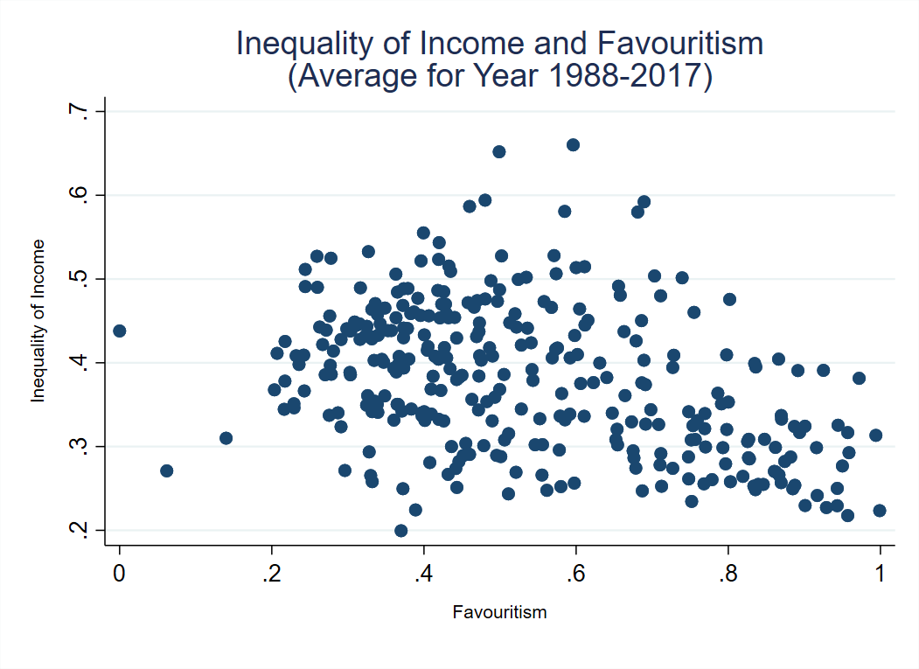
Figure D- 1 Scatter Plot for Inequality of Income and Favouritism (Average for Year 1988-2017)

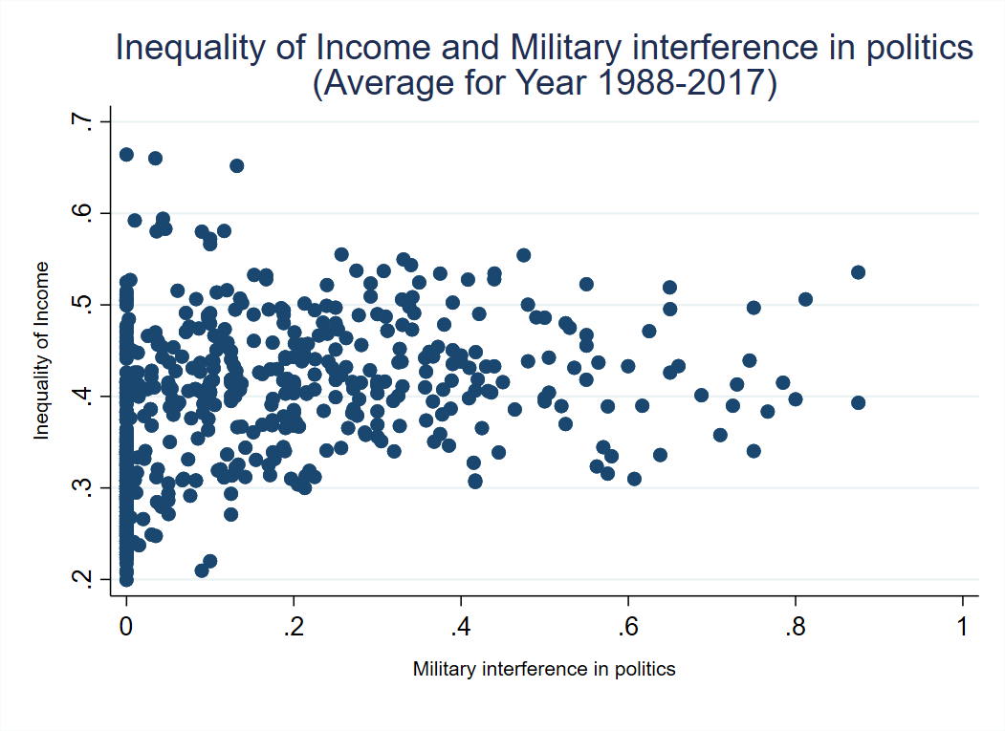

Figure D- 2 Scatter Plot for Inequality of Income and Military interference in Politics (Average for Year 1988-2017)

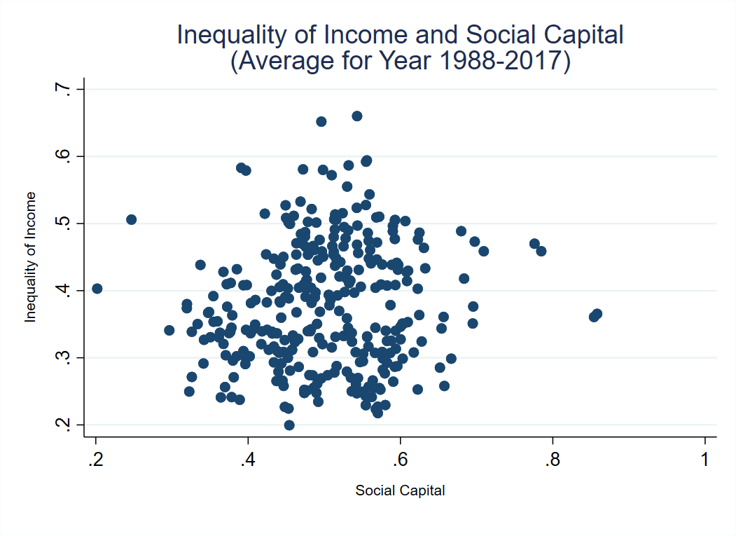

Figure D- 3 Scatter Plot for Inequality of Income and Social Capital (Average for Year 1988-2017)

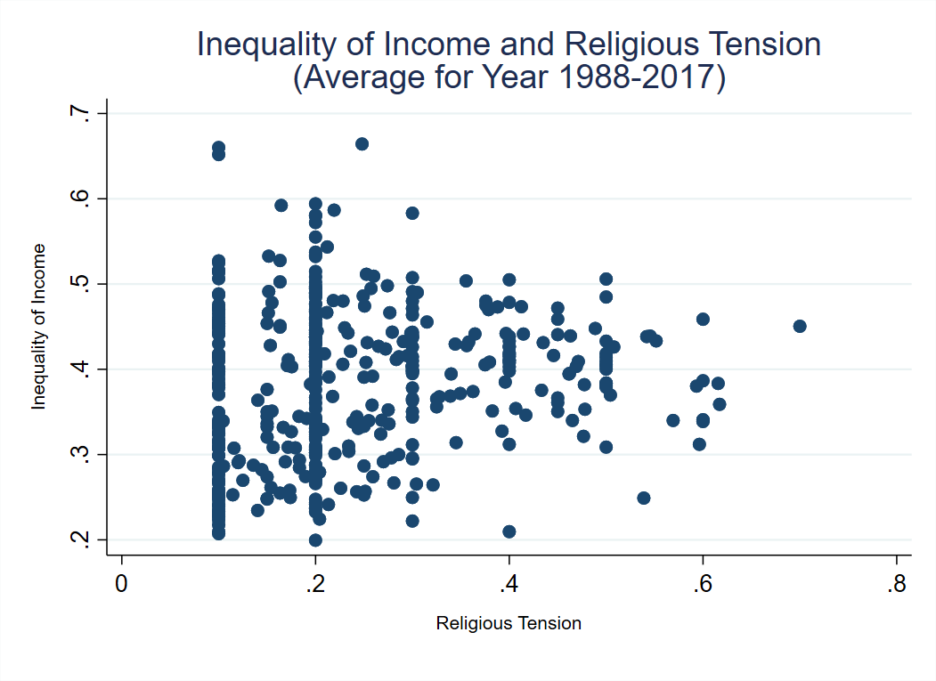

Figure D- 4 Scatter Plot for Inequality of Income and Religious Tension (Average for Year 1988-2017)

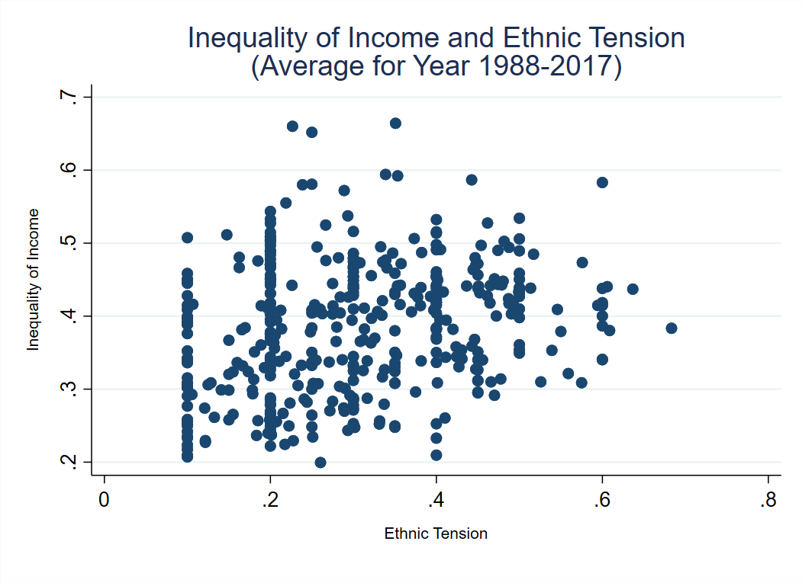
Figure D- 5 Scatter Plot for Inequality of Income and Ethnic Tension (Average for Year 1988-2017)

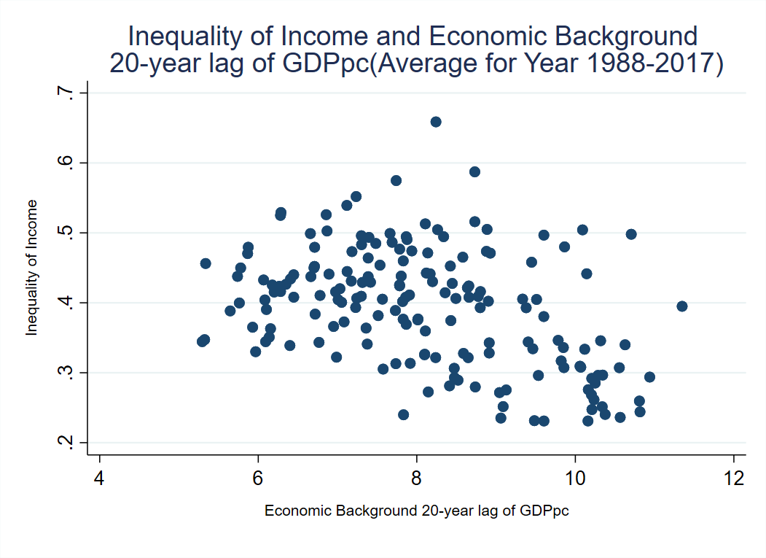
Figure D- 6 Scatter Plot for Inequality of Income and Economic Background 20-year lag of GDPpc (Average for Year 1988-2017)

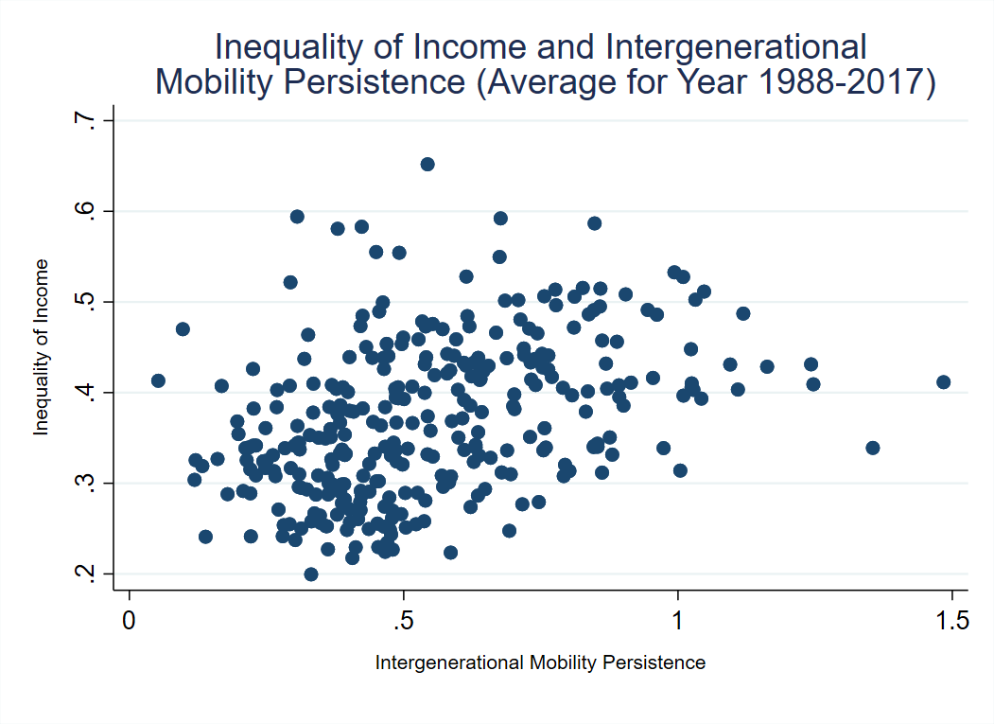

Figure D- 7 Scatter Plot for Inequality of Income and Intergenwrational Mobility Persistence (Average for Year 1988-2017)

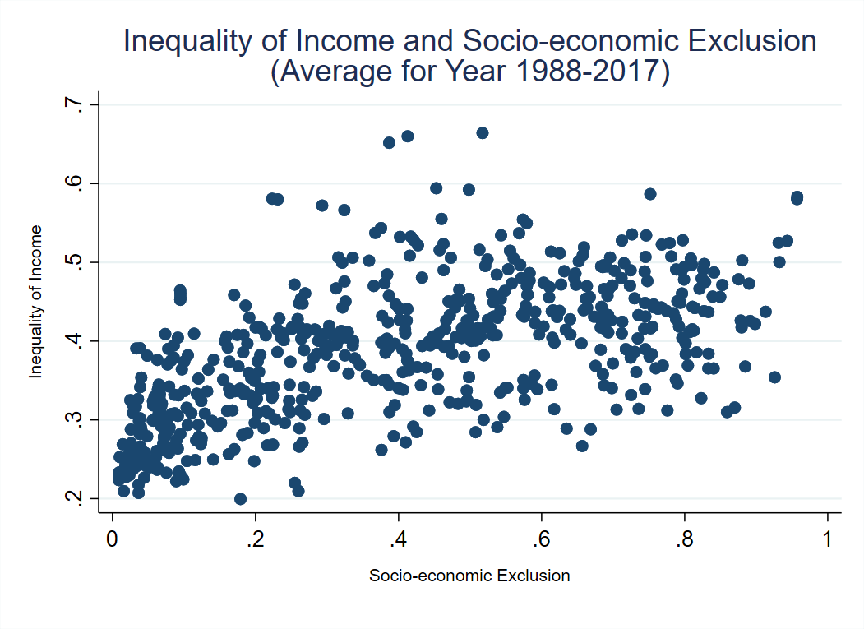
Figure D- 8 Scatter Plot for Inequality of Income and Socio-Economic Exclusion (Average for Year 1988-2017)

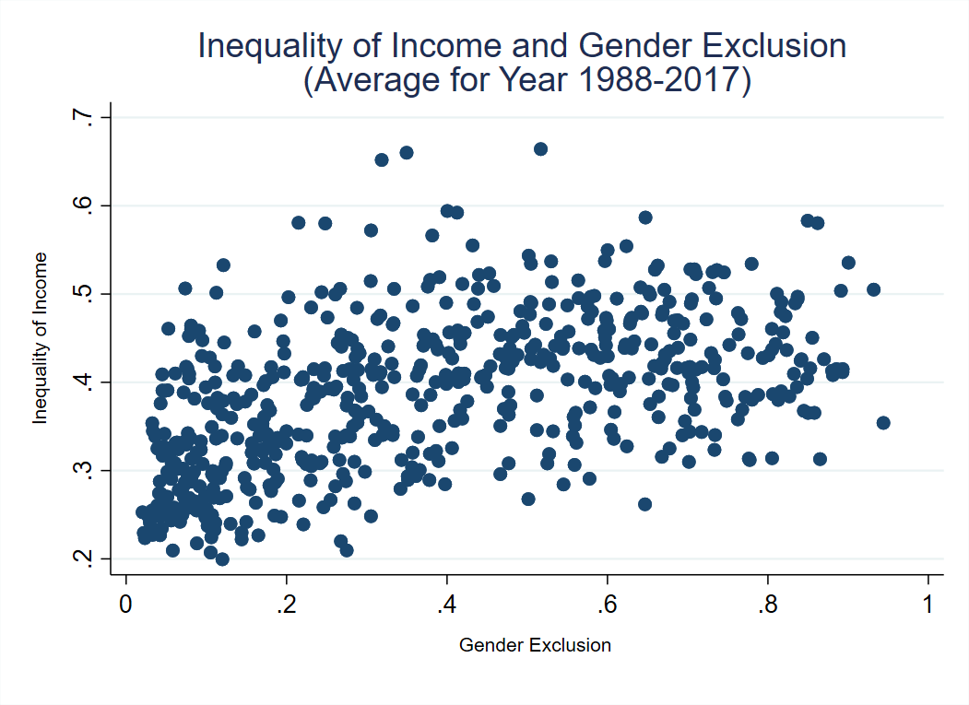
Figure D- 9 Scatter Plot for Inequality of Income and Gender Exclusion (Average for Year 1988-2017)

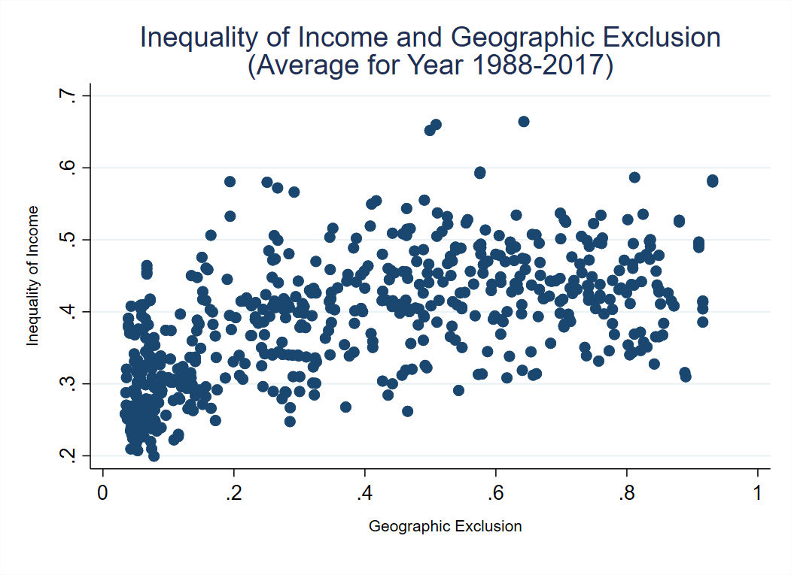
Figure D- 10 Scatter Plot for Inequality of Income and Geographic Exclusion (Average for Year 1988-2017)

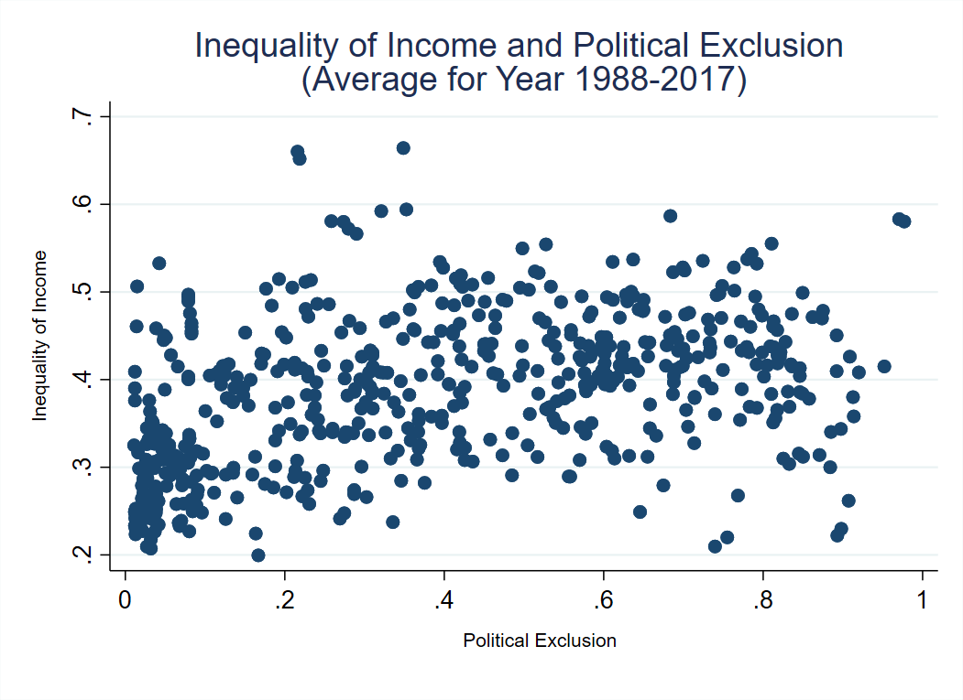
Figure D- 11 Scatter Plot for Inequality of Income and Political Exclusion (Average for Year 1988-2017)

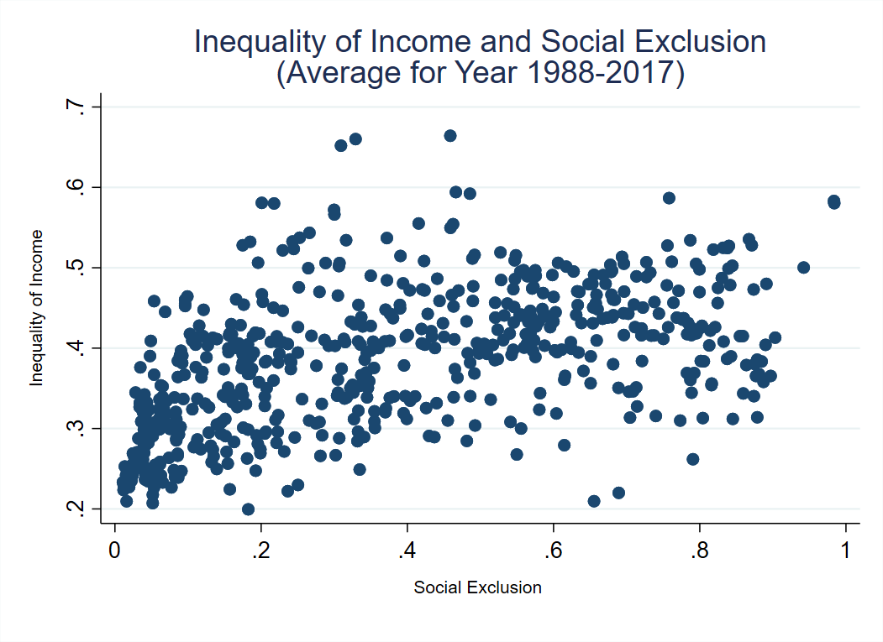

Figure D- 12 Scatter Plot for Inequality of Income and Social Exclusion (Average for Year 1988-2017)

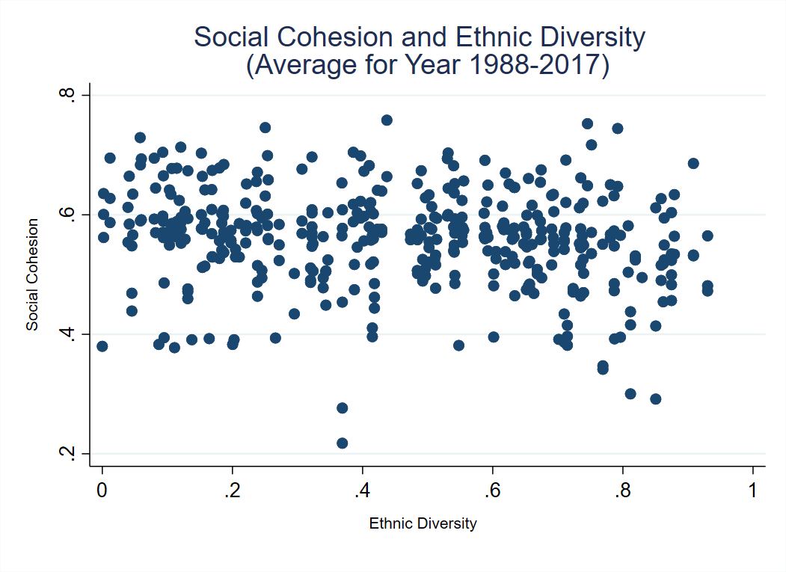

Figure D- 13 Scatter Plot for Social Cohesion and Ethnic Diversity (Average for Year 1988-2017)

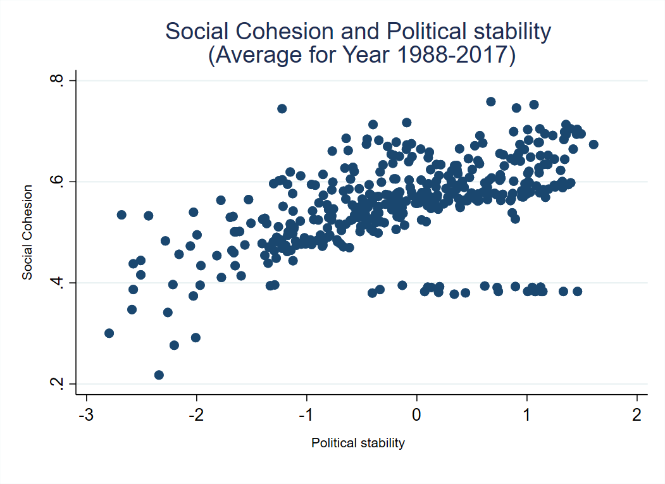

Figure D- 14 Scatter Plot for Social Cohesion and Political Stability (Average for Year 1988-2017)

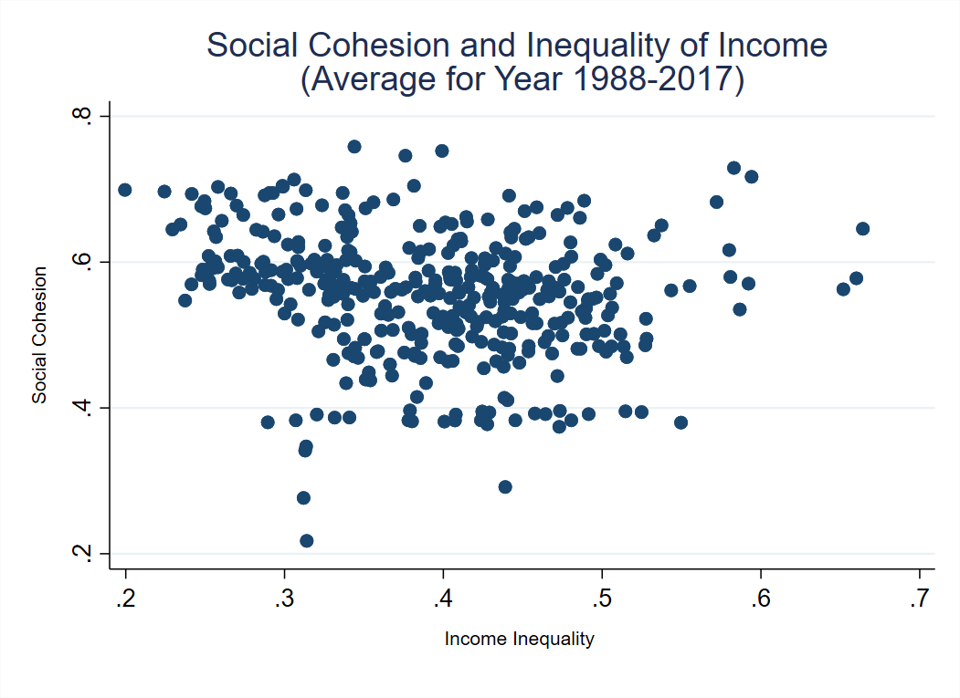

Figure D- 15 Scatter Plot for Social Cohesion and Inequality of Income (Average for Year 1988-2017)

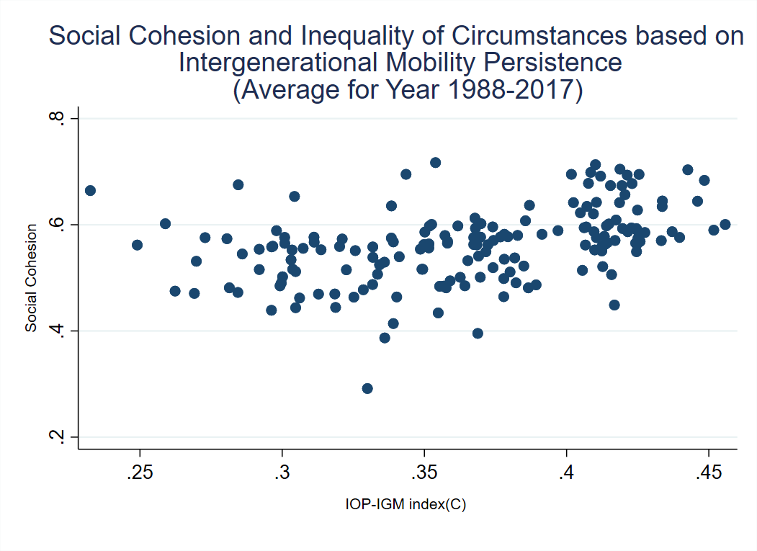

Figure D- 16 Scatter Plot for Social Cohesion and Inequality of Circumstances based on Intergenerational Mobility Persistence (Average for Year 1988-2017)

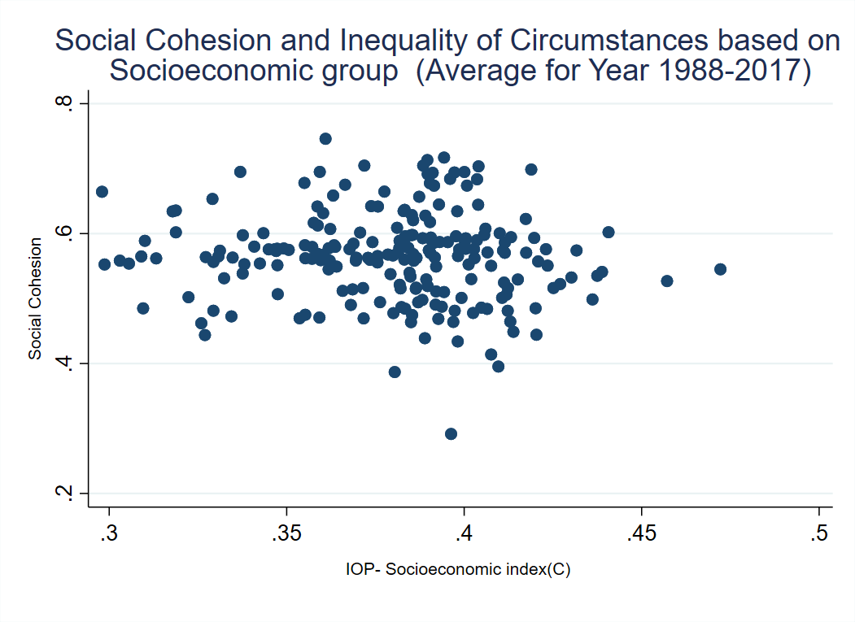

Figure D- 17 Scatter Plot for Social Cohesion and Inequality of Circumstances based on Socioeconomic Group (Average for Year 1988-2017)

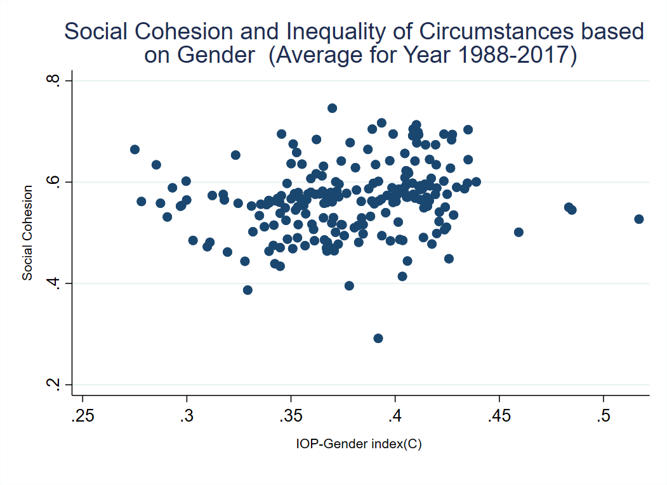

Figure D- 18 Scatter Plot for Social Cohesion and Inequality of Circumstances based on Gender (Average for Year 1988-2017)

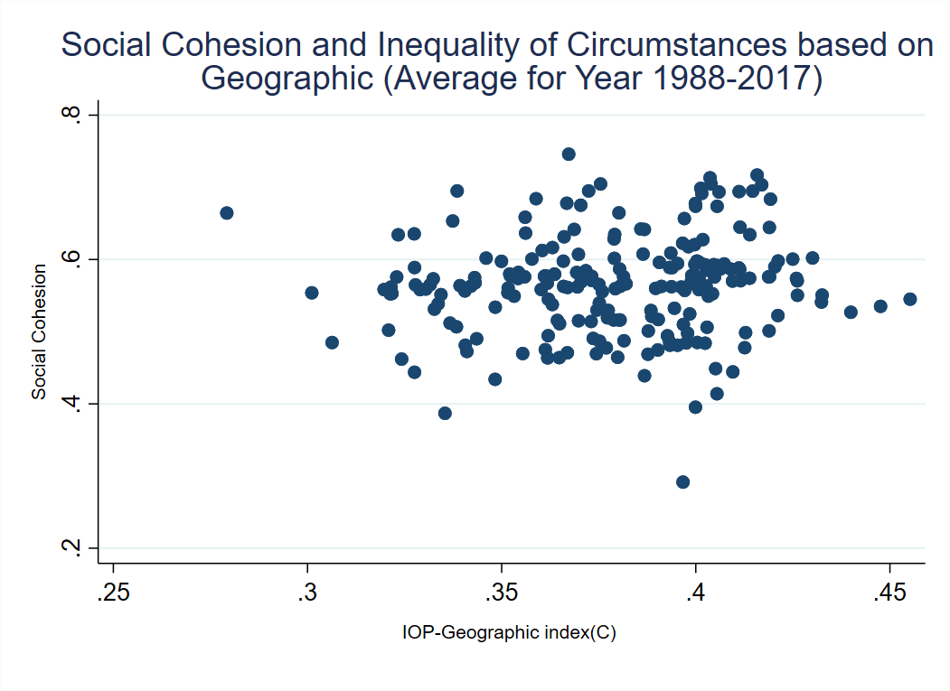

Figure D- 19 Scatter Plot for Social Cohesion and Inequality of Circumstances based on Geographic (Average for Year 1988-2017)

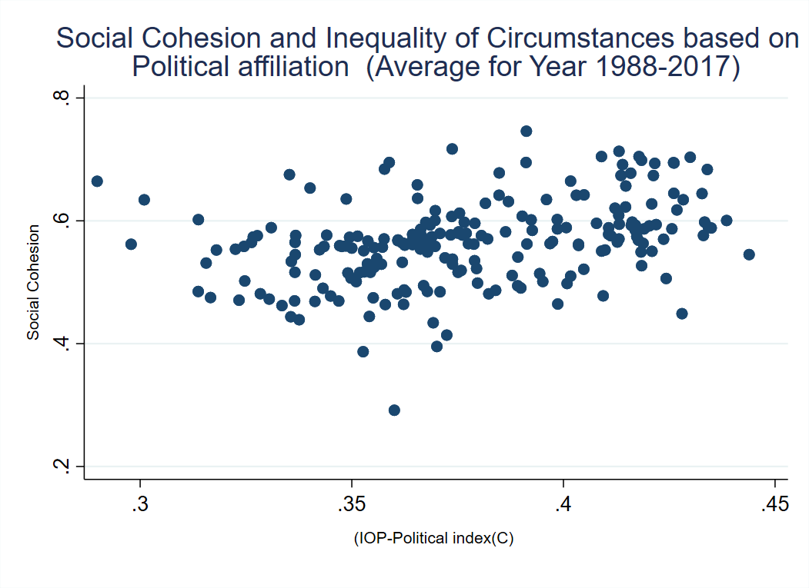

Figure D- 20 Scatter Plot for Social Cohesion and Inequality of Circumstances based on Political Affiliation (Average for Year 1988-2017)

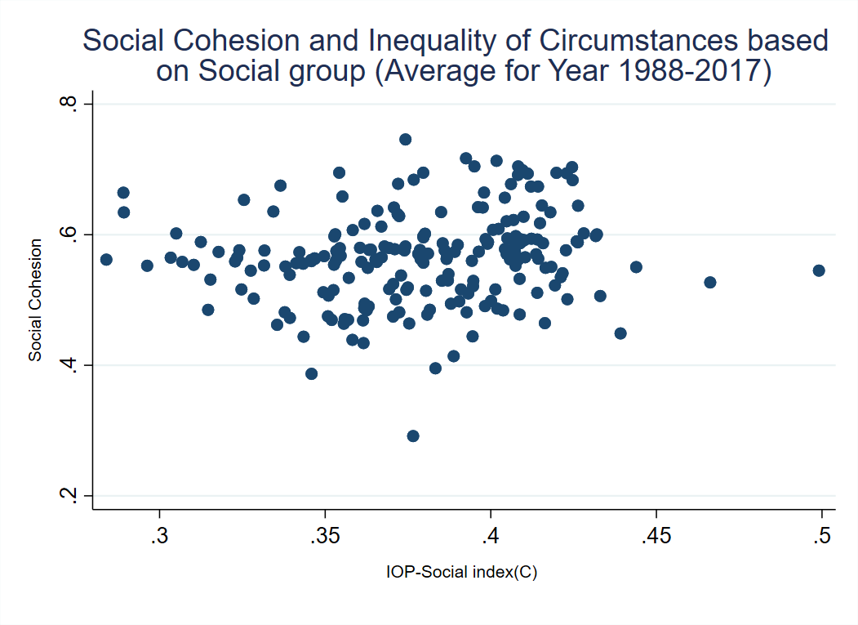

Figure D- 21 Scatter Plot for Social Cohesion and Inequality of Circumstances based on Social Group (Average for Year 1988-2017)

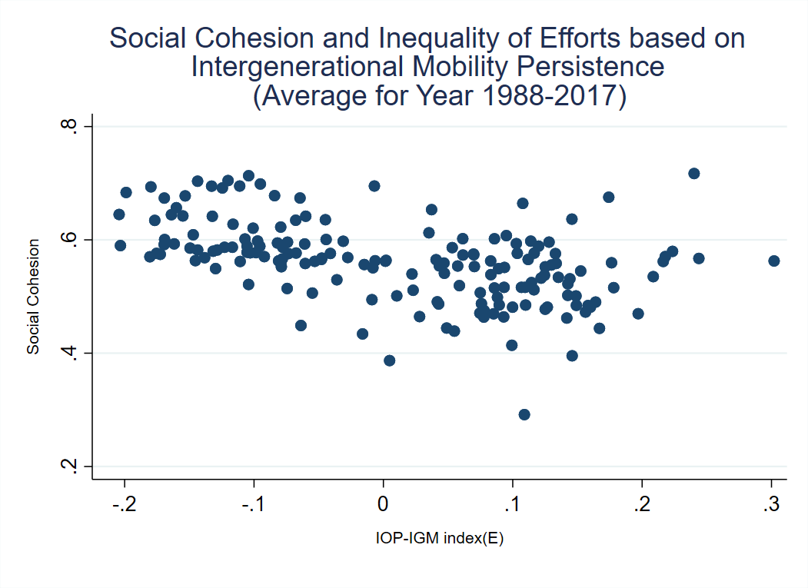

Figure D- 22 Scatter Plot for Social Cohesion and Inequality of Efforts based on Intergenerational Mobility Persistence (Average for Year 1988-2017)

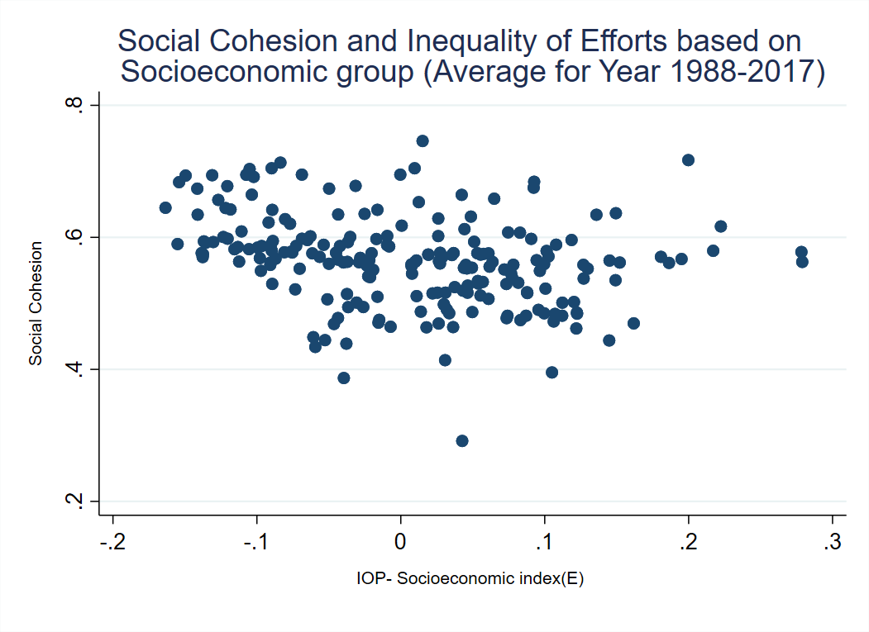
Figure D- 23 Scatter Plot for Social Cohesion and Inequality of Efforts based on Socioeconomic Group (Average for Year 1988-2017)

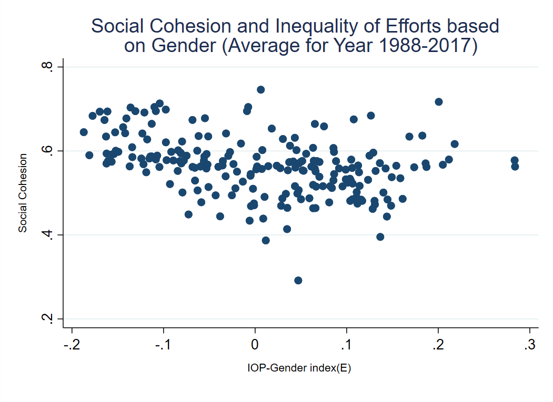
Figure D- 24 Scatter Plot for Social Cohesion and Inequality of Efforts based on Gender (Average for Year 1988-2017)

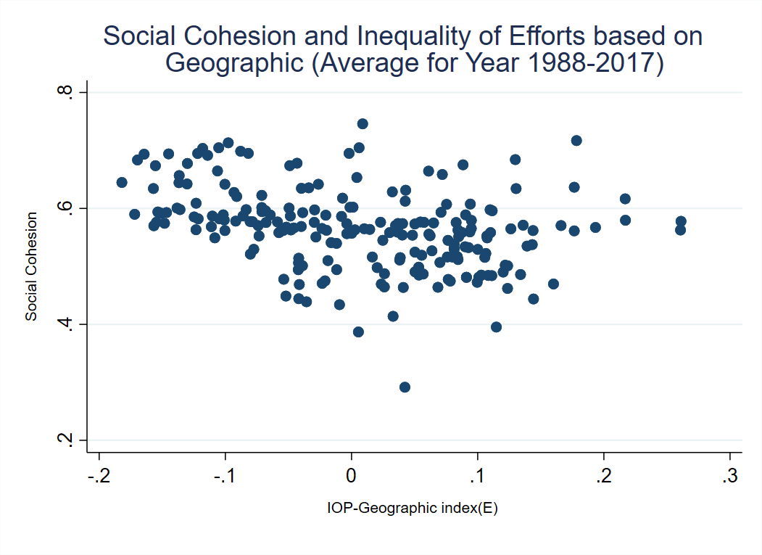
Figure D- 25 Scatter Plot for Social Cohesion and Inequality of Efforts based on Geographic (Average for Year 1988-2017)

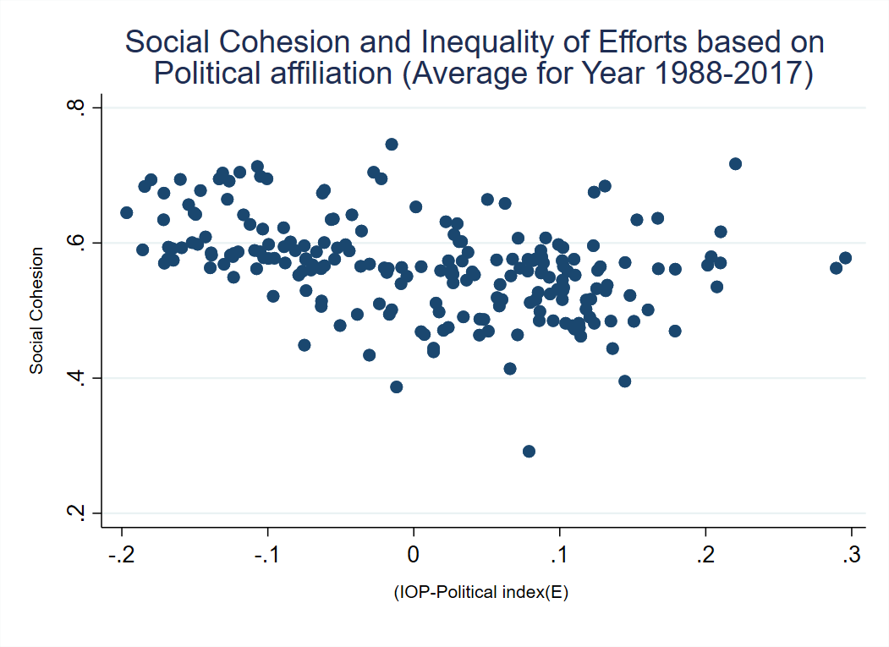
Figure D- 26 Scatter Plot for Social Cohesion and Inequality of Efforts based on Political Affiliation (Average for Year 1988-2017)

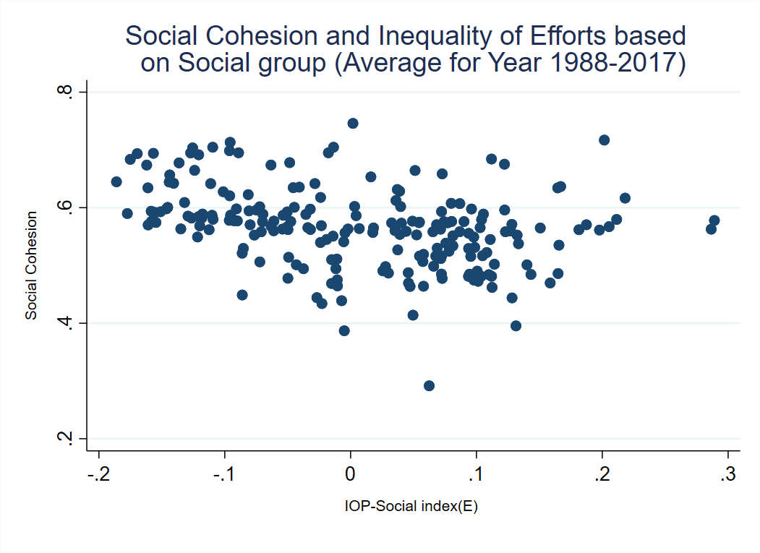
Figure D- 27 Scatter Plot for Social Cohesion and Inequality of Efforts based on Social Group (Average for Year 1988-2017)

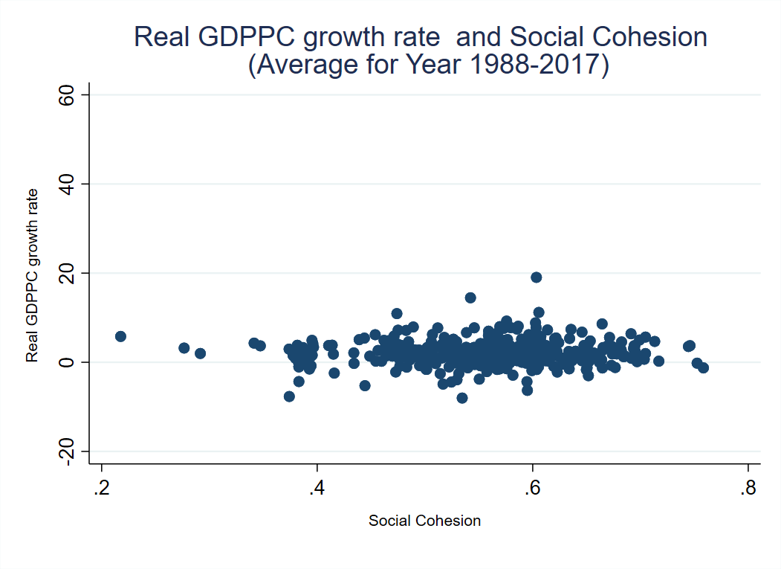
Figure D- 28 Scatter Plot for Real GDPpc Growth Rate and Social Cohesion (Average for Year 1988-2017)

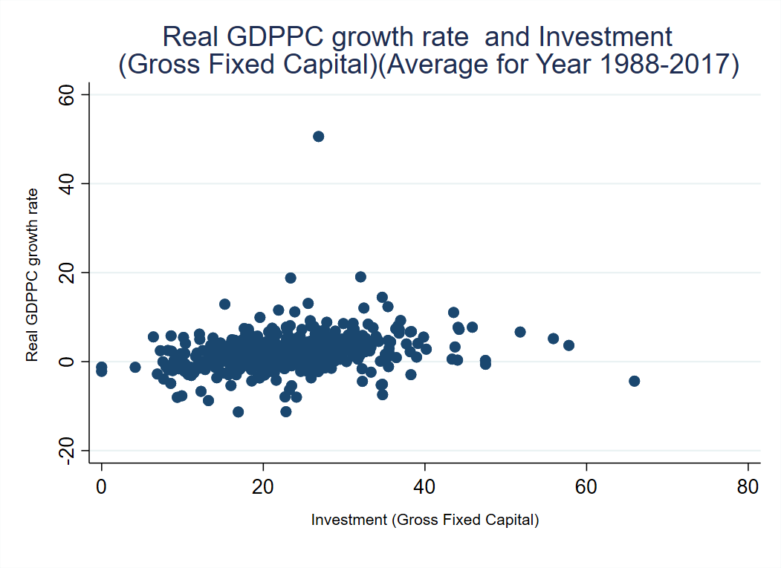
Figure D- 29 Scatter Plot for Real GDPpc Growth Rate and Investment (Gross Fixed Capital) (Average for Year 1988-2017)

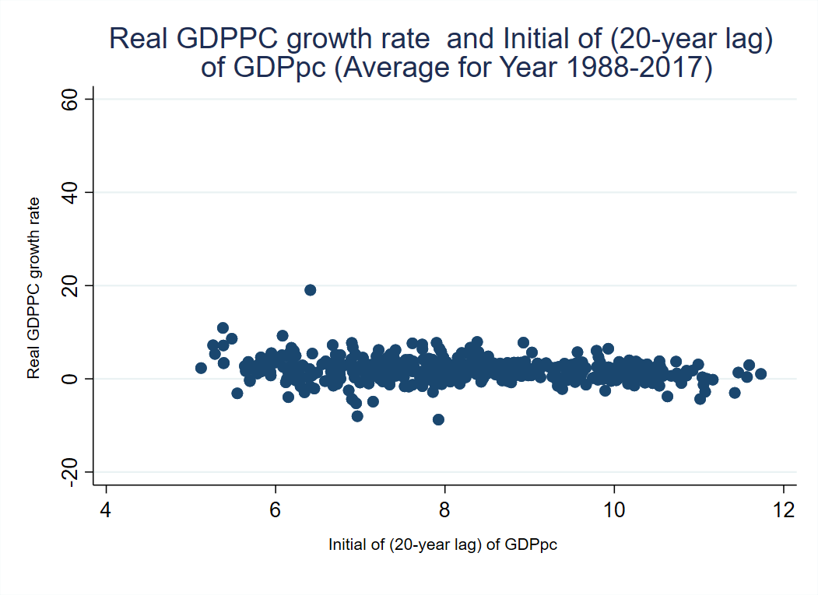
Figure D- 30 Scatter Plot for Real GDPpc Growth Rate and Intial of (20-year lag) GDPpc (Average for Year 1988-2017)

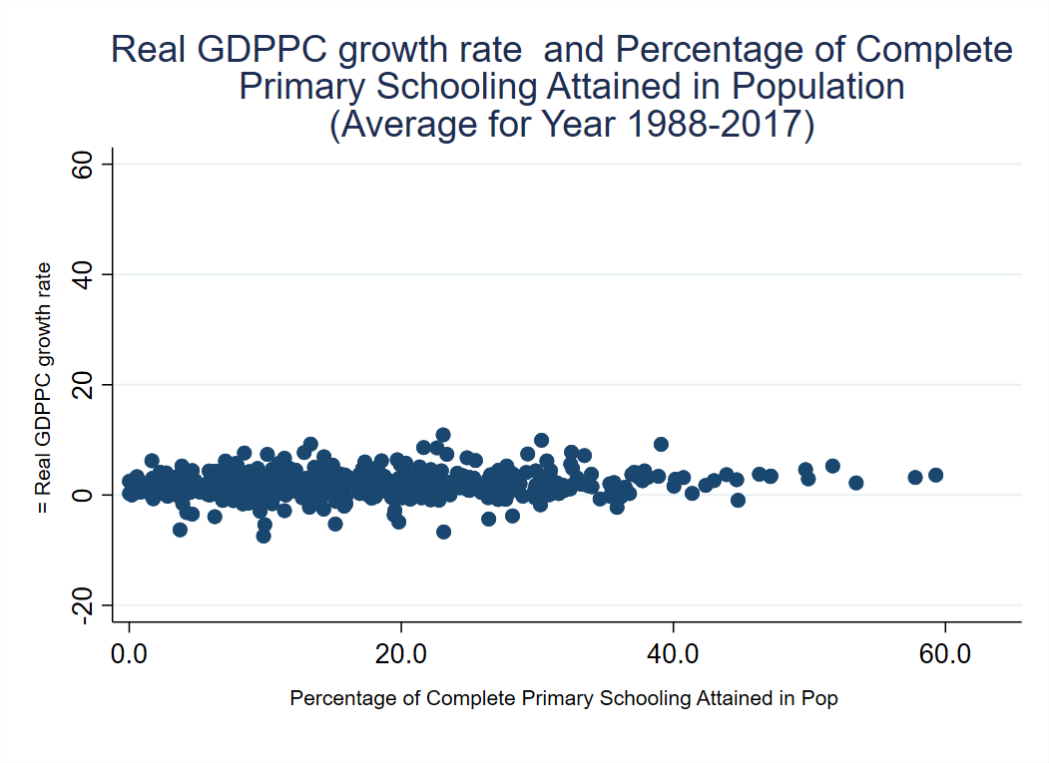
Figure D- 31 Scatter Plot for Real GDPpc Growth Rate and Percentage of Complete Primary Schooling Attained in Population (Average for Year 1988-2017)

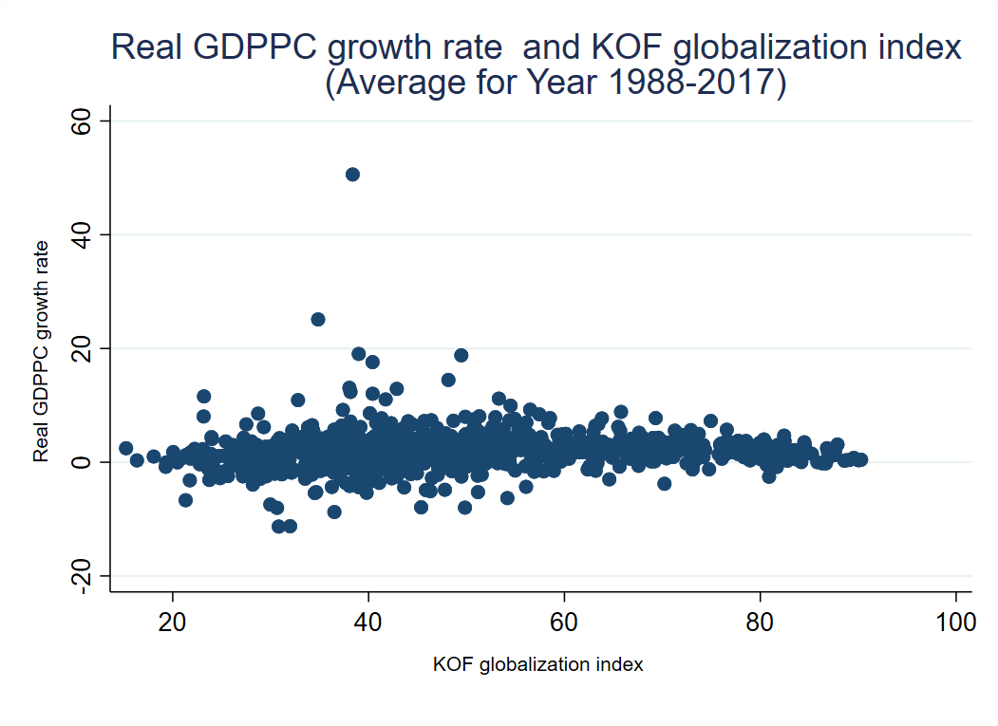
Figure D- 32 Scatter Plot for Real GDPpc Growth Rate and KOF Globalization Index (Average for Year 1988-2017)

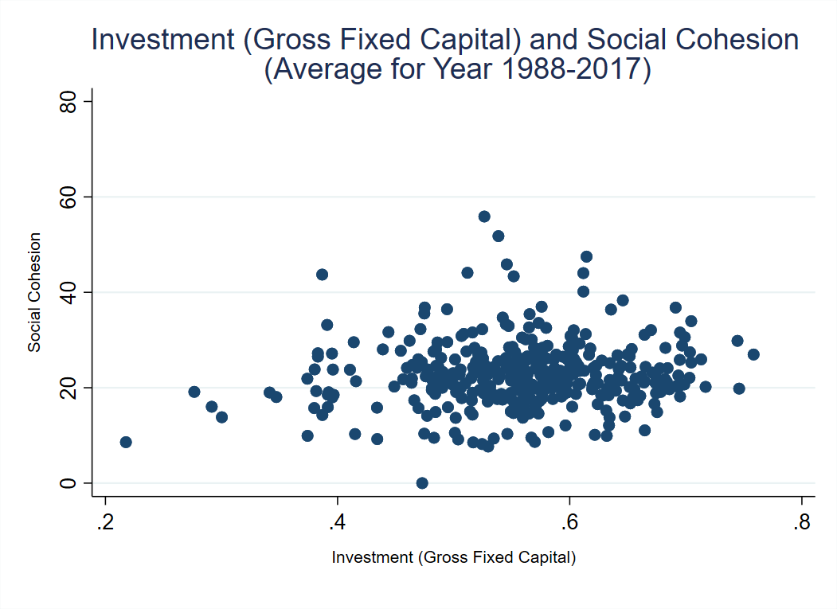
Figure D- 33 Scatter Plot for Investment (Gross Fixed Capital) and Social Cohesion (Average for Year 1988-2017)

