

②
FIG. 1
READ THIS PRODUCT INSERT THOROUGHLY BEFORE USE
C1® DEPTH LIMITER TECHNOLOGY GUIDE
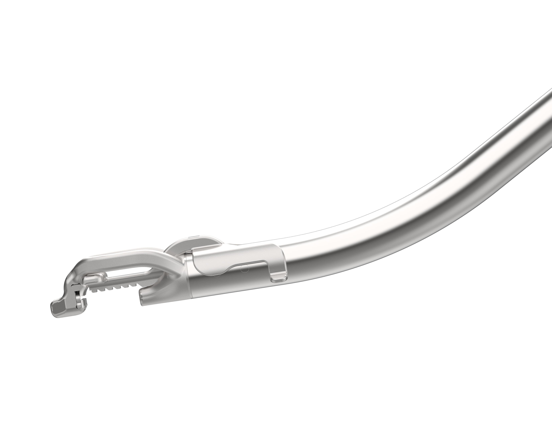
③

①
④
⑤

① CONTOURED MOUNT
② STABILIZER ARM
③ SNAP-FIT FLEXURES
④ RETENTION TABS
⑤ SERRATED TEETH

C1® Depth Limiter Description:

The C1® Depth Limiter is a sterile, single-use metal accessory used in conjunction with the C1® Device to support controlled, non-transmural suture placement by restricting how deeply tissue is seated within the device tip prior to needle deployment.
The contoured mount ① of the stabilizer arm ② interfaces with the inner surface of the device above the needle cap compartment. Two snap-fit flexures ③ secure the C1® Depth Limiter to the device shaft. Retention tabs ④, located at the ends of the flexures, assist with accessory removal. On the underside of the stabilizer arm, serrated teeth ⑤ gently stabilize the device against the tissue surface to promote consistent positioning during use.
Indications for Use:
The C1® Depth Limiter is indicated for use in conjunction with the C1® Device to facilitate shallow bites in the approximation of soft tissue and prosthetic materials.




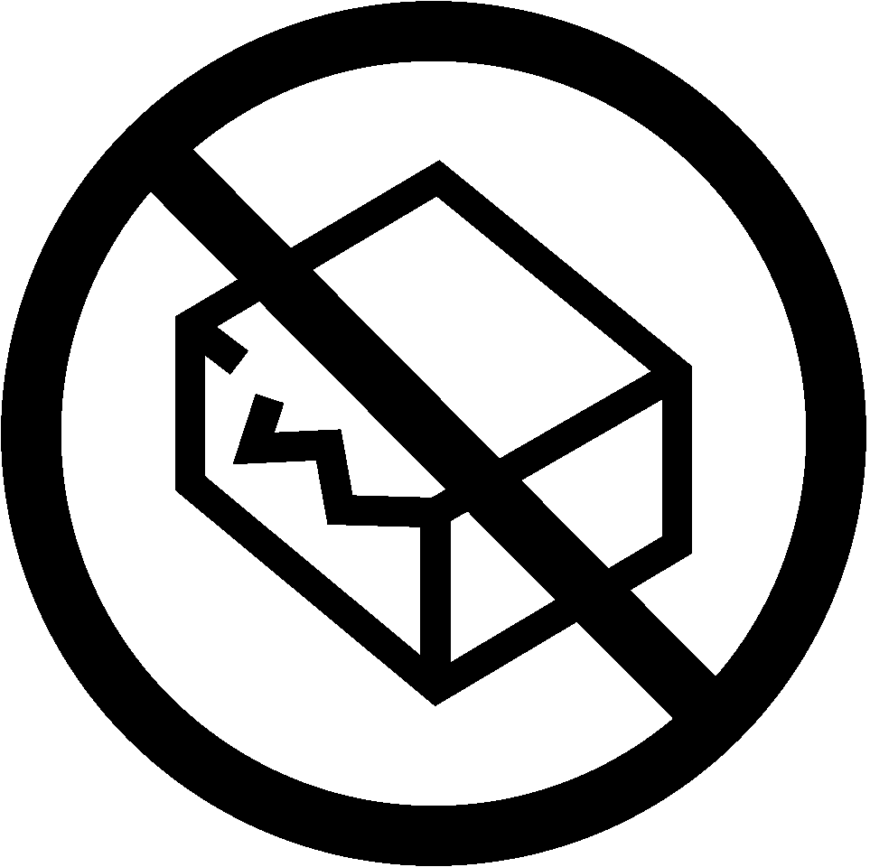

Patents: www.lsisolutions.com/patents

The LSI logo, LSI Solutions, C1, and Perfect Performance Policy are registered trademarks and trademarks of LSI SOLUTIONS®.
Copyright © 2025, LSI SOLUTIONS®. All Rights Reserved.

Symbol Glossary:
www.lsisolutions.com/symbols
1 P/N 022397C Rev. B 22OCT25 11`1



LSI SOLUTIONS, Inc.

7796 Victor
-
Mendon Road

Victor, New York 14564 U.S.A.

Phone: +1 585.869.6600

Customer Service: +1 866.575.3493

Technical Support: +1 866.428.9092

Fax: +1 585.742.8086

www.lsisolutions.com

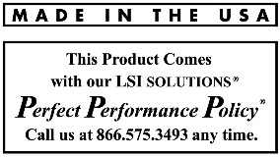





INSTRUCTIONS FOR USE
The C1® Depth Limiter attaches to the sew tip of the angled or straight C1® Device

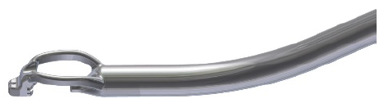



NOTE: Verify that the C1® Device needle passes freely beneath the tissue engagement teeth of the C1® Depth Limiter and ensure there are no obstructions impeding needle movement.
3 PRESS
3. PRESS down on the two snap-fit flexures to engage them around the device shaft, locking the C1® Depth Limiter securely in place.

1 INSERT
2 ROTATE
2. ROTATE the C1® Depth Limiter back 90°, ensuring the stabilizer arm is positioned parallel to the device tip and the contoured mount is aligned against the inner surface, just above the ferrule compartment.
1. INSERT the contoured mount into the upper opening of the C1® Device by rotating the C1® Depth Limiter 90°.
REMOVAL

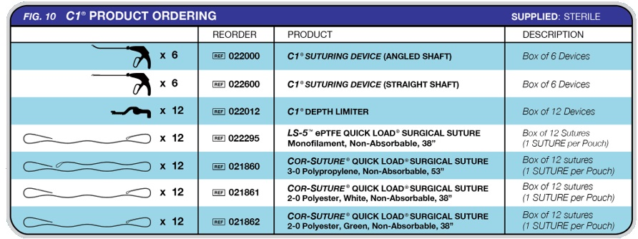

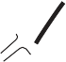

ACTIONS
3 REMOVE
2 DISENGAGE
3. REMOVE the C1® Depth Limiter from the sew tip of the C1® Device.

2. DISENGAGE the snap-fit flexures by manually or using a suitable instrument to lift upward on the retention tabs to release the flexures from the device shaft.
1. STABILIZE the C1® Device by holding securely to prevent movement.
NOTE: Once the flexures are disengaged, the C1® Depth Limiter may naturally lift away from the C1® Device tip with minimal resistance.
1 STABILIZE
The C1® Depth Limiter restricts the amount of tissue that can be positioned within the jaw of the C1® Device. It is used to facilitate controlled, shallower suture bites such as non-transmural or partial-thickness placements where full tissue penetration is not desired.
CONTRAINDICATIONS
- The C1® Depth Limiter is not intended to be used with any device other than a C1® DEVICE.
WARNINGS
- Federal (U.S.A.) law restricts this device to sale, distribution, and use by, or on, the order of a physician.
- Do not resterilize. The C1® Depth Limiter is designed and intended for single-patient use only. The performance of the C1® Depth Limiter after cleaning or other reprocessing has not been verified and is not supported by LSI SOLUTIONS ®. Reuse, reprocessing, or resterilization may compromise the integrity of the devices and/or create a risk of contamination of the devices, which could result in patient injury, illness, or death.
- Discard open (unsealed), unused, expired or damaged devices or devices in damaged primary packaging
- Invasive surgical procedures should only be performed by physicians having adequate training and familiarity with open direct visualization or video-enhanced endoscopic techniques. In addition, medical literature should be consulted relative to techniques, complications, and hazards prior to the performance of invasive procedures.
- Do not use this suture under conditions in which excessive suture tension can lead to tissue damage. For example, do not use COR-SUTURE® or LS-5™ QUICK LOAD® surgical suture through an excessively narrow, restrictive, or defective cannula access port, which could significantly impair easy and smooth passage of the suture or device.
- Read and become familiar with all instructions, warnings, and precautions before using this product.
- Users should be familiar with surgical procedures and techniques involving suture before employing the C1® DEVICE for wound closure, as the risk of wound dehiscence may vary with the site of application.
- Acceptable surgical practice and good surgical judgment must be followed with respect to drainage and closure of infected or contaminated wounds.
- Redundant, cut-away suture remnants, used needle caps, and C1® Depth Limiter, along with packaging, must be inspected, handled, and disposed of consistent with standard, accepted medical device disposal procedures.
- Applications other than the intended use, can result in failure to pick up suture or in damage to the device making it unsuitable for continued use.
PRECAUTIONS
- Do not use the C1® Depth Limiter if it does not satisfactorily perform its intended function or if it has physical damage. Avoid mechanical impact or overstressing the device.
- The C1® DEVICE is compatible with minimally invasive access devices, such as cannulas and trocars, that are capable of accommodating instruments 15mm in diameter.
- When handling the C1® Depth Limiter, care should be taken to avoid damage to the device.
- Check for hemostasis or leakage where appropriate.
- Always assure C1® Depth Limiter and C1® Device tip are viewed under direct visualization before advancing the needle.
- Ensure obstructions do not interfere with the movement of the needle of C1. Obstructions may cause damage or breakage.
- Do not squeeze the blue lever of the C1® Device while attaching or detaching the C1® Depth Limiter; squeezing the blue lever may expose the sharp needle and/or damage the needle.
- Avoid damage to or dislodgement of the C1® Depth Limiter due to direct application of surgical instruments, like forceps, needle holders, clamps, etc. If damage is noted, ensure that there are no device pieces, needle fragments, or free suture sections in the surgical field.
- Do not use the C1® DEVICE or C1® Depth Limiter to dissect or aggressively manipulate tissue structures.
- Surgical instruments may vary in size from manufacturer to manufacturer. Before open surgical or endoscopic instruments and accessories from different manufacturers are employed together in a procedure, verify compatibility and ensure that electrical isolation or grounding are not compromised.
- The surgeon’s judgment regarding bite location remains imperative, for example, where avoidance of calcific tissue is usually warranted.
- Care must be taken when inserting this or any device through minimally invasive access devices, such as cannulas or trocars, to avoid advancing the device incorrectly (e.g., too far or too quickly). Device insertion should be easy, smooth, and controlled to minimize the risks of trauma to the patient or damage to the device.
- Before squeezing the C1® DEVICE lever to advance the needles, always ensure that proper insufflation is achieved and the device tip location is adequately visualized.

ADVERSE REACTIONS
Adverse effects associated with the use of suture include wound dehiscence, failure of adequate wound support in closure sites where expansion, stretching or distension occur, enhanced bacterial infectivity, minimal acute inflammatory tissue reaction, localized irritation when skin sutures are left in place for greater than 7 days, calculi formation in urinary and biliary tracts when prolonged contact with salt solutions such as urine and bile occurs, and pain, edema and erythema.

