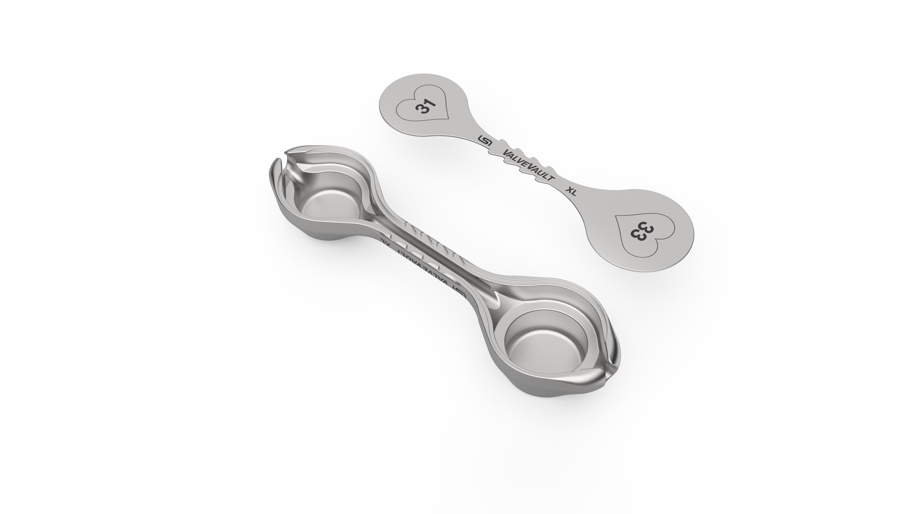
⑤

- READ THIS PRODUCT INSERT THOROUGHLY BEFORE USE

VALVEVAULT® EXTRA LARGE DEVICE
TECHNOLOGY GUIDE
③

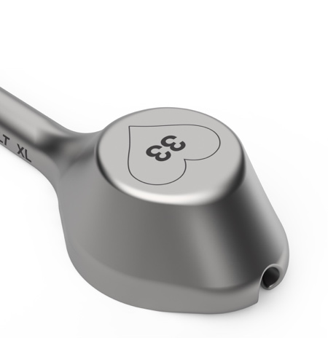
⑩
⑨
⑩
⑨
⑧
⑦
⑥
⑥
④

①
②
FIG. 1 - VALVEVAULT® EXTRA LARGE DEVICE (shown with cover removed.)
VALVEVAULT® DEVICE Holder bottom with chamber diameter (in mm)
① HOLDER
② CHAMBERS
③ DEVICE SIZE
④ CHAMBER DIAMETER
⑤ COVER
⑥ ALIGNMENT ARROWS
⑦ SHAFT
⑧ CHANNEL
⑨ INSIDE SHOULDER
⑩ SUTURE OPENING
1
④

VALVEVAULT® EXTRA LARGE DEVICE DESCRIPTION
The VALVEVAULT® EXTRA LARGE DEVICE (FIG. 1) is a reusable, sterilizable delivery device for transporting a prosthesis through a surgical incision. Each holder ① has two differently sized chambers ② designed to hold a prosthesis. The device is marked XL ③, found on both the holder and cover ⑤, and denotes the Extra Large size VALVEVAULT® DEVICE. The chamber diameter ④ is marked within a heart shaped symbol on both the cover and bottom of the VALVEVAULT® DEVICE to denote the approximate diameter for each chamber. Alignment arrows ⑥ point towards the larger chamber and are used to orient and pair a corresponding holder and cover together while establishing enclosure of the prosthesis and corresponding suture. A shaft ⑦ contains a channel ⑧ connecting the two chambers of the holder. During use, annular facing suture from the surgical site is guided through the suture opening ⑩ of the selected chamber allowing the prosthesis sewing cuff to rest on or just below the inside shoulder ⑨. Free ends of the suture from the prosthesis are routed within the channel and over the vacant chamber to exit through the opposite suture opening. The cover alignment arrows are then matched to the holder alignment arrows to completely encase and protect the prosthesis and suture for delivery through the surgical incision.

INDICATIONS FOR USE:
The VALVEVAULT® EXTRA LARGE DEVICE is indicated for use to hold and deliver a prosthesis through a surgical incision.
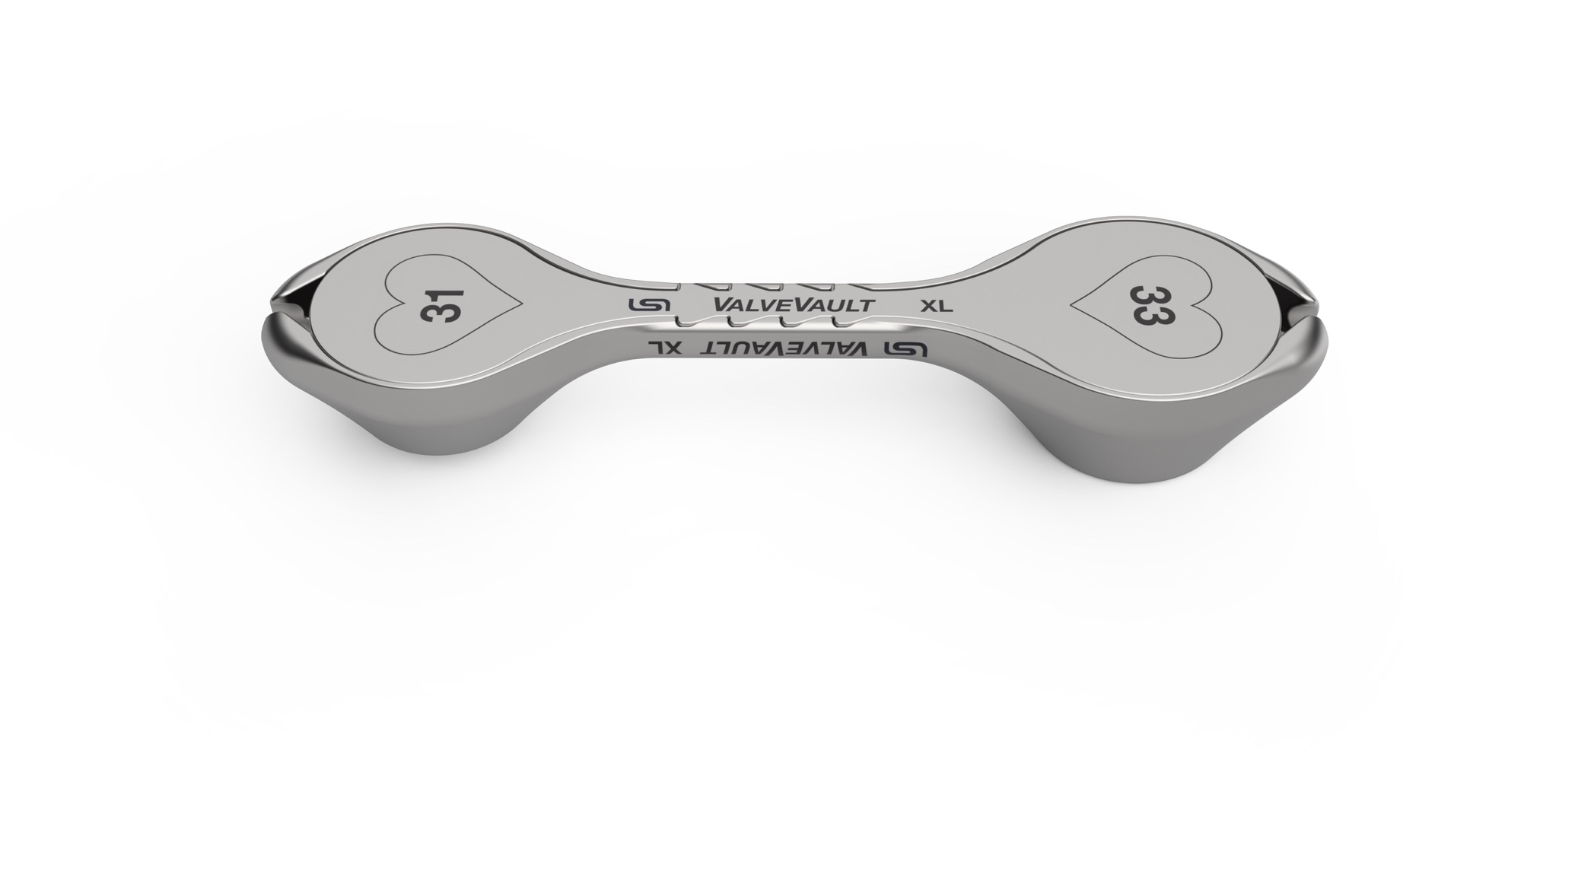
CHOOSING THE SIZE OF THE VALVEVAULT® DEVICE

CONTRAINDICATIONS
- The VALVEVAULT® EXTRA LARGE DEVICE is contraindicated for use with any balloon or self-expandable prosthesis.
- The VALVEVAULT® EXTRA LARGE DEVICE is contraindicated for prosthesis extraction.

NOTE: For each chamber of the VALVEVAULT® DEVICE, the approximate chamber diameter (measured in mm) is printed within a heart shape on the bottom of the holder and top of the cover. This numerical designation for chamber diameter is not intended to represent the prosthesis size.

TABLE 1. VALVEVAULT® DEVICE SIZE GUIDE
VALVEVAULT®  DEVICE Size | Reorder Number | Chamber Diameter (mm) | Chamber Depth (mm)
Small (S) | 081025 | 19 | 11.5
Small (S) | 081025 | 21 | 12.5
Medium (M) | 081030 | 23 | 13.5
Medium (M) | 081030 | 25 | 14.5
Large (L) | 081035 | 27 | 15.5
Large (L) | 081035 | 29 | 16.2
Extra Large (XL) | 082605 | 31 | 21.0
Extra Large (XL) | 082605 | 33 | 25.5

NOTE: Surgeons should choose their preferred device size and chamber size based on surgical approach, prosthesis knowledge, and patient anatomy.

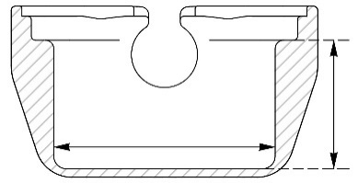

CHAMBER
DEPTH
CHAMBER
DIAMETER

1 SELECT

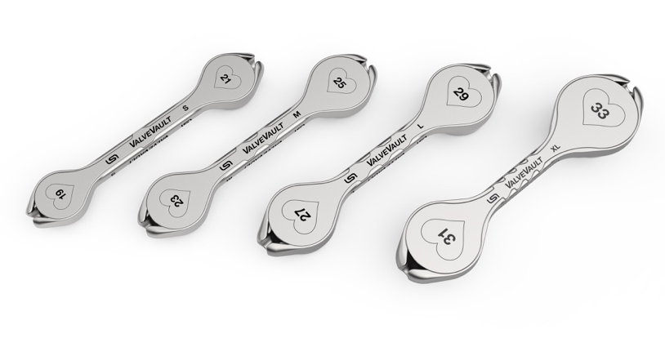
1. SELECT the appropriately sterilized VALVEVAULT® DEVICE, (i.e., small, medium, large, or extra large) based on the chamber most likely to readily fit the outer profile (i.e., height as well as width) of the sutured prosthesis.

SMALL
MEDIUM
EXTRA LARGE
LARGE

2. SIZE the chamber if desired to estimate an appropriate fit for the prosthesis. Compare the selected valve sizer to the selected prosthesis. The valve sizer should fit easily into the selected chamber.
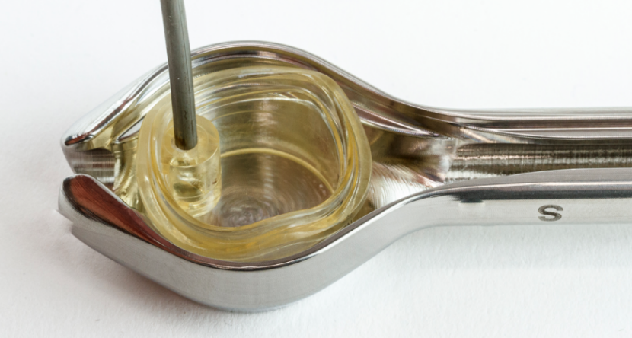
2 SIZE

2
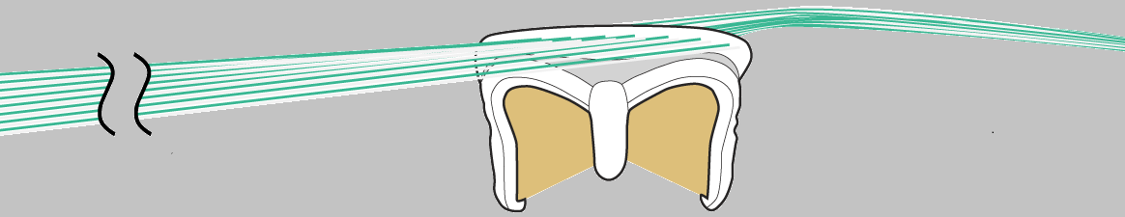
SUTURE FROM THE ANNULUS
SURGICAL
SITE
For the following loading steps, note that suture sections are named as shown:
LOADING THE VALVEVAULT® DEVICE

FREE ENDS OF THE SUTURE
NOTE: Avoid potential prosthesis damage by ensuring suture does not become entangled with prosthesis leaflets. Ensure all surgical needles are removed prior to VALVEVAULT® DEVICE use to affirm that only the suture strands from the annulus and the free ends are associated with the prosthesis.
DRAFT V10 – CONFIDENTIAL 5-May-26 8:30:34 AM NDA/TJH/AEL

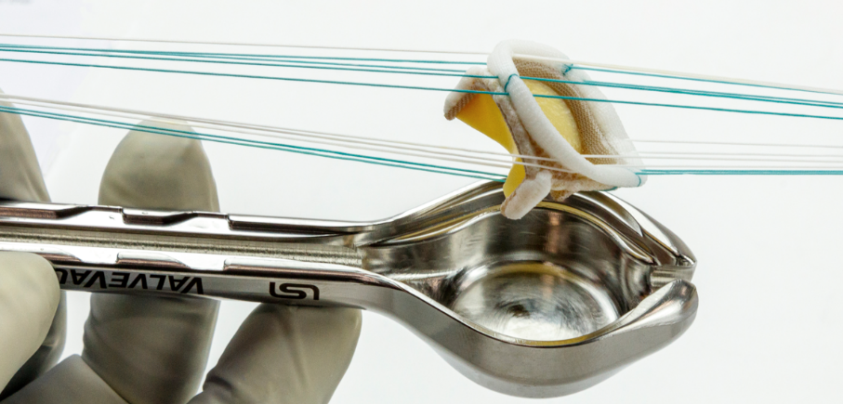
1 ORIENT / PLACE

1. ORIENT the selected VALVEVAULT® DEVICE Chamber to be closest to the patient. With suture from the annulus through the prosthetic sewing cuff, gently PLACE the prosthesis into selected chamber with leaflets facing down, sewing cuff up. The prosthetic sewing cuff should rest on or under the inside shoulder. Ensure the suture from the annulus is gathered completely within the suture opening. Never force the prosthesis into the chamber or the cover onto the prosthesis.

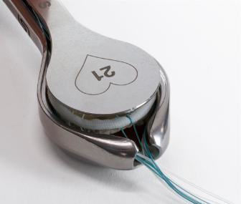

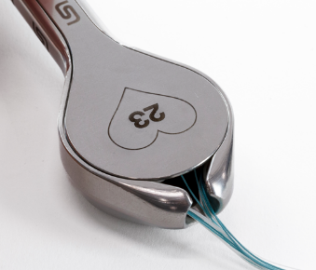
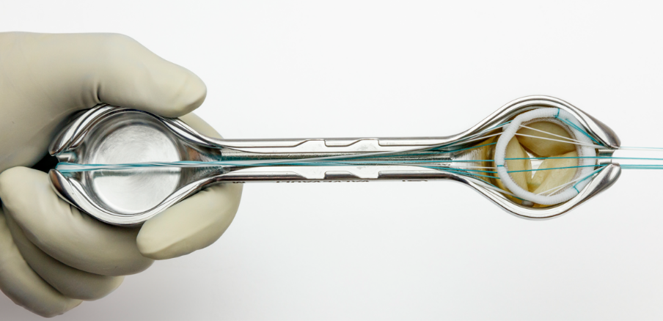
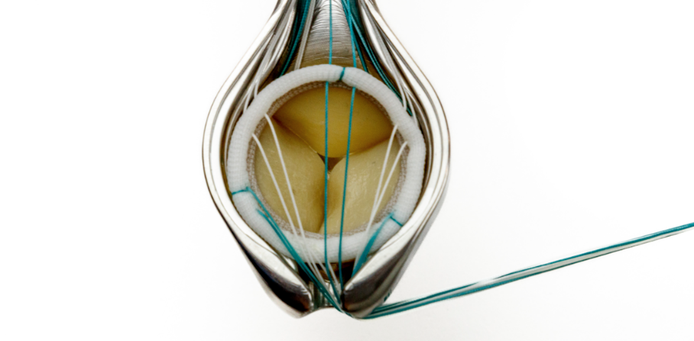
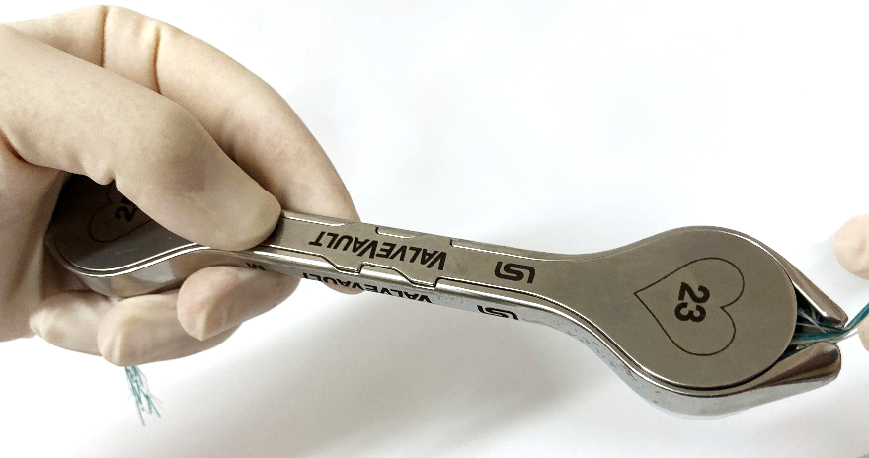
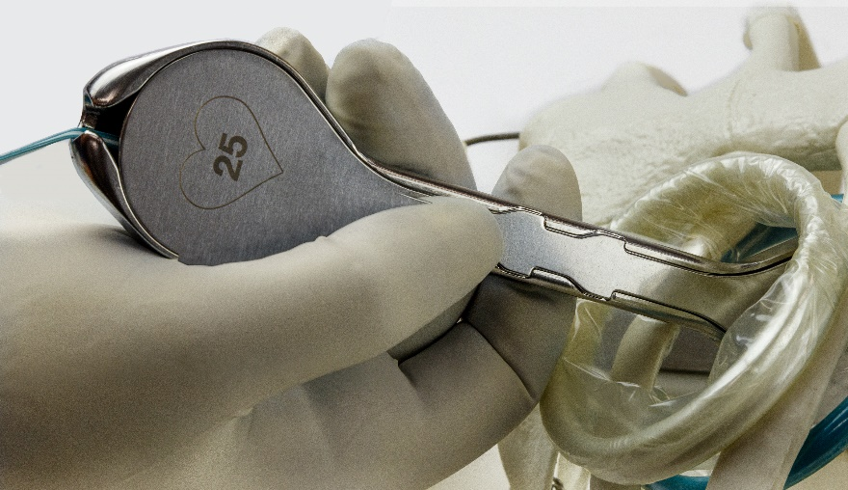
CHANNEL
OPPOSITE SUTURE OPENING
INSIDE SHOULDER
SUTURE OPENING

SUTURE FROM
THE ANNULUS
3
ALIGNMENT
ARROWS
SUTURE OPENING
3. GUIDE the free ends of the suture from the prosthetic sewing cuff through the channel and unused chamber and out of the opposite suture opening.
4. CLOSE the VALVEVAULT® DEVICE Holder by matching the alignment arrows on the cover to those on the holder. Ensure all suture is contained within the suture openings and the cover is flush with the holder’s edges without compressing the prosthesis. Do not force the cover onto the prosthesis if it does not easily lay flush with the holder. If needed, select the next size larger chamber and try again.

2. INSPECT the prosthesis and suture to ensure leaflets are not compromised and suture lays correctly.
3 GUIDE

2 INSPECT

4 CLOSE

1DELIVER

DELIVERING THE PROSTHESIS WITH THE VALVEVAULT® DEVICE

1. DELIVER the VALVEVAULT® DEVICE through the surgical incision, preferably with the device cover facing the lower rib.

SIMULATED SURGICAL ACCESS SITE

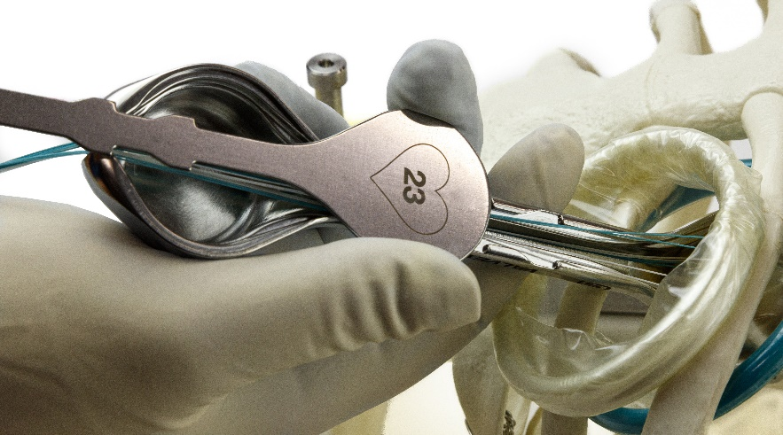
2 OPEN

2. OPEN the VALVEVAULT® DEVICE by removing the cover from the holder. Do not expose the prosthesis or compromise it by contact with other structures. Remove the cover from the surgical incision and away from the surgical site.


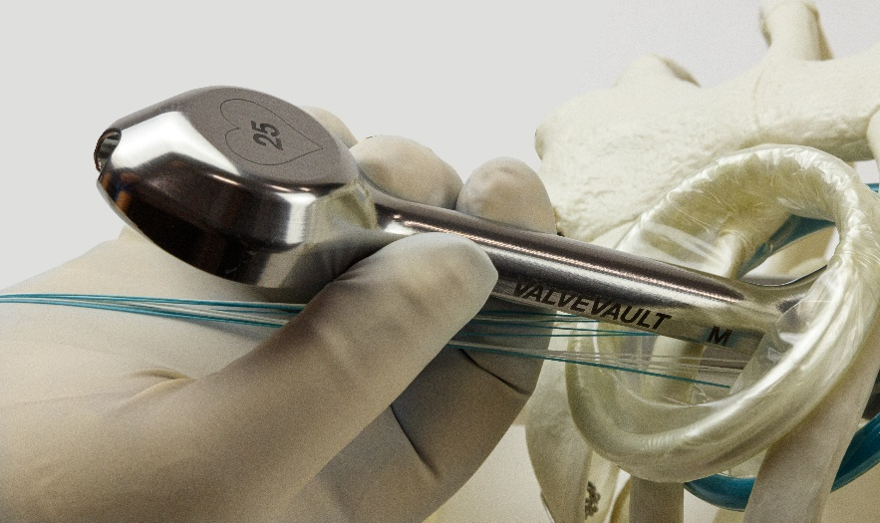
3 TRANSFER
3. TRANSFER the suture and prosthesis from the VALVEVAULT® DEVICE Holder to the surgical site by gently turning the shaft within the incision. If the prosthesis does not freely exit the chamber, the
sutures can be used to gently pull the prosthesis
out of the chamber. Care must be taken to avoid applying excess force to the prosthesis or sutures connected to the annulus.

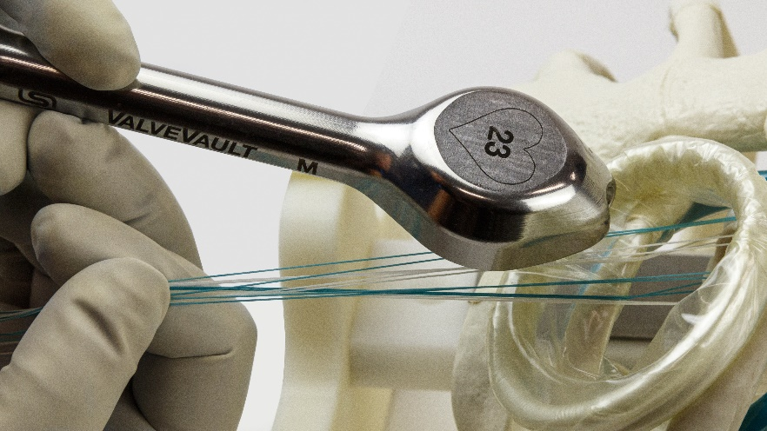
4 REMOVE
4. REMOVE the VALVEVAULT® DEVICE Holder from the surgical incision taking care not to contact/damage the prosthesis, especially avoid contact with the prosthetic leaflets, while ensuring all suture is away from both suture openings.

4
VALVEVAULT® DEVICE REPROCESSING
- Disassemble and clean the device immediately after use. Do not allow a soiled device to dry.
- The VALVEVAULT® DEVICE is not validated to be cleaned or sterilized in the fully assembled state. It should be disassembled into the components as shown in FIGS. 2 and 3.
- Cleaning agent used in validation: Steris Prolystica 2X (Enzymatic, Neutral pH)
- Perform the final rinse using only freshly prepared purified water/highly purified water.
- Never use metal brushes or steel wool for cleaning.
- This device is unaffected by pressure changes associated with reprocessing

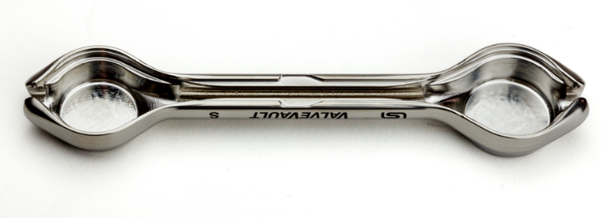
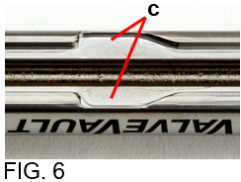
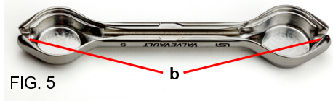
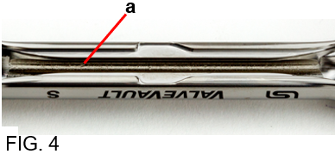
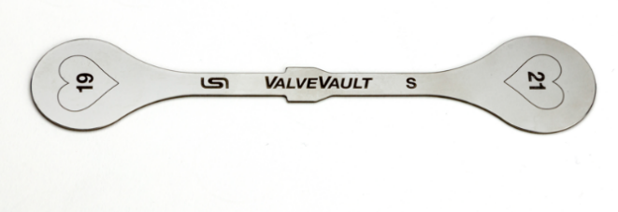

1. Remove the cover from the
VALVEVAULT® DEVICE.

1. Disassemble and clean device immediately after use.
2. Do not allow potential contaminants/bioburden to dry on the device (i.e. soiled device).
POINT OF USE

FIG. 2
FIG. 3

PREPARATION

MANUAL
PRE-CLEANING
1. Soak in enzymatic, neutral pH cleaning solution for 5 minutes minimum. Refer to
detergent manufacturer’s instructions for temperature and concentration.
2. Use a plastic bristled brush to thoroughly scrub the device’s exterior and interior
surfaces, paying special attention to the following:
a. Inside of channel (FIG. 4)
b. Suture openings (FIG. 5)
c. Alignment arrows (FIG. 6)

3. Rinse with warm water (38–45°C [100–113°F]) for 2 minutes minimum.

4. Proceed with one of the two required cleaning options (ultrasonic or automated).

5
OR
1. Clean in ultrasonic bath with enzymatic, neutral pH cleaning solution for 15 minutes
minimum. Refer to detergent manufacturer’s instructions for temperature and
concentration.
2. Rinse with warm water (38–45°C [100–113°F]) for 4 minutes minimum. To ensure a
complete rinse, use a clean brush to scrub the cover and holder.

ULTRASONIC
CLEANING
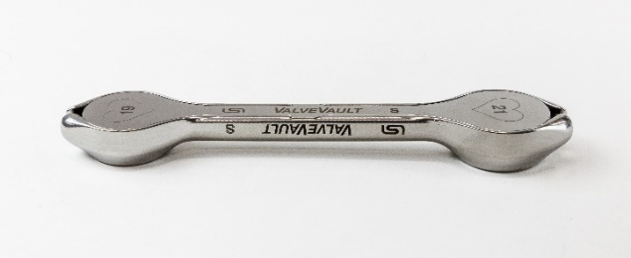
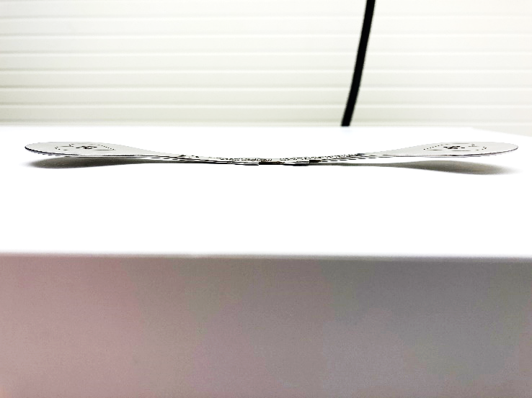
4. Perform a functional check for adequate cover fit by placing the cover on the VALVEVAULT® DEVICE Holder. Ensure the cover rests flush with the top edges of the device as shown in FIG. 8.

FIG. 8
(SHOWN BENT)
FIG. 7
2. Visually inspect the device for mild or excessive corrosion. If corrosion is present, complete the reprocessing, but discontinue use of the device in surgery.
3. Visually inspect the device for any damage. (For example, see the bent cover in FIG. 7.) If parts are damaged, complete reprocessing, but discontinue use of the device in surgery.
1. Carefully inspect the cover and holder to assure that all visible soil has been removed. Generally un-magnified visual inspection under good light conditions is sufficient. Particular attention should be paid to the locations indicated in FIGS. 4-6. Repeat cleaning process if soil is detected.

INSPECTION

LUBRICATION

1. Apply instrument lubricant mixed to manufacturer’s recommendations to prolong instrument life by submerging the holder and cover into the lubricant for at least 30
seconds. If the hospital washer-disinfector has a lubrication cycle this can be used instead of manual lubrication. NOTE: LSI SOLUTIONS® has validated the use of MicroLube™ C Instrument Lubricant on this device. Other instrument lubricant brands have not been tested and performance and results cannot be guaranteed.

AUTOMATED
CLEANING
1. A washer-disinfector is required with fundamentally approved efficiency (e.g. according to EN ISO 15883) and must be properly installed, qualified, and regularly subjected to maintenance and testing.

2. Load the device(s) into the washer-disinfector. Avoid contact between devices and
arrange to allow for proper drainage.
3. The following minimum parameters were validated as effective for cleaning this device
in an automated washer:
Treatment | Time  (mm:ss) | Temperature  °C (°F) | Additive
Pre-wash (Cold tap) | 2:00 | 17 (63) | N/A
Wash (Hot tap) | 2:00 | 40 (104) | Steris Prolystica® 2X
Rinse | 2:00 | 70 (158) | N/A
Rinse | 2:00 | 70 (158) | Optional lubricant
Dry | 15:00 | 80 (176) | N/A

6

PACKAGING

1. Ensure the cover is removed from the VALVEVAULT® DEVICE before sterilization.
2. Confirm that cover and holder are both present. If using sterilization pouches, place the holder and the cover in their own individual pouch.
3. Package the VALVEVAULT® DEVICE according to TABLE 2. The barrier system for
sterilized re-usable instruments should meet the following requirements:
ISO 11607-1
Suitable for Pre-Vacuum steam sterilization
Appropriate for medical use

WARNINGS
- Federal law restricts this device to sale, distribution and use by, or on, the order of a physician.
- Read and become familiar with all instructions, warnings and cautions before using this product.
- This device shall be used in accordance with these Instructions for Use.
- The chamber diameter designations of the VALVEVAULT® DEVICE are not intended to represent valve size.
- Improper use of this device may cause serious injury. Improper care and maintenance of the device may render the device non-sterile prior to patient use and may cause serious injury to the health care provider or the patient.
- All actions beyond passing the chamber through the surgical access site (e.g., an intercostal space) should be smooth and easily performed. Avoid applying any excess compression or tensioning forces to the prosthesis and/or the suture. Avoid unnecessary stressors on VALVEVAULT® components, the prosthesis, suture etc.
- Do not use a VALVEVAULT® chamber that does not readily accommodate the prosthesis. If there is any doubt regarding the appropriate fit of the prosthesis in the selected chamber, use the next size up chamber.
- If passage of the VALVEVAULT® through the surgical access site is not easily achieved, consider increasing the size of the access site or appropriate alternative routes.

ADVERSE REACTIONS

STORAGE

STERILIZATION
- During storage, ensure the device remains in a sterile condition ready for reuse.
- Shelf life is dependent on the sterile barrier employed, storage manner, and environmental and handling conditions.

1. The device must be properly cleaned before sterilization.
2. Perform sterilization cycle according to TABLE 2:
TABLE 2: VALVEVAULT® EXTRA LARGE DEVICE
Packaging and Processing
Method | Moist heat (steam) sterilization according to ANSI/AAMI ST 79 | Immediate Use Steam Sterilization according to ANSI/AAMI ST 79
Container | No Tray | No Tray
Cycle | Pre-Vacuum (Pre-Vac) | Pre-Vacuum (Pre-Vac)
Packaging | Pouch | No Packaging
Temperature | 132-137°C  (270–279°F) | 132-137°C  (270–279°F)
Exposure Time | 4– 18 minutes | 4– 18 minutes
Dry Time | 25 minutes minimum | N/A

Device(s) processed by Immediate Use Sterilization should be transferred immediately, using aseptic technique, from the sterilizer to the point of use.

Refer to ANSI/AAMI ST79 Comprehensive Guide to Steam Sterilization and Sterility Assurance in Health Care Facilities.

The VALVEVAULT® DEVICE has been validated to one hundred (100) reprocessing cycles. The useful lifespan of a surgical instrument is largely dependent on the care and handling of the instrument. Careful inspection and functional testing of the instrument should be used to determine the end of its serviceable life.

7
WARNINGS (continued)
- When using most surgical devices, harsh contact with tissue or forcing the device during its handling and use can damage or injure the prosthesis, suture or tissue structures like bone, blood vessels, nerves, soft tissue (e.g., cardiac valve tissue), etc. Inappropriate device handling and use can lead to bleeding, tissue structural damage, nerve impairment, infection, disability and even death. Special care should be taken to avoid damaging delicate tissue structures.
- Discontinue use of the VALVEVAULT® DEVICE when moving patient or when patient is moving.
- Endoscopic procedures should be performed only by physicians having adequate training and familiarity with endoscopic techniques and relevant anatomy. Medical literature relative to techniques, complications and hazards should be consulted prior to use.
- When using the VALVEVAULT® DEVICE, an insufficient surgical access site incision and dissection may cause increased penetration force which may reduce the surgeon’s control during entry.
- Direct contact between sensitive tissue structures and foreign materials can lead to tissue injury or damage.
- When using the VALVEVAULT® DEVICE, keep the prosthesis irrigated per Manufacturer’s instructions.
PRECAUTIONS
- Devices are packaged as non-sterile. Cleaning and sterilizing of this device must occur prior to use.
- If there are variations between these Instructions for Use and either your facility’s policies and/or your cleaning-sterilizing equipment manufacturer’s instructions, those variations should be brought to the attention of appropriate responsible hospital personnel for resolution before proceeding with device cleaning and sterilizing.
- Use of a device for a task other than what it is intended for will usually result in a damaged or broken device.
- Prior to use, inspect the cover and holder to ensure proper fit and condition. Do not use the cover or holder if they do not fit together or if they have physical damage.
- Surgical instruments vary between manufacturers. Before instruments and accessories from different manufacturers are employed together in a procedure, verify compatibility and ensure electrical isolation or grounding are not compromised.
- Avoid mechanical shock or overstressing the devices.
- Only the cleaning and sterilization processes defined within these Instructions for Use have been validated.
- Care should be taken to ensure that all sutures are manually seated properly within the channel and the suture openings to avoid damage to the prosthesis or damage to the sutures.
- Store at room temperature.
ADVERSE REACTIONS
No documented adverse reactions.

ADVERSE REACTIONS

P/N 082066A 05-MAY-2026
Patents: www.lsisolutions.com/patents

The LSI logo, LSI SOLUTIONS, Perfect Performance Policy, and VALVEVAULT are registered trademarks and trademarks of LSI Solutions, Inc. Copyright © 2020,
LSI SOLUTIONS®. All Rights Reserved.

Symbol Glossary: www.lsisolutions.com/symbols
LSI SOLUTIONS, Inc
7796 Victor-Mendon Road
Victor, New York 14564 U.S.A.
Phone: +1 585.869.6600
Customer Service: +1 866.575.3493
Technical Support: +1 866.428.9092
Fax: +1 585.742.8086
www.lsisolutions.com

Prolystica is a registered trademark of Steris. MicroLube is a registered trademark of PurposeBuilt Brands. Use of these names, trademarks and brands does not imply endorsement. All company, product and service names used in this technology guide are for identification purposes only.
ORDERING INFORMATION
TABLE 3. VALVEVAULT® EXTRA LARGE DEVICE SUPPLIED: NONSTERILE, REUSABLE
 | REORDER | PRODUCT | DESCRIPTION
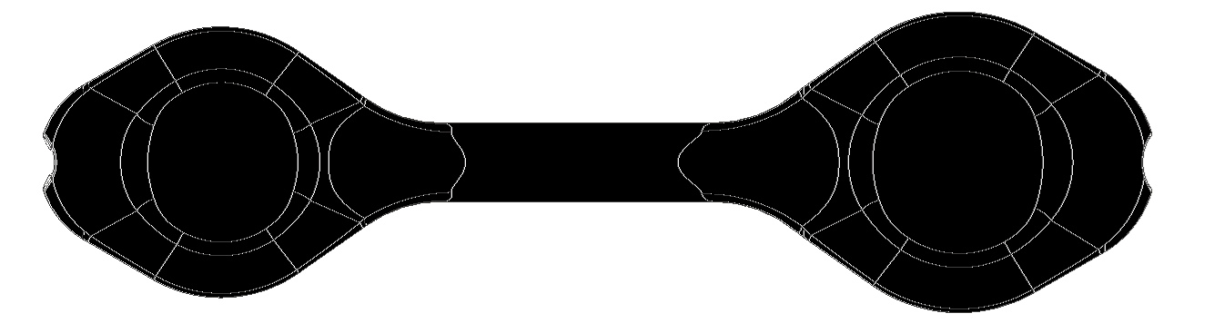x1 XL | REF 082065 | VALVEVAULT® DEVICE  (XL) 31mm / 33mm | Box of 1 Device


8

