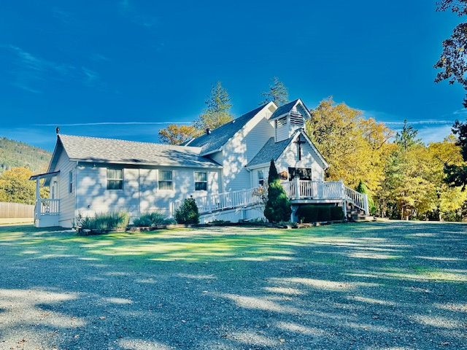
History of Hugo Community Church
Hugo Community Church is located in a rural area of Hugo which is north of Grants Pass, Oregon. It was dedicated on May 14, 1913 and has a rich history of time gone by. Located close to former Three Pines School which closed in 1942. The bell from the school now resides at the church after being donated in 1947. Several additions have been added to the original building over the years, making it larger with many improvements made to the exterior.
Hugo Community Church is one of only two early church structures left, with the other being in Golden, east of Wolf Creek and north of Grants Pass in Josephine County.
Walter and Pearl Penney moved to the area in 1908 and soon decided it was time to build a church. After receiving donated land from Caroline Sexton they began the construction with donated lumber and labor. It was dedicated in 1913 as Hugo Community Baptist Church and was nicknamed “The Little Church in the Wildwood”. The congregation had fewer than 20 people at the time.
On October 25, 1990 the First Baptist Church of Hugo was certified as meeting the Natural Register of Historic Places because of its history as a Community Center. A plaque is displayed on the exterior of the church.
Also, in 1997 the members of the church voted to drop their affiliation with the American Baptist Church so that it would be independent of outside influences. That is how it stands today.
Pastor History
There have been numerous pastors in the church history. The most recent were Terry Isabell from 1990 – 2008 and Dan Garland from 2008 – 2025.
Community Information
The “Town of Hugo” had its beginning in 1880 and was first called Gravel Pit Station. The Southern Pacific Railroad christened the stop “Hugo” after an early settler Hugo Garber.
It even had its own Post Office until 1956 located in the former Hugo Hitching Post Store, which still stands today a short distance from the church.
In the early days, Hugo was very productive fruit growing area and the Three Pines Planing Mill sat nearby. The early mill workers along with 20 – 30 families worshiped in a Chapel Car provided by the railroad.
The town of Hugo is located north of the unincorporated city of Merlin which has a population of approximately 1800 people. Merlin is a small rural area known as the “Gateway to the Wild and Scenic Rogue River”. It is a very popular base in the summer months for guided river rafting trips, fishing and hiking activities. It has famous attractions nearby like Hellgate Canyon and the Rogue River Trail. Another popular tourist site is the Wildlife Images Rehab and Education Center.
Most of the shopping, medical and professional services are found in the city of Grants Pass which is about 12 miles south of the Hugo area. Grants Pass has a population of approximately 39,500 and is located along the Rogue River. Well known also for its outdoor activities, historic downtown and small town feel.
Both Merlin and Grants Pass are located along interstate 5 and U.S. route 199 is nearby.

Current Information of Our Church
Ministries Currently Supported
Young Life Ministries Pregnancy Care Center Gospel Rescue Mission Fir Point Bible Camp Ethnos 360 Child Evangelism fellowship
Ministries and other Outreaches Within Our Church
Free Sale Harvest Dinner Christmas Gift Tree Tags (gifts for less fortunate) Lap Blankets for the elderly Men’s Breakfast
Possible Future Ministries
Food Baskets (Thanksgiving & Christmas) Raking Leaves in Neighborhood (for elderly or injured) Spring Fling dinner
Potential Areas of Growth
Wednesday Service In Home Bible Study Women’s Bible Study Women’s Once a Month Activity Monthly Hymn Sing Children’s Sunday School
Current Church Schedule
Adult Sunday School (9:30 – 10:30) Worship Service (10:45 – 12:00) 1st Sunday – end of service Communion 2nd Sunday – after service Pot Luck 4th Sunday – after service Senior Fellowship Weekly- Wednesday -Men’s breakfast annual – overnight campout & outdoor service in the fall
We are a warm, welcoming, close knit, caring congregation with approximately 30 attendees each Sunday. We get to know each other and pray for each other. We use a call multiplier to easily contact member with prayer requests, information and reminders of events. We are mostly a conservative congregation.
Our Church Beliefs

The Scriptures
WE BELIEVE the Bible to be the infallible word of God, the final authority for Christian faith and life.

The Godhead
WE BELIEVE in the one true God – the God of the Bible – who is eternal, infinite and unchanging: in love and faithfulness, in holiness and righteousness, in wisdom and knowledge, and in glory and power.
WE BELIEVE that God is a spiritual and personal being, separate from and above the world as its Creator yet everywhere present as the Upholder of all things and the God who offers Himself for loving fellowship with mankind through Jesus Christ, the Son.
WE BELIEVE that God has revealed Himself to us in Scripture as Father, Son and Holy Spirit – three equal and eternal persons within the one God – each having a distinct ministry in God’s relation to His creation and people.

The Person and Work of Jesus Christ
WE BELIEVE that the Lord Jesus Christ, the eternal Son of God, became man, without ceasing to be God, having been conceived of the Holy Spirit and born of a virgin, in order that He might reveal God and redeem sinful man. We believe that the Lord Jesus Christ accomplished our redemption through His death on the cross as a substitutionary sacrifice, and that our redemption is made sure to us by His resurrection from the dead.
WE BELIEVE that the Lord Jesus Christ is now in Heaven exalted at the right hand of God where as High Priest for His people, He fulfills the ministry of Representative and Intercessor.
WE BELIEVE in the imminent and personal return of our Lord Jesus Christ in the clouds to take His saints from the earth to be with Him in heaven and in His subsequent coming to the earth with His saints to establish His millennial kingdom.

The Holy Spirit
WE BELIEVE that the Holy spirit, the third person of the Godhead, regenerates and indwells all believers in the Lord Jesus Christ, baptizes them into the Body of Christ and seals them unto the day of redemption, and we believe that every believer is commanded of God to be filled and led by the Holy Spirit.

Man's Creation and Fall
WE BELIEVE that man was created in the image and likeness of God but through Adam's sin became alienated from God, acquired a sin nature, and came under the judicial sentence of death. We believe that all people are by nature and choice sinful and lost and that apart from faith in Christ are doomed to eternal judgment.

Salvation
WE BELIEVE that the death and resurrection of Jesus Christ provide the only ground for forgiveness of sin and acceptance with God, that salvation is the gift of God offered to man by grace and received by personal faith in the Lord Jesus Christ, believers once saved shall be kept saved forever.

The Church and The Churches
WE BELIEVE in the Church, the body of Christ, made up of all born-again persons, irrespective of affiliation with Christian organizations.
WE BELIEVE also in "local churches" as expressions of the Body of Christ, whose members are called to meet together regularly for fellowship, ministry to one another in love, teaching, the Lord's Supper, baptism, prayer, worship, and preparation for bearing witness of Christ to the lost.
WE BELIEVE in the unity and fellowship of all believers in Christ and in the freedom of each church to govern itself according to the Word of God and the guidance of the Holy Spirit without state or ecclesiastical interference.

Baptism and the Lord's Supper
WE BELIEVE that water baptism, by immersion, is symbolic of the believers union with Christ in His death and resurrection to newness of life and should be administered subsequent to a personal decision to follow Christ.
WE BELIEVE that the Lord's Supper is a memorial service, the elements representing in symbolic form the body and blood of the Lord Jesus Christ, but possessing no saving grace in and of themselves.
The Final State
WE BELIEVE that the spirits of the saved at death go immediately to be with Christ eternally in heaven, and that the spirits of the unsaved at death go immediately into Hades to await the final judgment, the lake of fire.
Conclusion
WE BELIEVE in doing something about it. We not only believe that the doctrine of Scripture is a sacred trust to be preserved and taught in its purity, but we also believe that it teaches a life to be lived and a Gospel to be preached.
HCC Beliefs on Family, Marriage, Gender, and Sexuality
WE BELIEVE God has ordained the family as the foundational institution of human society. Marriage is the unity of one man and one woman in covenant commitment for a lifetime. God commands sexual intimacy to occur only between a man and a woman who are married to each other. The husband and wife are of equal worth before God, since both are created in God's image - male and female. The marriage relationship models the way God relates to His people. Children, from the moment of conception, are a blessing and heritage from the Lord.
WE BELIEVE Christian marriage is God's unique gift to reveal the union between Christ and His Church. As such, this local church believes that wedding ceremonies on church property are spiritual observances of worship of God who created this divine institution. As worship services, weddings on church property shall be officiated by one or more ordained ministers of the gospel. The church may decline to make its facilities or ministers available for any wedding if it is determined that one or both of the parties are not biblically and/or legally qualified to marry. Such determinations may be made by the pastor, church board, or wedding committee subject to the direction of the church. No minister or employee of the church shall officiate at any marriage ceremony unless such marriage is consistent with this policy.

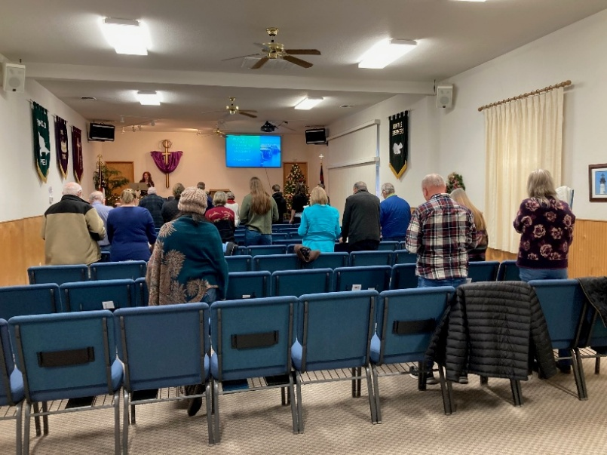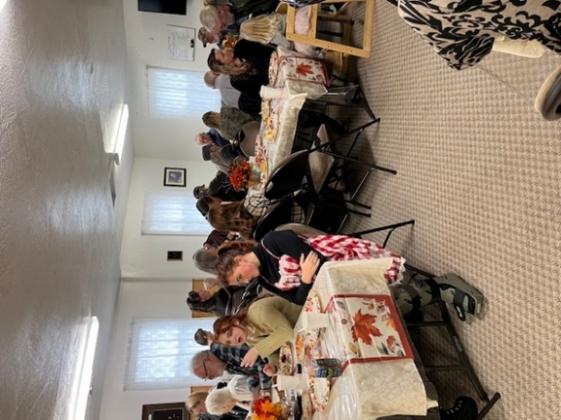
The sanctuary Our Harvest dinner
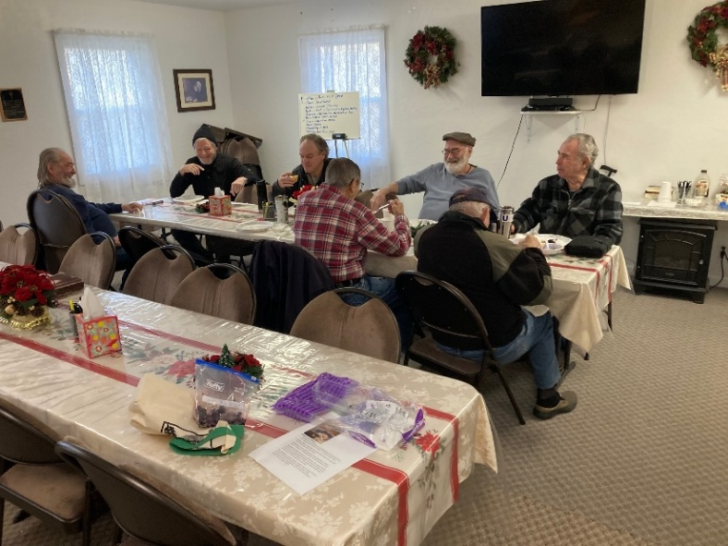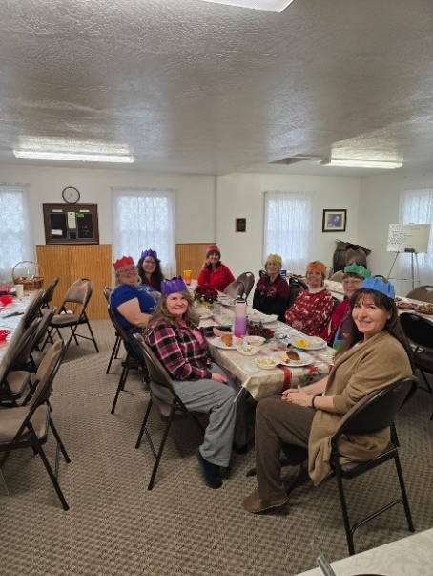
Men’s breakfast One of our ladies’ events
