DVCS Limits to Confidentiality Easy Read Resource
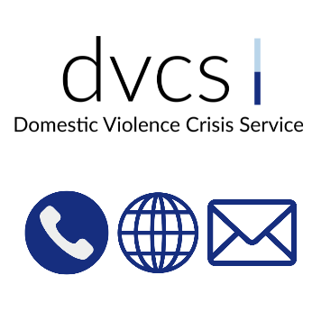 | This book was written for DVCS.  We are also called the Domestic Violence Crisis Service.  We have an Easy Read resource telling you what we do.
 | You can contact us by:  - 24/7 phone line on 02 62 800 900  - Email crisis@dvcs.org.au if it is not urgent  - Website www.dvcs.org.au
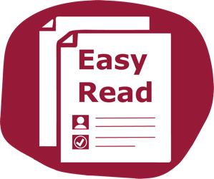 | This document is about how you can keep yourself safe.  This document is written so it is easy to read.
 | You might not know some words.  The first time we use those words they are blue.  You can find all these words in a list at the end.
 | We tell you what the word means in a blue box like this.
 | You can ask for help to read this document.  You can ask:  - A family member  - A friend  - A support worker.  Please do not ask the person hurting you.

Limits to Confidentiality
 | We will do our best to keep your information confidential.  Sometimes we need to share your information.
 | Confidential means a private thing.  It is information that is only for people who need to know.
 | We take notes to remember what you told us.  This is so you do not have to say it again later.  We do not record your call.
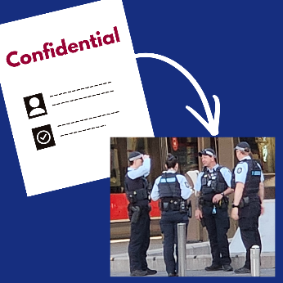 | Sometimes the law says we must share your information.  This is to keep you and other people safe.  This is called limits to confidentiality.
 | We have to share information with others if:  - You tell us you want to hurt yourself or someone else  - A child is in danger  - A court or police ask for information by law.
 | You can choose how much information you share with us.
 | We will do our best to tell you if we need to share your information.

When we share information
 | We might need to:  - Talk to another service for you  - Make a referral to another service for you
 | Referral means to send you to a different person or place for help.  You can say yes or no to the referral.
We will ask you before we refer you to another service.
You can ask us to talk to another service for you.
 | Sometimes we need your consent to share information.
 | Consent means saying yes for something to happen.  You can choose to say yes or no.  You can ask us more questions if you do not understand.

 | For your safety:
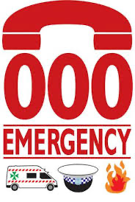 | We need to call 000 for emergency if we are worried about your health and safety.
 | This can be:  - If you are not feeling safe  - If you are worried about your safety  - If you tell us you want to hurt yourself or someone else.
 | We have to report if we are worried about the safety of a child.  We report to Children, Youth and Families.  They are part of the Health and Community Services Directorate in the ACT Government.
 | We need to share your information if we are asked to by law.  This can happen if we are subpoenaed.
 | Subpoenaed means we need to share information that is on our system with the courts.

Word List
Confidential
Confidential means a private thing.
It is information that is only for people who need to know.
Consent
Consent means saying yes for something to happen.
You can choose to say yes or no.
You can ask us more questions if you do not understand.
Limits to confidentiality
Sometimes the law says we must share your information.
This is to keep you and other people safe.
Referral
This means to send you to a different person or place for help.

Subpoenaed
Subpoenaed means that we must go to court to share your information that is on our system.


This book was written by Teigan Southwell for The Easy Read Toolbox.
0403 073 071 | info@easyreadtoolbox.info
www.easyreadtoolbox.info | ABN 92 654 050 058
Easy Read images by The Easy Read Toolbox or through Creative Commons (Microsoft 365, Canva).

