DVCS Safety Planning Easy Read Resource
 | About this book
 | This book was written for DVCS.  We are also called the Domestic Violence Crisis Service.  We have an Easy Read resource telling you what we do.
 | You can contact us by:  - 24/7 phone line on 02 62 800 900  - Email crisis@dvcs.org.au if it is not urgent  - Website www.dvcs.org.au
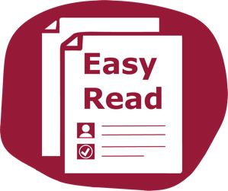 | This document is about how to make yourself safer.  This document is written so it is easy to read.
 | You might not know some words.  The first time we use those words they are blue.  You can find all these words in a list at the end.
 | We tell you what the word means in a blue box.
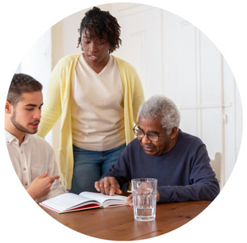 | You can ask for help to read this document.  You can ask:  - A family member  - A friend  - A support worker.  Please do not ask the person hurting you.

 | Domestic Violence Crisis Service
 | We also call ourselves DVCS.  DVCS can support you:  - If you want to stay in the relationship.
 | - If you want to leave the relationship.  - To stay safe in your home  - If you are not sure what to do.
 | You can call us on our 24/7 phone line on 02 62 800 900.
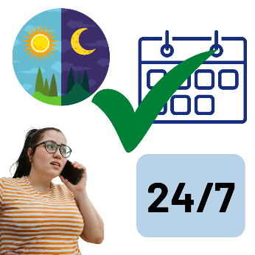 | 24 / 7 means you can call us:  - Day or night  - Every day including weekends and public holidays.
 | We can help you make a safety plan.
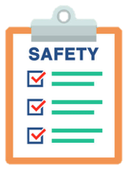 | A safety plan is a list of things you can do to make yourself safer.

 | Making a Safety Plan
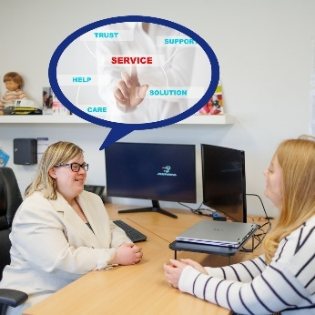 | We can make a safety plan with you.  You can tell us what you already do to stay safe.  We will try to find new ways to support and plan for your safety.
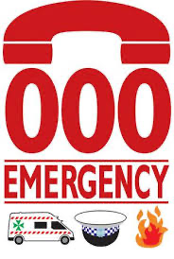 | Your safety plan can be:  - Call 000 if you are in danger for police or an emergency
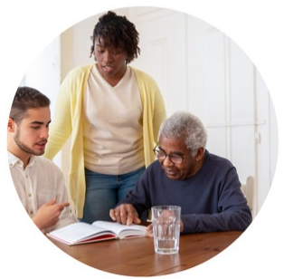 | - Know who you can call if you are not feeling safe.  This can be:  - A friend you trust  - A family member  - DVCS: 02 62 800 900.
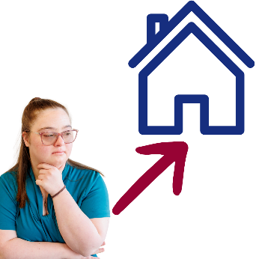 | - Decide somewhere safe you can go if you need to leave quickly.  This should be a place the person hurting you does not know about.
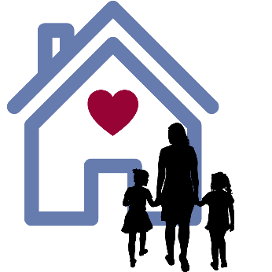 | It can be:  - A friend’s home  - Your family home  - A refuge.
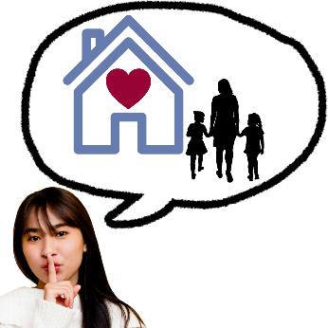 | A refuge is a safe and secret house.  Women and their children can go there when they are not safe at home.  It gives them a place to stay and get help.
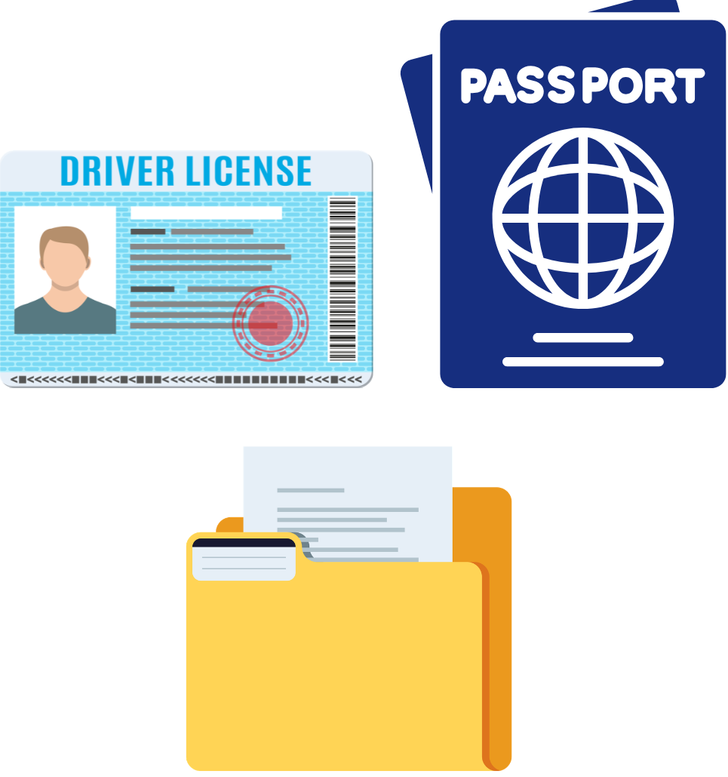 | - Collect all your important documents in a safe place or with a trusted person.  This can be:  - ID cards  - Passports and visa information  - Driver’s licence
 | - Birth certificate  - Your children’s blue book  - Child support information  - Marriage certificate
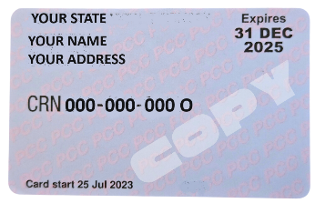 | - Health care cards and pension cards  - Health records and prescriptions  - Bank cards  - Insurance papers  - Rental agreement or mortgage papers
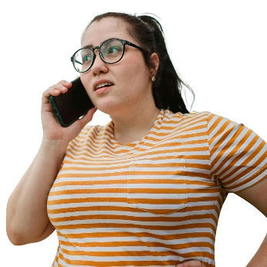 | - Keep your mobile phone charged and with you all the time.  We can give you a safe mobile phone if you need
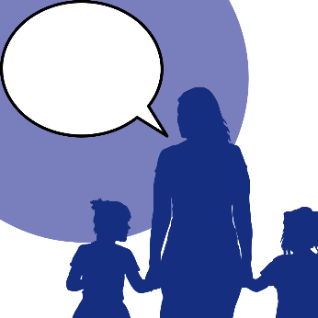 | - Talk with your children about how they can be part of your safety plan
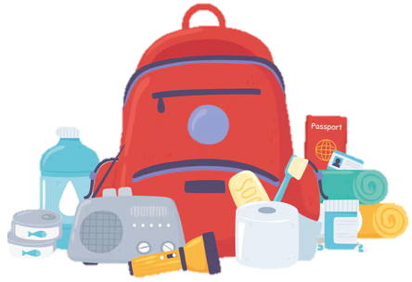 | - Pack your important things in case you need to leave quickly. You can keep these in your car or at your work. This can be:  - Mobile phone, laptop, iPad, and chargers
 | - Important documents or photocopies of documents  - Medicare card, prescription medication and prescriptions  - Money, spare keys and bank cards
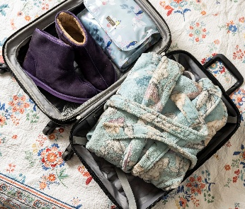 | - Clothes, toiletries and children’s clothes, belongings and toys.
You can start your safety plan and keep it somewhere private and safe.
You can share your safety plan with someone you trust.
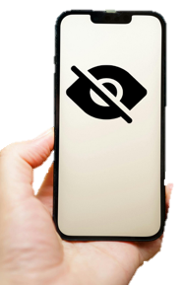 | If your safety plan is on your mobile phone, make sure your phone is password protected.
 | Please do not share your safety plan with the person hurting you.
 |  | Preparing to Leave
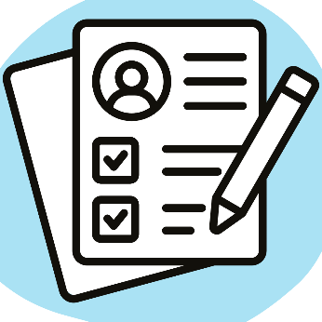 |  | You can do some things to stay safe if you choose to leave the relationship.
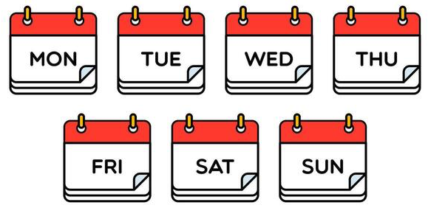 |  | Plan when and how you want to leave where you are. This can be:  - The day and time that is safest to leave
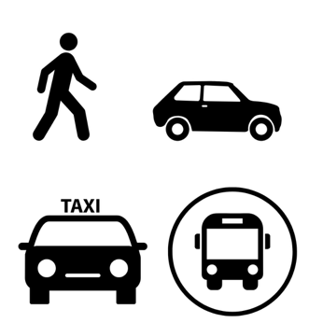 |  | - How you will leave. This can be:  - By car  - In a taxi  - With a friend you can trust.
 |  | We can help you to plan to leave the relationship.  Call us on the 24/7 phone line on  02 62 800 900.
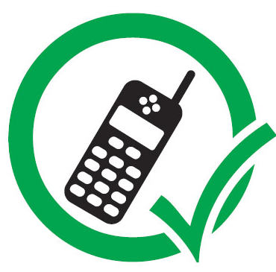 |  | Have a safe mobile phone that the person hurting you does not know about.  We can give you a safe mobile phone if you need.
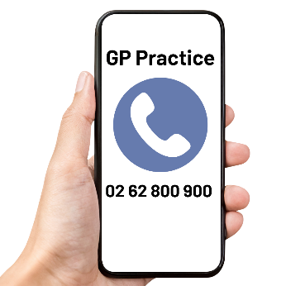 |  | Save important numbers on your mobile phone under a different name that only you know.  You might save our phone number  02 62 800 900 as:  - GP Practice  - or Insurance.
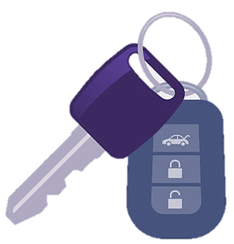 |  | Have spare house or car keys.  You can keep them:  - At your work  - Give them to someone you trust.
 |  | Make a new email address.  Do not tell the person hurting you about this email.  Use this email with important people like:  - Your lawyer  - DVCS  - Police.
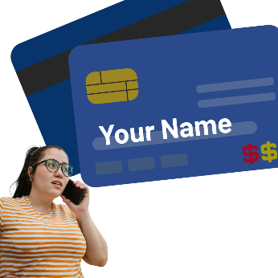 |  | Open a bank account that is only in your name.  Do not tell the person hurting you about this bank account.  Put some money in it whenever you can.
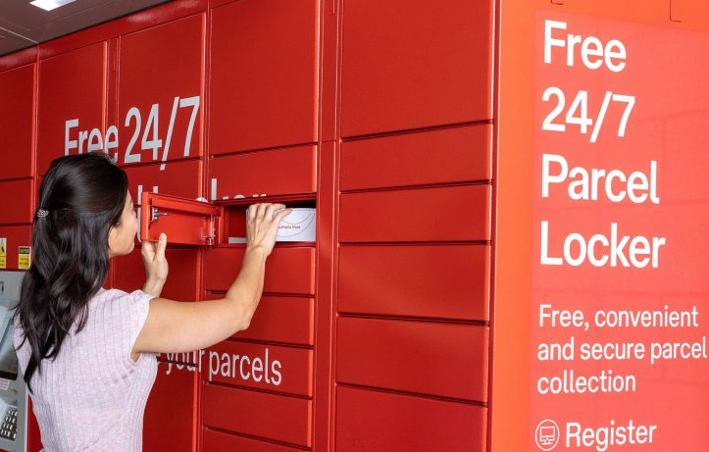 |  | Get a PO Box for important mail.  Do not tell the person hurting you about this PO Box.
 |  | Plan who can care for your pets.  You can apply for RSPCA ACT Pet and Family Assistance.  They may be able to look after your pets for a short time.
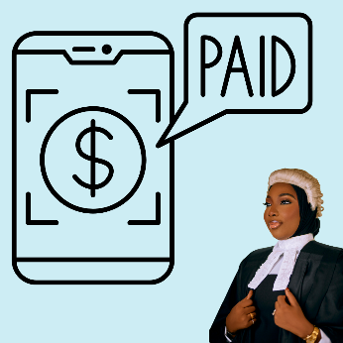 |  | Ask your work if you can get paid family and domestic violence leave.  You can use it if you need to attend courts or meet your lawyer.

 | Staying Safe in your Home
 | You can do some things to stay safe in your home after you leave the relationship.
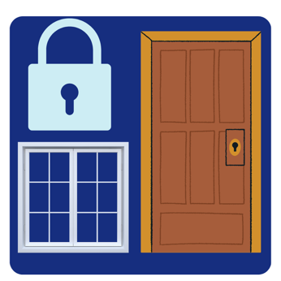 | Change the locks and security alarms in your house. This can be:  - Gates  - Front and back doors  - Windows  You can use a door chain on your front door.
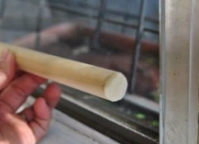 | Put wooden dowel rods behind any sliding doors or windows in your house.  It stops sliding doors or windows from opening.
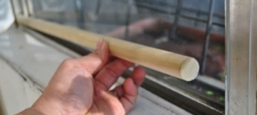 | A wooden dowel rod is a long piece of wood.
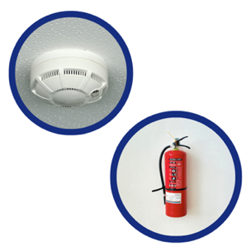 |  | Test the smoke detector and fire alarm in your house.  Buy a fire extinguisher for your home.
 |  | Put motion lights outside your house.
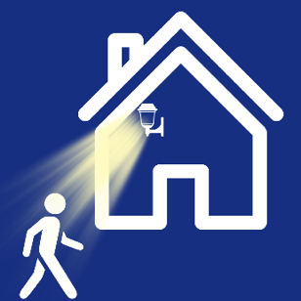 |  | Motion lights are lights that turn on when something moves.  They turn on if a person comes near your house.
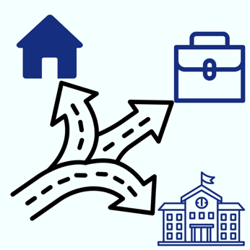 |  | Try to change where you go and how you get there.  This can be:  - Where you go shopping  - The bus you take  - How you get to work  - What time you leave for work.
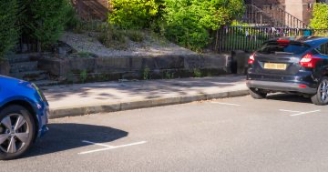 |  | Park your car so no one can park behind you to stop you from leaving.
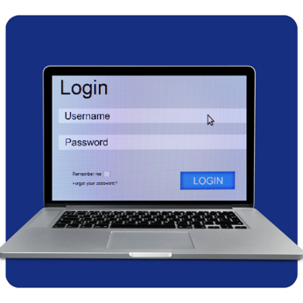 |  | Change your passwords on your devices and online accounts.  Try to use different passwords for each account.
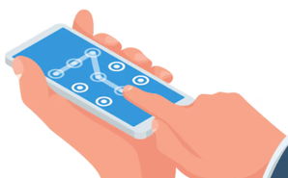 |  | Change your phone passcode.  Do not share your passcode with the person hurting you.
 |  | Turn on call screening on your mobile phone.
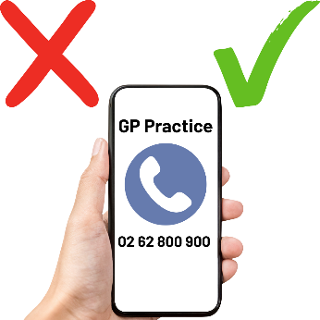 |  | Call screening lets you see who is calling and why.
 |  | You may have to speak to or see the person who was hurting you sometimes.  You might need to talk about shared children or pets.  You can ask a lawyer about this.
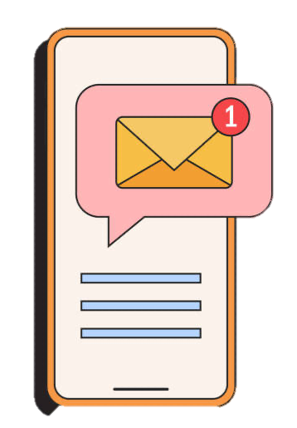 |  | Using email can be safer than calling or meeting in-person.  It is an easy way to save your chat history.  Remember not to use your new email address with them.
 |  | Talk to your neighbours or someone you trust.  Ask them to call the police if they feel you are unsafe.
 |  | Teach your children about how and when to call 000 in case of an emergency.
 |  |  | Tell people who take care of your children who can and cannot pick them up.  This might be:  - Childcare centre  - School  - Babysitters  - Family or friends.
 |  |  | Talk to a lawyer about applying for a  Family Violence Order.
 |  |  | A Family Violence Order is a court document.  It is also called a FVO.  A FVO tries to keep a person safe from family and domestic violence.
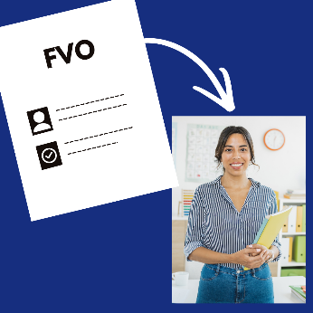 |  |  | You might share it with:  - Childcare centre  - Services  - Schools  - Your employer.

Word List
Call screening
Call screening lets you see who is calling and why.
 |  | Family Violence Order or FVO  This is a court document.  It tries to keep a person safe from family and domestic violence
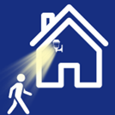 |  | Motion lights  These are lights that turn on when something moves nearby.
Refuge
A refuge is a safe and secret house.
Women and their children can go there when they are not safe at home. It gives them a place to stay and get help.
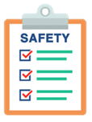 |  | Safety plan  A safety plan is a list of things you can do to make yourself safer.
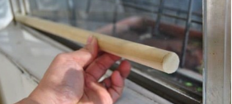 |  | Wooden dowel rod  This is a long piece of wood.  It stops sliding doors or windows from opening.

