**Catholic Diocese of Nottingham**



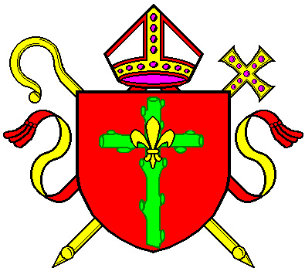

The Catholic Diocese of Nottingham is a registered charity with charity number 1134449

The Parish of The Holy Family, Leicester is a part of the Catholic Diocese of Nottingham. Thank you for being part of our parish community and for sharing your information with us to further the mission of the church.

|  |  |  |  |
| --- | --- | --- | --- |
| Family Name/Surname (For Filing Purposes) |  | Your usual church & Mass |  |
| Address |  | | |

**Please complete below for each member of the household with children at the bottom.**

|  |  |  |  |  |  |  |  |
| --- | --- | --- | --- | --- | --- | --- | --- |
| Surname | First Name | Date of birth | Nationality | Marital Status *Single/Married/ Widowed/ Divorced* | Telephone & Email | Occupation or School/College/Uni name | Are you a church volunteer? What do you do? |
|  |  |  |  |  |  |  |  |
|  |  |  |  |  |  |  |  |
|  |  |  |  |  |  |  |  |
|  |  |  |  |  |  |  |  |
|  |  |  |  |  |  |  |  |
|  |  |  |  |  |  |  |  |
|  |  |  |  |  |  |  |  |

Emergency Contact Name and Number _____________________________________________________________________________

**Any other information you would like to share, or support required e.g., mobility issues etc.**

__________________________________________________________________________________________________________________________________________________________________________________________________________________________

**Keeping In Touch**

We would like to use your contact information to send you messages about future events and Parish/Diocese news. Your name and contact details will be added to our parish database, and you can unsubscribe at any time, by contacting the Parish Administrator by email at [holyfamilyleicester@dioceseofnottingham.uk](mailto:holyfamilyleicester@dioceseofnottingham.uk) or by telephone on 0116 2511 437.

**I consent to receiving Parish relate information via:**

**☐ Email ☐ Telephone (Please tick accordingly)**

You can read our Short Privacy Notice below regarding this form and our full Privacy Notice regarding all processing of personal data in the Diocese, available on the Diocese website or from the Parish office.

**Short Privacy Notice**

The lawful basis for collecting your personal data to inform you about The Holy Family Parish, Leicester (the ‘Parish’) and the Catholic Diocese of Nottingham (the ‘Diocese’) events and information is your consent. The lawful basis for sharing your personal data within the Diocese only is the legitimate interest of Parish and Diocese administration.

**Your personal data:**

* will be used to inform you about news, events, fundraising and activities within the Diocese.
* will be seen by the Parish Priest and Parish Office employees and volunteers.
* will not be shared with anyone external (i.e. a contractor) unless it is a legal obligation or within the legitimate interests of the Diocese.
* will not be used for any other purpose than for providing Parish and Diocese information and for Parish and Diocese administration unless it is a legal obligation or within the legitimate interests of the Diocese.
* will be stored on the Diocese secure sever accessed by password login; any paper records will be stored in a lockable cabinet in lockable office; sensitive personal data (e.g. for under 18s) will be saved in a password encrypted file.
* will be kept while you are a regular member of the Diocese. Every 7 years parishioners will be informed by email that we still hold your data and reminded that you may access, amend, or delete your data; contact details we hold for people that are no longer regular members will be deleted securely, and will be reviewed after 7 years or earlier if you inform the Diocese that you do not wish to remain on the parishioner database.

**Your decision:**

It is optional to agree to be on the Parish and Diocese mailing list and there are no negative consequences as a parishioner for not agreeing, however we will not be able to inform you of activities and events in the Diocese.

As a data subject you have the right to withdraw your consent to process your personal data, make an objection to any particular use of your personal data by the Diocese, or access, amend or delete any of your personal data held by the Diocese. Please email [holyfamilyleicester@dioceseofnottingham.uk](mailto:holyfamilyleicester@dioceseofnottingham.uk).

Information provided on this form, together with all other personal data held about these individuals by the Parish and the Catholic Diocese of Nottingham, is processed in accordance with the Diocese's Privacy Notice, which can be obtained from [Privacy (dioceseofnottingham.uk)](https://www.dioceseofnottingham.uk/privacy) or from the Parish office.

**Please tick to confirm you understand the described use of**

**your personal data and understand your data subject rights.**