Plattco model H-0822 Double Flap Airlock Valves replace Rotary valves on electro- static precipitator

Overview;
January 2019 Scotch Plywood’s maintenance planner reached out to Plattco requesting a Rotary valve for their ESP. We informed the customer we supply Plattco Airlock Valves which are considerably different than Rotary Valves. We discussed the differences and why they should choose Plattco. Our regional sales manager went onsite and took field measurements for the customer and discussed the best option for their application.

The problems at Scotch Plywood were;
- The Rotary valves did not have a good seal between the rotors and the housing
- False air was coming back up into the hopper above allowing moisture into the Rotary valve allowing the material to build up and pack in the valve as well as the screw conveyor and the hopper above
- The screw conveyor and hoppers plugged daily- had to use the access door on the hopper to clean it out
- The Rotary valve had to be pulled out of service to be cleaned and unplug the veins and chutes
- This issue created a lot of maintenance headaches and increased costs

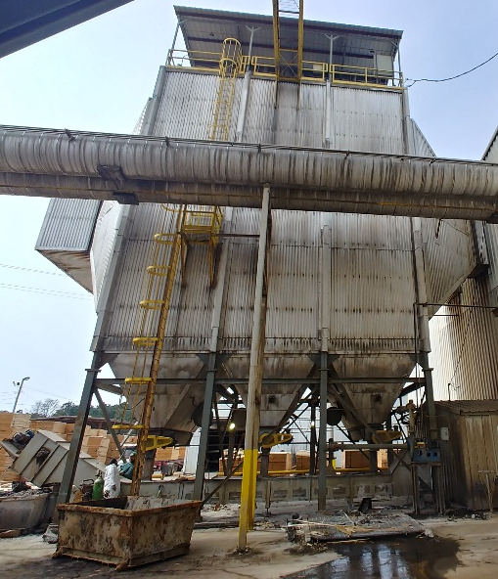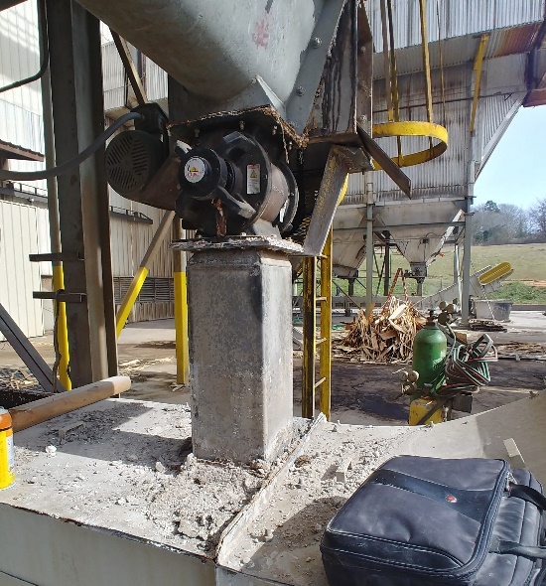
- (3) Rotary Valves under the electro- static precipitator

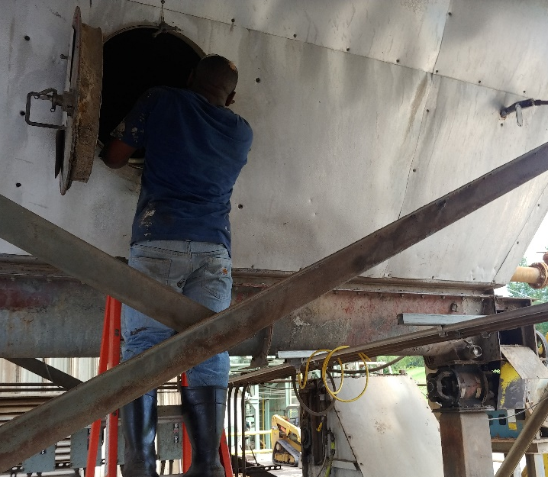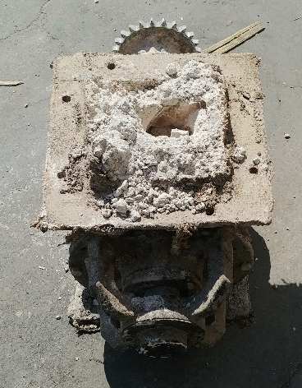
- Cleaning out the hopper above and a plugged Rotary Valve

May 2019 Plattco Airlock Valves we installed with maintenance gates above. These valves were installed in less than 8 hours. Plattco supplied onsite free assistance during installation.
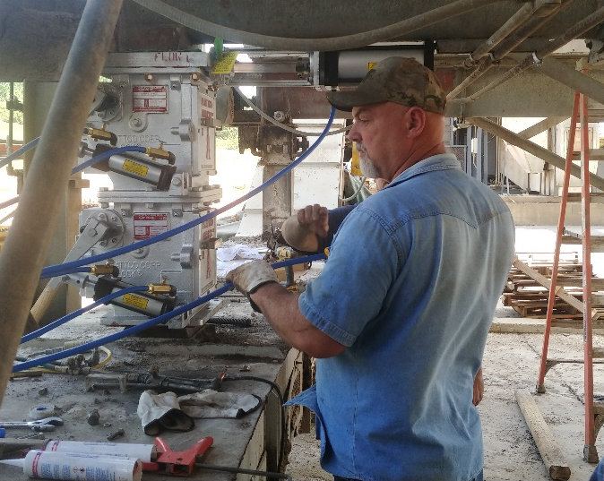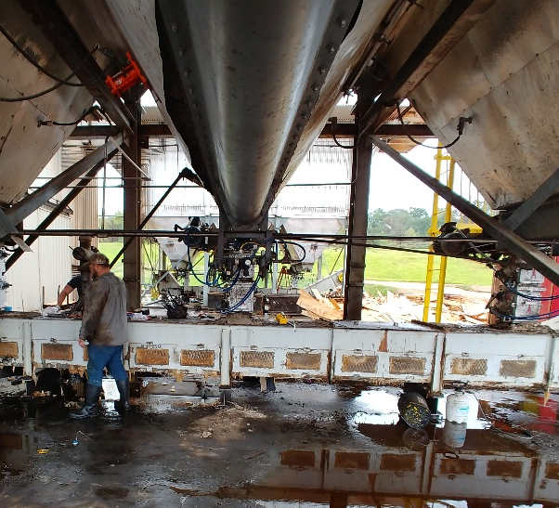
- New Plattco Valves installed

Benefits to using Plattco Airlock Valves;
- Plattco Airlock valves reduce downtime with our Internal mating surfaces that create the Airlock Seal eliminating the false air entering the systems above and allowing the material to flow as needed.
- Scotch Plywood experiences increased production time and profits because less maintenance is required allowing for less interruptions
- Huge savings in maintenance costs and time since the Plattco valves can easily be maintained in line
- Plattco valves are designed to be easily maintained in line using our access covers on the valve itself without removing the unit completely
- Maintenance gates can be closed for access to the valve safely allowing for preventative maintenance or isolating the transport system downstream if needed for repairs.

The Plattco valves have been installed for 6+ years and have required minimal maintenance

We appreciate the partnership with Scotch Plywood and for giving us the opportunity to solve your dry material handling needs. Solving customer issues is what we do. We look forward to our future working together.

