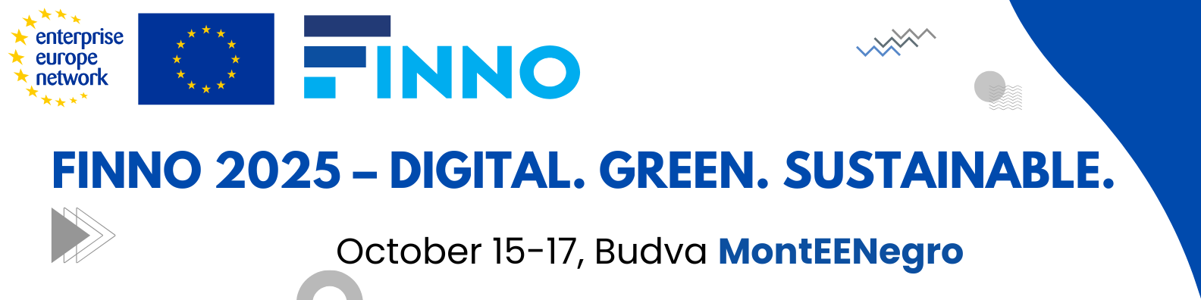

**AGENDA**

|  |  |
| --- | --- |
| 10:00 – 10:30 Conference Opening | Representatives of Montenegro:   * Minister Ernad Suljević, Ministry of Regional-Investment Development and Cooperation with Non-Governmental Organizations * Dr. Nina Drakić, President of the Chamber of Economy of Montenegro * Dr Radoje Vujadinović, Dean of Faculty of mechanical engineering - University of Montenegro   Representatives of EU:   * Ms Muriel DE GRANDE - European Innovation Council and SMEs Executive Agency (EISMEA) * Representative of CEFTA |
| 10:30 – 11:30 | **Panel 1: Digital Transformation of SMEs – Challenges and Solutions**  **Moderator:** Aleksandar Janičić  **Panelists:** Tomo Popović (CC-UDG), Sinisa Maricic (Regional Cooperation Council- TBD), Jasna Pejović (Digital Bee SME), Sanja Popovic (Mihailo Pupin Institutie), Ss. Cyril and Methodius University in Skopje (TBD) |
| 11:30 – 12:00 | Coffee Break |
| 12:00 – 13:00 | **Panel 2: The Role of EEN in Strengthening Innovation Ecosystems**  **Moderator:** Dr. Aleksandar Vujovic,  **Panelists:** Vesna Raskovic Depalov (Faculty of Technical Science University of Novi Sad), Beti Kostadinovska Dimitrovska (Ss. Cyril and Methodius University in Skopje), Emilija Stručić (Technology Park Varaždin), Drugačija – Different radio station (SME from MNE) |
| 13:00 – 14:00 | Lunch |
| 14:00 – 15:00 | **Panel 3: Synergy of European Projects – Connecting Horizon, Interreg, EIT, Digital Europe, and the EEN Network**  **Moderator:** Dr. sc. Miro Hegedić (EIT- HR - TBD)  **Panelists:** Igor Rradusinović (EDIH), Prof. Dr. Simona Kustec (University of Primorska),  Sanja Bojić (Faculty of Technical Science University of Novi Sad), Bojan Ćudić (Digital Innovation Hub ONEX), Gabriela Kostovska Bogoeska (Foundation for Management and Industrial Research) |
| 15:00 – 16:00 | **Panel 4: Green Transition and Circular Economy – Potential and Practice**  **Moderator:** Radovan Nikčević- Green agenda expert  **Panelists:** Aleksandar Filiposki (UNIDO), Maja Sušec (Slovenia), Katarina Pavlović (BINS, Serbia), Tijana Sekulić (SME from Serbia -TBD), EMPRESS (SME from Bosnia and Herzegovina) |
| 16:00 – 17:00 | **Presentation of the Western Balkans Circular Economy Hub and Awards Ceremony (RECONOMY) - Milena Rmuš Chamber of Economy of Montenegro** |

**October 16th** and **October 17**  
**B2B Meetings in assigned room (TBD)** and all participants are invited to attend **Economic Conference** **Montenegro 2025**, organized by the Chamber of Economy of Montenegro (separate registration required on following link: ).