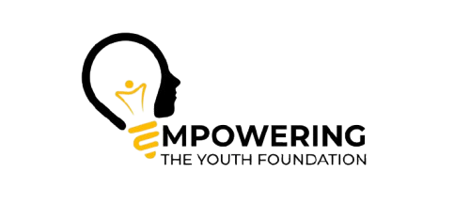

LIGHT THE WAY PROGRAMME
Referral Form
Delivered by Empowering the Youth CIC
Project Coordinator: Ali Raza
Email: ali.raza@etyfoundation.co.uk
Phone: 07727 867862
Please complete all sections of this referral form. All information will be treated confidentially in line with data protection and safeguarding policies.
1. Young Person Details
Full Name: ________________________________
Date of Birth: ________________________________
Gender: ________________________________
Address: ________________________________
School / Setting: ________________________________
Year Group: ________________________________
Parent/Guardian Name(s): ________________________________
Parent/Guardian Contact Number: ________________________________
2. Referrer Details
Referrer Name: ________________________________
Job Title: ________________________________
Organisation: ________________________________
Email Address: ________________________________
Phone Number: ________________________________
Relationship to Young Person: ________________________________
3. Reason for Referral (tick all that apply)
☐ Risk of youth violence
☐ School exclusion / risk of exclusion
☐ Anti-social behaviour
☐ Youth Justice involvement
☐ Gang association / exploitation risk
☐ Emotional wellbeing concerns
☐ Low confidence / self-esteem
☐ Other: ________________________________________
4. Presenting Concerns & Background Information
Please provide relevant background information, including behavioural concerns, safeguarding issues, or previous interventions:
______________________________________________________________________________
______________________________________________________________________________
______________________________________________________________________________
______________________________________________________________________________
5. Risk Information
Is the young person known to Youth Justice Services? Yes / No
Are there any current safeguarding concerns? Yes / No
Risk to self? Yes / No
Risk to others? Yes / No
Additional risk information: ________________________________________________
6. Desired Outcomes
What would success look like for this young person after 12 weeks of mentoring?
______________________________________________________________________________
______________________________________________________________________________
______________________________________________________________________________
7. Consent
I confirm that consent has been obtained from the parent/guardian (where appropriate) for this referral to be made.
Referrer Signature: ________________________________
Date: ________________________________

