Sunday | Monday | Tuesday | Wednesday | Thursday | Friday | Saturday
 | 1  Labor Day | 2 | 3 | 4 | 5 | 6
7  Grandparents Day | 8 | 9 | 10 | 11 | 12 | 13
14 | 15 | 16 | 17 | 18 | 19 | 20  Oktoberfest Begins
21 | 22  Rosh Hashanah Begins  Autumn Begins | 23 | 24 | 25 | 26 | 27
28 | 29 | 30

 | CLOSED | Welcome  OCAL BINGO  10 Million Steps Start  Monthly Gazette  Birthday Celebration  Labor Day Laughs  A-Z Occupational | Rock N Roll  Intergenerational Day  Lunch at Tim’s Tavern  Old Time Rock  Pictionary  Pitch the Records  The first Inductees | Popcorn  *Food Box Pick-Up  Bible Study  History  Relay  Pop up Songs  Colorful Corn | Go Buckeyes  Buckeye-BINGO  Green Farms  Wear Scarlet and Gray  Pigskins  Know the signs  Tailgating foods | 
 | Grandparents Day  Visit from Learning Center  Granny Pants  Grandparents are hosts  Grand Categories | Cloud ‘Nine”  Dollar Tree and Pete’s  B-9 Bingo  Saying come from  Dress to the 9’s  Golf Hole 9 | Cherry Day  Intergenerational Day  Mercy Bingo  Neil Diamond Songs  Cheery Cherry Lollie’s  Drop the fruit  Hi Ho Cherry O | 9/11  Bible Study  Lunch at Tim’s Tavern  Wear Red/White/Blue  You inspire Me/I inspire you  War Card Game | Bee Happy  Allay & Astoria Craft  Spelling Bee  Sudoku  Commonly Confused Words  Balance All Books | Black: Theme of Day  Red: Field Trips  Green: Cooking Club  Blue: Guest Visit  Orange: Special Events
  Ha – 4th  Marvin – 25th  Volunteer  Lesley – 19th | Hispanic Heritage  Wear Red/Green/White  Mini Pinata  Tissue Flowers  Walking Taco  Pass the Sombreros | Gilligan Island  Walk the Plank  Pirate Trivia  Who Am I  Life Preserver Toss  TV Show Bingo | Country Music  Intergenerational Day Field Trip Canal Ride  Amherst &The Regency Painting  Wear Boots/Hat  Bluegrass V/S Country | Cheeseburger Day  Bible Study  Build A Burger  Jimmy Buffett  Order of the Cheeseburger  Funny Quotes | Oktoberfest  Lunch at Tim’s Tavern  St. Luke BINGO  Toss the Pretzel  German Americans  Virtual Tour to Germany | Breakfast: 8:30 a.m.  Lunch: 12 p.m.  Afternoon Snack: 3 p.m.  Crafts, Senior Stretch,  Person Centered Activities,  In2L daily.
National  Adult Day Center Week | Autumn Begins  Beauty Shop 10am  Getting to Know you BINGO  Members Word Search  Slide Show | Back to School  Entertainment -1:30pm  A-Z School Daze  Apple to Apples Game  Picking Apples  Craft – Pressing Apples | The Grape Harbor  Intergenerational Day  Mckinley BINGO  Silly Grape Jokes  Stomping Grapes  Wine Cork Craft | Fall Festival  OPEN House  Cherish BINGO  Branching Out  Scarecrow contest  Fall Leaf Collage  A-Z Contest | The Cherry on Top  Ice Cream Social  Strike a “Pose”  Build a Sundae  Scrambled Toppings  True or False | Alzheimer’s Walk  8:30am
 | Grapevine  Louisville Gardens  Gladys Knight/Marvin Gaye  Grape Race  Raisin VS Grapes  Sweet Carmel Grapes | 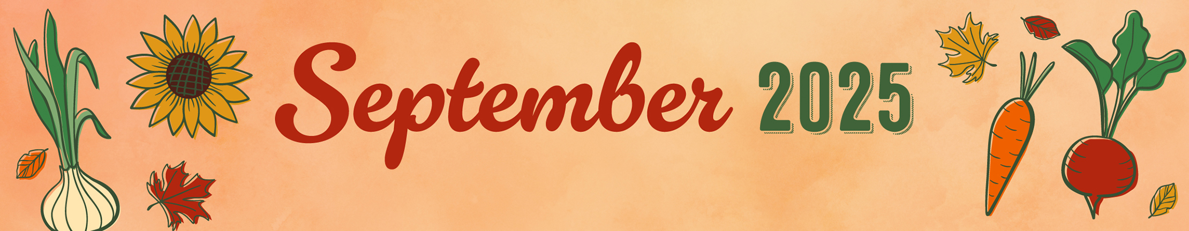  Flying into Oct  Lunch at Tim’s Tavern  Bid High ~ Auction  History of the Frisbee  Disc Golf  Tic Tac Toe | JRC Adult Day Center
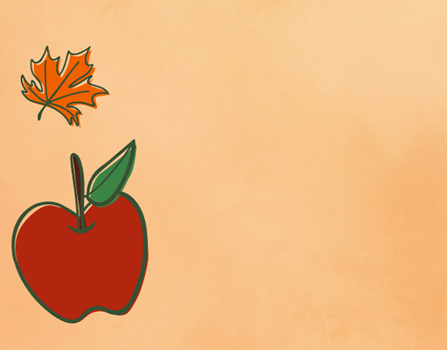
JRC ADULT DAY CENTER ~ 3300 PARKWAY STREET N.W CANTON, OHIO 44708 ~ 330-454-3471 ~ Mon. -Fri. 7:30 a.m to 5:00 p.m ~ www.JRCcares.org

