BOSQAR INVEST Reports Strong Q3 results with 75% Revenue Growth and EBITDA up 77%

- Strong earnings momentum driven by continued growth in organic revenue and profitability;
- Strong deal pipeline conversion and M&A growth

Zagreb, Croatia, October 31st, 2025
BOSQAR INVEST (BOSQAR d.d. – ZSE: BSQR), a perpetual capital investor and company builder in the Adria region, announced its unaudited financial results for the third quarter of 2025, which showcased strong growth across the group’s three core verticals – Business Process and Technology Outsourcing & Customer Care (BPTO/CC – branded as Mplus), Human Resources (HR – branded as Workplace), and Food (branded as Future Food).
BOSQAR’s strong growth credentials continue to be underpinned by its focus on resilient business verticals benefiting from long-term trends, including demographic change, digitalization, and rising food demand.

Key Financial Highlights (Q3 2025 vs. Q3 2024):
- Revenue: EUR 449 million (+75%)
- EBITDA: EUR 48 million (+77%)
- Adjusted EBITDA: EUR 56 million (+76%)

Key Corporate Highlights:
- Successful closing of the Mlinar Group acquisition (EUR 100 million in aggregate) and integration of Panvita Group’s sales function strengthens Food vertical (Future Food);
- BPTO vertical (Mplus): further expanded capacity in SEE and CEE markets through the closing of BPO Valoris acquisition;
- Leadership in AI technology is underpinning organic growth at Mplus;
- The Group’s AI portfolio (GRAIA): consolidated its market position via new Agentic AI platform module, supplemented by significant new partnerships and sales contracts;
- HR vertical (Workplace): strong growth in Southeast Europe (SEE); expansion of service line (RPO, BPO, and IT), realization of large tenders, and new partnerships in automotive, technology, transport, and energy.

Darko Horvat, President of the Management Board, commented: “Our businesses are positioned to capture growth opportunities stemming from key global megatrends – such as demographic change, digitalization, and rising food demand – which continue to underpin growth and strong earnings momentum. Our diversified and synergistic business verticals form a resilient platform capable of delivering value in differing macro environments. These results reflect the success of our approach to growth which combines a long buy-and-build track record, with strong organic growth achieved by building a portfolio of capabilities in fast-growing verticals, reinforced by the successful implementation of operational improvement programmes, all of which combine to deliver significant economic value and job creation in our regions.”
Robust Growth Stemming from Balanced Portfolio of Resilient Businesses
BOSQAR INVEST continues to build on its track record for delivering consistently strong quarterly results, underpinned by a disciplined capital allocation strategy targeting sectors with structural growth and resilient demand.
Strong third quarter results were driven by continued and robust organic revenue and EBITDA growth at the Group level, complemented by M&A gains achieved by converting a robust deal pipeline.
The Group’s balanced and well-diversified operating model continues to deliver stability, with the Food and BPTO/CC segments now contributing almost equally to Adjusted EBITDA – marking a milestone in diversification and reduced concentration risk.
The ongoing expansion of the Group’s workforce in Croatia and Slovenia also reflects its growing scale and commitment to delivering significant economic contribution in key regions.
Reinforced Diversification Strategy
Diversification remains a core mechanism for managing risk and sustaining stability.
Each business vertical within the Group operates with its own market cycles, minimising cyclicality risk, ensuring that no single segment is overly exposed to external factors affecting geography, sector exposure or client concentration risk and that the Group benefits from complementary growth dynamics.
With operations in more than 20 countries, the Group maintains a balanced mix of enterprise and consumer exposure supported by a broad portfolio of products and services.
This structure provides resilience through economic cycles and supports stable revenue development.
Evolution of Future Food Vertical
During the quarter, the Future Food vertical saw meaningful advancements, underscored by the successful closing of the EUR 100 million Mlinar Group acquisition and continued efficiency initiatives within Panvita Group.
The Future Food vertical is developing leading positions in key product categories, supported by a strong and experienced management team with proven execution capabilities.
Across the first nine months of 2025, Panvita modernized its production processes, strengthened management capabilities, and expanded sustainable agricultural practices. Greater operational efficiency in Q3 was achieved through the centralization of the sales function, supported by ongoing production investments.
The Mlinar acquisition represents a major step in sector consolidation and the development of a leading regional food platform.
BPTO/Customer Care: Market Position Consolidation in CEE
Significant progress was made in consolidating the BPTO/Customer Care vertical’s market position in Central and Eastern Europe through strategic acquisitions and regional expansion.
Key milestones included the announcement and subsequent completion of the acquisition (in October) of Valoris, a Romanian CX and BPO provider.
Alongside the acquisition of BPO Conectart in the Czech Republic in April, these transactions – with a combined value of EUR 14 million – strengthen operational scale and delivery capabilities across key near-shore markets.
AI leadership within the BPTO/CC vertical continues to underpin strong organic growth, supported by advanced automation capabilities, proprietary technology solutions, and deep operational expertise.
Advancements in AI Portfolio
Earlier in the year, the Group’s technology portfolio consolidated a new generation of AI solutions under the GRAIA brand. This represents a key strategic step in establishing an integrated platform for intelligent automation of customer experience.
Supported by the Group’s innovation ecosystem and backing from strategic partners, including the EBRD and MidEuropa, GRAIA leverages proprietary Agentic CCaaS and Agentic AI technologies to drive accelerated development.
In the third quarter, product innovation continued at pace, highlighted by enhancements to the Agentic AI platform and the addition of a new AI QA module. Alongside technology advances, several new partnership and commercial agreements were secured, further strengthening GRAIA’s market presence and adoption.
Outlook*
Results achieved in the first nine months of 2025 illustrate the success of the Group’s strategy and provide additional momentum for our ambitious expansion plans.
BOSQAR INVEST remains focused on operational excellence, integration and governance as it achieves its long-term vision of building a modern, multi-vertical business system with strong roots in Southeast Europe.
The Group is well-positioned to capture regional growth opportunities and continue creating sustainable value for all stakeholders.
The full Q3 2025 financial report can be found here: https://eho.zse.hr/en/issuer-announcements/view/63961

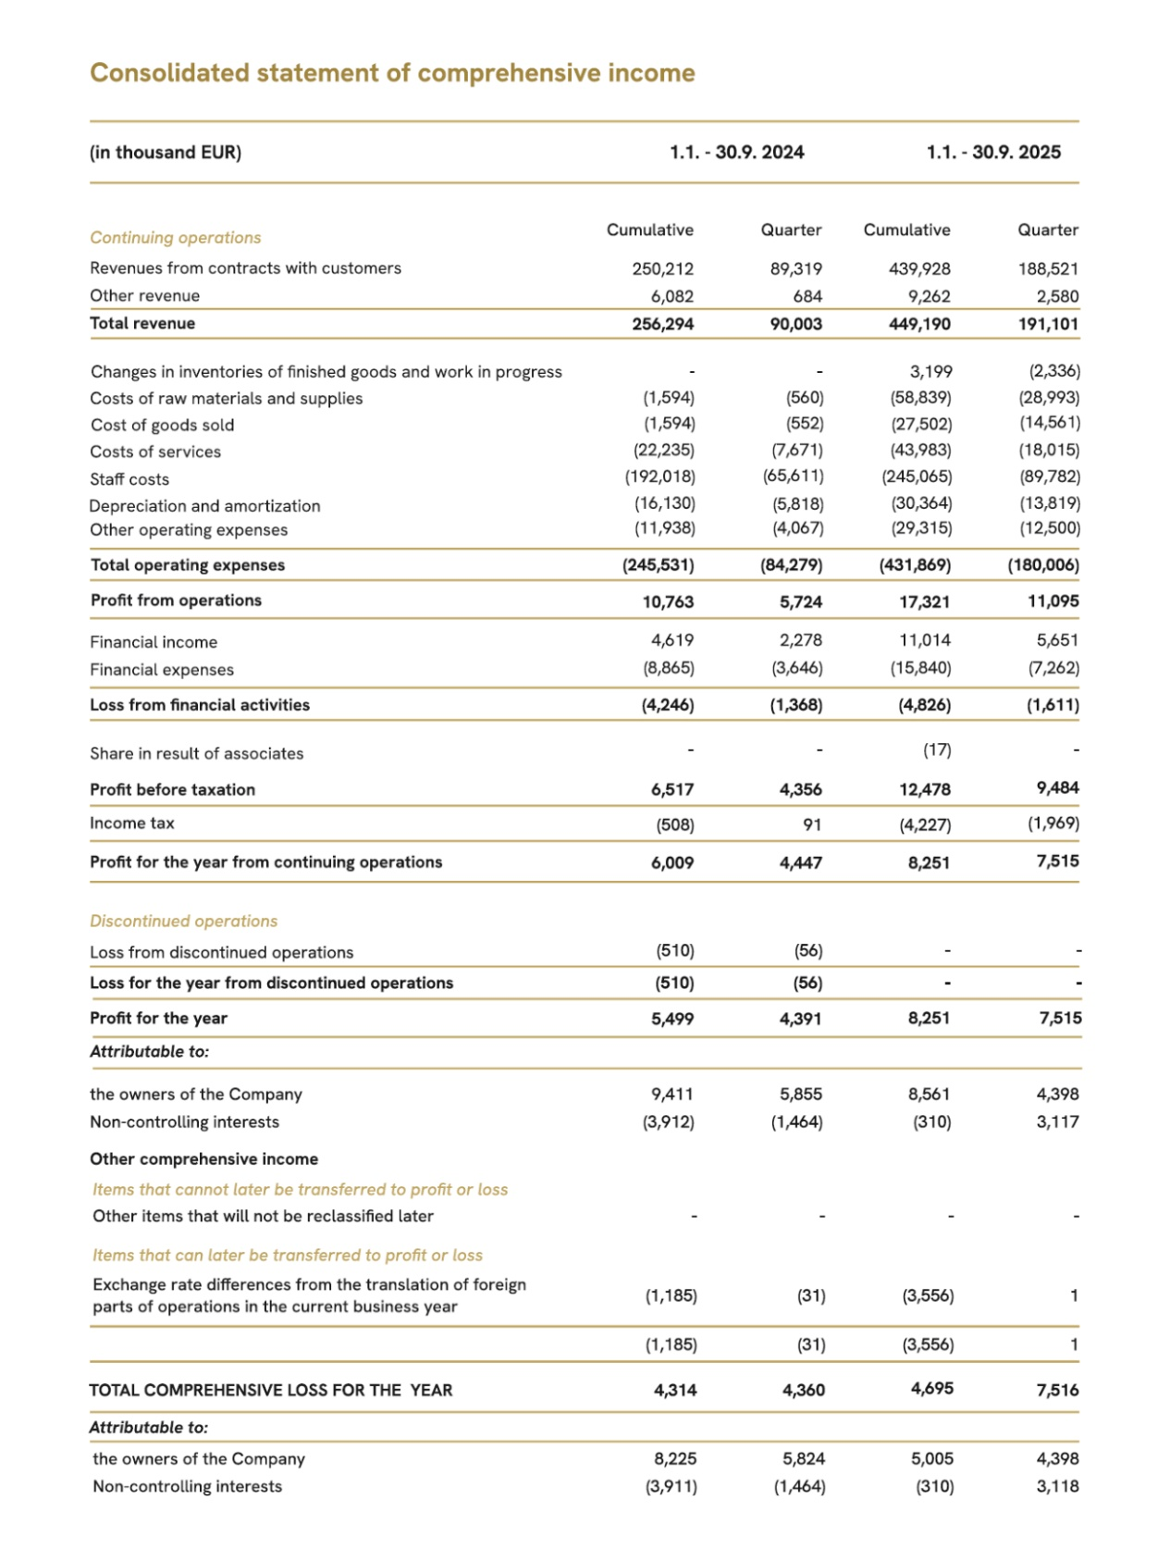

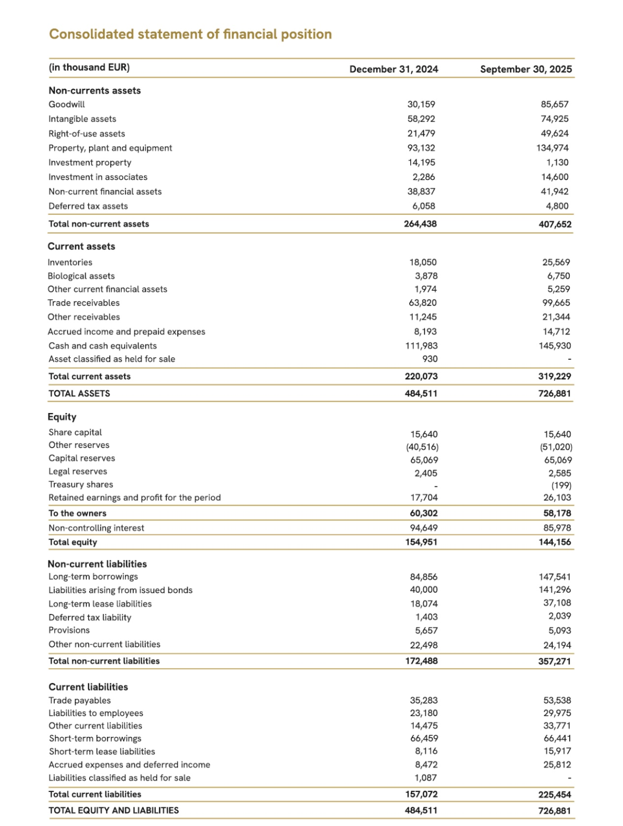

About BOSQAR INVEST:

BOSQAR INVEST (BOSQAR d.d., together with its subsidiaries) is a European perpetual capital investor and company builder that operates in several industries, including business process and technology outsourcing (BPTO), customer care, information technology, employment services (HR), and Food.

With an innovative business model, BOSQAR INVEST accelerated its expansion on the market with intensive organic growth and an M&A platform. BOSQAR's buy-and-build strategy is proven in executing more than 80 acquisitions since 2016, with improved profitability and operations of each of its acquired companies through its standardized operational models that result in significant organic growth of all companies inside the Group and the Group itself.

Today, BOSQAR INVEST operates through several business verticals: the BPTO/Customer Care business vertical (brands: Mplus, GRAIA), the HR business vertical (brands: Manpower SEE and Workplace), the Food business vertical (brands: Future Food, Panvita, Mlinar), and Other industries. All business verticals are focused on shareholder value creation through a commitment to best practices in digitalization, structured key accounts management programs, rigorous financial stability and focus on results, and strong and dedicated management teams.

In its ownership structure, BOSQAR INVEST brings together pension funds, institutional investors, international private equity funds, development institutions, and private investors. The BOSQAR INVEST business community consists of over 18,000 employees, and the group’s companies operate from 23 countries around the world.

BOSQAR d.d.

* The text included in these sections of the report contains statements that are or may be considered forward-looking statements. These forward-looking statements can be identified by the use of certain forward-looking terminology, including, but not limited to, terms such as: believes, estimates, forecasts, considers, expects, seeks, aims, strategy, purpose, intends, continues, may, will, should, or, in each case, their negative or other variations of these or similar expressions. These forward-looking statements relate to matters that are not historical facts. Such statements include, among other things, statements regarding the Group’s intentions, beliefs and/or current expectations concerning, among other things, plans, objectives, achievements, strategies, future events, future revenues or performance, capital expenditures, financing needs, acquisition-related plans and intentions, competitive advantages and disadvantages, business strategies and industry trends, as well as the political and legal environment in which the Group operates, and other information that is not historical data. By their nature, the forward-looking statements included in this document involve risks and uncertainties because they relate to events and depend on circumstances that may or may not occur in the future and are to a lesser or greater extent beyond the Group’s control and influence. Forward-looking statements are not guarantees of future performance. Actual results, operations, financial position, liquidity, trends, development of business strategies, and performance in the markets in which the Group operates, whether directly or indirectly, as well as the actual resources available, may materially differ from those expressed or implied by the forward-looking statements contained in this document. Furthermore, even if the investment outcomes, operating results, financial position, liquidity, and the development of financial strategies and performance in the markets in which the Group operates – either directly or indirectly – are consistent with the forward-looking statements made in this section of the report, they may not be indicative of results, developments, markets, or resources in future periods.

