Tennessee Tiered Supports Center Overview

What is the Tennessee Technical Assistance Network (TN-TAN)?
TN-TAN provides school districts, administrators, educators, and families access to high-quality professional learning, resources, and supports designed to improve student outcomes. The supports offered through TN-TAN include the areas of intensive behavior, autism, assistive technology, post-secondary transition, family engagement, and Response to Instruction and Intervention for Academics and Behavior (RTI²-A+B). Tennessee Tiered Supports Center (Tennessee TSC) is a grant within TN-TAN focused on providing support related to RTI²-A+B.
What is Tennessee TSC?
Tennessee TSC builds district and school capacity to implement and sustain a tiered support system that matches instruction and intervention to student needs. We provide professional learning, technical assistance, coaching, and resources on best practices to improve academic and nonacademic outcomes for all students. We engage with districts through intensive partnerships while also providing open-access events and resources for those not part of an intensive partnership with us.
What open-access supports are available?
Our website features readily available open-access resources. Examples of these include asynchronous modules that can be completed at one’s own pace, toolkits with tailored collections of resources to support specific areas of RTI²-A+B implementation, and individual implementation resources designed to enhance the alignment of Leadership, Data-Based Decision Making, Assessment, and Instruction and Intervention.
We also host open-access virtual Community of Practice events for educators across Tennessee. Topics include data-based decision-making and early warning systems, strengthening preventative classroom management practices, supporting Tier II within RTI²-B, implementing Check-In/Check-Out and Breaks are Better, self-regulation strategies, and more! Registration details can be found on the Events page of our website.
How can you connect with us?
 | Tennessee TSC | TN-TAN
Visit our websites | https://www.tennesseetsc.org | https://tn-tan.tnedu.gov/
Subscribe to our newsletters | 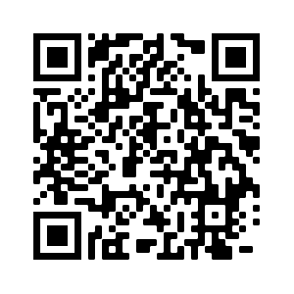 | 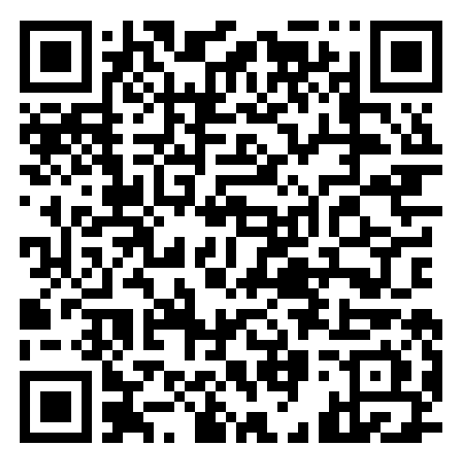
Follow us on social media (e.g., X, Facebook, LinkedIn) | @tennesseetsc | @Tennessee_TAN
Email us | tennesseetsc@vanderbilt.edu | TN-TAN@utk.edu
How can you request assistance? 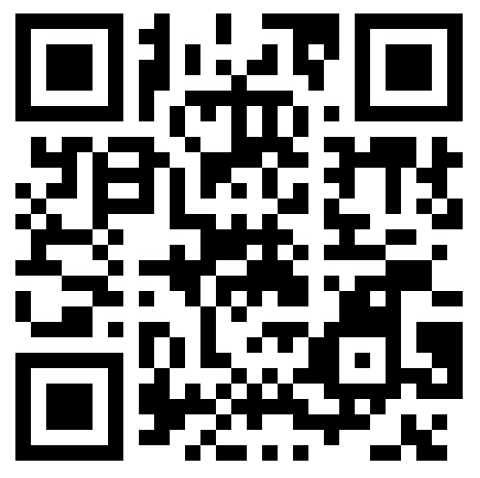
If you are interested in partnering with us or another member of TN-TAN, please complete the TN-TAN Request for Assistance Form by clicking this link or scanning the QR code.

