District Partnership with Tennessee Tiered Supports Center

What is Tennessee Tiered Supports Center?
Tennessee Tiered Supports Center (Tennessee TSC) is a technical assistance center and partner within the Tennessee Technical Assistance Network (TN-TAN). We assist districts and schools in implementing Response to Instruction and Intervention for Academics and Behavior (RTI²-A+B) through professional learning, coaching, and resources. Our technical assistance services are designed to build implementation capacity. This means we prioritize district partnerships to strengthen systems and activities that are necessary for schools to successfully implement and sustain RTI²-A+B. We depend on dedicated teams of district leaders to champion and sustain RTI²-A+B implementation across schools. Our services are provided at no cost through a grant contract with the Tennessee Department of Education and a long-standing partnership between University of Tennessee and Vanderbilt University.

What is RTI²-A+B?

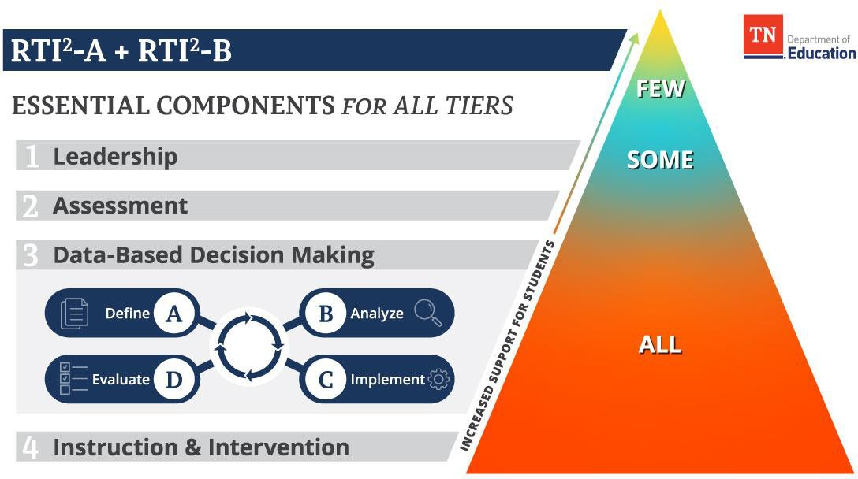

Although RTI²-A and RTI²-B can be implemented as stand-alone frameworks, students’ academic and behavioral needs should be considered together, rather than in isolation. The term RTI²-A+B connects Tennessee’s student support frameworks and represents how they are intended to work together. Aligned implementation of both frameworks, with a focus on how their common elements can be streamlined, can be an effective and efficient way to leverage resources and set all students on a path to success. RTI²- A+B is prevention focused. It relies on continuous, data-driven problem solving and research-based practices to identify and address student need, NOT a “wait and fail” approach.

Why partner with Tennessee TSC?
While Tennessee TSC offers professional learning opportunities and resources that are available to non-partnering districts and schools, district partnerships allow us to provide support that is highly aligned to a district’s unique needs. We provide partnering districts with individualized professional learning opportunities and coaching driven by multiple data sources, including the District Capacity Assessment–Tennessee (DCAT) and the School Implementation Fidelity Assessment (SIFA), which both assess the essential components of RTI²-A+B.
Benefits of a partnership include:
- needs-driven, individualized coaching;
- professional learning for local schools;
- support to monitor, share, and make decisions based on implementation data and district improvement goals;
- access to a “data dashboard” that manages and visually displays RTI²-A+B implementation data; and
- opportunities to network with other district partners.

What is the process for getting started?
Engaging in a partnership with Tennessee TSC requires foundational work at the district level. Districts must:
- sign an agreement of collaboration,
- identify a district coordinator,
- establish a district leadership team (DLT) comprised of individuals with academic and behavioral expertise,
- evaluate current RTI²-A+B implementation practices, and
- develop a district implementation plan.
The DLT is responsible for:
- guiding the assessment process;
- leading the district’s action planning process;
- coordinating professional learning, coaching, and evaluation activities to support school teams; and
- creating changes in district procedures that will support long-term and efficient use of the frameworks.

What is the District Model of Demonstration (MOD) Program?
Districts in partnership with Tennessee TSC are invited to apply to be recognized for their work aligning RTI²-A+B to provide comprehensive supports for their students. There are three district MOD distinctions: Ground Breakers Award, Change Makers Award, and Community Builders Award.

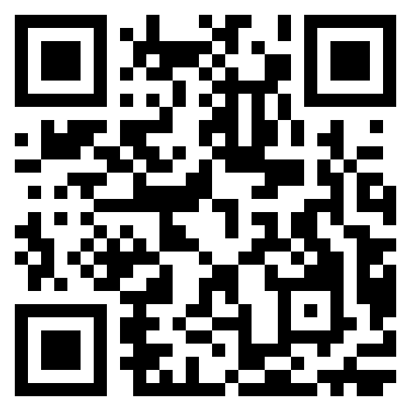
How can you learn more?
For more information, visit our website by scanning the QR code or clicking this link: https://tennesseetsc.org/.

