
Self-Regulation Resource Pack

Self-Regulation Resource Pack

Purpose
Self-regulation comprises a set of skills that some students, regardless of their age or ability level, may find challenging to consistently demonstrate. It is the process of managing one’s thoughts, emotions, and behaviors to adapt to a given context and enable goal-directed behavior (Frei et. al., 2021). This resource pack is designed to assist districts and schools in teaching self-regulation skills through research-based strategies, including goal setting, self-monitoring, and self-graphing. The strategies covered in this resource pack can be used by schools to help students in need of additional support. The first section provides an overview of self-regulation and how it can be taught in classroom settings. The second section includes strategy-specific information and example tools that can be tailored to meet students’ skill-specific needs.

Table of Contents
- Self-Regulation
- Self-Regulation Strategies
  - Goal Setting
    - Goal Setting Examples
  - Self-Monitoring
    - Self-Monitoring Examples
  - Self-Graphing
    - Self-Graphing Examples
- References

Self-Regulation

Self-regulation as an area of need is often characterized by behavior patterns that look like difficulty controlling one’s actions and reactions. These patterns stem from difficulty understanding expectations, directing behavior to meet those expectations, and managing impulsivity. Outwardly, behaviors can look like restlessness, overactivity, impulsivity, distractibility, and difficulty concentrating (Goodman, 1997; McDaniel et al., 2024).
Teaching self-regulation focuses on helping students understand their ability to take control of how they approach and respond to various situations and stressors. Developing these skills is crucial for students' personal growth in school and everyday life. Self-regulation strategies are simple to use, inexpensive to incorporate, and can be taught to students in all grades. Teaching self-regulation in combination with academic strategies can strengthen student outcomes, help decrease classroom behavior challenges, and empower students (The IRIS Center, 2008). The Treatment and Research Institute for Autism Spectrum Disorders (TRIAD) offers several methods for teaching self-regulation skills that mirror the way academic skills are taught in schools. These include direct instruction, modeling and demonstrating ways to cope, role-play, consistent feedback from educators, and regular opportunities to practice emerging self-regulation skills. These methods are effective for students with and without disabilities (TRIAD, 2023).
It is best to teach self-regulation skills and provide opportunities for practice in settings where students feel the greatest sense of ease. Supporting and coaching students as they work to address challenging situations instead of avoiding them is a major component of learning self-regulation (Child Mind Institute, 2024). In addition, for students who lack these skills, attempting to teach them when they are emotionally dysregulated is often unproductive. TRIAD (2023) reminds us that this learning needs to take place when students are ready, calm, and regulated. Once the foundation of skills is established, purposeful practice should be provided over time with gradual increases in the demands placed on the students, who then move to new settings for generalization when ready.

Self-Regulation Strategies

Goal Setting

Overview

Goal setting empowers students to take ownership of their academic and behavioral growth. It involves focusing one's attention, effort, and choices to achieve meaningful and relevant desired outcomes (Zimmerman, 2012). This focus clarifies the relationship between students’ immediate actions and future results, resulting in improved academic and behavioral outcomes (Stronge & Grant, 2014; McKenna et al., 2023). Students working to achieve academic or behavioral goals may choose to make personal changes in areas they find achievable and realistic while also considering larger goals that may require more time and effort. In both cases, educators play a crucial role by providing instruction and support that helps students achieve their goals. This includes framing conversations about data, providing positive feedback, and creating opportunities to reflect on learning (Nordegren, 2022).

Teaching Goal Setting

When teaching goal setting, it is essential to establish a clear process that helps students understand the importance of selecting meaningful goals, identifying the steps involved, and knowing how to achieve their goals. Although the specific steps may vary based on the developmental needs of each student, the fundamental elements of goal setting will remain consistent. As a starting point, consider procedures that incorporate these basic steps:
Step 1: Co-construct an appropriate goal. The teacher and student work together to understand the student’s current strengths and areas for growth. Together, they establish a goal for the student, set a timeline for achieving it, and outline the steps the student must take to reach the goal. The teacher uses this as an opportunity to identify how instruction and the environment can be adapted to support the student.
Step 2: Evaluate student progress. As the student works toward the goal, the teacher and student evaluate the student’s performance relative to the goal. They identify barriers to learning and adjust their plan for meeting the goal when needed.
Step 3: Celebrate growth and goal attainment. The teacher acknowledges the student’s progress and efforts toward achieving the goal (The Iris Center, 2008; Nordegren, 2022).
When working with older students, it is useful to introduce the concept of SMART goals. SMART goals are those that are Specific, Measurable, Achievable, Relevant, and Time-Bound. In addition to ensuring their goals have these main components, students in middle and high school should also consider why their goals are important to them, what kind of support they might need to accomplish the goal, and who they could ask for that help if they need it. Older students are an excellent target audience to focus on self-advocacy, and goal setting is a great place to help them establish self-advocacy skills.

Goal Setting Examples

Goal Setting Form Example
Goal Setting
My goal is:

Steps to making my goal:

How will I know I achieved my goal?

SMART Goal Form Example
SMART GOAL
Why is the goal important?

What is your goal?

S
M
T
R
A
S
M
Does the goal have a clear timeline?

Is the goal important or meaningful to you?

Can you meet this goal?

Is the goal measurable?

Is the goal clearly written?

SMART stands for Specific, Measurable, Attainable, Relevant, and Time-Bound. Fill this document out with your SMART goal in mind.
What are the potential obstacles?

Checklist

Self-Monitoring

Overview
Self-monitoring is one of the most widely used and researched strategies for reducing challenging classroom behaviors (Bruhn, 2022). It is a multi-component strategy that helps students recognize when they are engaging in certain behaviors, reflect on their behavior at set times during the school day, and review data to track their progress toward a behavioral goal (Estrapala et al., 2024).
This strategy is often used with students who have difficulty with self-regulation because it helps them practice academic and social skills, become aware of their behavior, and manage their behavior, resulting in improved academic and behavioral success (Bruhn et al., 2022). Additional benefits to self-monitoring include allowing the teacher to customize the intervention to the student's needs, provide more immediate feedback, and save time by delegating behavior data collection to their students (The IRIS Center, 2008).

Setting Up Self-Monitoring

The process of self-monitoring must be taught, modeled, and practiced. Once self-monitoring is implemented, the teacher should closely observe the first few days to ensure the student is self-monitoring accurately and provide feedback to the student. The steps below describe the process of setting up a self-monitoring plan for each student.

Step 1: Select a target behavior.
Identify a specific behavior to address with the student. Clearly define the behavior to ensure it is evident when the behavior is occurring and when it is not.

Step 2: Collect baseline data.
Gather data that shows how the student is currently performing the target behavior. The table below describes ways a behavior can be measured. Checklists that outline the steps for appropriately engaging in a behavior, as well as interval-based recording methods, can provide valuable information when establishing a student’s baseline performance and are often more practical than other methods.

Methods for Measuring Challenging Behavior in Self-Monitoring
Measurement Method | How to Measure the Behavior
Checklist  A list of steps that lead to completion of a task or behavior | The teacher lists steps that need to be taken to complete a task. The student records whether the step was completed or not (e.g., adding a check mark or circling “yes” or “no”) at the end of the interval or completion of the task.
Count  The total number of occurrences of a behavior | The student records each occurrence of the behavior (e.g., makes a tally).
Duration  How long a behavior lasts | The student times and records how long the behavior lasts.
Time Sampling  Partial-interval sampling  An estimate of how often the behavior occurs | The teacher divides a set period of time into equal intervals (e.g., 5-minute intervals). At the end of each interval, the student records whether the behavior did or did not occur (e.g., “yes” or “no”) at any point during the interval.
Momentary time sampling  An estimate of how often the behavior occurs | The teacher divides a set period of time into equal intervals (e.g., 5-minute intervals). The student records whether the behavior is or is not occurring (e.g., “yes” or “no”) at the exact moment the interval ends.
Direct Behavior Rating  A self-evaluation score that reflects a student’s perception of their own behavior against a set of criteria. | At the end of a set period of time, the student rates their own behavior using a rating scale with criteria for each score (e.g., 0 = I did not demonstrate the behavior. 1 = I demonstrated the behavior with help. 2 = I demonstrated the behavior on my own).
(Cooper et al., 2019)
Step 3: Establish a goal.
Co-create an appropriate behavioral goal with the student. The goal should be attainable and based on the student’s current performance.

Step 4: Monitor the target behavior.
Model for the student how and when to take data on the target behavior and/or replacement behavior using their data collection form. Provide the student with opportunities to practice, and offer feedback as they begin monitoring independently.

Recording data does not always need to be done with paper and pencil. Technology can be used to make self-monitoring easier for students. Some examples could include using a timer, a handheld mobile device (e.g., a cellphone or palm pilot), or an audio recorder. The table below describes tools that can be used to assist students with data collection.

Step 5: Evaluate progress.
Transfer target behavior and/or replacement behavior data to a graph and evaluate progress in comparison to baseline data. A visual provides teams (and the student) with a quick and easy way to analyze and discuss data. See the “Self-Graphing” section of this resource pack for more information.

To learn more, check out the Iris Center’s module on self-monitoring.

Self-Monitoring Examples

Checklist Recording Form Example

Behavior: ________________
Start and end time: _________________
 | Yes | No
<insert behavior here>

Behavior: ________________
Start and end time: _________________
0 = never 1 = rarely 2 = often 3 = yes, always
<insert time interval here> | <insert behavior here> | 0 | 1 | 2 | 3
<insert time interval here> | <insert behavior here> | 0 | 1 | 2 | 3
<insert time interval here> | <insert behavior here> | 0 | 1 | 2 | 3
<insert time interval here> | <insert behavior here> | 0 | 1 | 2 | 3
(McDaniel, et al., 2024)

Event or Count Recording Form Example

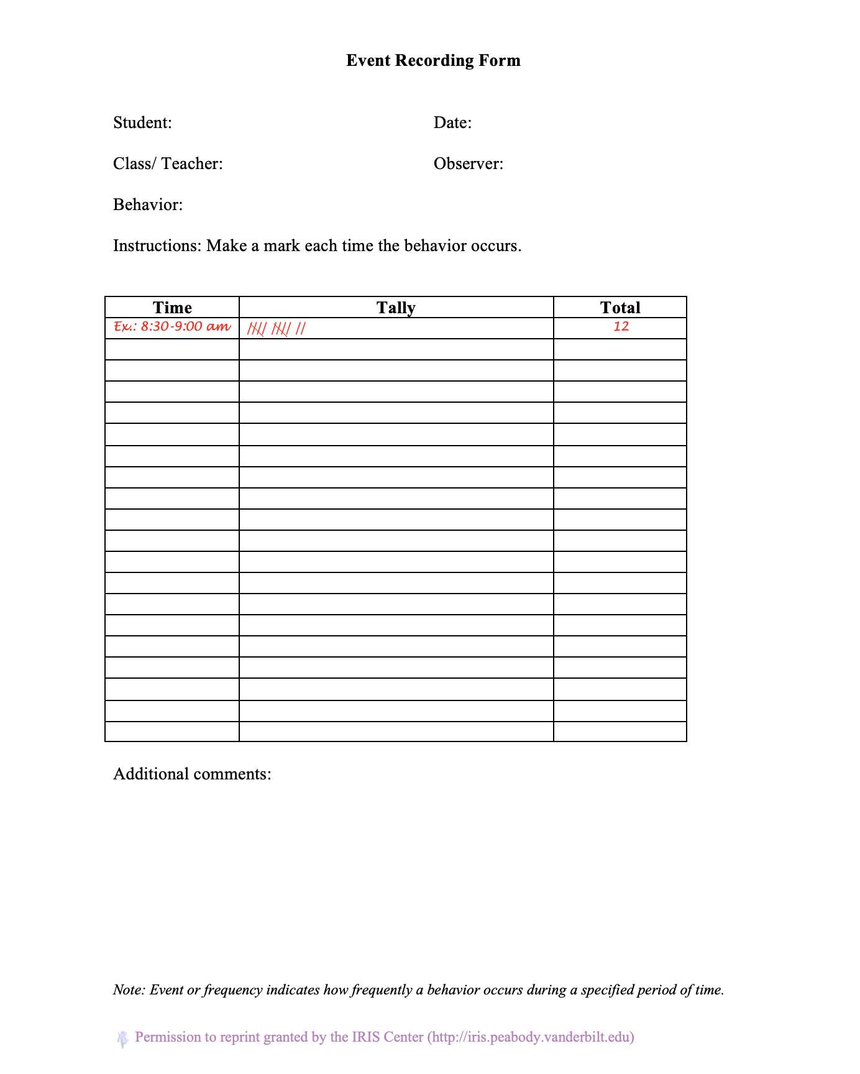

Duration Recording Form Example

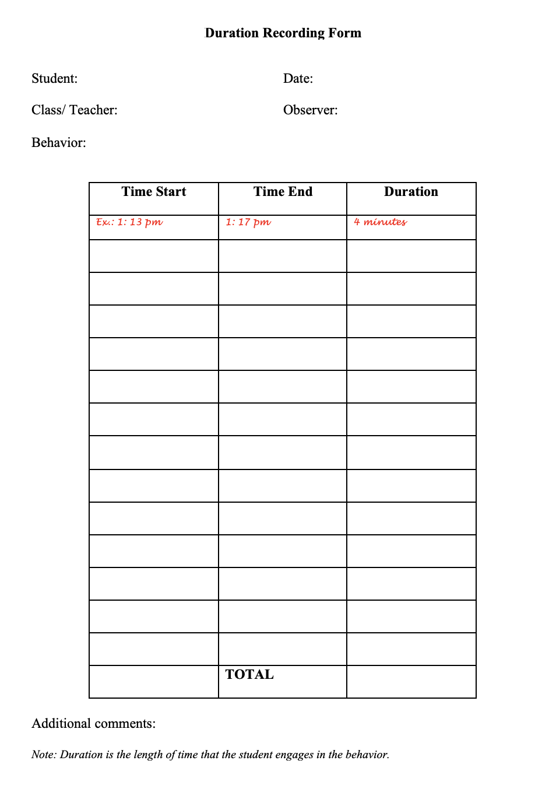

Partial-Interval Sampling or Momentary Time Sampling Recording Form Example

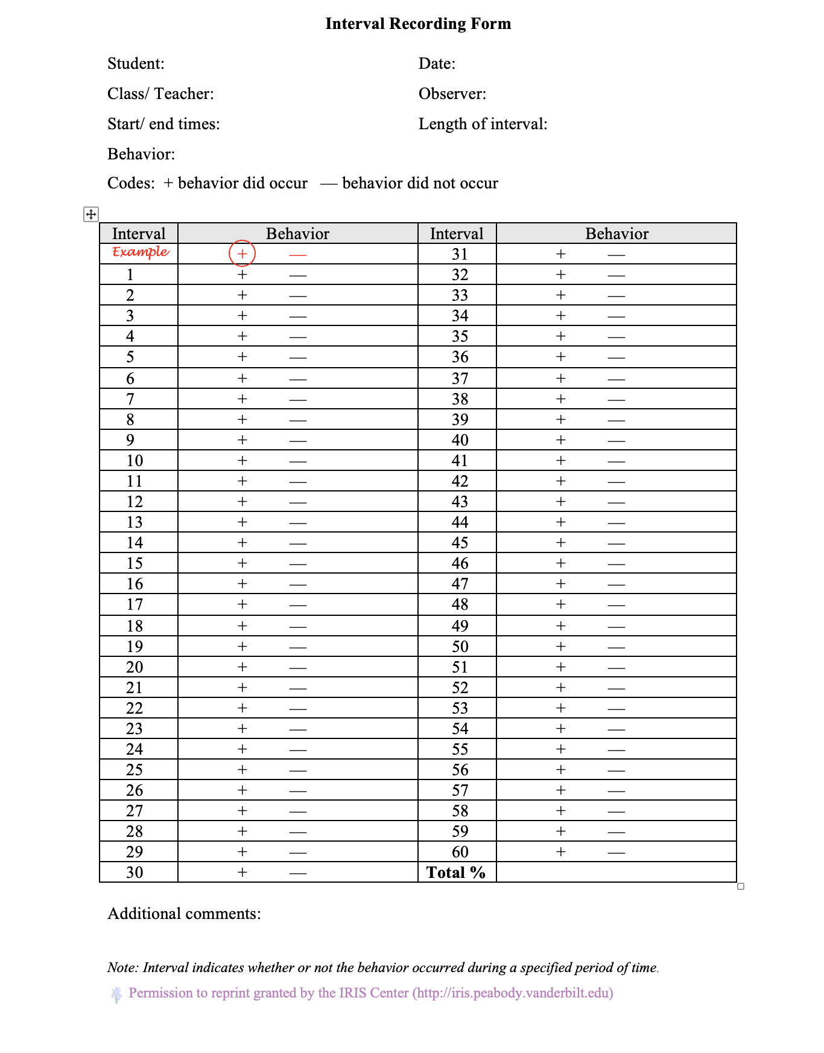
To find Microsoft Word versions of these forms, check out the Iris Center’s webpage.

Self-Graphing

Overview

Self-graphing is a strategy that can be used alongside other interventions, such as self-monitoring, to help students visualize their performance of a behavior or skill over time (Hirsch et al., 2013). In this approach, students graph and track data related to a target behavior or skill, motivating them to evaluate their progress toward a desired outcome. Data can be collected by either the student or the teacher on any behavior or skill of interest, and it can be easily shared with parents or caregivers.

Teaching Self-Graphing

Self-graphing can be completed in a variety of ways, such as line graphs, bar graphs, and picture graphs. Each of these graphs can be done by hand or by using a web-based resource. These graphs can represent data as a frequency count or percentage (from interval-based data collection or components completed of a checklist). Like any intervention, self-graphing should be taught, modeled, and practiced. For younger students, self-graphing can be used by coloring in parts of an object on a piece of paper for each step they complete.

While the specific components of self-graphing may vary based on developmental needs, they should include these steps.

Step 1: Create a graphing template.
Determine how the student will graph their data. This can be done by hand or electronically as a bar graph, line graph, or with pictures.

Step 2: Teach the student to graph data.
Explain to the student how to graph their data and model the process for them. Allow opportunities for the student to practice and provide feedback where needed. Provide students the opportunity to personalize their graphs with color or fonts. Discuss how to review the data in relation to their goal.

Step 3: Have the student graph new data independently.
Monitor the student’s graphing and continue to provide feedback and support. Provide an incentive or checklist to help students complete each individual step of the self-graphing process correctly if needed.

Step 4: Review graphed data with the student.
Use progress monitoring to track the student’s performance. Discuss what changes may need to be made to the intervention or self-graphing process.

Step 5: Celebrate growth and goal attainment.
Celebrate the student’s accomplishments as they make growth or reach their goal. Consider adding a goal line to the graph for quick visual analysis.

Self-Graphing Examples

Computer-Generated Line Graph Example

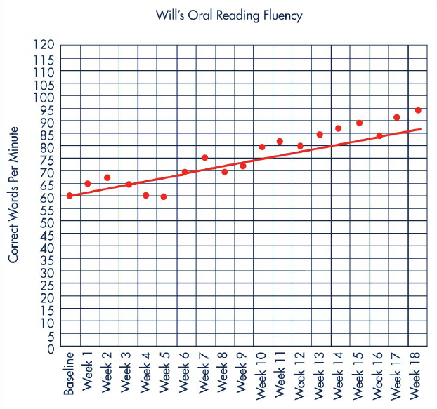
(Hirsch et al., 2013)

For an online tool to assist in creating a line graph, visit The National Center on Intensive Interventions’ webpage.

Additional Computer-Generated Line Graph Example

To access the Progress Monitoring Tool and Guide, visit the Tennessee Tiered Supports Center’s webpage.
Computer-Generated Bar Graph Example

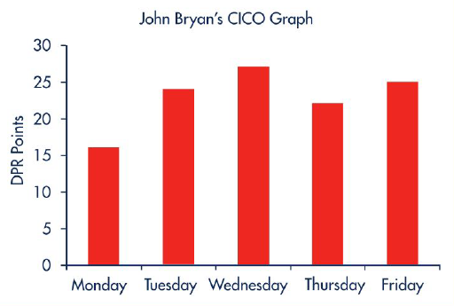
(Hirsch et al., 2013)

Hand-Colored Bar Graph Example

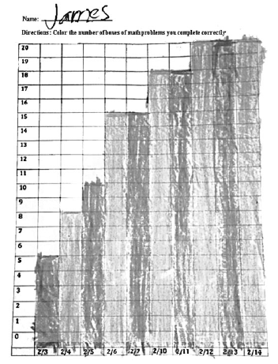
(Wells et al., 2017)

For an online tool to assist in creating a bar graph, visit the Template Lab webpage.
References

Ackerman, C. E., (2024). 42 goal setting activities for Students & Kids. https://positivepsychology.com/goal-setting-students-kids/

Bruhn, A., Gilmour, A., Rila, A., Van Camp, A., Sheaffer, A., Hancock, E., Fernando, J., & Wehby, J.
(2022). Treatment components and participant characteristics associated with outcomes in self-
monitoring interventions. Journal of Positive Behavior Interventions, 24(2), 156-168.
https://doi.org/10.1177/1098300720946651

Bruhn, A., McDaniel, S., & Kreigh, C. (2015). Self-monitoring interventions for students with behavior
problems: A systematic review of current research. Behavioral Disorders, 40(2), 102–121.
https://doi.org/10.17988/BD-13-45.1

Child Mind Institute. (2024). How can we help kids with self-regulation?
https://childmind.org/article/can-help-kids-self-regulation/

Cooper, J.O., Heron, T.E., & Heward, W.L. (2019). Applied behavior analysis (3rd ed.). Hoboken, NJ
Pearson Education.

Estrapala, S., Bruhn, A., & Wilkinson, S. (2024). 2k — Strategies to identify & adopt
evidence-based tier 2 interventions. National PBIS Leadership Forum, Chicago, IL.

Frei, A. and Herman-Stahl, M. (2021). Co-regulation in practice series. OPRE Brief #2021-91,
Washington, DC: Office of Planning, Research and Evaluation, Administration for Children and
Families, U.S. Department of Health and Human Services.

Goodman, R. (1997). The Strengths and Difficulties Questionnaire: A research note. Journal of Child Psychology and Psychiatry, 38(5) 581-586. https://acamh-onlinelibrary-wiley-com.proxy.library.vanderbilt.edu/doi/pdf/10.1111/j.1469-7610.1997.tb01545.x
Hirsch, S. E., Ennis, R. P., & McDaniel, S. C. (2013). Student self-graphing as a strategy to increase teacher effectiveness and student motivation. Beyond Behavior, 22(3), 31–39.
McDaniel, S. C., Bruhn, A. L., & Estrapala, S. (2024). Social, emotional, and behavioral supports in schools: Linking assessment to tier 2 intervention. Guilford Press.

McKenna, K., Bray, M. A., Fitzmaurice, B., Choi, D., DeMaio, E., Bray, C. R., & Bernstein, C. (2023). Self-monitoring with goal-setting: Decreasing disruptive behavior in children with attention-deficit/hyperactivity disorder. Psychology in the Schools, 60(12), 5167–5188. https://doi.org/10.1002/pits.23026

National Center on Intensive Interventions at the American Institutes for Research. (2025, March). Student Progress Monitoring Tool for Data Collection and Graphing (Excel). https://intensiveintervention.org/resource/student-progress-monitoring-tool-data-collection-and-graphing-excel#content

Nordengren, C., & ProQuest. (2022). Step into student goal setting: A path to growth, motivation, and agency. SAGE Publications.

Stevenson, N. A., and Mussalow, P.R. (2019). The effects of planning, goal setting, and performance
feedback on avoidance behaviors for struggling readers. Journal of Positive Behavior Interventions
Vol. 21 (3), 171-180. https://doi.org/10.1177/1098300718804566

Stronge, J. H. & Grant, L. W. (2014) Student achievement goal setting. Routledge https://doi-org.utk.idm.oclc.org/10.4324/9781315854953.

Template Lab. (2025). 39 Blank Bar Graph Templates [Bar Graph Worksheets].
https://templatelab.com/bar-graph-templates/

Tennessee Department of Education. (2017). K-12 Social and personal competencies resource
guide. https://www.tn.gov/content/dam/tn/education/safety/safe_sch/SPC_Resource_Guide.pdf

Tennessee Tiered Supports Center. (2024). Progress Monitoring. Retrieved from
https://www.tennesseetsc.org/implementation-resources

The IRIS Center. (2019, Rev. 2023). Progress monitoring: Mathematics. Retrieved from
https://iris.peabody.vanderbilt.edu/module/pmm/ - content

The IRIS Center. (2008). SOS: Helping students become independent learners. Retrieved from
https://iris.peabody.vanderbilt.edu/module/sr/

The IRIS Center. (2008). SRSD: Using learning strategies to enhance student learning. Retrieved
from https://iris.peabody.vanderbilt.edu/module/srs/

Treatment and Research Institute for Autism Spectrum Disorders. (2023). Teaching behavioral coping and self-regulation skills to learners. https://vkc.vumc.org/assets/files/triad/tips/Beh_Coping_Self-Regulation.pdf

Wells, J. C., Sheehey, P. H., & Sheehey, M. (2017). Using self-monitoring of performance with self-
graphing to increase academic productivity in math. Beyond Behavior, 26(2), 57–65. https://www.jstor.org/stable/26866787

Zimmerman, B. J. (2012). Goal setting: A key proactive source of academic self-regulation. In D. H. Schunk & B. J. Zimmerman (Eds.), Motivation and self-regulated learning: Theory, research, and applications (pp. 267–295). Lawrence Erlbaum Associates Publishers. https://doi.org/10.4324/9780203831076

