Data Analysis
Purpose: This resource explains methods for analyzing formal progress monitoring data, which is one type of data that should be analyzed alongside other data sources collected to monitor student progress. It is recommended that progress monitoring be conducted at least bi-weekly, tailored to each student’s instructional level, as advised by the Tennessee Department of Education (2023). This document presents two effective methods for analyzing formal progress monitoring and includes probing questions that teams can use to evaluate student progress across multiple data sources.

Four-Point Method
The four-point method involves evaluating the student’s progress by comparing their four most recent progress monitoring data points to their established goal line (National Center on Response to Intervention, 2013). Teams examine these data points to determine if the student is progressing adequately toward their academic goals. This method provides a snapshot of the student's current performance in relation to their expected growth.

Adequate Progress
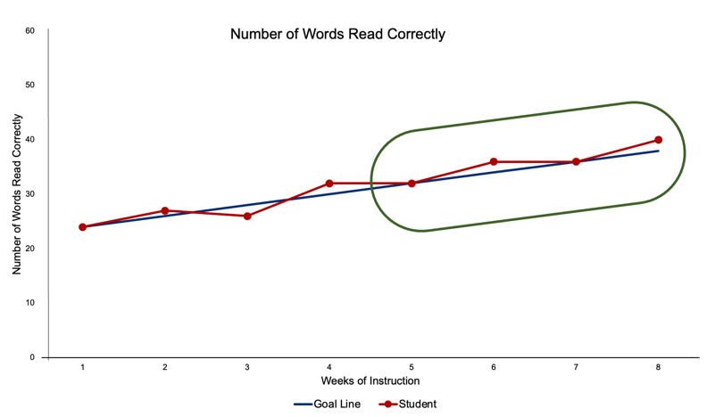
If the four most recent data points are on or around the goal line, it is one indication that the student is making adequate progress and showing a positive response to the intervention. The intervention should continue as planned if a similar response is seen across other data sources. An example of this is shown in the graph below.

Inadequate Progress
If the four most recent data points fall below the goal line, it is one indication that the student is not making adequate progress and is responding poorly to intervention. Teams should consider a change to the intervention to increase effectiveness if a similar response is seen across other data sources. An example of this is shown in the graph below.
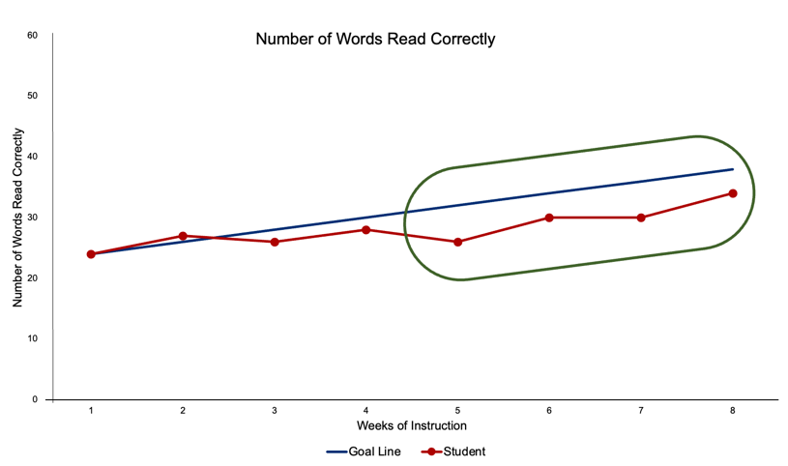

Note. The four-point method allows quick evaluation of progress but is not appropriate to use in all situations. If student data is highly variable or if students do not have a clear pattern of four consecutive data points above or below the goal line, use trend line analysis instead (The Iris Center, 2014).

Trend Line Analysis
In trend line analysis, a trend line representing the student's rate of growth over time is generated using the student's progress monitoring data and compared to the goal line (National Center on Response to Intervention, 2013). Trend lines can be drawn using various methods, including linear regression. Trend lines are helpful as they provide a visual illustration of the student's current performance and future progress.

Adequate Progress
If the student's trend line is steeper or the same as the goal line, it is one indication the student is making adequate progress and showing a positive response to intervention. The intervention should continue as planned if a similar response is seen across other data sources. An example of this is shown in the graph below.
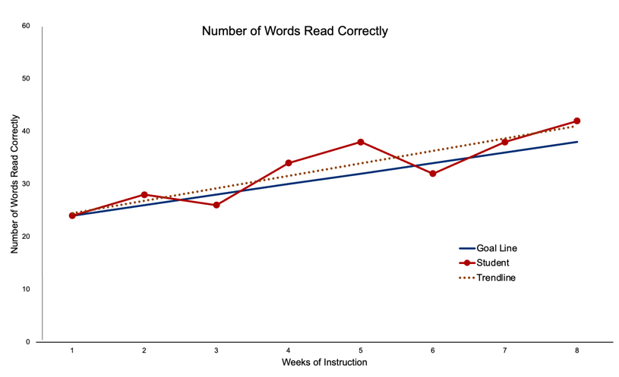

Inadequate Progress
If the student's trend line is flatter than the goal line, it is one indication the student is making inadequate progress and responding poorly to intervention. Teams should consider a change to the intervention to increase effectiveness if a similar response is seen across other data sources. An example of this is shown in the graph below.
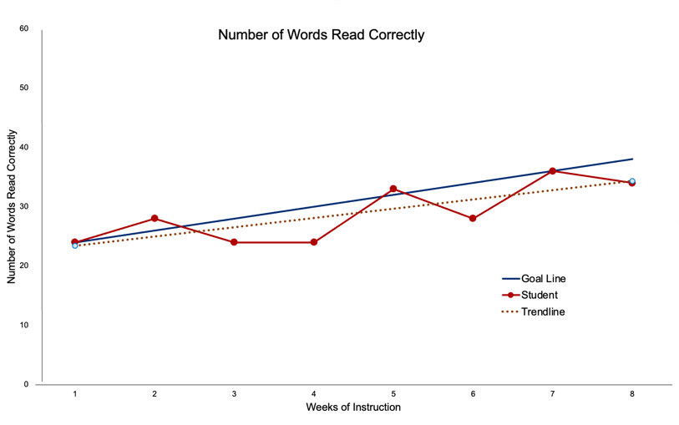

Note. The Tukey method is another method that can be used to draw students' trend lines and is less affected by outliers.

Probing Questions
When interpreting student progress data, teams should consider several key questions to ensure accurate and effective decision-making. These questions can guide educators when determining whether a student is on track to meet their goals. It is also essential to consider whether the intervention is being implemented with fidelity and whether the progress monitoring tools appropriately align with the skills targeted in the intervention. By addressing these questions, teams can make informed adjustments regarding instruction and improve student outcomes.

Teams can ask these questions when interpreting the data:
- Will the student reach the established goal within a reasonable time period?
- Are there data outliers that should be excluded from our analysis?
- What do our other data sources tell us?
- Is the intervention being implemented with fidelity?
- Are our progress monitoring probes sensitive to change and aligned with skills targeted by the intervention?
(National Center on Intensive Intervention, 2023)

References
National Center on Response to Intervention (2013, January). Progress monitoring brief #3: Common progress monitoring graph omissions: Making instructional decisions. Washington, DC: U.S. Department of Education, Office of Special Education Programs, National Center on Response to Intervention. https://files.eric.ed.gov/fulltext/ED578046.pdf

National Center on Intensive Interventions at the American Institutes for Research. (2023, January). Data rich, information poor? Making sense of progress monitoring data to guide intervention decisions. https://intensiveintervention.org/resource/data-rich-information-poor-making-sense-progress-monitoring-data-guide-intervention

Tennessee Department of Education. (2023). Response to instruction and intervention framework. https://www.tn.gov/content/dam/tn/education/special-education/rti/Updated_RTI2_Manual.pdf

The IRIS Center (2014). Evidence-based practices (part 1): Identifying and selecting a practice or program. https://iris.peabody.vanderbilt.edu/module/ebp_01/

