
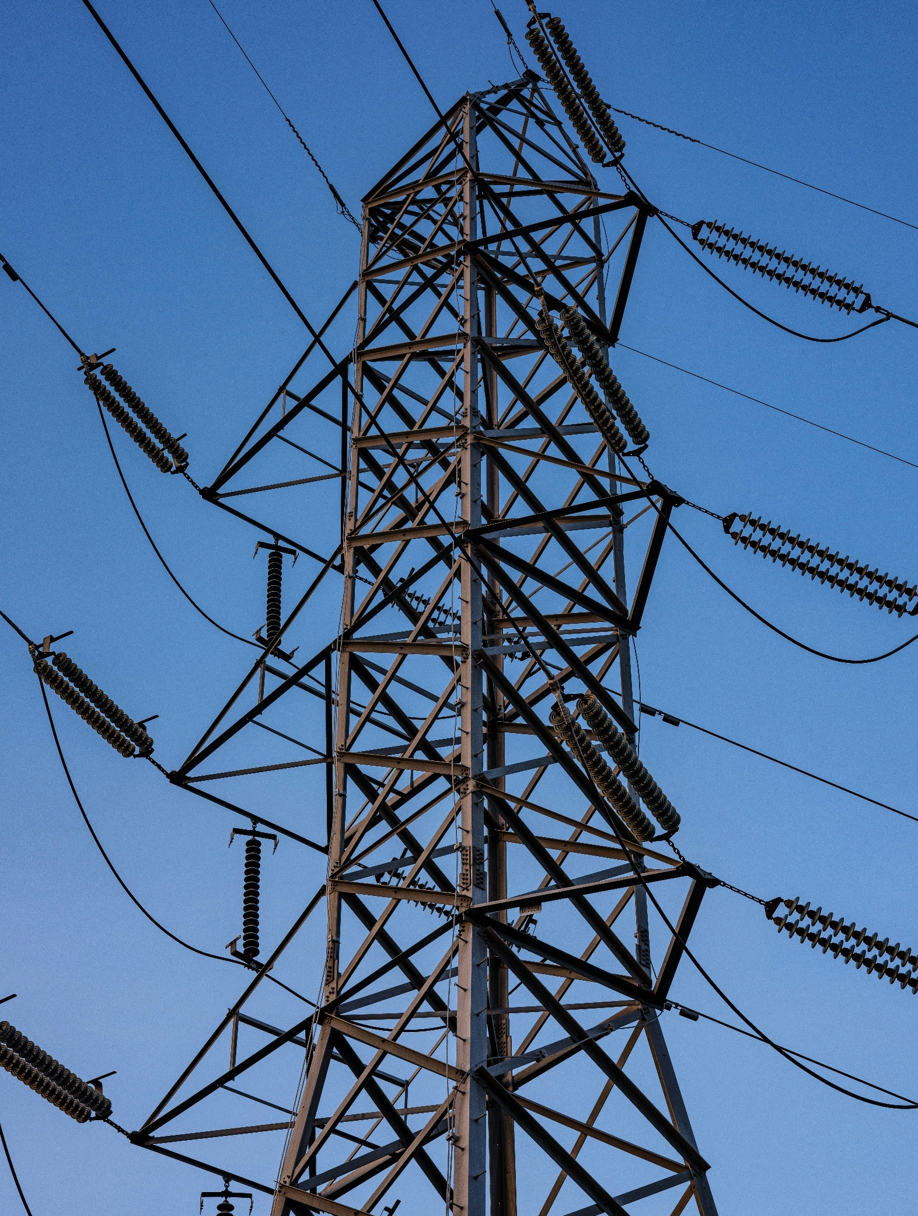

[Registered Entity Name]
NERC ID: [NCRXXXXX]

EOP-012-3 – Extreme Cold Weather Preparedness and Operations
R1, R3, R4, R5, R6 and R7
2026 Self-Certification

TABLE OF CONTENTS
Instructions 2
Scope 3
Assessment Guidance 4
Requirement 1 4
Requirement 3 7
Requirement 4 9
Requirement 5 12
Requirement 6 15
Requirement 7 18
For Previous Compliance Monitoring engagement follow-up 20

Instructions
- Populate the cover page by adding your entity’s name and NERC identification number.
- Complete the tasks listed under Assessment Guidance.
- Log into Align and complete your self-certification response.
- Submit via the Secure Evidence Locker (SEL):
  - This completed Worksheet; and
  - Specific evidence requested within this document. Please make sure to use unique file names for each evidence file submitted and identify within your narratives which specific evidence files support each conclusion made. These references and the use of unique file names helps facilitate and expedite NPCC’s review of the Self-Certification work that has been performed.

Scope
EOP-012-3 – Extreme Cold Weather Preparedness and Operations: R1, R3, R4, R5, R6 and R7

Assessment Guidance

Requirement 1
Provide a brief explanation, in your own words, of how you comply with EOP-012-3 R1. References to supplied evidence, including references to the appropriate page, are recommended.

Populate Table 1 with the file names of any documents referenced above that will be submitted as evidence. Add additional rows as necessary:
Table 1: Document File Names
File Name | Document Title | Revision or Version | Document Date | Relevant Page(s) or Section(s) | Description of Applicability of Document

Evidence Requests:
Note: If any of the below questions are addressed in your narrative response above, please write “This is covered in the narrative response above.”
R1.
1. For each applicable generating unit under your entity, please provide:
• the Extreme Cold Weather Temperature,
• the date of calculation,
• how the temperature was calculated; and
• the source of the temperature data.

[Provide any evidence narratives here]

2. Has your entity recalculated the Extreme Cold Weather Temperature after October 1, 2024, the effective date of EOP-012-2? If so, please describe what prompted the recalculation, when the recalculation was completed, the process used for the recalculation, and any changes made because of this recalculation. If applicable, please provide the Corrective Action Plan(s) your entity developed from R1.1.1, along with documentation of the review of your cold weather preparedness plan(s).
[Provide any evidence narratives here]

3. How does your entity handle missing or invalid hourly temperature data in the calculation of its Extreme Cold Weather Temperature (ECWT)? What adjustments, if any, were made to the ECWT?
[Provide any evidence narratives here]

- Where is the cold weather data for each applicable generating unit documented? If not already provided, please provide this information.

[Provide any evidence narratives here]

5. How did your entity calculate the generating unit(s) operating limitations for cold weather?
[Provide any evidence narratives here]

6. For each applicable generating unit, does your unit have the ability to use multiple fuel sources? If so, please describe the sources and the process of switching between them.
[Provide any evidence narratives here]

7. Describe your entity’s generating unit(s) minimum: (Please note which option used for each generating unit from the three below)
• Design temperature, and if available, the concurrent wind speed and precipitation;
• Historical operating temperature at least one hour in duration, and if available, the concurrent wind speed and precipitation; or
• Current cold weather performance temperature determined by an engineering analysis, which includes the concurrent wind speed and precipitation were calculated.

[Provide any evidence narratives here]

8. Please describe or provide your entity’s process for ensuring each generating unit’s ECWT and generating unit(s) cold weather data is updated as required.
[Provide any evidence narratives here]

9. Please provide an Internal Control Matrix, flowcharts, or similar document(s), which details the internal controls in place for this requirement, frequency of the internal control, the person/department responsible for the internal control, and any testing of the internal control.
[Provide any evidence narratives here]

Populate Table 2 with the file names of any documents referenced above in requests 1 – 9 that will be submitted as evidence. Add additional rows as necessary.
Table 2: Document File Names
File Name | Document Title | Revision or Version | Document Date | Relevant Page(s) or Section(s) | Description of Applicability of Document

Requirement 3
Provide a brief explanation, in your own words, of how you comply with EOP-012-3 R3. References to supplied evidence, including references to the appropriate page, are recommended.

Populate Table 3 with the file names of any documents referenced above that will be submitted as evidence. Add additional rows as necessary:
Table 3: Document File Names
File Name | Document Title | Revision or Version | Document Date | Relevant Page(s) or Section(s) | Description of Applicability of Document

Evidence Requests:
Note: If any of the below questions are addressed in your narrative response above, please write “This is covered in the narrative response above.”
R3.
1. Please provide a list of your entity’s applicable generating unit(s) whose Extreme Cold Weather Temperature (ECWT) determined to be at or below 32 degrees Fahrenheit (zero degrees Celsius) that self-commits or is required to operate at or below a temperature of 32 degrees Fahrenheit (zero degrees Celsius).

[Provide any evidence narratives here]

2. Please provide a list of implemented freeze protection measures used to protect your entity’s applicable generating unit(s) Generator Cold Weather Critical Components.
[Provide any evidence narratives here]

3. Have all freeze protections to protect your Generator Cold Weather Critical Components been implemented? If not, please provide your Corrective Action Plan(s) showing milestones and scheduled completion dates (or completion dates for those already completed) for new or modified freeze protection measures to operate at your generating unit(s) ECWT.
[Provide any evidence narratives here]

4. How did your entity determine the freeze protection measure(s) would result in your generating unit(s) being able to operate at its ECWT?
[Provide any evidence narratives here]

5. Please provide an Internal Control Matrix, flowcharts, or similar document(s), which details the internal controls in place for this requirement, frequency of the internal control, the person/department responsible for the internal control, and any testing of the internal control.
[Provide any evidence narratives here]

Populate Table 4 with the file names of any documents referenced above in requests 1 – 5 that will be submitted as evidence. Add additional rows as necessary.
Table 4: Document File Names
File Name | Document Title | Revision or Version | Document Date | Relevant Page(s) or Section(s) | Description of Applicability of Document

Requirement 4
Provide a brief explanation, in your own words, of how you comply with EOP-012-3 R4. References to supplied evidence, including references to the appropriate page, are recommended.

Populate Table 5 with the file names of any documents referenced above that will be submitted as evidence. Add additional rows as necessary:
Table 5: Document File Names
File Name | Document Title | Revision or Version | Document Date | Relevant Page(s) or Section(s) | Description of Applicability of Document

Evidence Requests:
Note: If any of the below questions are addressed in your narrative response above, please write “This is covered in the narrative response above.”
R4.
1. If not provided above, please provide the cold weather preparedness plan(s) for each applicable generating unit.

[Provide any evidence narratives here]

2. Please specify where in your cold weather preparedness plan(s) the information for R4.1, R4.2, R4.3, R4.4, and R4.5 is documented.
[Provide any evidence narratives here]

3. How did your entity determine its list(s) of Generator Cold Weather Critical Components? What criteria were used? Please specify which, if any components, are located outside.

[Provide any evidence narratives here]

- For each Generator Cold Weather Critical Component, how did your entity determine what freeze protection measures were applied? How did your entity specifically consider the effects of wind or freezing precipitation?

[Provide any evidence narratives here]

5. Has your entity added or removed freeze protection measures to any Generator Cold Weather Critical Components since the effective date of this standard? If so, please describe the measures and why they were added or removed.

[Provide any evidence narratives here]

- What type of annual inspection and maintenance of generating unit(s) freeze protection measures are used for your entity’s generating unit(s)? How did your entity determine that this inspection and maintenance is adequate?

[Provide any evidence narratives here]

7. Please provide evidence that your entity has implemented its cold weather preparedness plan(s). This could include inspection and maintenance records for freeze protection measures on your Generator Cold Weather Critical Components.
[Provide any evidence narratives here]

8. Please provide an Internal Control Matrix, flowcharts, or similar document(s), which details the internal controls in place for this requirement, frequency of the internal control, the person/department responsible for the internal control, and any testing of the internal control.
[Provide any evidence narratives here]

Populate Table 6 with the file names of any documents referenced above in requests 1 – 8 that will be submitted as evidence. Add additional rows as necessary.
Table 6: Document File Names
File Name | Document Title | Revision or Version | Document Date | Relevant Page(s) or Section(s) | Description of Applicability of Document

Requirement 5
Provide a brief explanation, in your own words, of how you comply with EOP-012-3 R5. References to supplied evidence, including references to the appropriate page, are recommended.

Populate Table 7 with the file names of any documents referenced above that will be submitted as evidence. Add additional rows as necessary:
Table 7: Document File Names
File Name | Document Title | Revision or Version | Document Date | Relevant Page(s) or Section(s) | Description of Applicability of Document

Evidence Requests:
Note: If any of the below questions are addressed in your narrative response above, please write “This is covered in the narrative response above.”
R5.
- Who is responsible for providing generator unit-specific training? How was that determination made between the Generator Owner and Generator Operator?

[Provide any evidence narratives here]

2. Which personnel are required to be trained on your entity’s cold weather preparedness plan(s)? How does your entity identify necessary personnel?
[Provide any evidence narratives here]

3. If not already provided, please provide the training material used for this requirement. Who develops the training material? How does your entity ensure that this training material is unit-specific?

[Provide any evidence narratives here]

- If not already provided, please provide the evidence confirming the completion of training for the relevant personnel.

[Provide any evidence narratives here]

- How does your entity ensure that your entity provides the applicable training annually?

[Provide any evidence narratives here]

- What internal controls are in place to ensure the training material is updated if there have been changes to the applicable cold weather preparedness plan(s)?

[Provide any evidence narratives here]

- Please provide an Internal Control Matrix, flowcharts, or similar document(s), which details the internal controls in place for this requirement, frequency of the internal control, the person/department responsible for the internal control, and any testing of the internal control.

[Provide any evidence narratives here]

Populate Table 8 with the file names of any documents referenced above in requests 1 – 7 that will be submitted as evidence. Add additional rows as necessary.
Table 8: Document File Names
File Name | Document Title | Revision or Version | Document Date | Relevant Page(s) or Section(s) | Description of Applicability of Document

Requirement 6
Provide a brief explanation, in your own words, of how you comply with EOP-012-3 R6. References to supplied evidence, including references to the appropriate page, are recommended.

Populate Table 9 with the file names of any documents referenced above that will be submitted as evidence. Add additional rows as necessary:
Table 9: Document File Names
File Name | Document Title | Revision or Version | Document Date | Relevant Page(s) or Section(s) | Description of Applicability of Document

Evidence Requests:
Note: If any of the below questions are addressed in your narrative response above, please write “This is covered in the narrative response above.”
R6.
- Have any of your applicable generating units experienced a Generator Cold Weather Reliability Event (GCWRE)? If yes, provide a summary of the Generator Cold Weather Reliability Event along with the Corrective Action Plan(s) detailing each Requirement R6.3 subparts. If no, please describe how it was determined that your applicable generating unit(s) did not experience a GCWRE.
[Provide any evidence narratives here]

- Please describe your process for developing a Corrective Action Plan (CAP) after experiencing a Generator Cold Weather Reliability Event.
[Provide any evidence narratives here]

- Have any units experiencing a Generator Cold Weather Reliability Event required a Generator Cold Weather Constraint (GCWC) to be declared? If yes, provide a summary of the GCWC for the applicable generating unit(s). If no, please describe how this was determined.
[Provide any evidence narratives here]

- Please provide your entity’s Extreme Cold Weather Temperature for applicable generating unit(s).
[Provide any evidence narratives here]

- If your entity’s applicable generating unit(s) experienced a Generator Cold Weather Reliability Event, please provide the process documentation and results of your generation fleet review along with any Corrective Action Plan(s) developed or updated, according to R6.2. For each Corrective Action Plan be sure to highlight all aspects of R6.3 subparts.
[Provide any evidence narratives here]

- Has your entity previously experienced a Generator Cold Weather Reliability Event and developed a Corrective Action Plan for the generating unit(s) under R6.1 or R6.2? If so, please provide the pertinent details.

[Provide any evidence narratives here]

- If applicable, did or will your entity require an extension to its original Corrective Action Plan(s) (CAP(s)), according to R6.4? If so, please provide any pertinent details and the CAP.
[Provide any evidence narratives here]

- Please provide an Internal Control Matrix, flowcharts, or similar document(s), which details the internal controls in place for this requirement, frequency of the internal control, the person/department responsible for the internal control, and any testing of the internal control.

[Provide any evidence narratives here]

Populate Table 10 with the file names of any documents referenced above in requests 1 – 8 that will be submitted as evidence. Add additional rows as necessary.
Table 10: Document File Names
File Name | Document Title | Revision or Version | Document Date | Relevant Page(s) or Section(s) | Description of Applicability of Document

Requirement 7
Provide a brief explanation, in your own words, of how you comply with EOP-012-3 R7. References to supplied evidence, including references to the appropriate page, are recommended.

Populate Table 11 with the file names of any documents referenced above that will be submitted as evidence. Add additional rows as necessary:
Table 11: Document File Names
File Name | Document Title | Revision or Version | Document Date | Relevant Page(s) or Section(s) | Description of Applicability of Document

Evidence Requests:
Note: If any of the below questions are addressed in your narrative response above, please write “This is covered in the narrative response above.”
R7.
- Have any Corrective Action Plans been developed pursuant to Requirements R1, R3 or R9? If yes, please provide a summary of the Corrective Action Plan(s) and the applicable generating unit(s) including source of the Corrective Action Plan (i.e., R1, R3, or R9).
[Provide any evidence narratives here]

2. How does your entity manage the implementation of Corrective Action Plans (CAPs)?
[Provide any evidence narratives here]

- For any Corrective Action Plans (CAPs) developed, has your entity encountered delays due to circumstances beyond your control and submitted an extension request? If so, please provide supporting documentation.

[Provide any evidence narratives here]

- Please provide an Internal Control Matrix, flowcharts, or similar document(s), which details the internal controls in place for this requirement, frequency of the internal control, the person/department responsible for the internal control, and any testing of the internal control.

[Provide any evidence narratives here]

Populate Table 12 with the file names of any documents referenced above in requests 1 – 4 that will be submitted as evidence. Add additional rows as necessary.
Table 12: Document File Names
File Name | Document Title | Revision or Version | Document Date | Relevant Page(s) or Section(s) | Description of Applicability of Document

For Previous Compliance Monitoring engagement follow-up
If applicable, provide your follow-up actions on the previous Compliance Monitoring engagement’s areas of concern (AOC) and recommendations for EOP-011-2 R7 or R8 and EOP-012-2. Compliance Monitoring engagements include audits (on-site or off-site), spot-checks, and self-certifications.

Populate Table 13 with the file names of any documents referenced above that will be submitted as evidence. Add additional rows as necessary.

Table 13: Document File Names
File Name | Document Title | Revision or Version | Document Date | Relevant Page(s) or Section(s) | Description of Applicability of Document


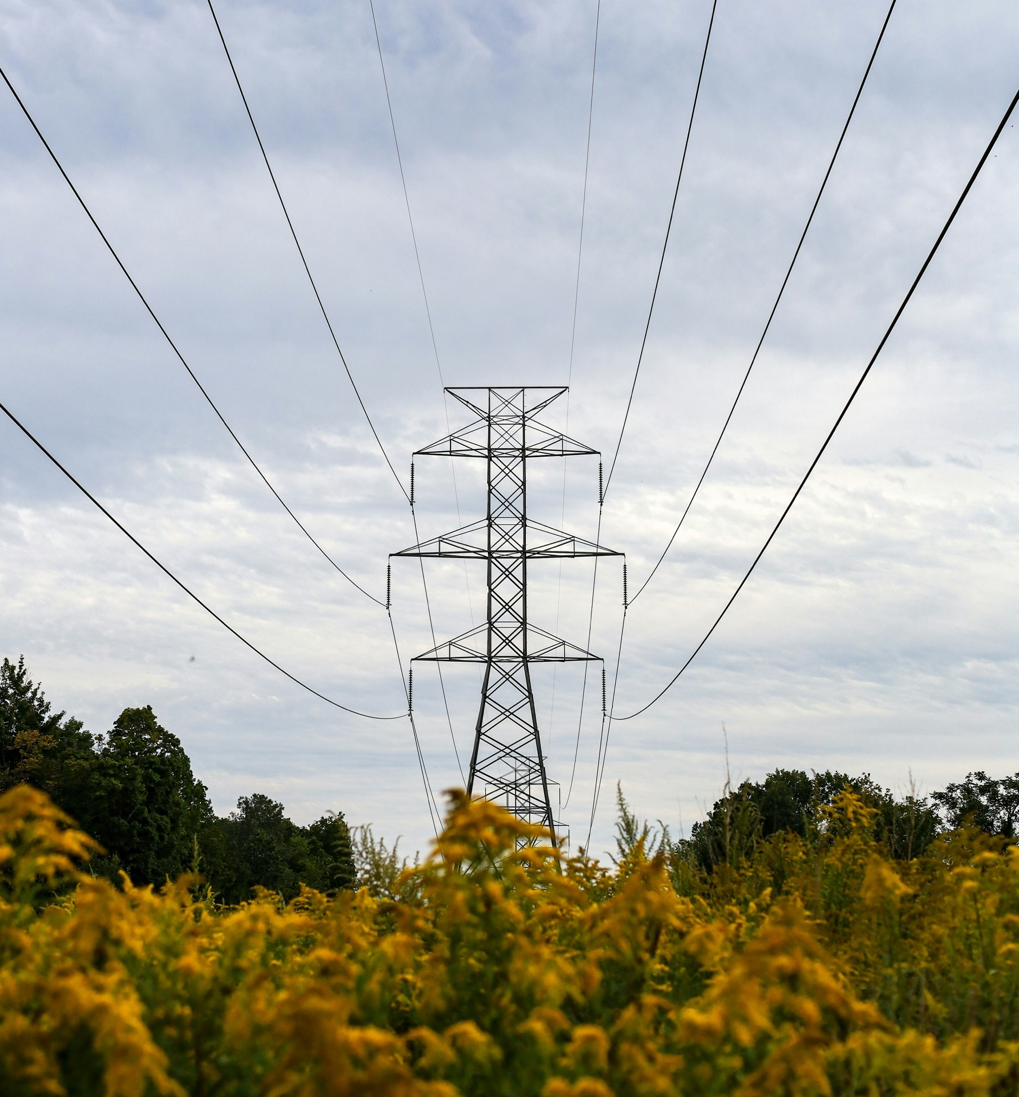

NPCC is dedicated to the continued reliability of the Bulk Power System in Northeastern North America.

NPCC is dedicated to the continued reliability of the Bulk Power System in Northeastern North America.
1040 Avenue of the Americas, 4th Floor
New York, NY 10018
www.npcc.org

1040 Avenue of the Americas 4th Floor
New York, NY 10018
www.npcc.org

Please visit the NERC Training Site for access to all Align and ERO SEL training materials, including training videos, user guides, and start, stop, continue guides.

