
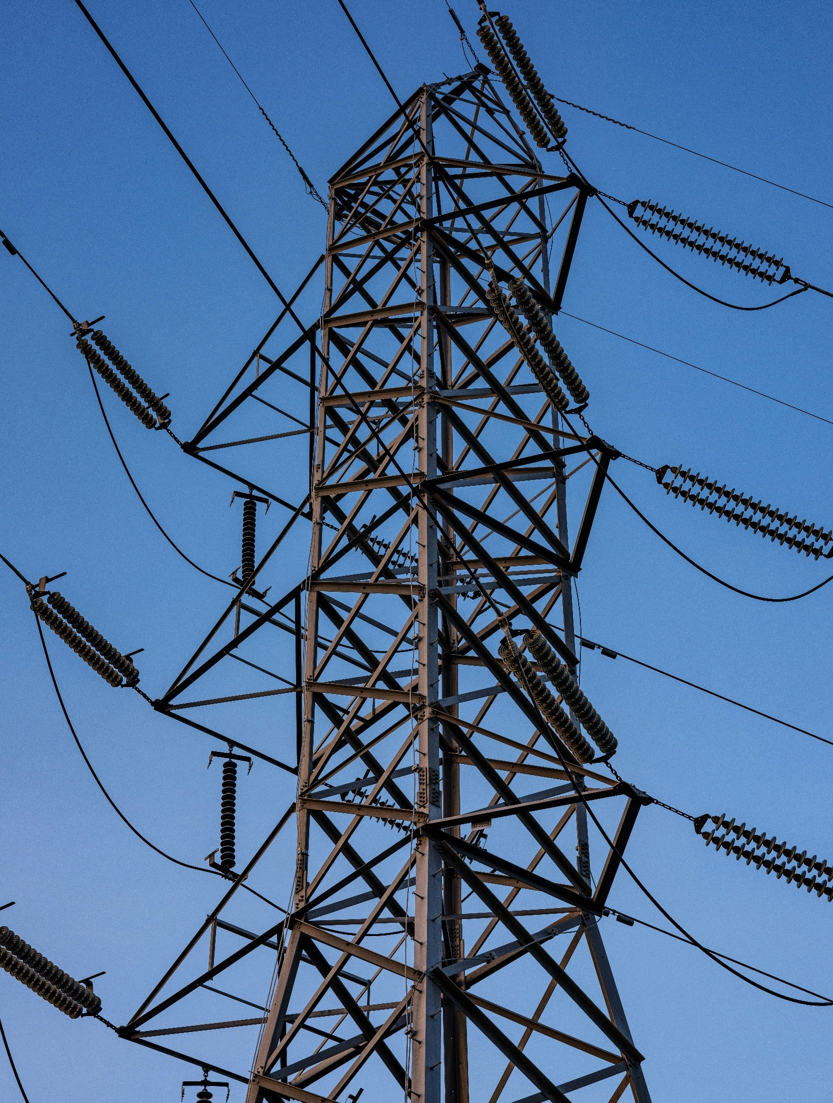
[Registered Entity Name]
NERC ID: [NCRXXXXX]

CIP-003-8 – Cyber Security – Security Management Controls
R2 Section 2, 3, 5
2026 Self-Certification

TABLE OF CONTENTS
Instructions 2
Scope 3
Assessment Guidance 4
Requirement 2 4
R2, Section 2 5
R2, Section 3.1 6
R2, Section 3.2 7
R2, Section 5.1 8
R2, Section 5.2 9
R2, Section 5.3 10
For Previous Compliance Monitoring Engagement Follow-up 12

Instructions
- Populate the cover page by adding your entity’s name and NERC identification number.
- Complete the tasks listed under Assessment Guidance.
- Log into Align and complete your self-certification response.
- Submit via the Secure Evidence Locker (SEL):
  - This completed Worksheet; and
  - Specific evidence requested within this document. Please make sure to use unique file names for each evidence file submitted and identify within your narratives which specific evidence files support each conclusion made. These references and the use of unique file names helps facilitate and expedite NPCC’s review of the Self-Certification work that has been performed.

Scope
CIP-003-8 Cyber Security – Security Management Controls; R2 Section 2, 3, 5

Assessment Guidance

Requirement 2
Provide a brief explanation, in your own words, of how you comply with CIP-003-8 R2 Sections 2, 3, and 5. References to supplied evidence, including references to the appropriate page(s), are recommended.

Populate Table 1 with the file names of any documents referenced above that will be submitted as evidence. Add additional rows as necessary:
Table 1: Document File Names
File Name | Document Title | Revision or Version | Document Date | Relevant Page(s) or Section(s) | Description of Applicability of Document

Evidence Requests:
Note: If any of the below questions are addressed in your narrative response above, please write “This is covered in the narrative response above.”

R2:

- Provide the documented cyber security plans for low impact BES Cyber Systems that address the required sections in Attachment 1.

[Provide any evidence narratives here]

R2, Section 2

  - Generate a list of all your BES Assets which contain a low impact BES Cyber System.

  - Select a random sample from the population of your assets identified in Step a., using the following sampling logic (a random sample may be selected using statistical functions available in Microsoft Excel, through use of https://www.random.org/integer-sets/?mode=advanced), or other statistical tool:
    - Select eight of your assets or locations if your total population is nine or greater;
    - If eight or fewer total assets or locations exist in the population, select the entire population.

  - Fill in Table 2 with the evidence of the sampling process used including:
- Samples selected (per Step b.)
- Evidence of the sampling process or tool utilized to create the sample (e.g. what are your samples and how are they created)

Table 2: Sampling
File Contents | File Name / Page(s)
Samples Selected
Statistical Function Output
Comments

- For each of the BES Assets which contain a low impact BES Cyber System generated in the sample above, provide evidence that physical security controls were implemented to control physical access, based on need as determined by entity, to:

- The asset or the locations of the low impact BES Cyber Systems within the asset; and
- The Cyber Asset(s), as specified by the Responsible Entity, that provide electronic access control(s) implemented for Section 3.1, if any.

[Provide any evidence narratives here]

R2, Section 3.1

- Generate a list of all your BES Assets which contain a low impact BES Cyber System with routable protocol communication entering or leaving the asset containing the low impact BES Cyber System.

- Select a random sample from the population of your assets identified in Step a., using the following sampling logic (a random sample may be selected using statistical functions available in Microsoft Excel, through use of https://www.random.org/integer-sets/?mode=advanced), or other statistical tool:
- Select eight of your assets or locations if your total population is nine or greater;
- If eight or fewer total assets or locations exist in the population, select the entire population.

- Fill in Table 3 with the evidence of the sampling process used including:
- Samples selected (per Step b.)
- Evidence of the sampling process or tool utilized to create the sample (e.g. what are your samples and how are they created)

Table 3: Sampling
File Contents | File Name / Page(s)
Samples Selected
Statistical Function Output
Comments

- For each BES asset containing a low impact BES Cyber System in the Sample Set above, provide the following evidence:

- Representative diagram(s) of the specific implementation of electronic access control(s);
- The inbound and outbound electronic access permissions; and
- Documentation that the enabled inbound and outbound electronic access are necessary.

[Provide any evidence narratives here]

R2, Section 3.2

- Generate a list of all your BES Assets which contain a low impact BES Cyber System with Dial-up Connectivity.

- Select a random sample from the population of your assets identified in Step a., using the following sampling logic (a random sample may be selected using statistical functions available in Microsoft Excel, through use of https://www.random.org/integer-sets/?mode=advanced), or other statistical tool:
- Select eight of your assets or locations if your total population is nine or greater;
- If eight or fewer total assets or locations exist in the population, select the entire population.

- Fill in Table 4 with the evidence of the sampling process used including:
- Samples selected (per Step b.)
- Evidence of the sampling process or tool utilized to create the sample (e.g. what are your samples and how are they created)

Table 4: Sampling
File Contents | File Name / Page(s)
Samples Selected
Statistical Function Output
Comments

- For each BES asset containing a low impact BES Cyber System in the Sample Set above, provide the following evidence:

- Representative diagram(s) of the specific implementation of Dial-up Connectivity; and
- For each BES Cyber Asset with Dial-up Connectivity:
    - Documentation of implemented method(s) used for Dial-up Connectivity authentication; or
    - Documentation of the incapability of the BES Cyber Asset to perform authentication.

[Provide any evidence narratives here]

R2, Section 5.1

- Generate a list of all your Transient Cyber Assets managed by yourself for BES Assets which contain a low impact BES Cyber System.

- Select a random sample from the population of your assets identified in Step a, using the following sampling logic (a random sample may be selected using statistical functions available in Microsoft Excel, through use of https://www.random.org/integer-sets/?mode=advanced), or other statistical tool:
- Select eight of your assets or locations if your total population is nine or greater;
- If eight or fewer total assets or locations exist in the population, select the entire population.

- Fill in Table 5 with the evidence of the sampling process used including:
- Samples selected (per Step b)
- Evidence of the sampling process or tool utilized to create the sample (e.g. what are your samples and how are they created)

Table 5: Sampling
File Contents | File Name / Page(s)
Samples Selected
Statistical Function Output
Comments

- For the TCA managed in an ongoing, on-demand, or combination of both in the Sample Set from Step a, provide evidence that each TCA has:

- Antivirus software, including manual or managed updates of signatures or patterns;
- Application whitelisting; or
- Other method(s) to mitigate the introduction of malicious code.

[Provide any evidence narratives here]

R2, Section 5.2

- Generate a list of all your Transient Cyber Assets not managed by yourself for BES Assets which contain a low impact BES Cyber System.

- Select a random sample from the population of your assets identified in Step a, using the following sampling logic (a random sample may be selected using statistical functions available in Microsoft Excel, through use of https://www.random.org/integer-sets/?mode=advanced), or other statistical tool:
- Select eight of your assets or locations if your total population is nine or greater;
- If eight or fewer total assets or locations exist in the population, select the entire population.

- Fill in Table 6 with the evidence of the sampling process used including:
- Samples selected (per Step b)
- Evidence of the sampling process or tool utilized to create the sample (e.g. what are your samples and how are they created)

Table 6: Sampling
File Contents | File Name / Page(s)
Samples Selected
Statistical Function Output
Comments

- For each access to a low Impact BES Cyber System by a TCA not managed by yourself in the Sample Set from Step a, provide evidence, including the date and time performed, that each TCA implemented one or more of the following:

- Review of antivirus update level;
- Review of antivirus update process used by the party;
- Review of application whitelisting used by the party;
- Review use of live operating system and software executable only from read-only media;
- Review of system hardening used by the party; or
- Other method(s) to mitigate the introduction of malicious code.
- Additional mitigation actions prior to connecting as determined necessary by the Responsible Entity.

[Provide any evidence narratives here]

R2, Section 5.3

- Generate a list of all your Removable Media.

- Select a random sample from the population of your assets identified in Step a, using the following sampling logic (a random sample may be selected using statistical functions available in Microsoft Excel, through use of https://www.random.org/integer-sets/?mode=advanced), or other statistical tool:
- Select eight of your assets or locations if your total population is nine or greater;
- If eight or fewer total assets or locations exist in the population, select the entire population.

- Fill in Table 7 with the evidence of the sampling process used including:
- Samples selected (per Step b)
- Evidence of the sampling process or tool utilized to create the sample (e.g. what are your samples and how are they created)

Table 7: Sampling
File Contents | File Name / Page(s)
Samples Selected
Statistical Function Output
Comments

- For each use of Removable Media in the Sample Set from Step a, provide evidence of:
- Method(s) to detect malicious code on Removable Media using a Cyber Asset other than a BES Cyber System; and
- Mitigation of the threat of detected malicious code, if any detected during the audit period, on the Removable Media prior to connecting Removable Media to a low impact BES Cyber System.

[Provide any evidence narratives here]

Internal Controls:
- If available, provide an Internal Control Matrix, flowcharts, or similar document(s), which details the internal controls in place for this requirement, frequency of the internal control, the person/dept. responsible for the internal control, and any testing of the internal control.
[Provide any evidence narratives here]

Populate Table 8 with the file names of any documents referenced above that will be submitted as evidence. Add additional rows as necessary.

Table 8: Document File Names
File Name | Document Title | Revision or Version | Document Date | Relevant Page(s) or Section(s) | Description of Applicability of Document

For Previous Compliance Monitoring Engagement Follow-up
If applicable, provide your follow-up actions on the previous Compliance Monitoring engagement’s areas of concern (AOC) and recommendations for CIP-003-8 R2. Compliance Monitoring engagements include audits (on-site or off-site), spot-checks, and guided self-certifications.

Populate Table 9 with the file names of any documents referenced above that will be submitted as evidence. Add additional rows as necessary.
Table 9: Document File Names
File Name | Document Title | Revision or Version | Document Date | Relevant Page(s) or Section(s) | Description of Applicability of Document


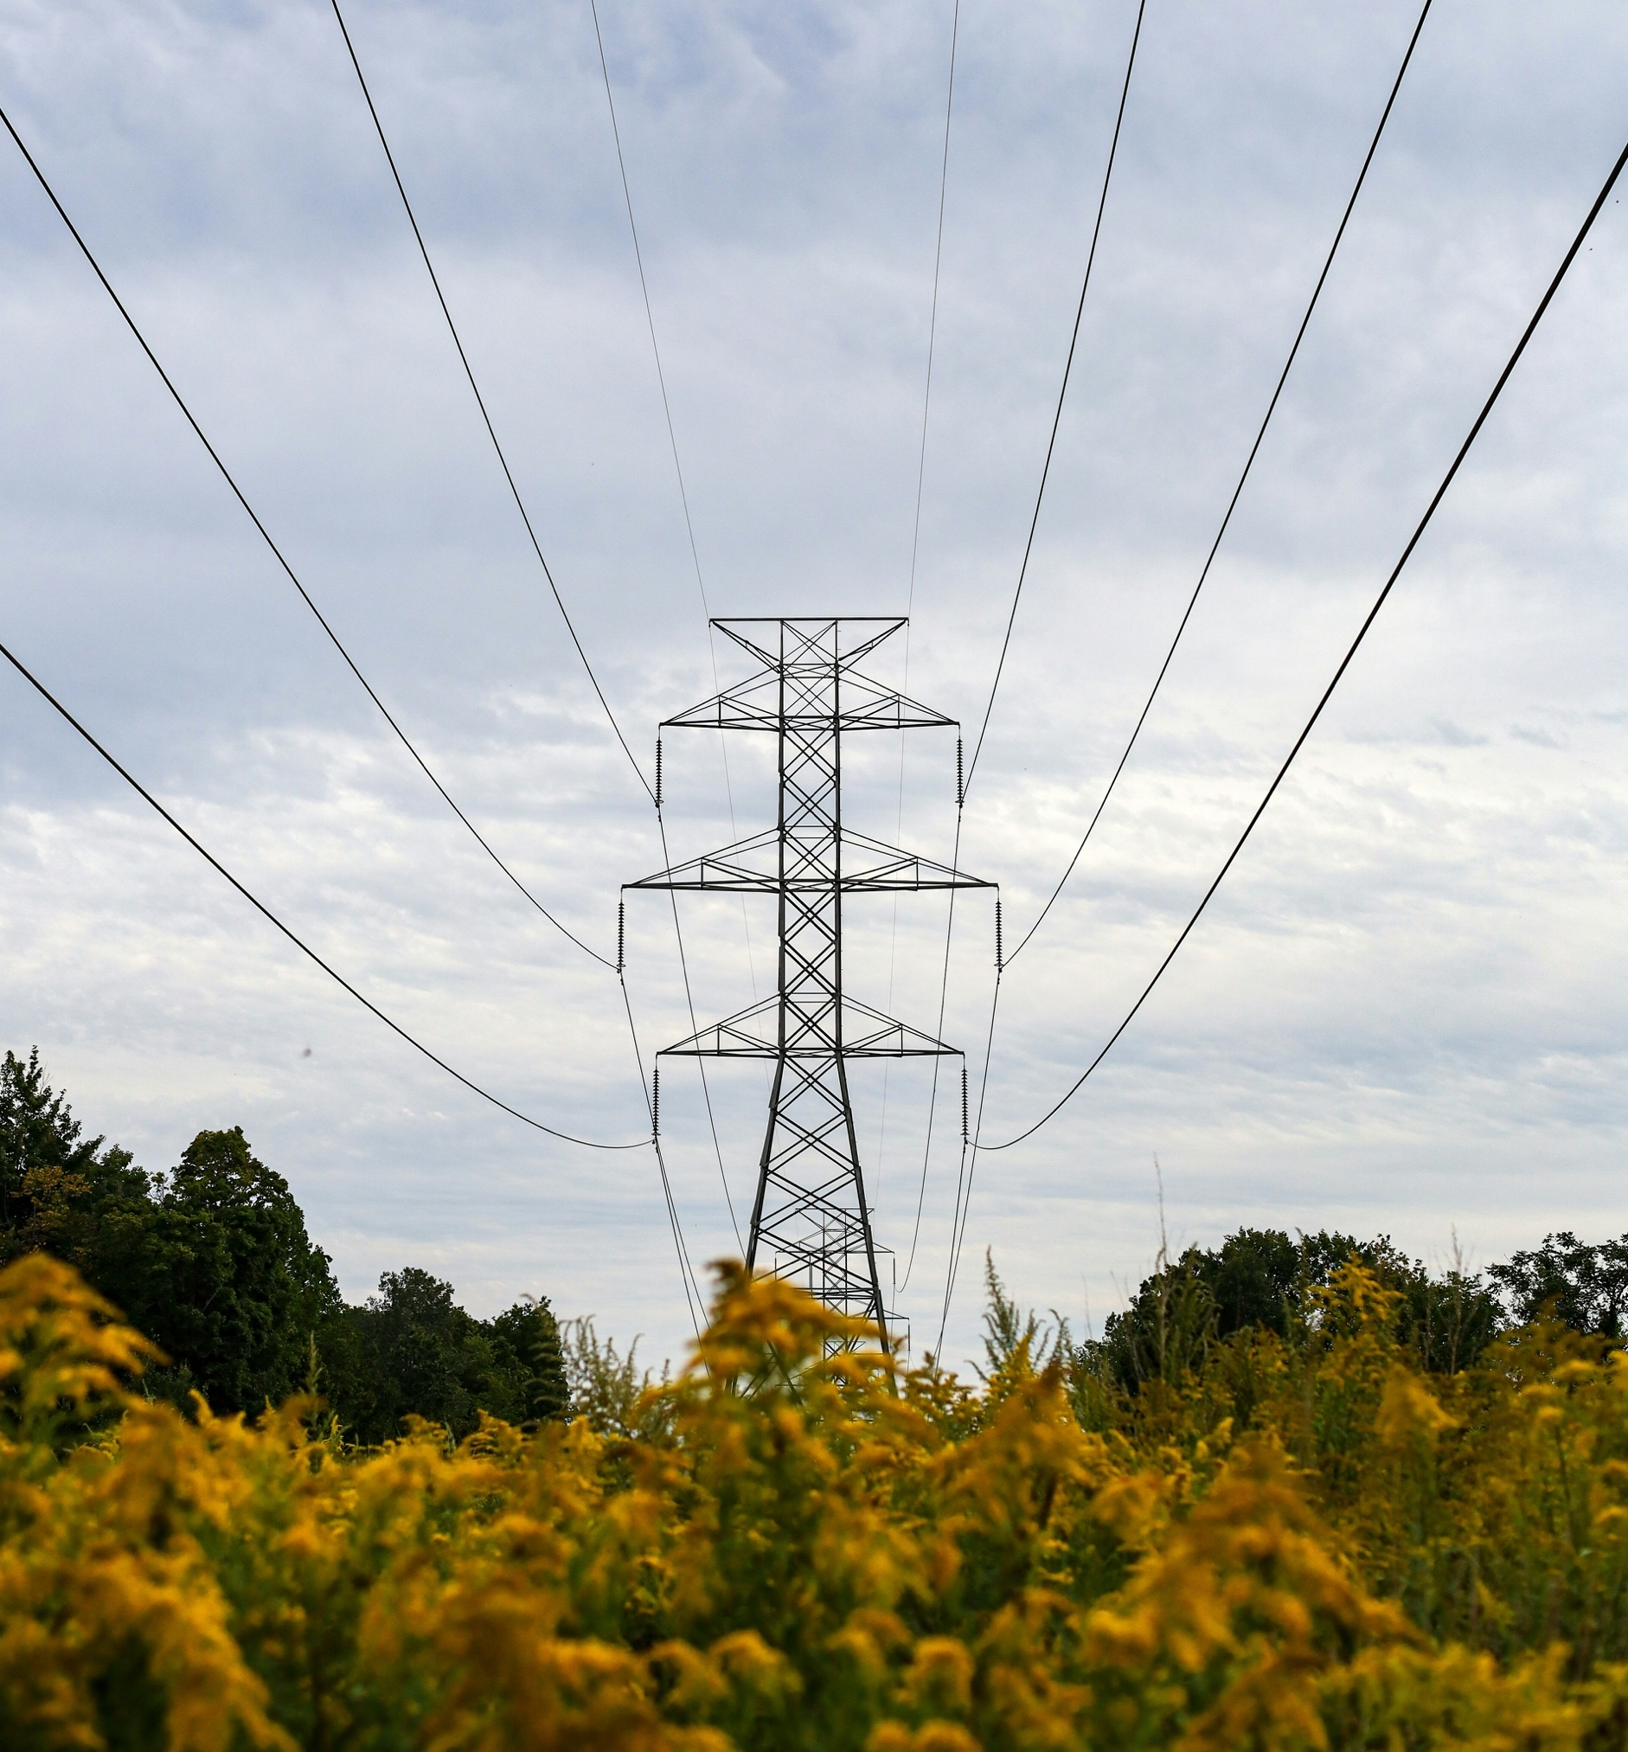

NPCC is dedicated to the continued reliability of the Bulk Power System in Northeastern North America.

NPCC is dedicated to the continued reliability of the Bulk Power System in Northeastern North America.
1040 Avenue of the Americas, 4th Floor
New York, NY 10018
www.npcc.org

1040 Avenue of the Americas 4th Floor
New York, NY 10018
www.npcc.org

Visit the NERC Training Site for access to all Align and ERO SEL training materials, including training videos, user guides, and start, stop, continue guides.

