Introduction
Dear Primary Compliance Contact,
This letter is intended to introduce and inform you of NPCC’s enforcement process.
The objective of the Enforcement review is to determine the extent of the noncompliance, assess the actual and potential risk, and ensure that the noncompliance is corrected and action is taken to prevent recurrence. The Enforcement review is conducted in accordance with the Compliance Monitoring and Enforcement Program (CMEP) and applicable NERC Rules of Procedure approved by the applicable regulator (in the United States, the Federal Energy Regulatory Commission). The Potential Noncompliance (PNC) under review must have a subject matter expert(s) available for the Enforcement team in case clarification of the submitted data is needed.


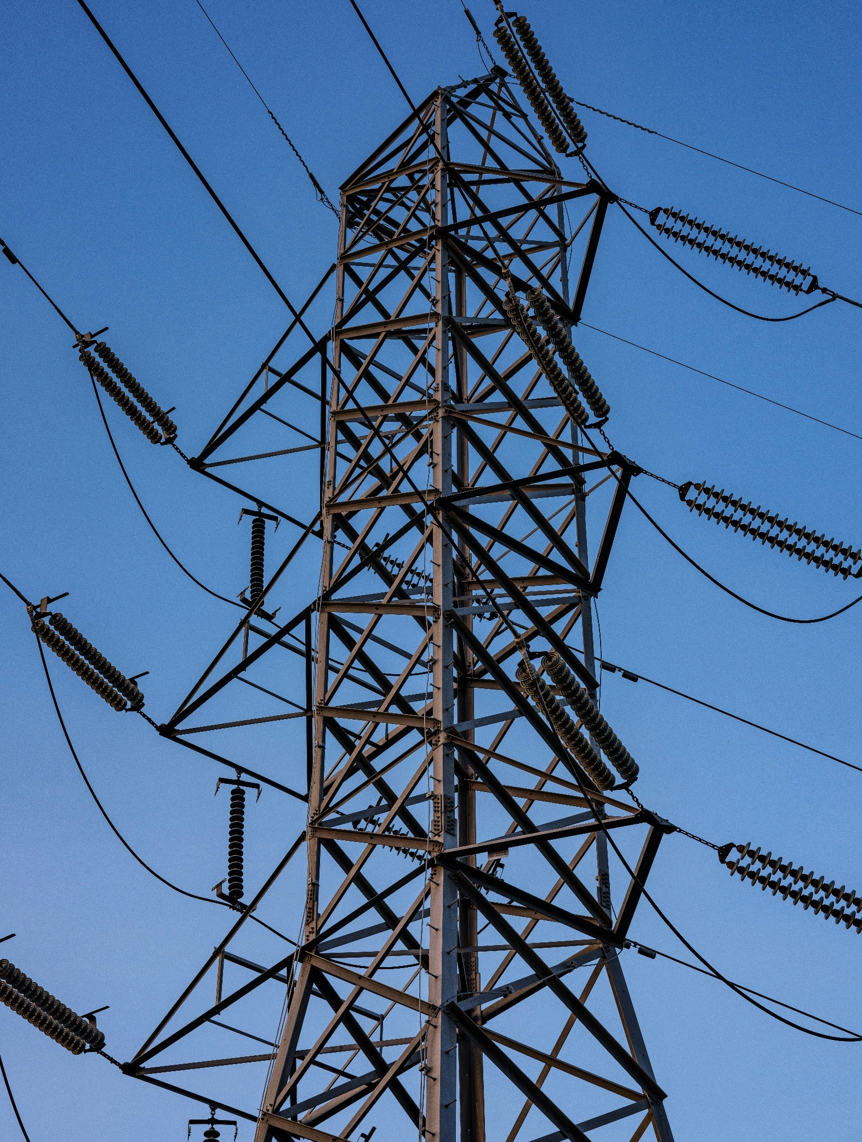

PRC-005-6 EIR
NPCC Enforcement Process

TABLE OF CONTENTS
Introduction 1
Enforcement Milestones and Deadlines 2
Align Quick Reference Guide 4
PRC-005-6 Enforcement Intake RFI 6
General Questions 6
PRC-005-6 R1 9
PRC-005-6 R3 11
PRC-005-6 R5 14
Revision History (For NPCC Use Only) 16

Enforcement Milestones and Deadlines
Please note the important dates/deadlines below (subject to change and may not be inclusive).
Activity | Utilization | Approximate Deadline
Preliminary Screen | To inform you that NPCC has confirmed the Standard and Requirements were applicable, the PNC is not a duplicate of an existing Open Enforcement Action, and to remind you of your obligation to preserve documentation pertaining to the PNC. | Within 10 business days after submittal
Triage | NPCC’s initial risk and mitigation assessment of your submitted PNC to determine priority and level of effort. NPCC internal process only. | Within 14 calendar days after submittal
Request for Information (RFI) | NPCC’s request to your organization to obtain information needed to complete Enforcement review. | Generally, 14 calendar days are given to respond for each RFI.
Request for Settlement | Your request to negotiate the terms of your disposition. | Entities can request settlement at any time.
Compliance Exception (CE) | To inform you that the PNC(s) is being filed as a minimal risk noncompliance with no monetary penalty. | Entity may object to the resolution within 7 calendar days.  - CE with completed mitigation will be considered closed 60 days after submitted to FERC unless NERC or FERC initiate a review within the 60-day review period.  - A CE with ongoing mitigation will not be closed until the mitigation is complete.  Any associated data hold is released 18 months from the date of CE notification or upon completion of mitigation activity, whichever is later.
Find, Fix, Track (FFT) | To inform you that the PNC(s) is being filed as a Minimal/Moderate risk noncompliance with no monetary penalty. | Entity may object to the resolution within 10 calendar days. Entity must provide affidavit within 10 calendar days.  - FFT with completed mitigation will be considered closed 60 days after FERC submittal unless NERC or FERC initiate a review within the 60-day review period.  - FFT with ongoing mitigation will not be closed until the mitigation is complete.  Any associated data hold is released 18 months from the date of the FFT treatment Notice or upon completion of mitigation activity, whichever is later.
Notice of Alleged Violation and Proposed Penalty or Sanction (NAVAPS) | To inform you that the PNC(s) is being considered for a monetary penalty or sanction. | Response required within 30 calendar days following the date of the NAVAPS. Otherwise, entity will have accepted the Compliance Enforcement Authority (CEA)’s determination.

Align Quick Reference Guide
How Do I…? | Video How-to | User Guide or Additional Information
Obtain an ERO Portal Account to access Align |  | - ERO Portal Website  - ERO Portal User Setup Guide  - Creating an ERO Portal Account (Pages 4-27)
Obtain or assign the correct credentials through ERO Portal. Within the ERO Portal, users can request the following access, and the Primary Compliance Contact approves.  - Align Submitter  - Align Reader  - Align Editor |  | - ERO Portal User Setup Guide  - Requesting Align Access (Pages 28-34)  - Approving Align Access Request (Pages 35-37)
Submit a Self-Report or Self-Log | (Video) Creating a Self-Report or Self-Log | - (User Guide) Creating a Finding (Pages 8-20)
Submit Mitigation  - User submits mitigation completion for regional verification | (Video) Submitting Mitigating Activities | - (User Guide) Submitting Mitigating Activities (Pages 28-33)  - (User Guide) Submitting Mitigation for CEA Verification (Page 41)
Respond to Noncompliance or Mitigation Requests for Information (RFI) | (Video) Responding to Mitigation RFI | - (User Guide) Responding to an RFI (Noncompliance) (Pages 25-28)  - (User Guide) Responding to an RFI (Mitigation) (Page 35)
Upload Evidence to the Secure Evidence Locker (SEL)  - User has SEL Submitter Role  - User has access to Align for SEL reference ID  User uses a TLS 1.3 compatible browser (e.g.: Chrome and Edge) | (Video) Submitting Evidence to SEL | - (Website) SEL Submission Website  - (User Guide) SEL
Update Finding with scope expansion. | (Video) Adding Information to a Self-Report after Submitting | - (User Guide) Updating a Finding (Pages 21-24)
Submit questions/issues with Align or the SEL  *Please add a screenshot of the issue* |  | - NERC Helpdesk Ticketing System

PRC-005-6 Enforcement Intake RFI
In the worksheet below please include all information regarding the noncompliance being reported. If you have any questions, please contact us through NPCC Contact Information. Thank you.

In the following table, include information for all instances associated with the possible noncompliance.

General Questions
NERC Potential Noncompliance (PNC) ID(s):  (List all that apply.) | Enter PNC ID(s); e.g., 2024-01234, 2024-01245
Function(s) associated with the PNC  (Select all that apply.) | ☐TO ☐GO ☐DP
Discovery Date of the PNC: | Enter the date the PNC was first identified.
Start Date of the PNC: | Enter the date upon which the PNC began
End Date/Expected End Date of the PNC: | Enter the date upon which the Entity returned to compliance or is expected to return to compliance.
Are Mitigating Activities (MAs) submitted in Align?  (Select either “Yes” or “No”.) | ☐ Yes ☐ No  If No, when will they be?  Enter the date mitigation is expected to be submitted.
Do the MAs include milestones remediating the noncompliance?  (Select either “Yes” or “No”.) | ☐ Yes ☐ No  If No, NPCC will send the Align MAs back to draft so remediation can be added.
Do the MAs include milestone(s) that address the identified PNC cause(s) and prevent recurrence?  (Select either “Yes” or “No”.) | ☐ Yes ☐ No  If No, NPCC will send the Align MAs back to draft so activities to address cause and prevent recurrence can be added.
Was the evidence to support Mitigation Completion submitted to the SEL?  (Select either “Yes” or “No”.) | ☐ Yes ☐ No  If No, evidence should be submitted no later than the submission of the certification of mitigation completion in Align.
Mitigation Completion Date/Expected Mitigation Completion Date: | Enter the date of the completed final mitigation milestone or the date the final mitigation milestone is expected to be completed.
Requirement(s) associated with the PNC:  (Please select all requirements that apply to the PNC.) | ☐ R1 ☐ R3  ☐ Part 1.1 ☐ R4  ☐ Part 1.2 ☐ R5  ☐ R2
Describe any ongoing or completed Extent of Condition (EOC) activity(ies). If no EOC activity(ies) was performed, describe why.  The EOC should consider the following:  - Other affiliate companies or facilities across your corporate structure.  - Procedures, assets, facilities, or personnel that are directly affected or could be affected as part of the noncompliance.  - Other Reliability Standards, to determine if any were also violated based on the facts of the reported noncompliance.  - Prior compliance history involving similar conduct or gap in internal controls, if known.  - Whether the extent of condition changed from what was originally reported (e.g., additional devices/facilities/personnel found to be affected). | Enter any ongoing or completed EOC review activities.
Describe the cause(s) of the PNC. | Enter the cause(s) of the PNC here.
Please provide any additional comments you may have. | Enter any additional comments.
Is compliance responsibility for this Requirement shared with another Registered Entity? | ☐ Yes ☐ No  (If “Yes” please answer the next three questions accordingly. If “No” please check the box that says “Not Applicable” for the next three questions.)
Please list the associated Facilities/Components. | Enter the applicable Facilities/Components.  ☐ Not Applicable
Please provide the formal agreement or other documentation describing the shared compliance responsibility if any. | Enter the location of your documentation.  (If you are attaching a document(s), please list where that document(s) is located, for example in the SEL.)  ☐ Not Applicable
Please provide any additional information about the shared compliance responsibility that may be useful to the Enforcement Team regarding this violation. | Enter any additional information here.  ☐ Not Applicable

PRC-005-6 R1
For PNCs involving PRC-005-6 R1, please answer the following questions.

Describe the scope of noncompliance, including:
- Indicate the date a Protection System Maintenance Program (PSMP) was established.
- List any Component Types for which the PSMP did not identify the maintenance method.
- Describe any monitored Component attributes used to extend maintenance intervals but not included in the PSMP.
- Indicate whether deficiencies in the PSMP (or absence of a PSMP) led to maintenance not being performed for any applicable Components, and if so, please answer the R3 questions.

Click or tap here to enter text.
Summarize the associated Bulk Electric System (BES) Facilities (e.g., generation, transmission, substations), including:
- For generation:
  - total nominal generating capacity (MW),
  - types (nuclear, coal, gas, wind, solar, hydro, etc.),
  - average capacity factors,
  - any identifications as a Blackstart Resource in a Transmission Operator’s restoration plan,
  - any associated Remedial Action Schemes (RAS)/ Special Protection Systems (SPS), and
  - any associations with an Interconnection Reliability Operating Limit (IROL).
- For transmission:
  - number of lines and/or substations, operating voltages (kV),
  - total load served (MW), and
  - any associated IROL(s), Inter-Area interfaces, RAS, or SPS.

Click or tap here to enter text.

PRC-005-6 R3
For PNCs involving PRC-005-6 R3, please answer the following questions.
Describe the full (known) scope of noncompliance, including the following:
- A full list of noncompliant component types.
- Number of noncompliant components with missing documentation or late maintenance performance.
- The total (for all Entity-owned Facilities) number of Components included within the associated Component Type (reference PRC-005-6 R3 Violation Severity Level table).
- The associated PRC-005-6 table, row, maintenance interval, and missed maintenance activity(ies).
- The date of the previous documented performance (if any) for each missed maintenance activity.
- The date (or planned date) of the subsequent documented performance following each missed maintenance activity.
- A description of any corrective maintenance actions required when a missed maintenance activity was ultimately performed (e.g., calibration, repair, or replacement).
Note: This information may be submitted in a separate spreadsheet if preferred.

Component Type(s) | # of Noncompliant Components | Total # of Components | Maintenance Table(s) | Maximum Maintenance Interval(s) | Missed Maintenance Activity(ies) | Prior Test Date | Remediating Test Date | Corrective Maintenance Actions
Enter in Component Type; e.g. Vented Lead-Acid Batteries. | Enter number of noncompliant components. | Enter total number of components. | Enter applicable table; e.g., Table 1-4(a) | Enter number of calendar months or years. | Enter any missed maintenance activities; e.g. Battery Terminals, Connection resistance. | Enter the prior test date. | Enter the most recent test date. | Enter results of Corrective Maintenance.
Enter in Component Type; e.g. Protective Relay excluding distributed UFLS and distributed UVLS. | Enter number of noncompliant components. | Enter total number of components. | Enter applicable table; e.g., Table 1-4(a) | Enter number of calendar months or years. | Enter any missed maintenance activities; e.g. Battery Terminals, Connection resistance. | Enter the prior test date. | Enter the most recent test date. | Enter results of Corrective Maintenance.

(Insert more rows above if necessary.)
Describe the associated BES Facilities (e.g., generation, transmission, substations), including:
- For generation:
  - nominal output (MW),
  - type (nuclear, coal, gas, wind, solar, hydro, etc.),
  - average capacity factors,
  - any identification as a Blackstart Resource in a Transmission Operator’s restoration plan,
  - any associated Remedial Action Scheme (RAS)/ Special Protection System (SPS), and
  - any association with an Interconnection Reliability Operating Limit (IROL).
- For transmission:
  - operating voltage (kV),
  - summer normal Facility Rating (Amp/MVA), and
  - any association with an IROL(s), Inter-Area interface, RAS, or SPS.
- For substations (especially if any Protection System Station dc Supply Maintenance Activities were impacted):
  - number of impacted BES Facilities potentially impacted by a loss of dc Supply.
Note: This information may be submitted in a separate spreadsheet or document if preferred.

Click or tap here to enter text.
Describe any compensating controls that reduced the risk of the noncompliance.
Examples of such controls could include but are not limited to monitoring attributes with alarming, equipment redundancy, or periodic inspections.
Click or tap here to enter text.
Describe any misoperations or equipment failure associated with the noncompliance.
Click or tap here to enter text.

PRC-005-6 R5
For PNCs involving PRC-005-6 R5, please answer the following questions.
Describe the scope of noncompliance, including:
- The date the Unresolved Maintenance Issue (UMI) was identified.
- The nature of the UMI, including the Component Type, associated maintenance activity, and related BES Facilities.
- The end date of the period during which no efforts to correct the UMI were demonstrated.

Click or tap here to enter text.
Describe any compensating controls that reduced the risk of the noncompliance.
Examples of such controls could include but are not limited to monitoring attributes with alarming, equipment redundancy, or periodic inspections.
Click or tap here to enter text.
Describe any misoperations or equipment failure associated with the noncompliance.
Click or tap here to enter text.

Revision History (For NPCC Use Only)
Version | Date | Details | Author
1.0 | 2/27/2026 | Completed Revision 1.0 for publication | NPCC


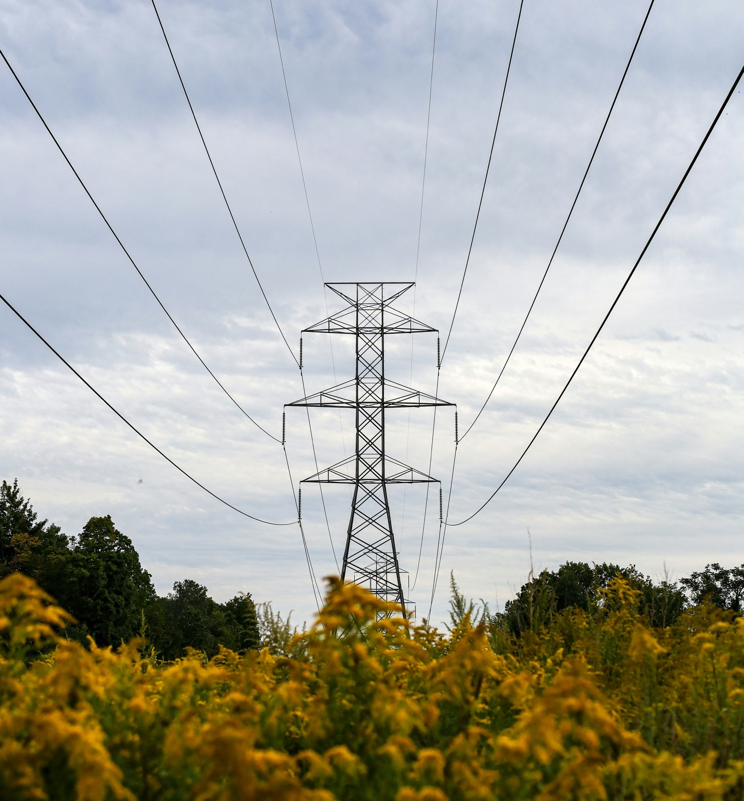

NPCC is dedicated to the continued reliability of the Bulk Power System in Northeastern North America.
1040 Avenue of the Americas, 4th Floor
New York, NY 10018
www.npcc.org

1040 Avenue of the Americas 4th Floor
New York, NY 10018
www.npcc.org

