
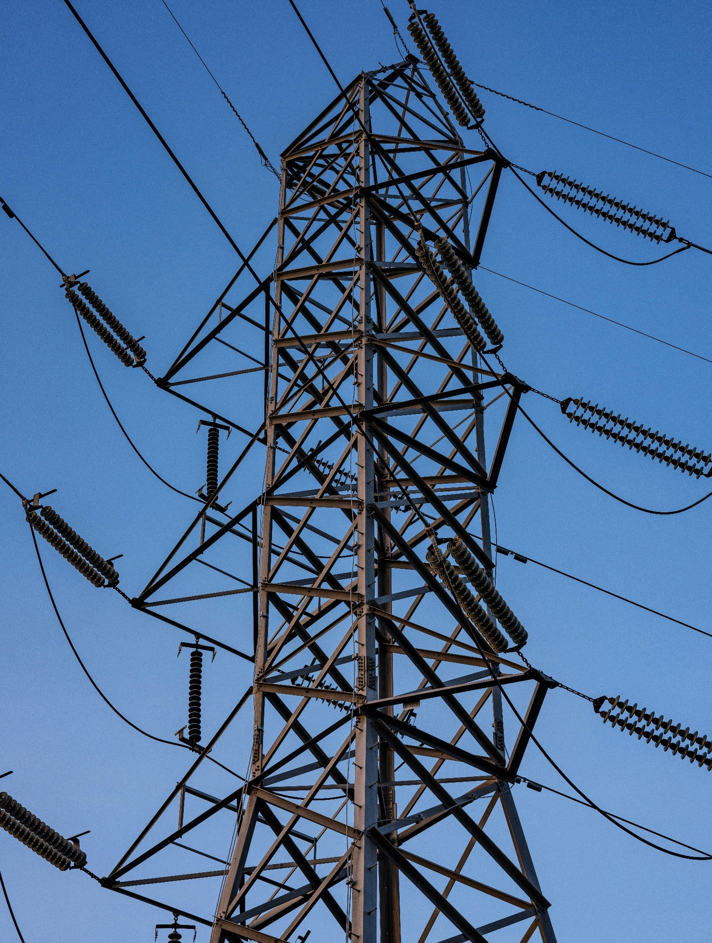

[Registered Entity Name]
NERC ID: [NCRXXXXX]
PRC-005-6 – Protection System, Automatic Reclosing, and Sudden Pressure Relaying Maintenance
R3 & R5
Self-Certification

TABLE OF CONTENTS
Instructions 2
Scope 3
Assessment Guidance 4
Requirement 3 4
Requirement 5 8
For Previous Compliance Monitoring engagement follow-up 11

Instructions
- Populate the cover page by adding your entity’s name and NERC identification number.
- Complete the tasks listed under Assessment Guidance.
- Log into Align and complete your self-certification response.
- Submit via the Secure Evidence Locker (SEL):
  - This completed Worksheet; and
  - Specific evidence requested within this document. Please make sure to use unique file names for each evidence file submitted and identify within your narratives which specific evidence files support each conclusion made. These references and the use of unique file names help facilitate and expedite NPCC’s review of the Self-Certification work that has been performed.

Scope
PRC-005-6 – Protection System, Automatic Reclosing, and Sudden Pressure Relaying Maintenance: R3, R5

Assessment Guidance

Requirement 3
Provide a brief explanation, in your own words, of how you comply with PRC-005-6 R3. References to supplied evidence, including references to the appropriate page, are recommended.

Populate Table 1 with the file names of any documents referenced above that will be submitted as evidence. Add additional rows as necessary:
Table 1: Document File Names
File Name | Document Title | Revision or Version | Document Date | Relevant Page(s) or Section(s) | Description of Applicability of Document

Evidence Requests:
Note: If any of the below questions are addressed in your narrative response above, please write “This is covered in the narrative response above.”
R3:
- Provide a complete list of all Protection Systems, Automatic Reclosing, and Sudden Pressure Relaying equipment that is covered under PRC-005. Populate this spreadsheet with your applicable equipment.

[Provide any evidence narratives here]

- Based on your complete list of all your Protection Systems, Automatic Reclosing, and Sudden Pressure Relaying equipment:

  - Select a random sample from the population of your equipment identified in 1, using the following sampling logic (a random sample may be selected using statistical functions available in Microsoft Excel, through use of https://www.random.org/integer-sets/?mode=advanced), or other statistical tool:
    - Select nine of your equipment if your total population is ten or greater;
    - If nine or fewer total equipment exist in the population, select the entire population.
  - If the random sample does not include at least one of each type of component from your entire list of Protection Systems, Automatic Reclosing, and Sudden Pressure Relaying equipment, then add at least 1 of each of these missing components to the sample generated in 2a.

  - Fill in Table 2 with the evidence of the sampling process used including:

    - Samples selected (per Step 2a and 2b).

    - Evidence of the sampling process or tool utilized to create the sample (e.g., what are your samples and how are they created).

Table 2: Sampling
File Contents | File Name / Page(s)
Samples Selected
Statistical Function Output
Comments

- For each of the Protection Systems, Automatic Reclosing, and Sudden Pressure Relaying equipment generated in the sample from 2a and 2b, provide the evidence indicated in the below document:

[Provide any evidence narratives here]

- Describe the Entity's process for establishing the baseline (last qualifying) maintenance dates for newly installed or commissioned Protection System, Automatic Reclosing, and Sudden Pressure Relaying Components to start PRC-005-6 maintenance intervals.

[Provide any evidence narratives here]

- Explain how the Entity verifies relay settings are as specified as part of its protective relay maintenance activities.

[Provide any evidence narratives here]

- Explain how the Entity verifies that instrument transformer inputs to the protective relay are accurate.

[Provide any evidence narratives here]

- Describe how the Entity verifies that each trip coil is able to operate the circuit breaker, interrupting device, or mitigating device.

[Provide any evidence narratives here]

- Describe the Entity's process for ensuring the accuracy and completeness of its Protection System, Automatic Reclosing, and Sudden Pressure Relaying inventory.

[Provide any evidence narratives here]

- Describe the Entity’s process for tracking maintenance intervals and due dates for each component to ensure compliance with PRC-005-6 maximum maintenance intervals.

[Provide any evidence narratives here]

- Describe the Entity’s process for reviewing maintenance records to verify the maintenance records clearly demonstrate performance of all applicable maintenance activities prescribed within the PRC-005-6 Tables.

[Provide any evidence narratives here]

- Explain the Entity’s process for tracking implementation plan milestones.

[Provide any evidence narratives here]

- If available, provide an Internal Control Matrix, flowcharts, or similar document(s), which details the internal controls in place for this requirement, frequency of the internal control, the person/dept. responsible for the internal control, and any testing of the internal control.

[Provide any evidence narratives here]

Populate Table 3 with the file names of any documents referenced above in requests 1 – 12 that will be submitted as evidence. Add additional rows as necessary.
Table 3: Document File Names
File Name | Document Title | Revision or Version | Document Date | Relevant Page(s) or Section(s) | Description of Applicability of Document

Requirement 5
Provide a brief explanation, in your own words, of how you comply with PRC-005-6 R5. References to supplied evidence, including references to the appropriate page, are recommended.

Populate Table 4 with the file names of any documents referenced above that will be submitted as evidence. Add additional rows as necessary:
Table 4: Document File Names
File Name | Document Title | Revision or Version | Document Date | Relevant Page(s) or Section(s) | Description of Applicability of Document

Evidence Requests:
Note: If any of the below questions are addressed in your narrative response above, please write “This is covered in the narrative response above.”
R5:
- Describe any Unresolved Maintenance Issues the Entity faced during the audit period.

[Provide any evidence narratives here]

- Provide a complete list of all Unresolved Maintenance Issues that are covered under PRC-005-6. Populate this spreadsheet with your applicable Unresolved Maintenance Issues.

[Provide any evidence narratives here]

- Explain how the Entity tracks Unresolved Maintenance Issues that have been identified.

[Provide any evidence narratives here]

- Describe how the Entity performs a risk analysis on Unresolved Maintenance Issues found.

[Provide any evidence narratives here]

- Explain how the Entity corrects the identified Unresolved Maintenance Issues.

[Provide any evidence narratives here]

- Explain how the Entity documents the efforts to correct identified Unresolved Maintenance Issues.

[Provide any evidence narratives here]

- Explain how the Entity verifies the Unresolved Maintenance Issues have been resolved.

[Provide any evidence narratives here]

- Describe the Entity’s process to review and update the Unresolved Maintenance Issue list.

[Provide any evidence narratives here]

- If available, provide an Internal Control Matrix, flowcharts, or similar document(s), which details the internal controls in place for this requirement, frequency of the internal control, the person/dept. responsible for the internal control, and any testing of the internal control.

[Provide any evidence narratives here]

Populate Table 5 with the file names of any documents referenced above in requests 1 – 9 that will be submitted as evidence. Add additional rows as necessary.
Table 5: Document File Names
File Name | Document Title | Revision or Version | Document Date | Relevant Page(s) or Section(s) | Description of Applicability of Document

For Previous Compliance Monitoring Engagement Follow-up
If applicable, provide your follow-up actions on the previous Compliance Monitoring engagement’s areas of concern (AOC) and recommendations for PRC-005-6 R3 or R5. Compliance Monitoring engagements include audits (on-site or off-site), spot-checks, and self-certifications.

Populate Table 6 with the file names of any documents referenced above that will be submitted as evidence. Add additional rows as necessary.

Table 6: Document File Names
File Name | Document Title | Revision or Version | Document Date | Relevant Page(s) or Section(s) | Description of Applicability of Document

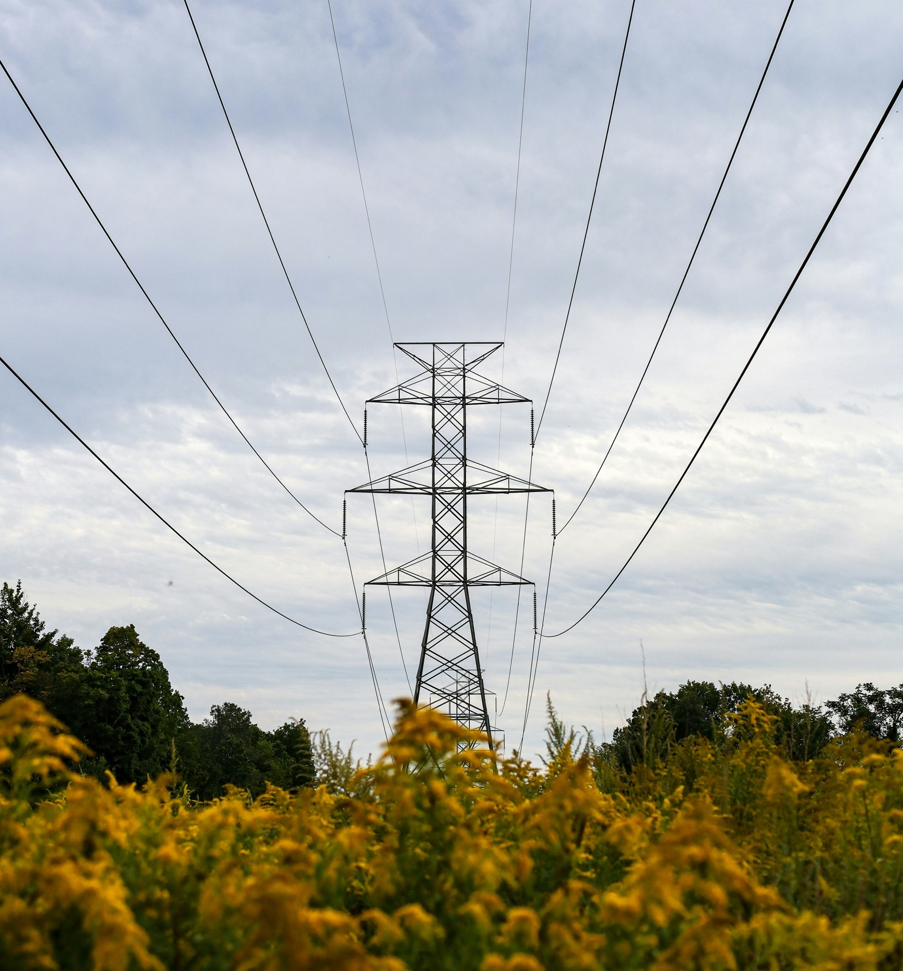


NPCC is dedicated to the continued reliability of the Bulk Power System in Northeastern North America.
1040 Avenue of the Americas, 4th Floor
New York, NY 10018
www.npcc.org

1040 Avenue of the Americas 4th Floor
New York, NY 10018
www.npcc.org

Please visit the NERC Training Site for access to all Align and ERO SEL training materials, including training videos, user guides, and start, stop, continue guides.

