
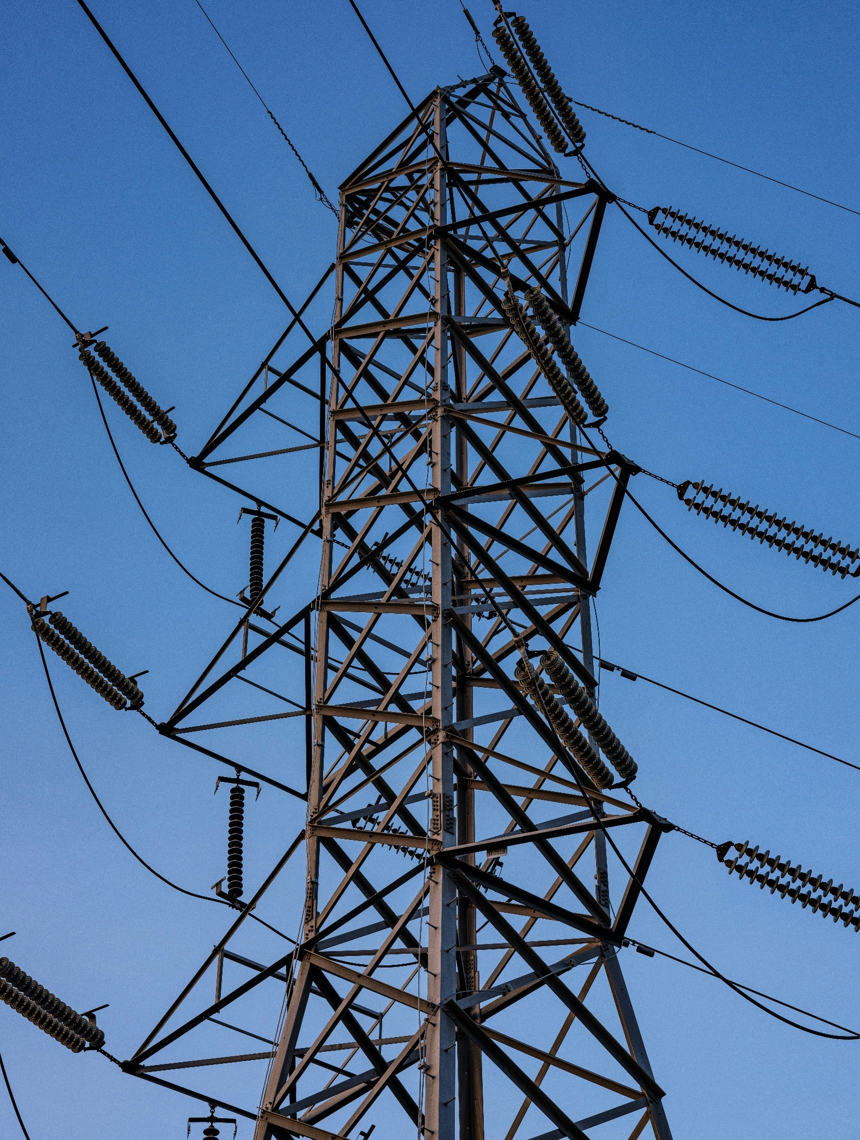

[Registered Entity Name]
NERC ID: [NCRXXXXX]
PRC-006-NPCC-2 – Automatic Underfrequency Load Shedding
R3

2026 Self-Certification

TABLE OF CONTENTS
Instructions 2
Scope 3
Assessment Guidance 4

Instructions
- Populate the cover page by adding your entity’s name and NERC identification number.
- Complete the tasks listed under Assessment Guidance.
- Log into Align and complete your self-certification response.
- Submit via the Secure Evidence Locker (SEL):
  - This completed Worksheet; and
  - Specific evidence requested within this document. Please make sure to use unique file names for each evidence file submitted and identify within your narratives which specific evidence files support each conclusion made. These references and the use of unique file names help facilitate and expedite NPCC’s review of the Self-Certification work that has been performed.

Scope
PRC-006-NPCC-2 Automatic Underfrequency Load Shedding: R3

Assessment Guidance

Requirement 3
Provide a brief explanation, in your own words, of how you comply with PRC-006-NPCC-2 R3. References to supplied evidence, including references to the appropriate page, are recommended.

Populate Table 1 with the file names of any documents referenced above that will be submitted as evidence. Add additional rows as necessary. Evidence may include: UFLS studies, reports, documentation and correspondence with the PC to demonstrate the entity implemented an automatic UFLS program.
Table 1: Document File Names
File Name | Document Title | Revision or Version | Document Date | Relevant Page(s) or Section(s) | Description of Applicability of Document

Evidence Requests:
Note: If any of the below questions are addressed in your narrative response above, please write “This is covered in the narrative response above.”
R3:
- Are you a Distribution Provider or Transmission Owner in the Eastern Interconnection portion of NPCC? ☐ Yes ☐ No

If Yes, provide the number of islands identified by the Planning Coordinator per Requirement R2 and your peak net load in each island below.

[Provide any evidence narratives here]

- Do you collectively implement the UFLS program, via mutual agreement, with multiple Distribution Providers or Transmission Owners that reside in the same UFLS island identified by the Planning Coordinator per Requirement R2? ☐ Yes ☐ No

If Yes,
- Provide the coincident peak aggregated net Load for the Distribution Providers or Transmission Owners that reside in the same UFLS island.
- Provide documentation or reports to demonstrate the UFLS program was implemented collectively with multiple Distribution Providers or Transmission Owners, residing in the same UFLS island. Complete the narrative section below to explain.
- Provide evidence these multiple Distribution Providers or Transmission Owners, act as a single entity to provide an aggregated automatic UFLS program that sheds their coincident peak aggregated net Load according to the frequency thresholds, total nominal operating time, and load shedding amounts specified in Attachment C, Tables 1-3.

[Provide any evidence narratives here]

- Populate the following spreadsheet with the UFLS program information for each year of the certification period:

[Provide any evidence narratives here]

- For the latest UFLS program year:
  - Select a random sample of circuits using the following sampling logic (a random sample may be selected using statistical functions available in Microsoft Excel, through use of https://www.random.org/integer-sets/?mode=advanced), or other statistical tool:
    - Select nine of your circuits if your total population is ten or greater;
    - If nine or fewer total circuits exist in the population, select the entire population.

  - If the random sample does not include at least one circuit in each UFLS Stage, manually add an additional circuit for the missing Stage(s).

  - Fill in Table 2 with the evidence of the sampling process used including:
- Samples selected (per Step 4a and 4b)
- Evidence of the sampling process or tool utilized to create the sample (e.g. what are your samples and how are they created)

Table 2: Sampling
File Contents | File Name / Page(s)
Samples Selected
Statistical Function Output
Comments

- For each circuit in the sample created from 4a and 4b, please provide the following evidence:
  - DC schematic showing UFLS tripping circuit from the underfrequency relay to the interrupting device trip coil
  - Most recent UFLS relay settings report showing the pickup and time delay values
  - Most recent UFLS relay test reports showing the actual operating frequency and time delay values
  - Documentation for any auxiliary relays used in the UFLS tripping circuits and their operating times, if applicable
  - Documentation for any communication systems used in the UFLS tripping circuits and their operating times, if applicable
  - All associated interrupting device nameplates showing their operating times

Populate the following spreadsheet with the sampled list of circuits and their current settings and operating times:

[Provide any evidence narratives here]

- Describe the Entity’s process for documenting and tracking the locations, thresholds, and amount of load to be tripped in any respective area.

[Provide any evidence narratives here]

- Describe the Entity’s process to validate that UFLS circuits operated as planned for any incident.

[Provide any evidence narratives here]

- If available, provide an Internal Control Matrix, flowcharts, or similar document(s), which detail the internal controls in place for this requirement, frequency of reviewing and updating the internal control, the person/dept. responsible for the internal control, and any testing of the internal control.
[Provide any evidence narratives here]

Populate Table 3 with the file names of any documents referenced above in requests 1 – 8 that will be submitted as evidence. Add additional rows as necessary.

Table 3: Document File Names
File Name | Document Title | Revision or Version | Document Date | Relevant Page(s) or Section(s) | Description of Applicability of Document

Previous Compliance Monitoring Engagement Follow-up
If applicable, provide the Entity’s follow-up actions on the previous Compliance Monitoring engagement’s areas of concern (AOC) and Recommendations for PRC-006-NPCC-2 R3 or PRC-006-NPCC-1 R4. Compliance Monitoring engagements include audits (on-site or off-site), spot-checks, and self-certifications.

Populate Table 4 with the file names of any documents referenced above that will be submitted as evidence. Add additional rows as necessary.
Table 4: Document File Names
File Name | Document Title | Revision or Version | Document Date | Relevant Page(s) or Section(s) | Description of Applicability of Document


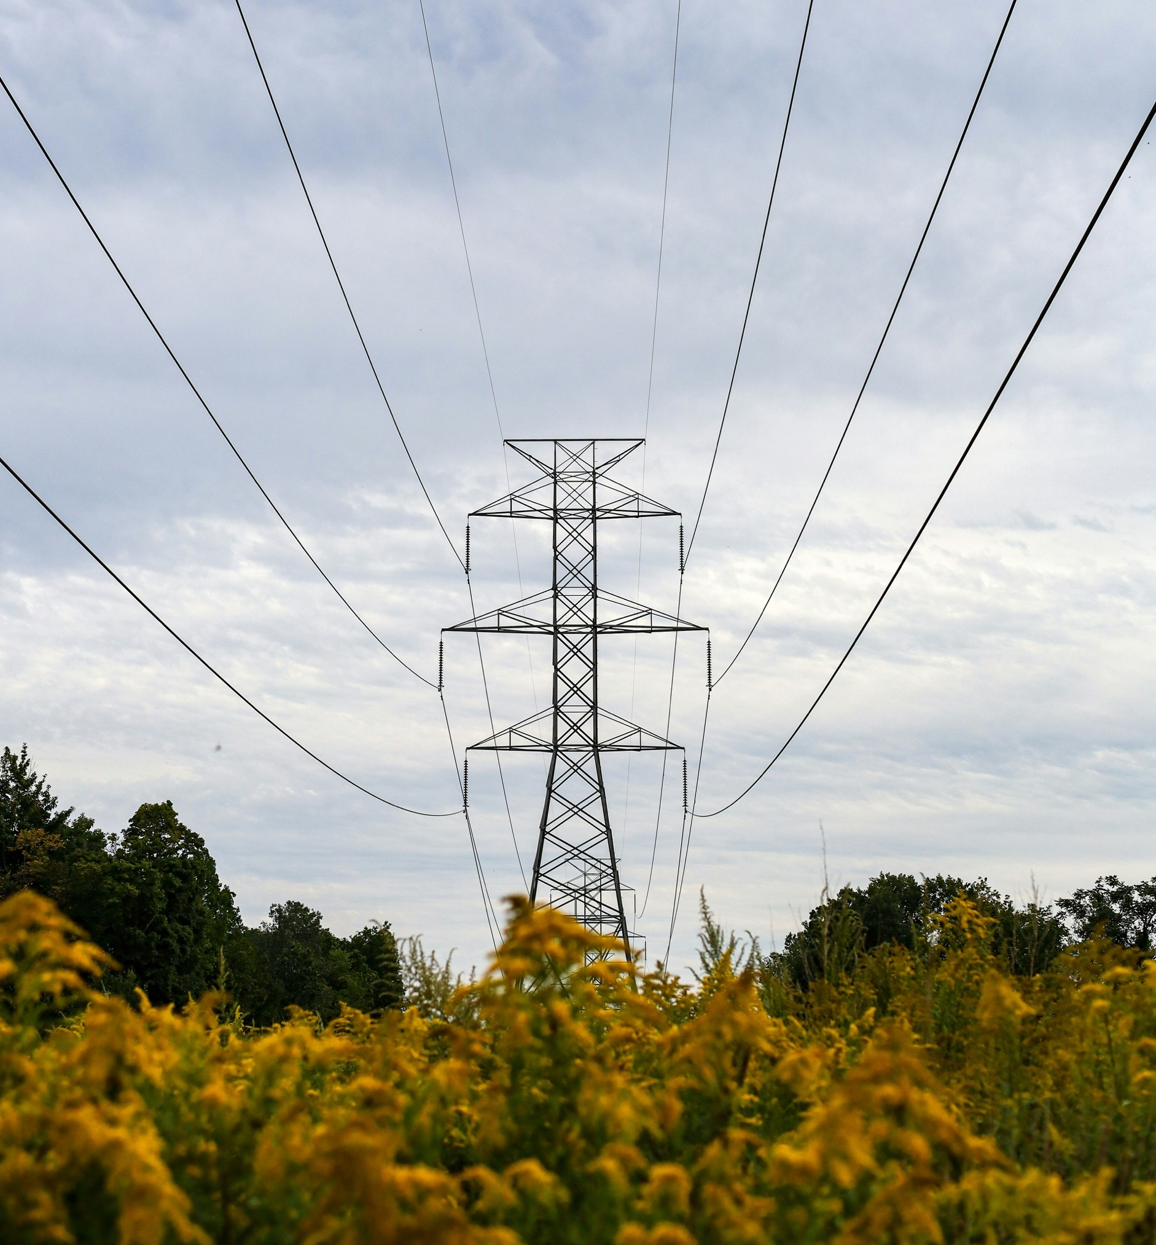

NPCC is dedicated to the continued reliability of the Bulk Power System in Northeastern North America.

NPCC is dedicated to the continued reliability of the Bulk Power System in Northeastern North America.
1040 Avenue of the Americas, 4th Floor
New York, NY 10018
www.npcc.org

1040 Avenue of the Americas 4th Floor
New York, NY 10018
www.npcc.org

Please visit the NERC Training Material site for access to all Align and ERO SEL training materials, including training videos, user guides, and start, stop, continue guides.

