Introduction
Dear Primary Compliance Contact,
This letter is intended to introduce and inform you of NPCC’s enforcement process.
The objective of the Enforcement review is to determine the extent of the noncompliance, assess the actual and potential risk, and ensure that the noncompliance is corrected and action is taken to prevent recurrence. The Enforcement review is conducted in accordance with the Compliance Monitoring and Enforcement Program (CMEP) and applicable NERC Rules of Procedure approved by the applicable regulator (in the United States, the Federal Energy Regulatory Commission). The Potential Noncompliance (PNC) review must have a subject matter expert(s) available for the Enforcement team in case clarification of the submitted data is needed.


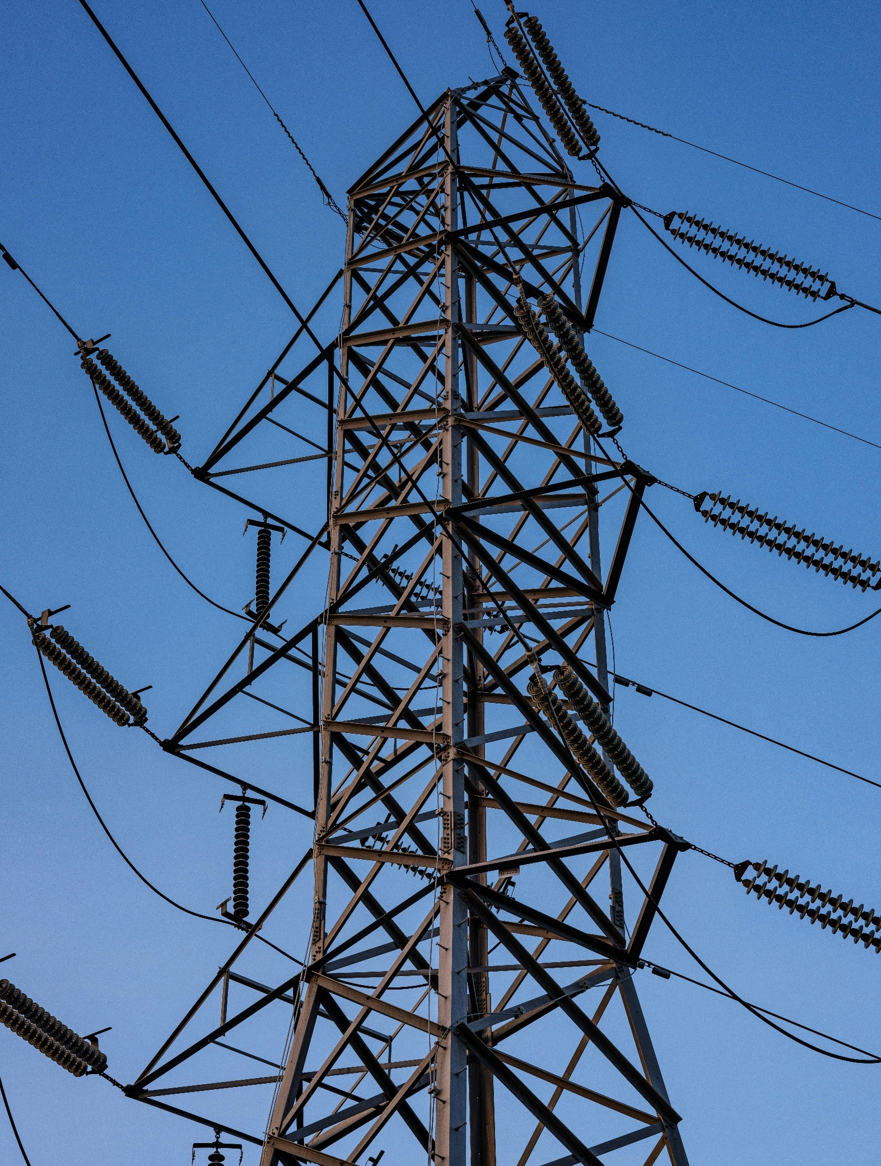

MOD-025-2 EIR
NPCC Enforcement Process

TABLE OF CONTENTS
Introduction 1
Enforcement Milestones and Deadlines 2
Align Quick Reference Guide 4
MOD-025-2 Enforcement Intake RFI 6
General Questions 6
Generators MOD-025-2 R1 and R2 9
Synchronous Condensers MOD-025-2 R2 and/or R3 11
Revision History (For NPCC Use Only) 13

Enforcement Milestones and Deadlines
Please note the important dates/deadlines below (subject to change and may not be inclusive).
Activity | Utilization | Approximate Deadline
Preliminary Screen | To inform you that NPCC has confirmed the Standard and Requirements were applicable, the PNC is not a duplicate of an existing Open Enforcement Action, and to remind you of your obligation to preserve documentation pertaining to the PNC. | Within 10 business days after submittal
Triage | NPCC’s initial risk and mitigation assessment of your submitted PNC to determine priority and level of effort. NPCC internal process only. | Within 14 calendar days after submittal
Request for Information (RFI) | NPCC’s request to your organization to obtain information needed to complete Enforcement review. | Generally, 14 calendar days are given to respond for each RFI.
Request for Settlement | Your request to negotiate the terms of your disposition. | Entities can request settlement at any time.
Compliance Exception (CE) | To inform you that the PNC(s) is being filed as a minimal risk noncompliance with no monetary penalty. | Entity may object to the resolution within 7 calendar days.  - CE with completed mitigation will be considered closed 60 days after submitted to FERC unless NERC or FERC initiate a review within the 60-day review period.  - A CE with ongoing mitigation will not be closed until the mitigation is complete.  Any associated data hold is released 18 months from the date of CE notification or upon completion of mitigation activity, whichever is later.
Find, Fix, Track (FFT) | To inform you that the PNC(s) is being filed as a Minimal/Moderate risk noncompliance with no monetary penalty. | Entity may object to the resolution within 10 calendar days. Entity must provide affidavit within 10 calendar days.  - FFT with completed mitigation will be considered closed 60 days after FERC submittal unless NERC or FERC initiate a review within the 60-day review period.  - FFT with ongoing mitigation will not be closed until the mitigation is complete.  Any associated data hold is released 18 months from the date of the FFT treatment Notice or upon completion of mitigation activity, whichever is later.
Notice of Alleged Violation and Proposed Penalty or Sanction (NAVAPS) | To inform you that the PNC(s) is being considered for a monetary penalty or sanction. | Response required within 30 calendar days following the date of the NAVAPS. Otherwise, entity will have accepted the Compliance Enforcement Authority (CEA)’s determination.

Align Quick Reference Guide
How Do I…? | Video How-to | User Guide or Additional Information
Obtain an ERO Portal Account to access Align |  | - ERO Portal Website  - ERO Portal User Setup Guide  - Creating an ERO Portal Account (Pages 4-27)
Obtain or assign the correct credentials through ERO Portal. Within the ERO Portal, users can request the following access, and the Primary Compliance Contact approves.  - Align Submitter  - Align Reader  - Align Editor |  | - ERO Portal User Setup Guide  - Requesting Align Access (Pages 28-34)  - Approving Align Access Request (Pages 35-37)
Submit a Self-Report or Self-Log | (Video) Creating a Self-Report or Self-Log | - (User Guide) Creating a Finding (Pages 8-20)
Submit Mitigation  - User submits mitigation completion for regional verification | (Video) Submitting Mitigating Activities | - (User Guide) Submitting Mitigating Activities (Pages 28-33)  - (User Guide) Submitting Mitigation for CEA Verification (Page 41)
Respond to Noncompliance or Mitigation Requests for Information (RFI) | (Video) Responding to Mitigation RFI | - (User Guide) Responding to an RFI (Noncompliance) (Pages 25-28)  - (User Guide) Responding to an RFI (Mitigation) (Page 35)
Upload Evidence to the Secure Evidence Locker (SEL)  - User has SEL Submitter Role  - User has access to Align for SEL reference ID  User uses a TLS 1.3 compatible browser (e.g.: Chrome and Edge) | (Video) Submitting Evidence to SEL | - (Website) SEL Submission Website  - (User Guide) SEL
Update Finding with scope expansion. | (Video) Adding Information to a Self-Report after Submitting | - (User Guide) Updating a Finding (Pages 21-24)
Submit questions/issues with Align or the SEL  *Please add a screenshot of the issue* |  | - NERC Helpdesk Ticketing System

MOD-025-2 Enforcement Intake RFI
The Enforcement Intake Request for Information (EIR) worksheet provides a structured format for submitting information related to a potential noncompliance and is specific to the applicable NERC Reliability Standard. The information requested reflects the details NPCC typically considers when assessing the scope, risk, and disposition of a potential noncompliance.

The worksheet may be used when preparing information related to a potential noncompliance, or it may be issued by NPCC to request additional information during its review of the matter.

In the worksheet below, please include all information regarding the noncompliance being reported. If you have any questions, please contact us through NPCC Contact Information. Thank you.

In the following table, include information for all instances associated with the possible noncompliance.

General Questions
NERC Potential Noncompliance (PNC) ID(s):  (List all that apply.) | Enter PNC ID(s); e.g., 2024-01234, 2024-01245
Function(s) associated with the PNC  (Select all that apply.) | ☐TO ☐GO
Discovery Date of the PNC: | Enter the date the PNC was first identified.
Start Date of the PNC: | Enter the date upon which the PNC began to be noncompliant.
End Date/Expected End Date of the PNC: | Enter the date upon which the Entity returned to compliance or is expected to return to compliance.
Are Mitigating Activities (MAs) submitted in Align?  (Select either “Yes” or “No”.) | ☐ Yes ☐ No  If No, when will they be?  Enter the date mitigation is expected to be submitted.
Do the MAs include milestones remediating the noncompliance?  (Select either “Yes” or “No”.) | ☐ Yes ☐ No  If No, NPCC will send the Align MAs back to draft so remediation can be added.
Do the MAs include milestone(s) that address the identified PNC cause(s) and prevent recurrence?  (Select either “Yes” or “No”.) | ☐ Yes ☐ No  If No, NPCC will send the Align MAs back to draft so activities to address cause and prevent recurrence can be added.
Was the evidence to support Mitigation Completion submitted to the SEL?  (Select either “Yes” or “No”.) | ☐ Yes ☐ No  If No, evidence should be submitted no later than the submission of the certification of mitigation completion in Align.
Mitigation Completion Date/Expected Mitigation Completion Date: | Enter the date of the completed final mitigation milestone or the date the final mitigation milestone is expected to be completed.
Requirement(s) associated with the PNC:  (Please select all requirements that apply to the PNC.) | ☐ R1 ☐ R3  ☐ Part 1.1 ☐ Part 3.1  ☐ Part 1.2 ☐ Part 3.2  ☐ R2  ☐ Part 2.1  ☐ Part 2.2
Describe any ongoing or completed Extent of Condition (EOC) activity(ies). If no EOC activity(ies) was performed, describe why.  The EOC should consider the following:  - Other affiliate companies or facilities across your corporate structure.  - Procedures, assets, facilities, or personnel that are directly affected or could be affected as part of the noncompliance.  - Other Reliability Standards, to determine if any were also violated based on the facts of the reported noncompliance.  - Prior compliance history involving similar conduct or gap in internal controls, if known.  - Whether the extent of condition changed from what was originally reported (e.g., additional devices/facilities/personnel found to be affected). | Enter any ongoing or completed EOC review activities.
Describe the cause(s) of the PNC. | Enter the cause(s) of the PNC here.  (If this is already thoroughly described in Align, please list that it’s addressed in Align.)
Please provide any additional comments you may have. | Enter any additional comments.
Is compliance responsibility for this Requirement shared with another Registered Entity? | ☐ Yes ☐ No  (If “Yes” please answer the next three questions accordingly. If “No” please check the box that says “Not Applicable” for the next three questions.)
Please list the associated Facilities/Components. | Enter the applicable Facilities/Components.  ☐ Not Applicable
Please provide the formal agreement or other documentation describing the shared compliance responsibility if any. | Enter the location of your documentation.  (If you are attaching a document(s), please list where that document(s) is located, for example in the SEL.)  ☐ Not Applicable
Please provide any additional information about the shared compliance responsibility that may be useful to the Enforcement Team regarding this violation. | Enter any additional information here.  ☐ Not Applicable

Generators MOD-025-2 R1 and R2
Describe the scope of noncompliance, including:
- List all applicable generating Facilities (generating units/plants) associated with the potential noncompliance.
- Provide the nameplate rating of the generating Facility (MVA).
- Provide the nominal output of the generating Facility (MW).
- Provide the type of resource used at the generating Facility (Coal, Gas, Wind, Solar, Hydro, Nuclear, etc.)
- Provide the annual capacity factor(s) for each year during the period of noncompliance
- Is the Facility identified as a Blackstart Resource in a transmission Operator’s restoration plan? (Yes/No)
- Is the Facility Associated with a Remedial Action Scheme or Special Protection System? (Yes/No)
- Is the Facility associated with an Interconnection Reliability Operating Limit? (Yes/No)
- Provide the date of the initial Real/Reactive power capability verification (Address both Real and Reactive verifications if both R1 and R2 noncompliance)
- Provide the date of the initial submission of MOD-025 Attachment 2 or form containing the same information as identified in Attachment 2 to the Transmission Planner
- If applicable, provide the date of the subsequent Real/Reactive power capability verification (Address both Real and Reactive verifications if both R1 and R2 noncompliance)
- If applicable, provide the date of the subsequent submission of MOD-025 Attachment 2 or form containing the same information as identified in Attachment 2 to the Transmission Planner
Please add additional rows for each Facility. You can submit an excel sheet if additional space is needed.
1.  Facility | 2.  MVA | 3.  MW | 4.  Type | 5.  CF | 6.  Blackstart? | 7.  RAS/SPS? | 8.  IROL? | 9.  Initial Verification Date | 10.  Initial Submittal Date | 11.  Subsequent Verification Date | 12. Subsequent Submittal Date
Enter in the Facility name here. | Enter in the nameplate rating of the generating facility. (MVA) | Enter in the nominal output of the generating Facility.(MW) | Enter in the type of resources used at the generating facility; e.g. coal, gas, wind, solar, hydro, nuclear, etc. | Enter in the capacity factor (CF). | Indicate if this Facility is identified as a Blackstart Facility or not. | Indicate if this Facility is associated with a Remedial Action Scheme (RAS) or a Special Protection System (SPS). | Indicate if this Facility is associated with an Interconnection Reliability Operating Limit (IROL)or not. | Enter in the date of when the initial Real/Reactive power capability verification took place. | Enter in the date of the initial submission of MOD-025 Attachment 2 or form containing the same information (identified in Attachment 2) to the Transmission Planner. | Enter in the date of when any subsequent Real/Reactive power cability verifications took place if applicable. | Enter in the date of the subsequent submission of MOD-025 Attachment 2 or form containing the same information (identified in Attachment 2) to the Transmission Planner if applicable.

Additional Questions
- Describe any known discrepancies between the verifications performed and the requirements of MOD-025 Attachment 1
- Describe any known deficiencies in the submittals to the Transmission Planner.
- Did the Real Power and/or Reactive Power capability verifications identify any unexpected changes to generator capability?
- Did the Real and/or Reactive Power capability verifications identify any unexpected limitations (e.g., unexpected alarms, unexpected control system limits, or unexpected protection system trips)?
- Did the Transmission Planner request any adjustments to the submitted capability verification results?
- Outside of/prior to MOD-025, are or were the applicable generating units/plants required to verify Real Power and/or Reactive Power capability pursuant to grid operator or market requirements?
- If yes, describe the nature and frequency of those verifications, as well any known discrepancies between those verification requirements and the verification requirements in MOD-025.
- Evidence of submitting previous verification results to the Transmission Planner can also be submitted to the SEL for evaluation as a risk-reducing factor.
- If the potential noncompliance has already been remediated, submit to the SEL 1) evidence of the verifications (such as a completed Attachment 2 or Generator Owner form with the same information, or dated information collected and used to complete attachments) and 2) evidence of submission to the Transmission Planner; (such as dated electronic mail messages or screenshots of Transmission Planner portal submittals).
Click or tap here to enter text.

Synchronous Condensers MOD-025-2 R2 and/or R3
For PNCs involving Synchronous Condensers, please answer the following questions.
Describe the scope of noncompliance, including:
- List all applicable synchronous condenser Facilities associated with the potential noncompliance.
- Provide the nameplate rating of the generating Facility (MVA).
- Provide the Interconnected Transmission Voltage (kV).
- Is the Facility associated with an Interconnection Reliability Operating Limit? (Yes/No)
- Provide the date of the initial MOD-025 Reactive Power capability verifications (pursuant to R2 Part 2.1 or R3 Part 3.1).
- Provide the date of the initial submission of MOD-025 Attachment 2 (or a form containing the same information as identified in Attachment 2) to the Transmission Planner (pursuant to R2 Part 2.2 or R3 Part 3.2).
- If applicable, provide the date of the subsequent MOD-025 Reactive Power capability verification (pursuant to R2 Part 2.1 or R3 Part 3.1).
- If applicable, provide the date of the subsequent submission of MOD-025 Attachment 2 (or a form containing the same information as identified in Attachment 2) to the Transmission Planner (pursuant to R2 Part 2.2 or R3 Part 3.2).

Please add additional rows for each new property. You can submit an excel sheet if additional space is needed.
1. Facility | 2. MVA | 3. kV | 4. IROL | 5. Initial Verification Date | 6. Initial Submittal Dates of Submission to the TP | 7. Subsequent Verification Date | 8. Subsequent Submittal Dates of Submission to the TP
Enter in the Facility name here. | Enter in the nameplate rating of the synchronous condenser Facility. (MVA) | Enter in the Interconnected Transmission Voltage. (kV) | Indicate if this Property is associated with an Interconnection Reliability Operating Limit (IROL)or not. | Enter in the date of when the initial Reactive power capability verification took place. | Enter in the date of the initial submission to the Transmission Planner (TP). | Enter in the date of when any subsequent Reactive power capabilities verification took place. | Enter in the date of any subsequent submissions to the Transmission Planner (TP).

Additional Questions:
- Describe any known discrepancies between the MOD-025 verifications and the requirements of MOD-025 Attachment 1.
- Describe any known deficiencies in the submittals to the Transmission Planner.
- Did the Reactive Power capability verifications identify any unexpected changes to synchronous condenser capability?
- Did the Reactive Power capability verifications identify any unexpected limitations (e.g., unexpected alarms, unexpected control system limits, or unexpected protection system trips)?
- Outside of/prior to MOD-025, are or were the applicable synchronous condensers required to verify Reactive Power capability pursuant to grid operator requirements?
  - If yes, describe the nature and frequency of those verifications, as well any known discrepancies between those verification requirements and the verification requirements in MOD-025.
  - Evidence of submitting previous verification results to the Transmission Planner can also be submitted to the SEL for evaluation as a risk-reducing factor.
- If the potential noncompliance has already been remediated, submit to the SEL 1) evidence of the verifications (such as a completed Attachment 2 or Generator Owner/Transmission Owner form with the same information, or dated information collected and used to complete attachments) and 2) evidence of submission to the Transmission Planner; (such as dated electronic mail messages or screenshots of Transmission Planner portal submittals).
Click or tap here to enter text.

Revision History (For NPCC Use Only)
Version | Date | Details | Author
1.0 | 2/27/2026 | Completed Revision 1.0 for publication | NPCC


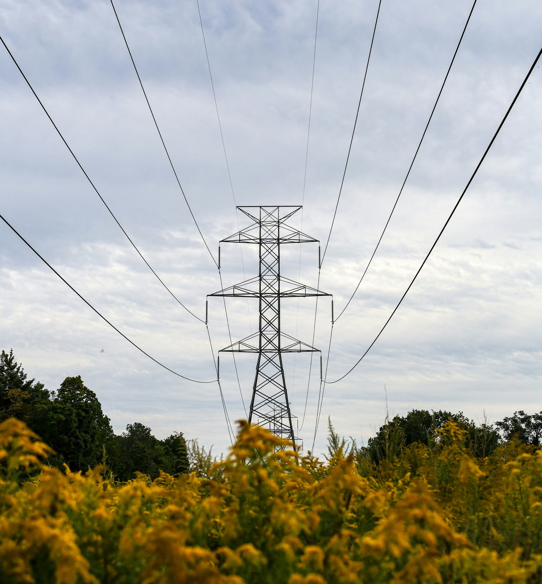

NPCC is dedicated to the continued reliability of the Bulk Power System in Northeastern North America.
1040 Avenue of the Americas, 4th Floor
New York, NY 10018
www.npcc.org

1040 Avenue of the Americas 4th Floor
New York, NY 10018
www.npcc.org

