Introduction
Dear Primary Compliance Contact,
This letter is intended to introduce and inform you of NPCC’s enforcement process.
The objective of the Enforcement review is to determine the extent of the noncompliance, assess the actual and potential risk, and ensure that the noncompliance is corrected, and action is taken to prevent recurrence. The Enforcement review is conducted in accordance with the Compliance Monitoring and Enforcement Program (CMEP) and the NERC Rules of Procedure approved by the applicable regulator (in the United States, the Federal Energy Regulatory Commission). The Potential Noncompliance (PNC) review must have a subject matter expert(s) available for the Enforcement team in case clarification of the submitted data is needed.


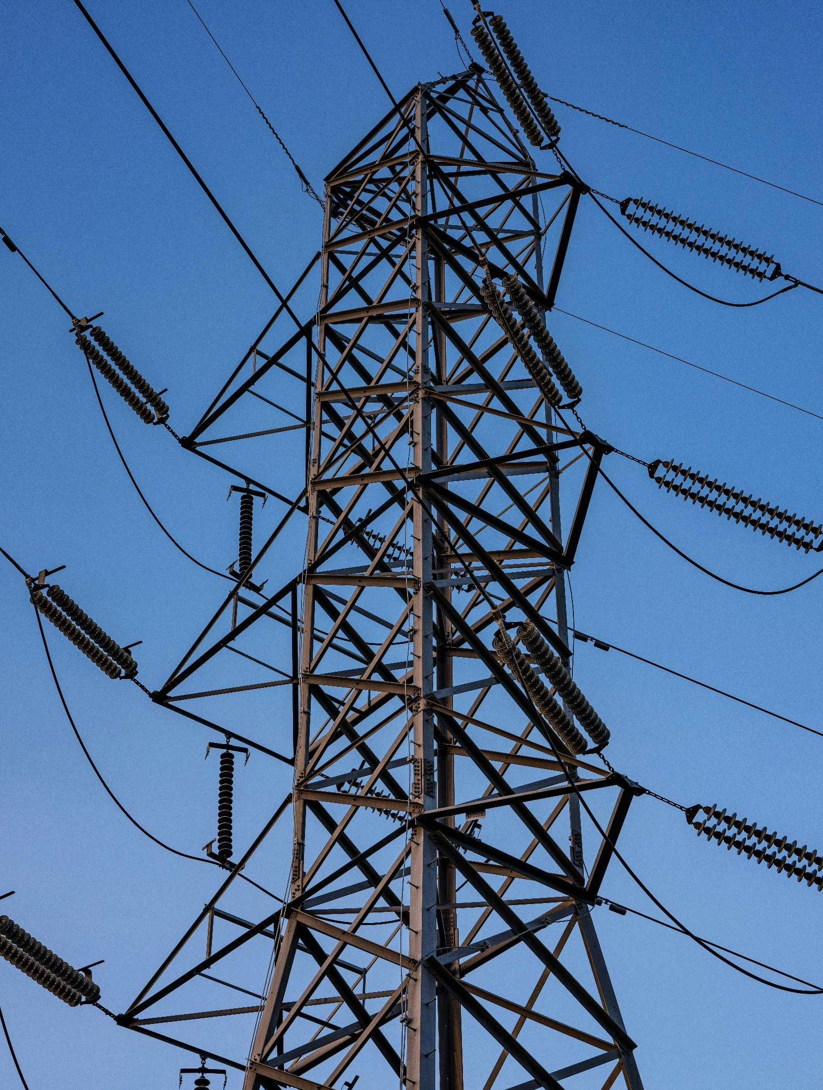

CIP-004-7 EIR
NPCC Enforcement Process

TABLE OF CONTENTS
Introduction 1
Enforcement Milestones and Deadlines 2
Align Quick Reference Guide 4
CIP-004-7 6
General Questions 6
CIP-004-7 R1 11
CIP-004-7 R2 14
CIP-004-7 R3 18
CIP-004-7 R4 21
CIP-004-7 R5 24
CIP-004-7 R6 28
Revision History (For NPCC Use Only) 32

Enforcement Milestones and Deadlines
Please note the important dates/deadlines below (subject to change and may not be inclusive).
Activity | Utilization | Approximate Deadline
Preliminary Screen | To inform you that NPCC has confirmed the Standard and Requirements were applicable, the PNC is not a duplicate of an existing Open Enforcement Action, and to remind you of your obligation to preserve documentation pertaining to the PNC. | Within 10 business days after submittal
Triage | NPCC’s initial risk and mitigation assessment of your submitted PNC to determine priority and level of effort. NPCC internal process only. | Within 14 calendar days after submittal
Request for Information (RFI) | NPCC’s request to your organization to obtain information needed to complete Enforcement review. | Generally, 14 calendar days are given to respond for each RFI.
Request for Settlement | Your request to negotiate the terms of your disposition. | Entities can request settlement at any time.
Compliance Exception (CE) | To inform you that the PNC(s) is being filed as a minimal risk noncompliance with no monetary penalty. | Entity may object to the resolution within 7 calendar days.  - CE with completed mitigation will be considered closed 60 days after submitted to FERC unless NERC or FERC initiate a review within the 60-day review period.  - A CE with ongoing mitigation will not be closed until the mitigation is complete.  Any associated data hold is released 18 months from the date of CE notification or upon completion of mitigation activity, whichever is later.
Find, Fix, Track (FFT) | To inform you that the PNC(s) is being filed as a Minimal/Moderate risk noncompliance with no monetary penalty. | Entity may object to the resolution within 10 calendar days. Entity must provide affidavit within 10 calendar days.  - FFT with completed mitigation will be considered closed 60 days after FERC submittal unless NERC or FERC initiate a review within the 60-day review period.  - FFT with ongoing mitigation will not be closed until the mitigation is complete.  Any associated data hold is released 18 months from the date of the FFT treatment Notice or upon completion of mitigation activity, whichever is later.
Notice of Alleged Violation and Proposed Penalty or Sanction (NAVAPS) | To inform you that the PNC(s) is being considered for a monetary penalty or sanction. | Response required within 30 calendar days following the date of the NAVAPS. Otherwise, entity will have accepted the Compliance Enforcement Authority (CEA)’s determination.

Align Quick Reference Guide
How Do I…? | Video How-to | User Guide or Additional Information
Obtain an ERO Portal Account to access Align |  | - ERO Portal Website  - ERO Portal User Setup Guide  - Creating an ERO Portal Account (Pages 4-27)
Obtain or assign the correct credentials through ERO Portal. Within the ERO Portal, users can request the following access, and the Primary Compliance Contact approves.  - Align Submitter  - Align Reader  - Align Editor |  | - ERO Portal User Setup Guide  - Requesting Align Access (Pages 28-34)  - Approving Align Access Request (Pages 35-37)
Submit a Self-Report or Self-Log | (Video) Creating a Self-Report or Self-Log | - (User Guide) Creating a Finding (Pages 8-20)
Submit Mitigation  - User submits mitigation completion for regional verification | (Video) Submitting Mitigating Activities | - (User Guide) Submitting Mitigating Activities (Pages 28-33)  - (User Guide) Submitting Mitigation for CEA Verification (Page 41)
Respond to Noncompliance or Mitigation Requests for Information (RFI) | (Video) Responding to Mitigation RFI | - (User Guide) Responding to an RFI (Noncompliance) (Pages 25-28)  - (User Guide) Responding to an RFI (Mitigation) (Page 35)
Upload Evidence to the Secure Evidence Locker (SEL)  - User has SEL Submitter Role  - User has access to Align for SEL reference ID  User uses a TLS 1.3 compatible browser (e.g.: Chrome and Edge) | (Video) Submitting Evidence to SEL | - (Website) SEL Submission Website  - (User Guide) SEL
Update Finding with scope expansion. | (Video) Adding Information to a Self-Report after Submitting | - (User Guide) Updating a Finding (Pages 21-24)
Submit questions/issues with Align or the SEL  *Please add a screenshot of the issue* |  | - NERC Helpdesk Ticketing System

CIP-004-7
Enforcement Intake RFI Form
September 1, 2026
The Enforcement Intake Request for Information (EIR) worksheet provides a structured format for submitting information related to a potential noncompliance and is specific to the applicable NERC Reliability Standard. The information requested reflects the details NPCC typically considers when assessing the scope, risk, and disposition of a potential noncompliance.
The worksheet may be used when preparing information related to a potential noncompliance, or it may be issued by NPCC to request additional information during its review of the matter.
In the worksheet below, please include all information regarding the noncompliance being reported. If you have any questions, please contact us through NPCC Contact Information. Thank you.
In the following table, include information for all instances associated with the possible noncompliance.

General Questions

NERC Potential Noncompliance (PNC) ID(s):  (List all that apply.) | Enter PNC ID(s); e.g., 2024-01234, 2024-01245
Function(s) associated with the PNC  (Select all that apply.) | ☐BA ☐DP ☐GO ☐GOP  ☐ RC ☐ TO ☐ TOP
Discovery Date of the PNC: | Enter the date the PNC was first identified.
Start Date of the PNC: | Enter the date upon which the PNC began to be noncompliant.
End Date/Expected End Date of the PNC: | Enter the date upon which the Entity returned to compliance or is expected to return to compliance.
Are Mitigating Activities (MAs) Submitted in Align?  (Select either “Yes” or “No”.) | ☐ Yes ☐ No  If No, when will they be?  Enter the date mitigation is expected to be submitted.
Does the MAs include milestones remediating the noncompliance?  (Select either “Yes” or “No”.) | ☐ Yes ☐ No  If No, NPCC will send the Align MAs back to draft so remediation can be added.
Does the MAs include milestone(s) addressing the identified PNC cause(s) and prevent recurrence?  (Select either “Yes” or “No”.) | ☐ Yes ☐ No  If no, NPCC will send the Align MAs back to draft so activities to address cause and prevent recurrence can be added.
Was evidence to support Mitigation Completion submitted to the SEL?  (Select either “Yes” or “No”.) | ☐ Yes ☐ No  If no, evidence should be submitted no later than the submission of the certification of mitigation completion in Align.
Mitigation Completion Date/Expected Mitigation Completion Date: | Enter the date of the completed final mitigation milestone or the date the final mitigation milestone is expected to be completed.
Requirement(s) and Parts associated with the PNC:  (Please select all requirements and Parts that apply to the PNC.) | ☐ R1 ☐ R4  ☐ Part 1.1 ☐ Part 4.1  ☐ Part 4.2  ☐ R2 ☐ Part 4.3  ☐ Part 2.1  ☐ Part 2.2 ☐ R5  ☐ Part 2.3 ☐ Part 5.1  ☐ Part 5.2  ☐ R3 ☐ Part 5.3  ☐ Part 3.1 ☐ Part 5.4  ☐ Part 3.2  ☐ Part 3.3 ☐ R6  ☐ Part 3.4 ☐ Part 6.1  ☐ Part 3.5 ☐ Part 6.2  ☐ Part 6.3
Describe any ongoing or completed Extent of Condition (EOC) activity(ies). If no EOC activity(ies) was performed, describe why.  The EOC should consider the following:  - Other affiliate companies or facilities across your corporate structure.  - Procedures, assets, facilities, or personnel that are directly affected or could be affected as part of the noncompliance.  - Other Reliability Standards, to see if any were also violated based on the facts of the reported noncompliance.  - Prior compliance history involving similar conduct or gap in internal controls, if known.  - Whether the extent of condition changed from what was originally reported (e.g., additional devices/facilities/personnel found to be affected) | Enter any ongoing or completed EOC review activities.
Describe the cause(s) of the PNC.  Enforcement Cause Code User Guide | Enter the cause(s) of the PNC here.
Please add any additional comments you may have. | Enter any additional comments.
Is compliance responsibility for this Requirement shared with another Registered Entity? | ☐ Yes ☐ No  (If “Yes” please answer the next three questions accordingly. If “No” please check the box that says “Not Applicable” for the next three questions.)
Please list the associated Facilities/Components. | Enter the applicable Facilities/Components.  ☐ Not Applicable
Please provide the formal agreement or other documentation describing the shared compliance responsibility if any. | Enter the location of your documentation.  (If you are attaching a document(s) please list where that document(s) is located, for example in the SEL.)  ☐ Not Applicable
Please provide any additional information about the shared compliance responsibility that may be useful to the enforcement team regarding this violation. | Enter any additional information here.  ☐ Not Applicable

CIP-004-7 R1

For PNCs involving CIP-004-7 R1, please answer the following questions.
Indicate the impact ratings that are applicable to this noncompliance. | ☐ High Impact BES Cyber System(s)  ☐ Medium Impact BES Cyber System(s)
Does your organization have a Security Awareness program? | ☐ Yes ☐ No
If yes, what procedures do you have in place to address Cyber Security Training?  If no, provide the date when a security awareness program was last implemented. | Enter the procedures you have in place to address Cyber Security Training.
Did your organization implement its documented process(es) for personnel who have either:  - authorized electronic access to BES Cyber Systems; or  - authorized unescorted physical access to BES Cyber Systems | ☐ Yes ☐ No
If no, provide a description of what failed.
Did your organization fail to implement one or more documented security awareness processes at least once each calendar quarter? (Yes/No) | ☐ Yes ☐ No
If yes, provide the calendar quarter(s)
in which the documented security awareness process(es) was not followed.
(List the year and quarter)
Did your organization’s security awareness include:  - Reinforcement of cyber security practices, or  - Reinforcement of physical security practices associated with cyber security? | ☐ Yes ☐ No
If no, which part was not included? Provide any additional details.
Do you have processes or procedures to handle confidential or sensitive information? | Enter any processes or procedures you have to address confidential or sensitive information.
Are there other organizational communications that discuss cyber security awareness? (Examples: emails, newsletters, presentations, or meetings) | Enter any programs you have in place that discuss Cyber Security Awareness.
What procedures do you have in place to address Cyber Security Training? This includes partial CIP-004-7 R2.1 training and other training. (Ex. State, Job, Professional, Etc.)

CIP-004-7 R2

For PNCs involving CIP-004-7 R2, please answer the following questions.
Indicate the impact ratings that are applicable to this noncompliance. | ☐ High Impact BES Cyber System(s)  ☐ Medium Impact BES Cyber System(s) with External Routable Connectivity
Indicate which content was NOT included within your organization’s cyber security training program  (Select all that apply) | ☐ 2.1.1. Cybersecurity Policies  ☐ 2.1.2. Physical Access Controls  ☐ 2.1.3. Electronic Access Controls  ☐ 2.1.4. The Visitor Control Program  ☐ 2.1.5. Handling of BES Cyber System Information and its storage  ☐ 2.1.6. Identification of a Cyber Security Incident and Initial notifications in accordance with the Entity’s Incident Response Plan (IRP)  ☐ 2.1.7. Recovery Plans for BES Cyber Systems  ☐ 2.1.8. Response to Cyber Security Incidents  ☐ 2.1.9. Cyber Security Risks Associated with a BES Cyber System’s Electronic Interconnectivity and Interoperability with other Cyber Assets, including Examples of evidence may include, but are not limited to, training material such as power point presentations, instructor notes, student notes, handouts, or other training materials.
What individual(s) were affected? | List the individuals that were affected.
For individuals who missed training content, did they receive other types of required training? | Enter in any required training.
Are there any content changes between the prior training and missed current training? | Enter in any content changes that occurred between the prior training and the missed training.
What type of access does the individual(s) in scope have? (Electronic and/or Physical) | Enter the type of access the individuals in scope have.
For the individual(s) in scope, what type of systems, devices or physical locations was access granted? | Enter in what type of systems, devices, and physical locations that the individuals in scope had access to.
How many of the system(s), devices and/or physical location(s) did the individuals have access to? (Include all that applies) | Enter in the number of system(s), devices and physical location(s) that the individuals in scope had access to.
For individuals who missed training, was a Personal Risk Assessment (PRA) performed? | ☐ Yes ☐ No  If Yes, when was the last PRA performed?  Enter in the date the last PRA was performed.
For individuals who did not receive required training, do they have prior history of handling confidential or sensitive information? | ☐ Yes ☐ No

CIP-004-7 R3

For PNCs involving CIP-004-7 R3, please answer the following questions.
What individual(s) were affected? | List the individuals that were affected.
Did you perform a background check for all individuals in scope? | ☐ Yes ☐ No
If background checks were conducted, what was the extent of the background check that was conducted? | Enter in the extent of the background check that was conducted if applicable. (e.g. A seven-year criminal history check being conducted.)
Do you have a documented Personnel Risk Assessment (PRA) program that includes a process to confirm the identity of the individual? | ☐ Yes ☐ No
What process(es) do you have in place to confirm the identity of personnel who have been granted authorized electronic access or unescorted physical access to Applicable Systems? | Enter in the process(es) you have in place to confirm the identity of individuals who have been granted authorized electronic access or unescorted physical access to the applicable systems in scope.
Has the initial Personnel Risk Assessment (PRA) been completed for the individual(s) in scope? | ☐ Yes ☐ No
For the individual(s) in scope, when was the last Personnel Risk Assessment (PRA) completed? | Enter in the date(s) the last PRA was completed for the individuals in scope.
What type of access do the individuals in scope have? (Electronic and/or Physical) | Enter in the type of access each individual in scope has. (e.g. Electronic and/or Physical)
For the individual(s) in scope, what type of system(s), device(s) or physical location(s) was access granted? | Enter in the type of system(s), devices and physical location(s) that the individuals in scope had access to.
How many of the system(s), devices and/or physical location(s) did the individual(s) have access to? (Include all that applies to the PNC.) | Enter in the number of system(s), devices and physical location(s) that the individuals in scope had access to.

CIP-004-7 R4

For PNCs involving CIP-004-7 R4, please answer the following questions.
What individual(s) were affected? | List the individuals that were affected.
Was a Personnel Risk Assessment (PRA) conducted for the individual(s) in scope? | ☐ Yes ☐ No  If Yes, when was the most recent PRA completed?  Enter in the date that the most recent PRA was completed.
Did the individual(s) in scope complete cyber security training? | ☐ Yes ☐ No
What is included in your cyber security training? | Enter in what is included in your Cyber Security training.
What type of access do the individuals in scope have? (Electronic and/or Physical) | Enter in the type of access each individual in scope has. (e.g. Electronic and/or Physical)
For the individual(s) in scope, what type of systems, devices or physical locations was access granted? | Enter in the type of system(s), devices and physical location(s) that the individuals in scope had access to.
How many of the system(s), devices and/or physical location(s) did the individual(s) have access to? (Include all that applies to this PNC.) | Enter in the number of system(s), devices and physical location(s) that the individuals in scope had access to.
How frequently was the access utilized during the noncompliance window? | Enter in the number of times access was utilized during the PNC window.
Was the access in scope necessary for business purposes? | ☐ Yes ☐ No
Was the individual(s) in good standing with your organization? | ☐ Yes ☐ No  If no, please explain why the individual(s) was not in good standing.  Enter in why the individual(s) in scope was not in good standing with your organization.
What controls do you have in place that could reduce the risk from an individual with unauthorized access? | Enter in any controls your organization has in place to help reduce the risk from an individual with unauthorized access. (e.g. Monitoring of accounts, Folders, Files, Storage Locations, etc.)
What type of information is being accessed? | Enter in the type of information being accessed. (e.g. Sensitive, Confidential, Public, etc.)
For quarterly and annual access verifications that were not completed on time, when were those last completed? | Enter in the date(s) in which the last quarterly and last annual access verifications were completed.

CIP-004-7 R5

For PNCs involving CIP-004-7 R5, please answer the following questions.
What individual(s) were affected? | List the individuals that were affected.
What were the terms and circumstances of any termination? | Please select the applicable terms and circumstances of any termination.
What were the terms and circumstances of reassignment or transfer? | Please select the applicable terms and circumstances of any reassignment or transfer.
What type of access did the individuals in scope have? | Enter in the type of access the individual(s) in scope had. (e.g. Electronic Access, Physical Access, Unescorted Physical Access, Interactive Remote Access.)
For the individual(s) in scope, what type of systems, devices or physical locations was access granted? | Enter in the type of system(s), devices and physical location(s) that the individuals in scope had access to.
How many of the system(s), devices and/or physical location(s) did the individuals have access to? (Include all that applies to the PNC.) | Enter in the number of system(s), devices and physical location(s) that the individuals in scope had access to.
Was a background check performed for each individual in scope? | ☐ Yes ☐ No
If the individual(s) was/were transferred or reassigned, do they still retain access to protected systems and confidential information in their new role? | ☐ Yes ☐ No ☐ Not Applicable
Was physical equipment that could grant access confiscated at termination?  (e.g. Retrieved physical access badge, retrieved entity-issued laptop, etc.) | ☐ Yes ☐ No
What account(s) did the terminated individual maintain improper access to?  Please address the following in your answer:  - purpose of the account(s);  - function of the account(s); and  - the privileges of the affected account(s). | Enter in what accounts the terminated individual(s) had improper access to.  Please check the following box if not applicable.  ☐ Not Applicable
For individuals who have been terminated, reassigned, or transferred, were they considered a trusted individual at the time of termination? | ☐ Yes ☐ No
For individuals who have been terminated, reassigned, or transferred, did the individual have a current Personnel Risk Assessment (PRA)? | ☐ Yes ☐ No
For individuals who have been terminated, reassigned, or transferred, did the individual have current CIP Training? | ☐ Yes ☐ No
How long after termination was access retained? | Enter in the length of time access was retained after the individual(s) in scope were terminated. (e.g. 1 day, 2 weeks, 3 years, etc.)
What was the date of termination? | Enter in the date that the individual(s) in scope were terminated if applicable.  Please check the following box if not applicable.  ☐ Not Applicable

CIP-004-7 R6

For PNCs involving CIP-004-7 R6, please answer the following questions.
Which type of access did the individual(s) in scope have? | ☐ Electronic ☐ Physical
How frequently was access utilized during the noncompliance window? | To the best of your ability, enter the frequency of use.
Did the individual(s) have any of the following prior to being provisioned BCSI access?  (Check all that applies) | ☐ Valid Business Need  ☐ Valid CIP Training  ☐ Valid PRA  Provide any additional information if not applicable to all in scope individuals.
Please describe the nature of BCSI the individual(s) had access to? (Please include multiple storage locations if applicable) | Enter the number of storage locations and describe the nature of the BCSI stored in each.
When was the prior completed review conducted?  Have you completed the review to return to compliance? | Enter both review date(s) here.
Were there any findings during the review that ended noncompliance?  (If “Yes” please answer the next three questions accordingly. If “No” please check the box that says “Not Applicable” for the next three questions.) | ☐ Yes ☐ No ☐ Not Applicable
How many individuals were granted access without authorization records? | Enter the number of users with provisioned access without authorization.  Please check the following box if not applicable.  ☐ Not Applicable
How many individuals have retained access without a continued business need? | Enter the number of users with provisioned access that no longer had a valid business need.  Please check the following box if not applicable.  ☐ Not Applicable
What action was taken to address the inappropriate access? | Enter the actions taken for remediation of access for users in scope.  Please check the following box if not applicable.  ☐ Not Applicable
What was the date of the termination action? | Enter the date(s) the user(s) termination was effective.
For terminated individuals in scope, what date was BCSI access revoked. | Enter the date(s) the user(s) BCSI access was revoked.
For a terminated individual(s) that retained access, did the individual(s) have the ability to utilize or access BCSI? (Ex. Retained Physical Access, Corporate Account, IRA etc.) | ☐ Yes ☐ No  If yes, explain in detail what methods or ability the user had to utilize BCSI.
Was the individual(s) termination amicable? | Describe the nature of the user(s) termination (Ex. For Cause, Voluntary, Involuntary)
Are there any additional information or controls relevant to understanding the details or impact of this potential noncompliance? | Enter any additional information here

Revision History (For NPCC Use Only)
Version | Date | Details | Author
1.0 | 9/28/2026 | Completed Revision 1.0 for publication | NPCC


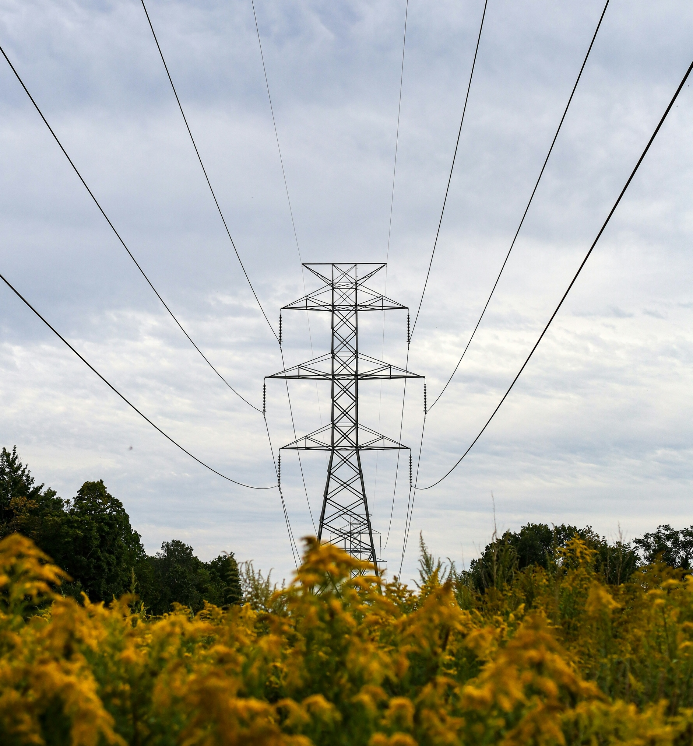

NPCC is dedicated to the continued reliability of the Bulk Power System in Northeastern North America.
1040 Avenue of the Americas, 4th Floor
New York, NY 10018
www.npcc.org

1040 Avenue of the Americas 4th Floor
New York, NY 10018
www.npcc.org

