

Background Information:

In accordance with the recommendations of the Strategic Review of the NPCC Criteria, the Task Force on System Protection (TFSP) is seeking comment on the cost effectiveness and contribution to Bulk Power System resilience of the reliability Criteria contained in Directory #4 System Protection Criteria.

Resilience is a necessary component of reliability and is an important characteristic of system design and operation. Resilience consists of the following operational components: 1) Robustness – the ability to withstand disturbances by supporting operations in a more secure state; 2) Resourcefulness – the ability to detect and manage a crisis as it unfolds; 3) Rapid Recovery – the ability to get services back as quickly as possible in a coordinated and controlled manner. (A fourth aspect of resilience involving lessons learned is also provided through the activities of NPCC’s task Forces and Working Groups).

The Strategic Review report concluded that the NPCC Criteria clearly contribute to the reliable
design, operation, and resilience of the international, interconnected NPCC Bulk Power System beyond what NERC Reliability Standards require. Those contributions to resilience are graphically represented in the figure below:

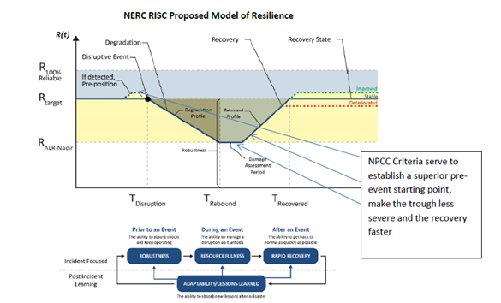

Additionally, the Strategic Review report also recommended that a further evaluation that considers the incremental reliability value and cost effectiveness of the Criteria should be undertaken by the Task Force having responsibility for the Directory. This assessment should take place during the Task Force’s regular review of each Directory and will consider whether the specific Criteria requirements add value to reliability and BPS resilience and if so, is this the most cost effective means of achieving this outcome. The results of the cost effectiveness evaluation will be documented in the permanent review record of each Directory.

NPCC is piloting this process to ensure that the NPCC Criteria requirements enhance reliability and system resilience and that cost effective alternatives are considered. The final process will be incorporated into a revised Directory Development and Revision Manual to govern future Directory reviews by the Task Forces.

The TFSP has determined that the Directory #4 Criteria requirements promote reliability and system resilience beyond the existing requirements in the approved NERC Standards and has detailed the reliability value and system resilience contribution of the Directory #4 Criteria requirements in the attached table.

NPCC More Stringent Criteria Attribute | Enhanced Reliability Value | Resilience Component
Protection Group Redundancy | Protection Group Redundancy provides dependable BPS performance assurance since each protection group must be capable of independently performing the specified protective function. | Robustness:  The ability to absorb shocks and continue operating.
Environment | Criteria requirements for ‘Environment’ protect against common mode failure by ensuring physical separation of cabling for protection groups and teleprotections which protect the same system elements. | Robustness:  The ability to absorb shocks and continue operating.
Dependability of Batteries and DC Supply. | Dependability of Batteries and DC Supply Criteria provides increased BPS resiliency by ensuring that a single battery or DC power supply failure does not prevent both independent protection groups from performing the intended function.  Dependability of Batteries and DC Supply also promotes additional BPS reliability by maintaining physical separation between the two station batteries or DC power supplies used to supply the independent protection groups. | Robustness:  The ability to absorb shocks and continue operating.  Rapid Recovery:  The ability to recover as quickly as possible in a coordinated and controlled manner to a better recovery state.  Resourcefulness:  The ability to manage an event as it unfolds.  .
Independent Circuit Breaker Trip Coils and Test Verification. | Independent Circuit Breaker Trip Coils and Test Verification Criteria provide enhanced BPS reliability since no single trip coil failure shall prevent both independent protection groups from performing the intended function.  Independent Circuit Breaker Trip Coils and Test Verification also promote additional reliability by monitoring the trip coil in a fail-safe manner and annunciating to allow for prompt attention. | Robustness:  The ability to absorb shocks and continue operating.  Resourcefulness:  The ability to manage an event as it unfolds.
AC Station Service. | AC Station Service Criteria provides enhanced reliability by ensuring that there are two sources of station service AC supply each capable of carrying at least all the critical loads associated with protection systems. | Robustness:  The ability to absorb shocks and continue operating.
Tele protection | Teleprotections Criteria ensures that communication facilities perform consistent with that required of the protection system.  Equipment for each protection group shall be separated physically on non-adjacent panels.  The communication medium outside the substation physical perimeter shall be designed to minimize the risk of both protection groups being disabled by a single event.  Tele protection shall be designed with continuous monitoring and alarming for loss of function. | Robustness:  The ability to absorb shocks and continue operating.  Resourcefulness:  The ability to manage an event as it unfolds.

The questions below seek to identify any cost effective alternatives to the identified reliability Criteria in the table and responses will be documented in the permanent record of the review of Directory #4.

The pilot will also contribute to the refinement of a repeatable and sustainable cost effective analysis process which will be incorporated into the NPCC Directory Development and Revision Manual.

Question #1:

Do you agree that the Directory #4 reliability criteria are important to enhancing NPCC’s BPS reliability and system resilience?

Yes
No

If you answered “No,” which parts of the criteria in Directory #4 are not important to NPCC’s BPS reliability and please explain why?

Question #2:

Are there any cost effective alternatives to achieving a similar or greater level of NPCC BPS reliability, system resilience and performance than provided by the criteria as described in the table?

Yes
No

If you answered “Yes,” please provide examples as well as any technical information or justification(s) that support your conclusions.

Strategic Review of the NPCC Criteria https://www.npcc.org/Committees/commRelCoord/Member%20Documents/NPCC%20Criteria%20Strategic%20Review%20Report%20to%20Members_Dec-2018.pdf
Reliability Issues Steering Committee (RISC) --- Report on Resilience https://www.nerc.com/comm/RISC/Related%20Files%20DL/RISC%20Resilience%20Report_Approved_RISC_Committee_November_8_2018_Board_Accepted.pdf

