



SUBMISSION TO THE LEGAL AND CONSTITUTIONAL AFFAIRS REFERENCES COMMITTEE FOR INQUIRY AND REPORT WITH REFERENCE TO AUSTRALIA’S YOUTH JUSTICE AND INCARCERATION SYSTEM

December 2025

Legal and Constitutional Affairs References Committee
TEQSA Provider ID: PRV12002 (Australian University)
CRICOS Provider Code: 00120C
wyut@anu.edu.au
Office of the Vice President, First Nations Portfolio
John Yencken Building #45, Sullivan’s Creek Road
The Australian National University
Canberra ACT 2601

Proudly supported by
TEQSA Provider ID: PRV12002 (Australian University)
CRICOS Provider Code: 00120C
wyut@anu.edu.au
Office of the Vice President, First Nations Portfolio
John Yencken Building #45, Sullivan’s Creek Road
The Australian National University
Canberra ACT 2601

Proudly supported by

Acknowledgement of Country
The Wiyi Yani U Thangani (Women’s Voices) Project has travelled across the continent and surrounding islands, including the Torres Strait, Tasmania and Tiwi, and has listened to women, girls (inclusive of Sistergirls and trans women) and gender-diverse people from many nations, over many years. The Wiyi Yani U Thangani Institute for First Nations Gender Justice gives special acknowledgement to our Matriarchs—the first mothers of this land—we pay our respects to them and all our Elders past and present who watch over us, our kin, our Countries, waters and skies.

About the Wiyi Yani U Thangani Institute

The Institute, based at the Australian National University, is Australia's first Institute dedicated to advancing the rights, knowledges, and leadership of First Nations women, girls and gender-diverse peoples as catalysts for systemic change. It is founded by June Oscar AO, who led the landmark Wiyi Yani U Thangani (Women's Voices) project as former Aboriginal and Torres Strait Islander Social Justice Commissioner at the Australian Human Rights Commission.

Throughout all stages of the Wiyi Yani U Thangani project, women have been clear that this work must be more than a report that sits on the shelf – it must result in lasting change. Women everywhere emphasised the need for a genuine mechanism for the representation of First Nations women that legitimises their diversity and affirms their multiple and vibrant identities, and does not conflate them with those of First Nations men or non-Indigenous women.

The Institute’s approach to First Nations gender justice is an evidence-based methodology that although developed with and for First Nations communities, the principles and ways of working employed are responsive to gender equality generally and caring for women, girls and gender-diverse peoples of all backgrounds. It is grounded in the voices of women and girls, and is a systems change, intersectional, human rights and peacebuilding framework, meaning that when addressing the needs of women and girls, the Institute advocates and supports action that has systemic and structural impacts rather than ones that are piecemeal. This will create sustainable changes with ripple effects beyond immediate challenges or issues. It also deeply values and actively engages with First Nations women, communities and organisations ensuring their voices are central and ongoing to the development of Institute works.

About this submission

Please note that this submission refers to ‘Australia’s youth justice and incarceration system’ in ways that refer to contact with policing and incarceration. It does not include ‘youth justice’ as the Institute acknowledges that this system is one that is unjust. This has been articulated by First Nations women and communities in sharing their experiences with this system with the Institute in engagements since 2017.

The Wiyi Yani U Thangani Institute for First Nations Gender Justice (the Institute) welcomes the opportunity to contribute the Legal and Constitutional Affairs References Committee (the Committee) for inquiry and report. This submission highlights that the challenges persistent within the incarceration and policing systems are the result of historical and contemporary failures that create conditions of harm, violence and discrimination. There is myriad evidence shared across civil society groups, First Nations communities and advocates, and concerned calls raised by United Nations experts calling for systems shifts that make this system one that is safe and just. The Institute points to evidence collected through the Wiyi Yani U Thangani engagements, highlighting that a systems change, intersectional and human rights approach needs to be taken in understanding the experiences of young people for meaningful and accurate accounts of how they have engaged with incarceration and police. Importantly, the Committee needs to deeply engage with the existing evidence and calls of action acknowledging young people and communities as the experts of their lives. The Institute urges the Committee to take action on these calls and develop meaningful and ongoing relationships with young people and communities to respond and drive change.

This submission is divided into three parts:
- Part 1 addresses the need to understand the context of over-incarceration of young people through a systems change approach. This necessitates understanding of the social, economic, environmental, political and cultural contexts which put young people at risk of contact with police and incarceration, and confront the systemic failures resulting from the ongoing harm and violence of colonisation.
- Part 2 details the Institute’s approach to meaningful engagement, urging the Committee to invest in meaningful ongoing relationships with young people and communities in order to eventuate change, and respond to existing evidence.
- Part 3 highlights Australia’s international obligations and calls to action urged by the United Nations. It highlights that creating a just incarceration and policing system requires safeguarding all rights of young people.

The Institute strongly encourages the Committee to engage in Wiyi Yani U Thangani’s resources, particularly the Change Agenda for First Nations Gender Justice (2024) as a framework for meaningful action towards creating safe, caring and just systems; the Implementation Framework (2022) and the Wiyi Yani U Thangani First Nations Women’s Safety Policy Forum Outcomes Report (2022) for evidence of what system shifts are needed to ensure women’s safety, health and wellbeing for a thriving life, communities and Countries; and the Wiyi Yani U Thangani Report: Securing our Rights, Securing our Future (2020) for extensive evidence of the lived experiences and calls to actions asked by First Nations women, girls and gender-diverse peoples across Australia, particularly chapters in Part 2 on safety.

Part 1: Framing the over-incarceration of First Nations children through a systems change approach

First Nations children are incarcerated at grossly disproportionate rates in every jurisdiction. This over-representation reflects systemic and structural failures, including poverty, racism, child removal, criminalisation of care and unmet disability and mental health needs. In particular, girls and gender-diverse First Nations young people are increasingly criminalised for survival-related behaviours linked to violence, homelessness and child protection involvement. The Institute emphasises that this is not a failure of children, but a failure of systems that continue to respond with punishment rather than care, healing and prevention. As one submission shared in the Wiyi Yani U Thangani Report (2020):
It has been widely recognised that Aboriginal and Torres Strait Islander communities are overpoliced. Women and girls routinely report harassment by police including police stopping them on the street for no reason. These interactions often lead to criminal charges. The intergenerational context of police violence and mistrust of police by Aboriginal and Torres Strait Islander women and girls, and communities more broadly, is poorly understood in the mainstream community.
Aboriginal and Torres Strait Islander women and girls also experience high levels of surveillance by other community members in public spaces, which may also increase their contact with police. For example, surveillance in shops, at train stations or in hospitals can often trigger community members to call police to respond to perceived ‘anti-social behaviour’ or situations that involve significant distress for women or girls. The experience of being ‘targeted’ in this manner is very detrimental to young women’s confidence.

The Report further includes lived experiences and calls to action addressing policing and incarceration. This information is most useful when read in conjunction with other sections including health, economic justice, culture, leadership and other areas of life. In this framing, the report highlights that responding to the policing and incarceration system requires a systems change approach, recognising social, cultural environmental and political contexts, and by examining historical, contemporary and intergenerational issues that perpetrate cycles of harm.

This approach will enable sustainable changes to take place that recognises that the contexts in which young people have contact with police and incarceration are not a result of isolated events or unique behaviours and actions, but reflect systems of harm that put young people in danger, vulnerability and disregard. These systems of harm are perpetuated before, within and after contact with incarceration and policing—with young people’s contact with these environments increasing their risks of harm and unsafety in the future.

Without this critical examination of the youth incarceration and policing system through this lens, action taken to address harm will be piecemeal and unsustainable. This is because the current system, without systems-based reform will continue to engage in the behaviours and reproduce settings that maintain how the system operates.

Understanding care and whole-of-life support

Women throughout the Wiyi Yani U Thangani engagements have advocated that in order to shift this system from one that over-incarcerates, over-polices and over-surveils First Nations children and their communities, is unsafe for young people within detention centres, and which maintains conditions which produces recidivism, the systems which touch the lives of First Nations peoples need to:
- centre care and healing over punitive approaches
- children and young people, and their families and communities need to be supported from the beginning of life
- mothers, families and communities need to be better resourced to keep young people safe, healthy, educated and thriving.

Care and whole-of-life support are central to how the Institute supports First Nations women and girls. Addressing all areas of life, care grounds the Institute’s relationships with communities and stakeholders, and undertakes projects, advocacy and research.

Care is described in the Caring about Care report, a collaboration between the Australian National University, University of Queensland and the Institute, as essential to supporting human rights in Australia, as Klein describes, ‘care is an essential part of life; it grows peoples, nourishes peoples, and no one can live without it’. When individuals and communities are supported and listened to, they are in turn able to participate in the economy and the economic benefits for all of society are multiple and widespread. To adequately capture this understanding of care, systemic change work needs to take place, reflecting and responding to lived experiences of First Nations women and adapting to change. Key to this is the strategy recognising this role of care and how informal care work impacts upon women’s economic justice.

To accurately recognise the extent and complexity of First Nations women’s care work requires tools and strategies to record and measure its value and contribution. Metrics must capture the full spectrum of care work as understood through a First Nations worldview, and recognise the significant economic contribution this makes. The deep interconnectedness of care systems and other systems, including education, health and justice, must also be considered in the approach to accounting for this work. By accurately measuring care work through this lens also provides opportunity to better understand different types of care conducted across Australia, including by girls, elders, carers with a disability and CALD carers, and recognise and respond to their lived experiences.

The Change Agenda articulates this approach through an outcomes framework, visualised as a Grandmother Tree, which shows how addressing women’s needs across all systems leads into systems shifts and long-term life outcomes. The framework is deeply relational and intersectional, emphasising that shifts in one area of life ripple into other systems. It is a useful framework that may be employed by the Committee to shift their understanding of the interrelationship of rights and factors that influence young peoples engagement and wellbeing with the policing and incarceration system. The Institute encourages the Committee to engage with the Change Agenda and embed its practices and approaches.

Below is the graphic of the Change Agenda’s Grandmother Tree.

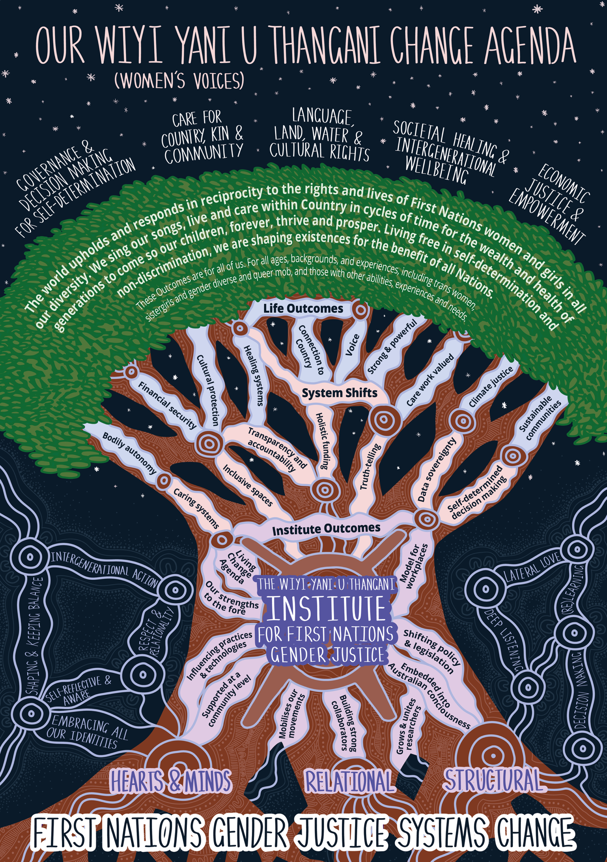

Part 2: Facilitating meaningful engagement with young people

In responding to the Committee’s Terms of Reference, it is essential that First Nations voices are forefront, and that they are meaningfully listened and responded to. The Wiyi Yani U Thangani report presents detailed evidence on the outcomes and impacts of youth incarceration. This includes:
- Intergenerational harm and trauma
- Criminalisation of trauma and care needs
- Loss of culture, identity and healing pathways
- Compliance of detention centres with young people’s human rights – including their safety, health and wellbeing

This evidence is detailed in Part Two of the Report, particularly Chapter 6 (Law and Justice), with calls to action on page 236. The report also provides specific detail of youth experiences in Chapter 13 (Social and emotional wellbeing).

It is important that this evidence is acknowledged and responded to, and that First Nations young people, and their families and communities are actively engaged in ongoing policy, legal, programmatic and infrastructure changes designed to shift this system. First Nations peoples are the experts of their own lives, and hold the knowledges and expertise about how to sustain their communities. Young people with contact with police and incarceration have deep knowledge about how this system works to keep them safe and create deeply unsafe environments that result in harm. It is only with their voices present in decision-making that policy and law makers can shape systems that work for young people.

The Institute encourages the Committee to embed meaningful community engagement processes and mechanisms, as foundational to understanding the impacts of incarceration and politicking on young people, and developing actions to make this system safe. This includes co-designing with First Nations young people and communities—approaches that enable those with lived experience to work directly with policy and decision-makers. These processes and mechanisms must go beyond advisory groups and commentary, but be designed to enable sustained and meaningful engagement ensuring First Nations young people can inform policy development and implementation for reform to be substantive rather than symbolic. In doing so, the Committee must be prepared to be accountable and responsive to how communities want support or change to take place, and actively work with communities in shaping implementation of programs and supports, ensuring they continually meet communities’ expectations.

The Institute works closely with First Nations women, girls, gender-diverse peoples and their
communities across the country, ensuring that their voices continually shape the agenda and priorities of the Institute. This grounded approach values and acknowledges that women are the experts of their lives, and hold the solutions to the challenges they face. In addition to extensive engagements and creating spaces for First Nations women to have their say, the Institute has built trusted relationships with First Nations women’s organisations, groups and collectives. These include for example, the Kimberely Aboriginal Women’s Collective (KAWC), South West Aboriginal Women’s Collective (SWAWC), and Thamarrur Development Corporation Women’s Centre—which act as mechanisms for collective decision-making and priorities for First Nations women across regions.

These collectives are key mechanisms for the Institute to ensure we are deeply listening to the needs and experiences of First Nations women and their communities, on the ground. The relationship also provides a platform for women to be heard and for the Institute to work in partnership with them to address key issues. Women have shared that these relationships are vital to their wellbeing as they can feel confident and safe knowing that their voices are being listened and responded to, and changes are emerging over time. It is critical that the Committee build meaningful relationships with young people, their families and communities who have come in contact with policing and incarceration for ongoing reporting and action related to shifting these systems.

Using the Institute’s Ways of Working and MEL

The Change Agenda presents Ways of Working and a measurement, evaluation and learning (MEL) framework, designed with First Nations women, girls and gender-diverse peoples, for making systems shifts a reality. The Institute encourages the Committee to engage with the Institute’s ‘Ways of Working’ and MEL framework described in the Change Agenda to better engage MEL and meaningful engagement practices. The Institute holds nine interconnected Ways of Working: (re)Learning, Lateral Love, Respect and Relationality, Embracing all our identities, Deep Listening, Self-reflective and aware, Intergenerational action, Shaping and keeping balance, and Sense-making. These are embodied practices that are used to pursue systemic change work, engaging in communities and implementing MEL activities. They serve as values, principles and actions that frame the work, ensuring that action reflects how First Nations communities want to be engaged with.

The Institute’s MEL framework shifts away from mainstream practices in that it is a continuous and dynamic process across the life of Institute work, programs and projects. It is purposely designed in this way to enable learnings to rapidly integrate into the agenda rather than learnings being understood at the end or at certain intervals, thereby delaying improvements. As a key data metric, the framework principally utilises ‘signals’ that are collected and heard from communities, stakeholders and our surroundings. The Change Agenda defines signals as: the things we see, hear, feel or sense that tell us that we are making progress towards our outcomes. Use of signals is a purposeful shift away from numerical rigid indicators that dictate process of change, and towards paying close and sustained attention to our surrounding environments and systems. Each set of outcome signals has been formed through our voices and speaks to the changes we would expect to see as we progress the outcome. This goes beyond conventional metrics to include cultural vitality, community wellbeing and intergenerational knowledge transfer.

Signals may also indicate negative outcomes (no changes over time or increased harm), reflecting the need for urgent change. Collecting signals regularly enables opportunity for urgent action to take place and shifting delivery of services, resources and support. It will also strengthen trust by communities in that policymakers and service providers are deeply listening and responding timely to their needs, rather than following a linear strategy or programmatic approach. The Institute strongly recommends using this MEL framework in the Strategy how the Committee deepens their engagement with young people and responds to the evidence presented.

In practice, signals can only be gathered through ongoing engagement with communities and stakeholders, and by projects/program teams engaging in the ways of working, particularly Deep Listening and Sense-making to be able to listen and be attuned to the changes that are or are not taking place.

Part 3: Conclusion and the Commonwealth's international obligations in regards to youth justice

The Institute urges the Committee to respond to the myriad of evidence and calls to action shared by First Nations peoples, communities and organisations advocating for just policing, incarceration and child protection systems. The Institute emphasises the value of engaging with the Change Agenda and Wiyi Yani U Thangani Report providing detailed evidence of First Nations women and girls experiences with policing and incarceration, and the frameworks required to make this system one that is just.

In responding to these calls, the government will be supporting its commitments under the United Nations Declaration on the Rights of Indigenous peoples, Convention on the Elimination of Discrimination against Women and Convention on the Rights of the Child, responding to the creation of systems and environments that enable First Nations peoples, women and girls, and children and young people to live lives without violence, discrimination and harm.

Case Study- First Nations Women’s Advocacy for Youth Justice Reform Following the Banksia Hill Riots

In May 2023, riots erupted at the Banksia Hill Juvenile Detention Centre in Western Australia, drawing national concern about the treatment and conditions of children held in youth detention. The unrest highlighted deeply entrenched issues within youth justice systems that disproportionately affect First Nations children. In response, hundreds of First Nations female leaders from across Australia—including commissioners, advocates, elders, and community organisers—converged in Canberra during the Wiyi Yani U Thangani National Summit to issue a powerful, unified call for urgent reform of Australia’s youth justice system. The crisis drew national and international condemnation, highlighting Australia’s failure to meet its international human rights obligations and calling for urgent need for a fundamentally different approach:

“The incarceration of Indigenous children in Australia is an ongoing form of state violence that perpetuates the trauma of colonialism and dispossession. This retributive punishment is not only a violation of the human rights of Indigenous children and their communities, but also undermines the Sustainable Development Goals of creating peaceful, just, and inclusive societies.” Chair of the Close Don Dale Now! movement, Josephine Crawshaw

“The UN Permanent Forum for Indigenous Issues met recently in New York and were absolutely shocked by the horrific reports of violence and cruel treatment of incarcerated Aboriginal children and youth. We made it very clear to Australia that no child belongs in prison. We also called on the Australian government to immediately remove its reservation to Article 37 (c) of the Convention on the Rights of the Child (CRC) which prohibits cruel and inhumane treatment of children in detention settings. Further, Australia has still not signed the Optional Protocol to the CRC. The Australian Government and the Attorney-General have a clear responsibility that has to date been neglected. We want to see action and appropriate responses. This has to stop. This Government should support an urgent national meeting to address these issues with Indigenous leaders.” Associate Professor Hannah McGlade, member of the UN Permanent Forum for Indigenous Peoples

“These children need to be cared for in a trauma informed and culturally appropriate way. This country needs to urgently address the crisis in youth justice to prevent further harm to children in detention, and to reduce youth offending through effective systems of support.” [Former] Aboriginal and Social Justice Commissioner, June Oscar AO

Together, these voices underscore a shared message: the Banksia Hill riots were not an isolated incident, but a symptom of systemic failure. First Nations women and communities continue to call for immediate reform that centres care over punishment, community-led solutions, and Australia’s human rights obligations to its children.

Read the full Australian Human Rights Commission media release

The Institute also urges the Committee and government respond to the concerned calls to action by United Nations Special Rapporteur on torture or other cruel, inhuman or degrading treatment or punishment; and Special Rapporteur on the rights of Indigenous Peoples and enable United Nations experts on arbitrary detention to visit Australia to provide critical and valuable advice on Australia’s incarceration system being one that is safe, respectful and responsive to the needs of communities, including those currently and formally detained.

By heeding these calls, Australia can demonstrate genuine commitment to transforming its incarceration and policing systems into ones that uphold human rights, centre First Nations self-determination, and create pathways toward healing rather than harm. The Institute supports driving this change and is available for further discussions with the Office.

