Fredrikstad, 01.09.2026

Nordic Kingfish Fredrikstad A/S
Locality number: 35778

Testing for ectoparasites

Cultured Species:
Yellowtail kingfish (Seriola lalandi)
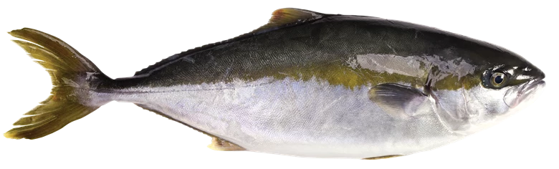

Latest test: 28.08.2026

Findings: 0 ectoparasites

