R&D PROJECT STRUCTURE CHEATSHEET

My Hours Step-by-Step Process and Best Practices

Follow the process and tips below to set up the right structure to efficiently capture qualifying R&D work.

1. Set Up a Client for R&D
Setting up a client specifically for R&D helps keep all work separate from non-R&D activities.

This creates a hard boundary between qualifying R&D work and everyday delivery, support, or admin. That separation is vital because R&D claims fail when eligible and non-eligible time are mixed and cannot be cleanly separated.

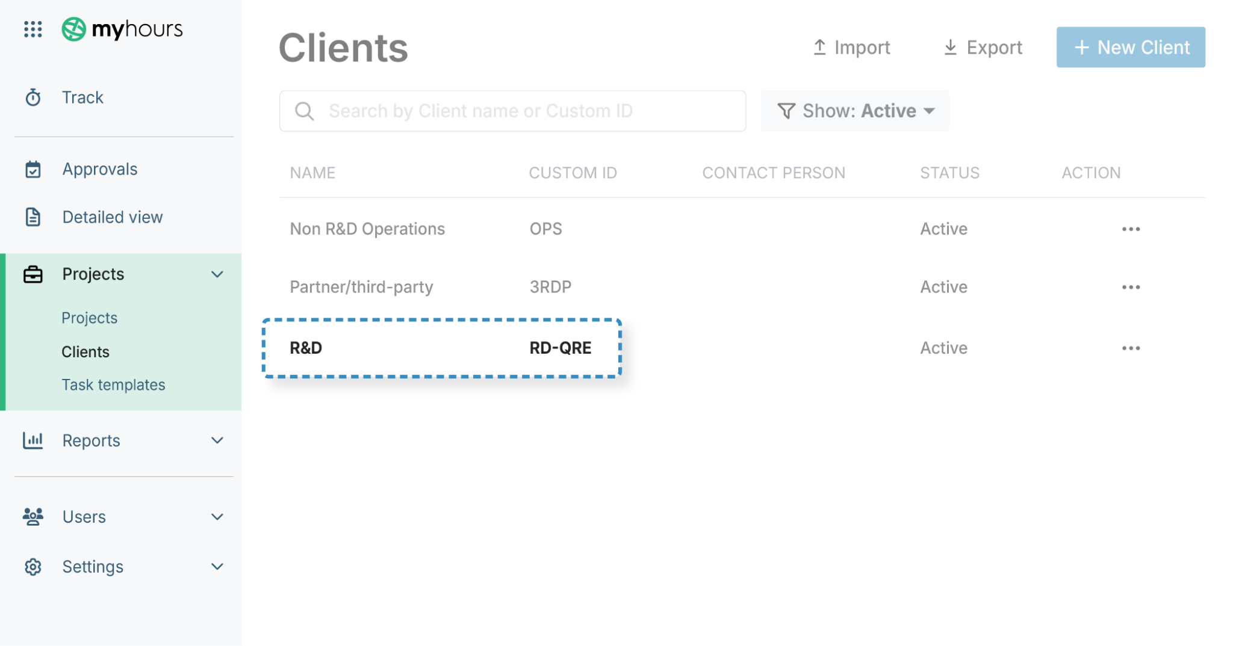

How to do it in My Hours:

- Click Projects > Clients > +New Client
- Name the new client R&D or similar
- Add a custom ID that you can use consistently. Example: RD-QRE
- Click Save

Tip: You can create clients in the same way for other business operations or internal departments. There is no limit to the number of clients you can add within My Hours.

2. Create a Project for Each Technical Uncertainty

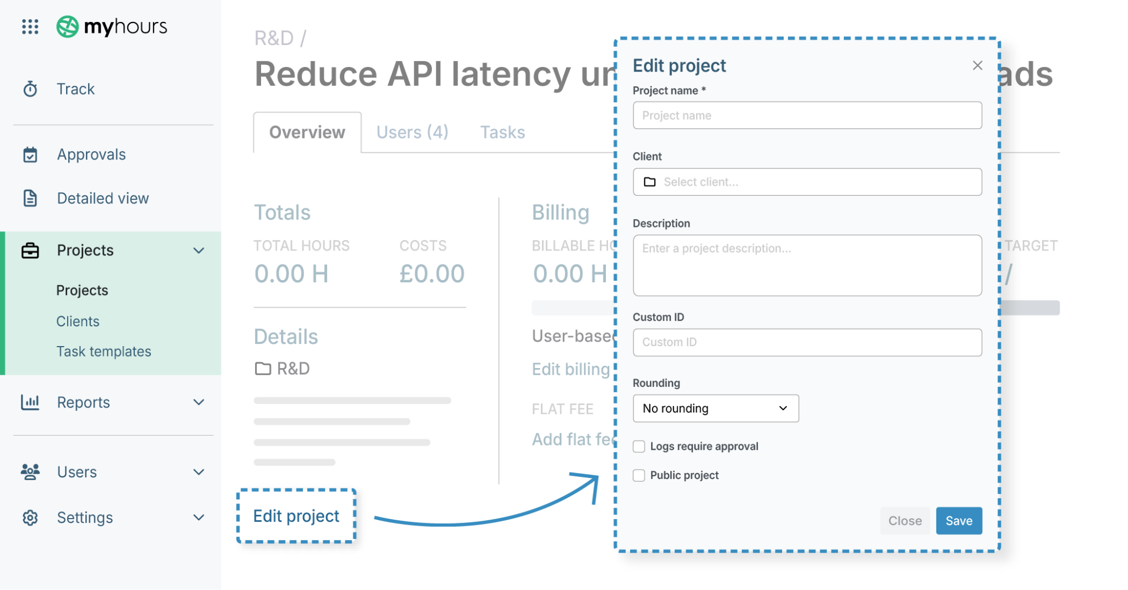

Every business component that is undergoing R&D for a technical uncertainty must have its own project. If a single business component has more than one technical uncertainty, then you must create separate projects for each.

How to do it in My Hours:

- Click Projects > Projects > +New Project
- Name the project and select the correct client (R&D)
- Click: Edit project
- Enter a project description and custom ID
- Click Save

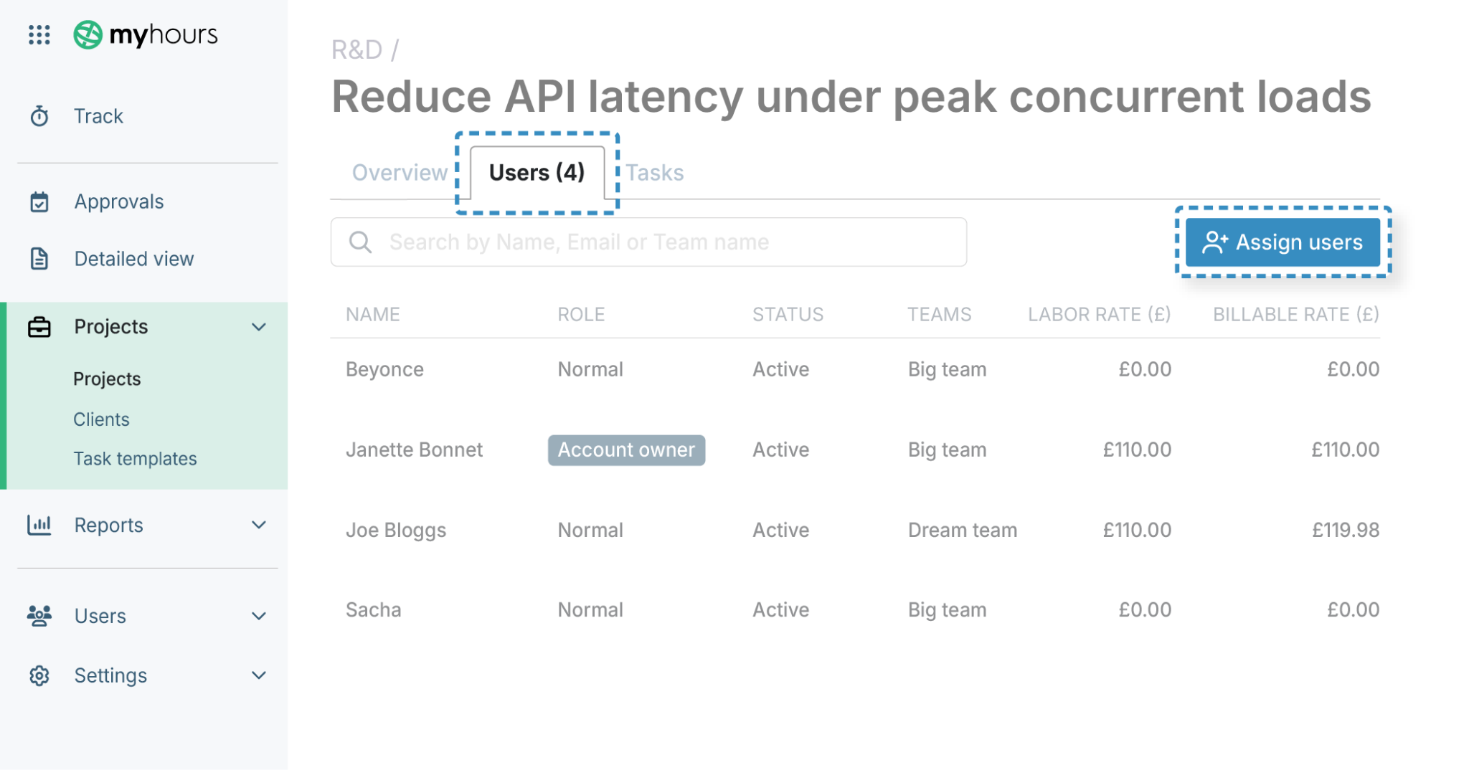

At this point, you can also assign users to the project. These are the individuals who will be working on the tasks.

Only those who are assigned to the project can be assigned tasks (and track time against them).

- While in the Projects tab, click on the relevant project name
- Click on the Users tab and then Assign users
- Select which users you wish to add to the project

Tips for creating compliant projects
A compliant project title should be named as follows:

Verb + Desired outcome + Constraint or uncertainty

Examples:

- Improve real-time data processing reliability under high-frequency event loads
- Determine whether modified assay conditions can improve signal stability in low-concentration samples
- Evaluate alternative material compositions to reduce fatigue failure under cyclic load condition

Regarding the project descriptions, their job is to make it immediately clear, to someone with no prior context, that the project involved technical uncertainty and systematic investigation, not routine delivery.

Therefore, state the:

- Technical objective
- Technical uncertainty
- Investigative approach
- Scope boundary

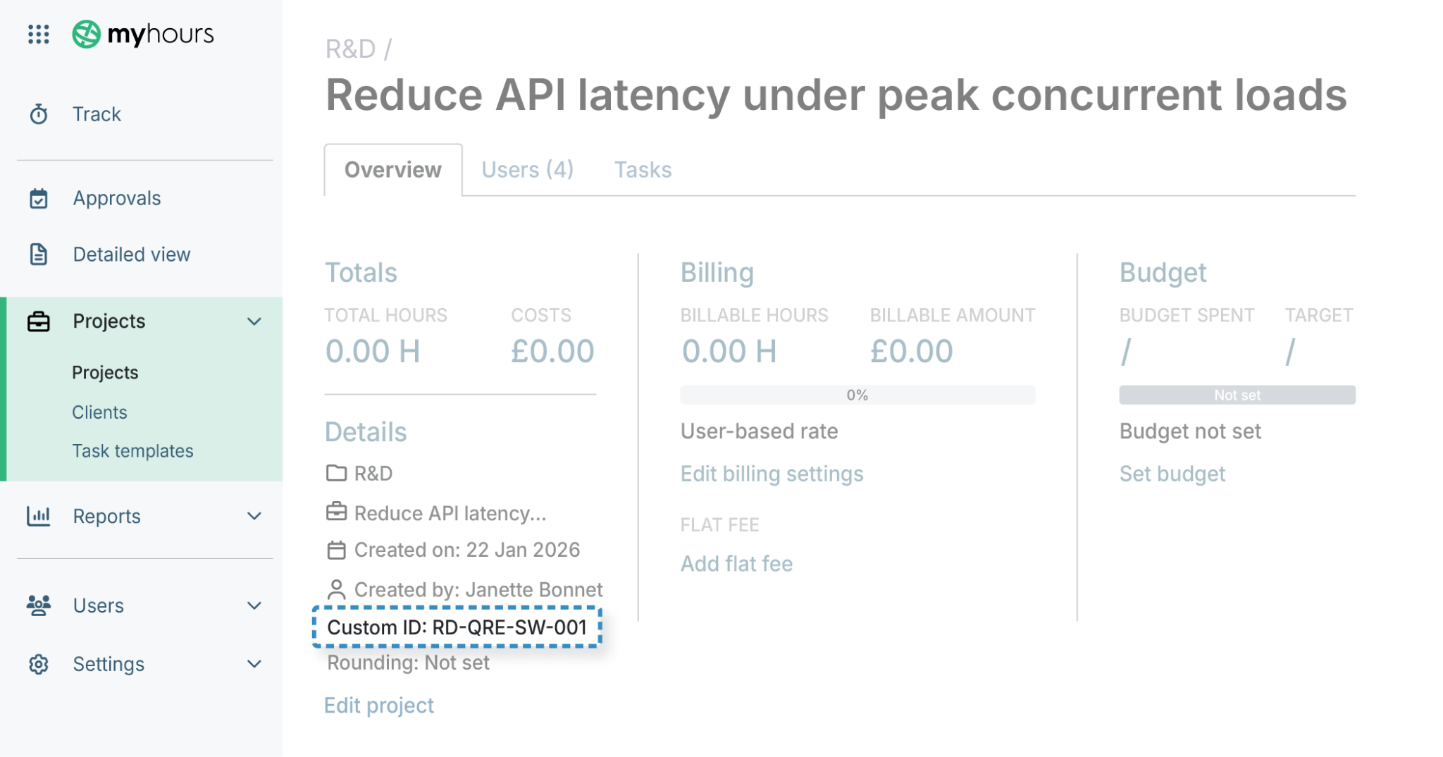

Project IDs should answer three questions at a glance:

- Is this an R&D project? Prefix the code clearly, for instance, RND, RD, or QRE.
- What type of work is it? Use a short discipline indicator, such as SW for “software.”
- Is it unique and traceable? Each project requires a unique number of suffixes that can be referenced over time (001, 002, etc.)

3. Create Tasks for Each R&D Project
A separate task must be created for each investigative activity that falls under a project title. This allows users to track time in the correct place.

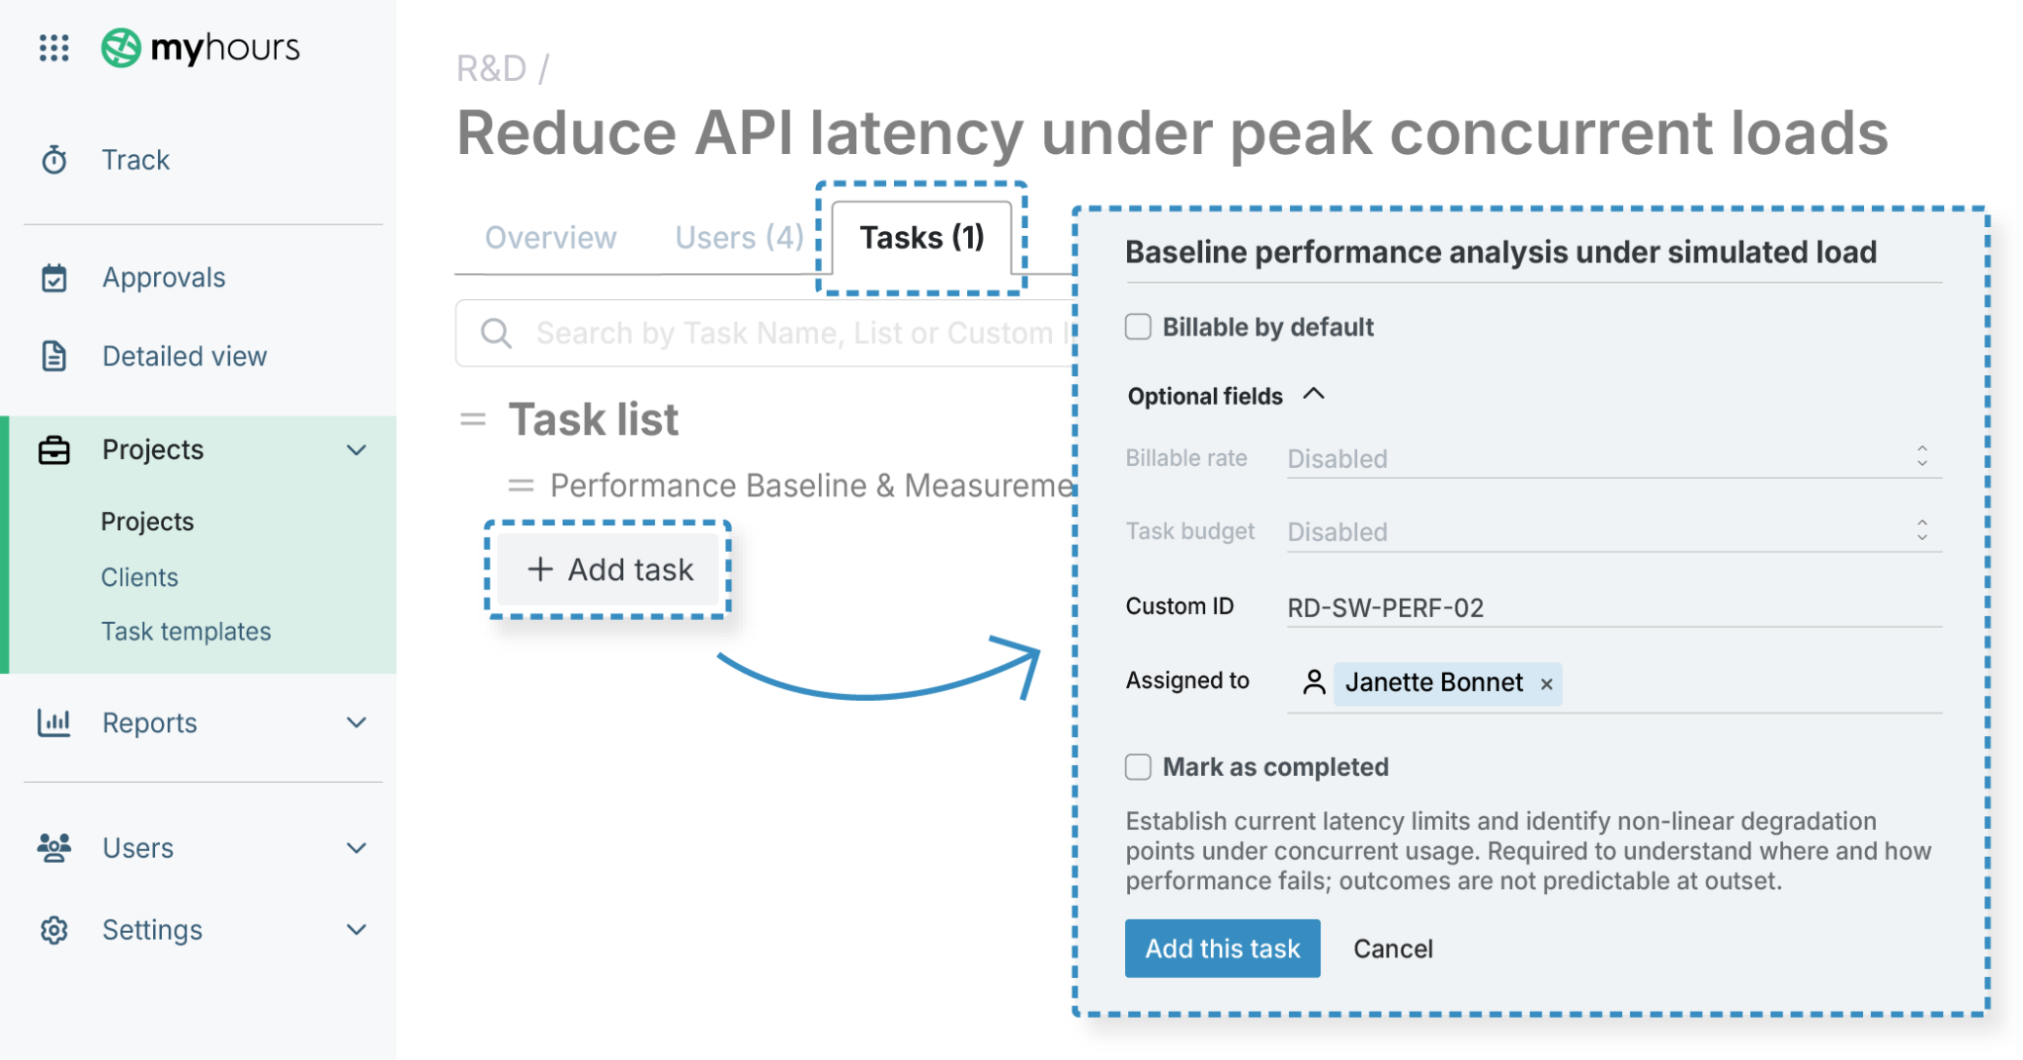

How to do it in My Hours:

- While in the Projects tab, click on the relevant project name
- Select the Tasks tab and click +Add task
- Enter the task name and task list*
- Ensure Billable by default is not selected (since you would only use this option when billing external clients)
- Click the Optional fields dropdown tab
- Input a custom ID
- Assign the users who will be working on the task
- Add a description
- Click Save

*Task lists group relevant tasks and keep deliverables organized within each project. It’s not mandatory to group a task into a list, but it can be very helpful when projects have dozens of tasks. As an example, for a software company, you might create task lists titled as follows:

- Performance Baseline & Measurement
- Concurrency & Load Behaviour Investigation
- Architecture & Design Experimentation
- And so on

Tips for creating compliant tasks

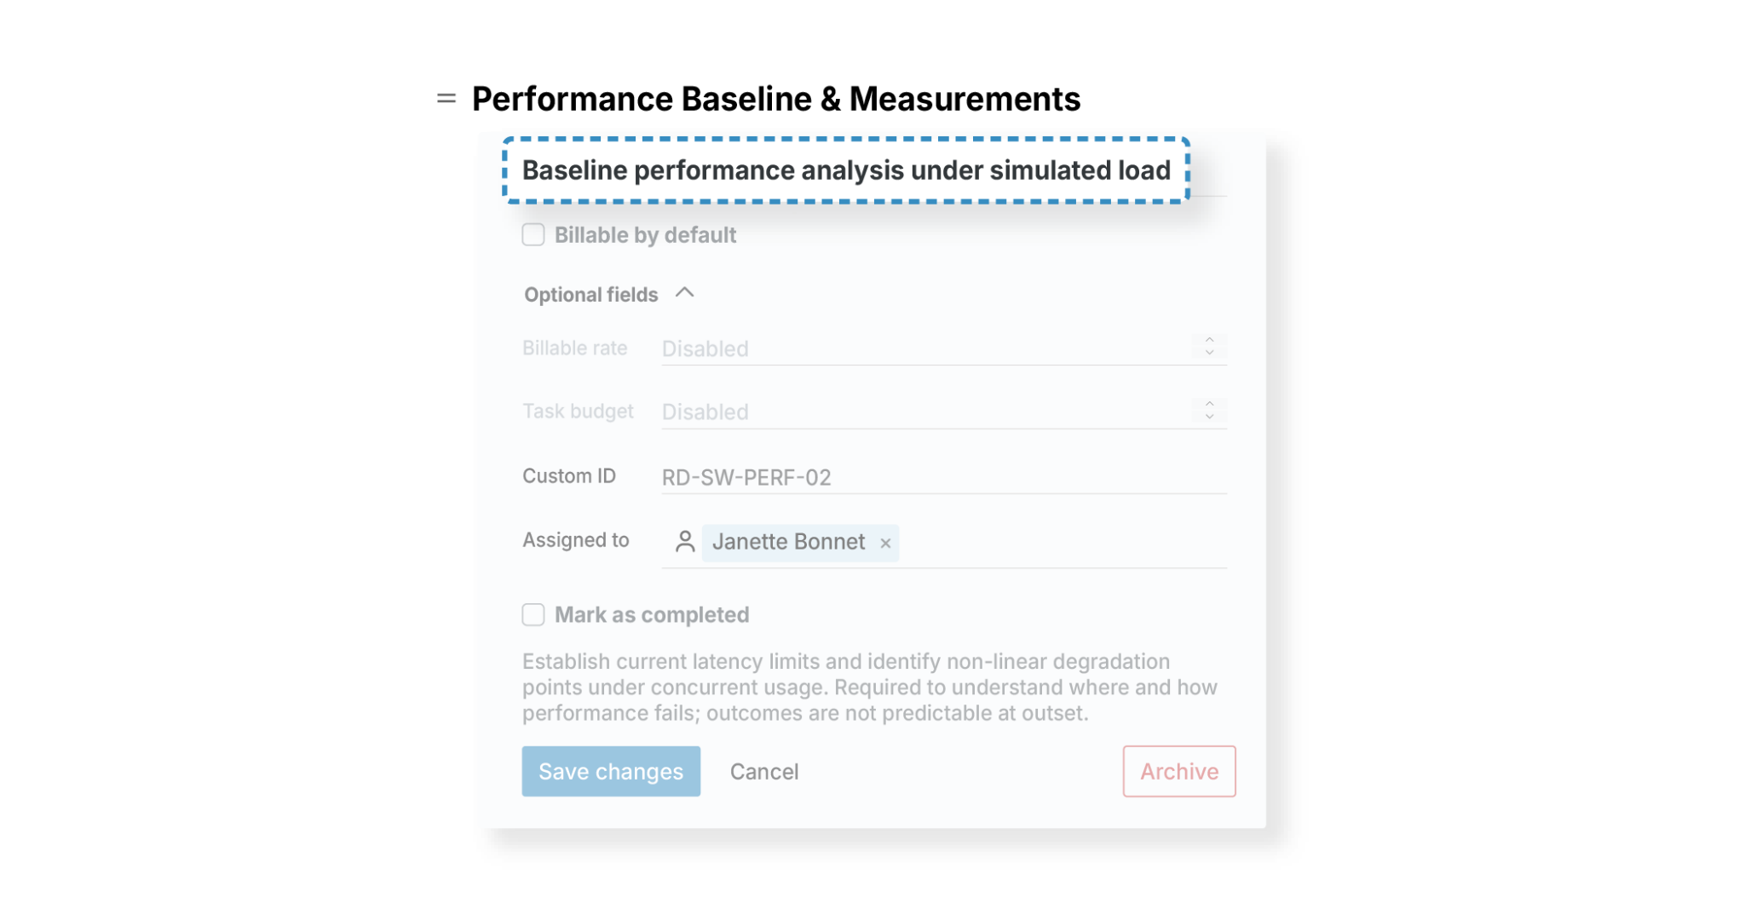
Keep task names broad and describe the type of work performed. Do not make them action specific (fix, debug, write tests, etc.), since this information can be detailed within the time entries.

Some good examples of task names include:

- Performance baseline & measurement
- Concurrency behavior investigation
- Experimental design & setup
- Exploratory testing & trials

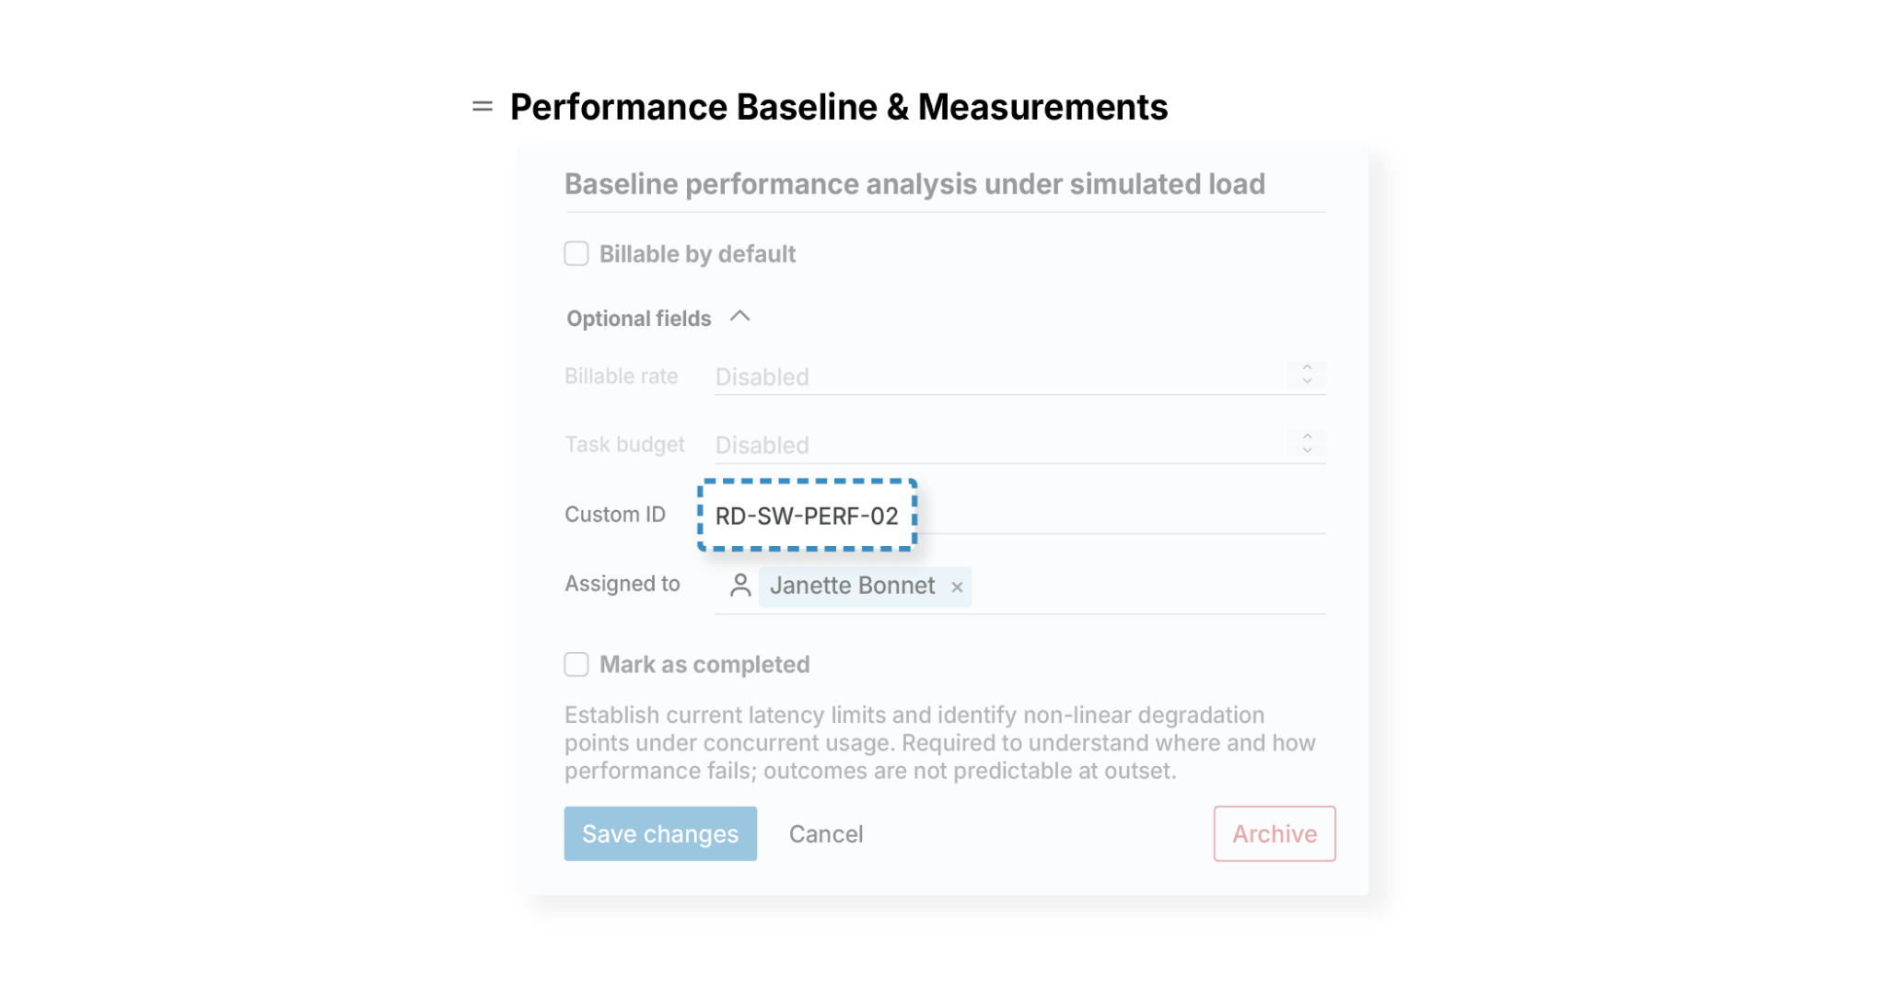
Task IDs exist to reference the type of work being done, not act as a unique identifier. Therefore, they should be reusable across different projects and easy to reference in reports and other documentation.

A good task ID should include the following:

- Start with an R&D identifier (RND, RD, QRE, etc.)
- Next, add a discipline indicator (SW for software, ML for machine learning, etc.)
- End with the task category that describes the type of investigative work, not the specific implementation. Examples:
  - PERF: Performance analysis
  - TEST: Exploratory or stress testing
  - EXP: Experimentation
  - ANALYSIS: Technical analysis
- If you want to keep task codes unique to a specific project, then you can also add a sequence number (01,02,03, etc.)

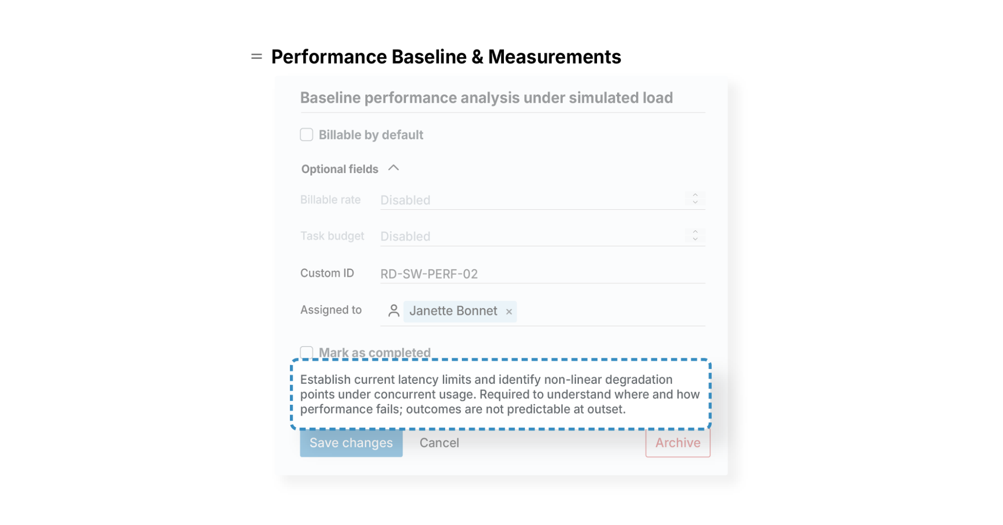
Task descriptions must answer why the time logged to the task represents a qualifying R&D activity. The aim isn’t to document what will happen, but rather why the task exists.

Best practices for task descriptions are to:

- Include the technical uncertainty
- Describe how the uncertainty will be addressed
- Avoid role-specific language and jargon

4. Set Up Custom Tags for Time Entries

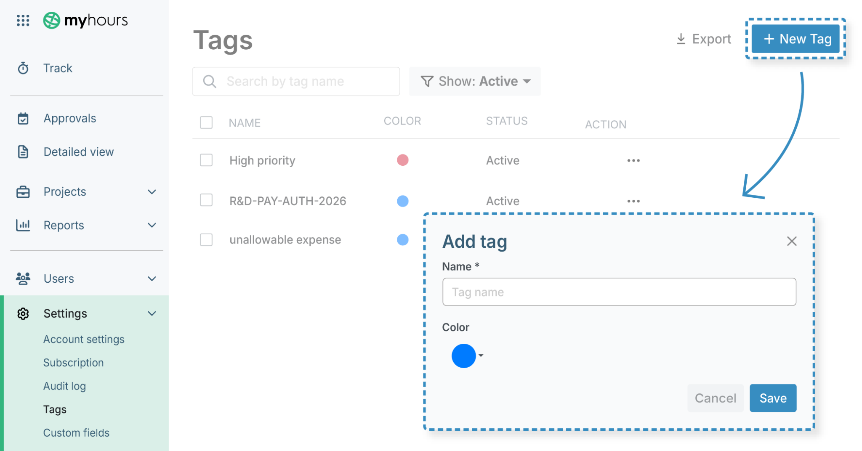
Tags are added to time entries and act as lightweight classifiers that can be filtered for reporting purposes. The advantage is that they can allow you to display time entries across multiple projects without changing your structure.

Importantly, they also act as identifiers for qualified and non-qualified R&D activities.

How to do it in My Hours:

- Click Settings > Tags > +New tag
- Write the tag name in the box provided
- You can assign a tag a color code to help keep it organized
- Click Save

Recommended R&D tag sets
Tag sets should be small, controlled, and easily understandable across teams. Additionally, they must be applicable across all projects and tasks and applied consistently.

Do not let users create their own tags. Develop an approved list and train staff on when and how to apply them.

Core tag set
This set distinguishes what is:

- Claimable under Section 174 (research and experimental expenses)
- Claimable under Section 41 (R&D tax credit)
- Non-claimable

Tags could, therefore, be:

- S174
- S41
- NonRD

Cost center tags
If your organization uses cost centers for different departments, then create a tag list for each one. For instance:

- CC-OPS
- CC-HR
- CC-IT

Activity type tags
These can be used to group similar types of activities across projects, for instance:

- Experimentation
- Iteration
- Testing
- Analysis

Domain tags
Useful if you run multiple R&D teams, yet you should only use these if they improve reporting. Examples include:

- Software
- Machine Learning
- Data
- Infrastructure
- Lab

