CapEx/OpEx TAGGING TEMPLATE PACK

This template pack gives you everything you need to set up and standardize CapEx/OpEx classification within a day, including:

- A ready-to-use tagging taxonomy
- Practical tagging examples
- Rules to guide tagging decisions
- Guidance for implementing the structure within My Hours

The goal is simple: Remove ambiguity from time entries so finance can rely on clean time and cost data without chasing workers for clarification.

Plug-and-Play Core Tag Taxonomy
Use this practical tag taxonomy so teams can classify CapEx vs. OpEx consistently, without rewriting your chart of accounts. It’s simple to roll out in a single day.

1. Top-level tags for core classification
First, you need to create two tags for defining which type of expense time entries relate to:

- CapEx
- OpEx

Then, teach the OpEx vs. CapEx rule to workers, so they know which core tag to apply:

- Tag as CapEx: If the work carried out creates or significantly improves a business asset that will bring long-term value to the organization.
- Tag as OpEx: If the work is related to running the business (recurring or short-term).

2. Work type
These tags determine what type of work was carried out. The aim of these is to support the CapEx or OpEx claim and reduce ambiguity over what happened.

These tags are also invaluable for preventing default OpEx treatment caused by vague descriptions.

As you can see, there are only a handful of tags, and we recommend keeping it this way. Using too many tags creates confusion about which one workers should apply.

You can use these tags as-is, or adapt the language so they work better for your organization.

CapEx tags:

- Typ-New asset
- Typ-Asset upgrade
- Typ-System/asset build
- Typ-Exp-RND (experimental research and development)
- Typ-Asset implementation

OpEx tags:

- Typ-Maintenance
- Typ-Issue resolution
- Typ-Minor improvement
- Typ-Customer support
- Typ-Service delivery
- Typ-Training
- Typ-Admin

3. Activity stage
This set of tags aims to provide clarity on where in the lifecycle the work occurs. This additional context helps finance understand where the work fits within a specific project.

Important: These tags are not meant for every single time entry.

They’re only useful when work is tied to a defined initiative, deliverable, or asset lifecycle where CapEx might be relevant. They’re not required for routine OpEx work.

- Stg-research
- Stg-Design
- Stg-Build
- Stg-Testing
- Stg-Deployment
- Stg-Post-release support

CapEx/OpEx Tagging Examples
So, what does all this tagging look like in practice? Here are a few examples:

Example 1: Product development

- Task name: Implement new recommendation engine
- Core classification: CapEx
- Work type: Typ-Asset implementation
- Activity stage: Stg-Deployment

Example 2: Operational maintenance

- Task name: Resolve checkout timeout bug
- Core classification: OpEx
- Work type: Typ-Issue resolution
- Activity stage: N/A

Example 3: Experimental R&D

- Task name: Evaluate machine-learning ranking models
- Core classification: CapEx
- Work type: Typ-Exp-RND
- Activity stage: Stg-research

Example 4: Routine operational administration

- Task name: Prepare monthly payroll reconciliation
- Core classification: OpEx
- Work type: Typ-Admin
- Activity stage: N/A

Example 5: Operational facilities

- Task name: Repair damaged warehouse shelving
- Core classification: OpEx
- Work type: Typ-Maintenance
- Activity stage: N/A

Example 6: Operations improvement

- Task name: Install new automated packing line in distribution center
- Core classification: CapEx
- Work type: Typ-System/asset build
- Activity stage: Stg-Build

Rules to Guide Tagging Decisions (Staff Training)
The tagging system only works if staff know how to apply it properly. Therefore, use this section to train staff on how to think about CapEx vs. OpEx.

Tip: Transform this into a one-page training guide that staff can keep handy and refer to as necessary. It should also be included within your policies and processes.

- 1. New, long‑term value usually means CapEx: If the work creates a new asset, capability, system, or meaningful improvement that will benefit the organization beyond the current reporting period, it’s typically CapEx.
- 2. Experimentation may indicate OpEx or CapEx: Work that involves testing ideas, evaluating alternatives, or solving problems does not automatically mean R&D or CapEx.
  - The correct classification depends on answering two questions: whether the activity creates long-term future value, and whether the outcome is uncertain.
    - If experimentation does not create a new or improved asset with lasting benefit, it should be treated as OpEx, even if the work feels innovative or complex.
    - If experimentation is directly tied to creating or significantly improving something that will provide future value, it may support CapEx.
    - If the outcome is genuinely uncertain and success would create future value, the activity may qualify as R&D in addition to being a CapEx candidate.
- 3. Keeping things running is OpEx: Activities that maintain, support, monitor, repair, administer, or operate existing processes and assets are operating expenses.
  - Even if the work is complex or time‑consuming, it remains OpEx when it does not create new future value.
- 4. Immediate benefit signals OpEx: If the result of the work is consumed right away (such as routine reporting, customer support, training delivery, or administrative coordination), it should be treated as OpEx because no enduring asset or capability is created.
- 5. When unsure, write a clearer time entry description, not a different tag: Unclear time entries are the biggest source of misclassification. Finance can only classify what it can understand. A precise description often resolves uncertainty faster than changing tags.
  - Staff should focus on briefly explaining:
    - What was created or improved
    - Why the work was necessary
    - Whether the benefit continues into the future

Ongoing training idea:
Review a small sample of time entries each month with your team.

Discuss why each example is CapEx or OpEx, and what could be done to improve or further clarify the time entry.

This builds a shared expectation of what time entries should look like and maintains consistency across departments. Ultimately, this will also reduce errors and help prevent finance from having to chase corrections during the month‑end close.

How to Do It in My Hours

Step 1: Create tag categories
The first thing you need to do is create the custom tags that staff will apply to their time entries.

- Head to Settings > Tags > + New tag
- Add the tag name in the provided field and hit Save
- Tip: We also recommend assigning a color to each tag set for quick identification

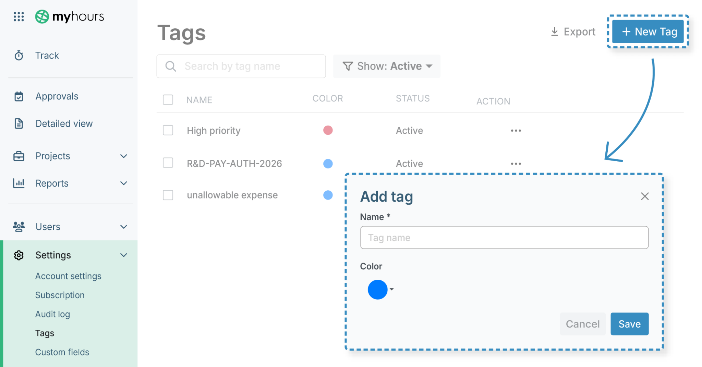

You should also prevent normal users from being able to create new tags. This stops the tagging system from becoming complicated or inconsistent.

To do this:

- Head to Settings > Account settings
- Click the Tracking form tab and scroll to the bottom of the screen
- Uncheck the box beside Allow normal users to create new tags
- Hit Save changes

Step 2: Set up projects and deliverables
Ensure that each project represents a real product, feature, or initiative rather than a department name. This helps finance connect labor directly to the applied classification tags.

To create a project, do the following:

- Head to Projects > Project > + New project
- Enter the project name
- You don’t have to assign a client, so you can leave this blank
- Hit Save

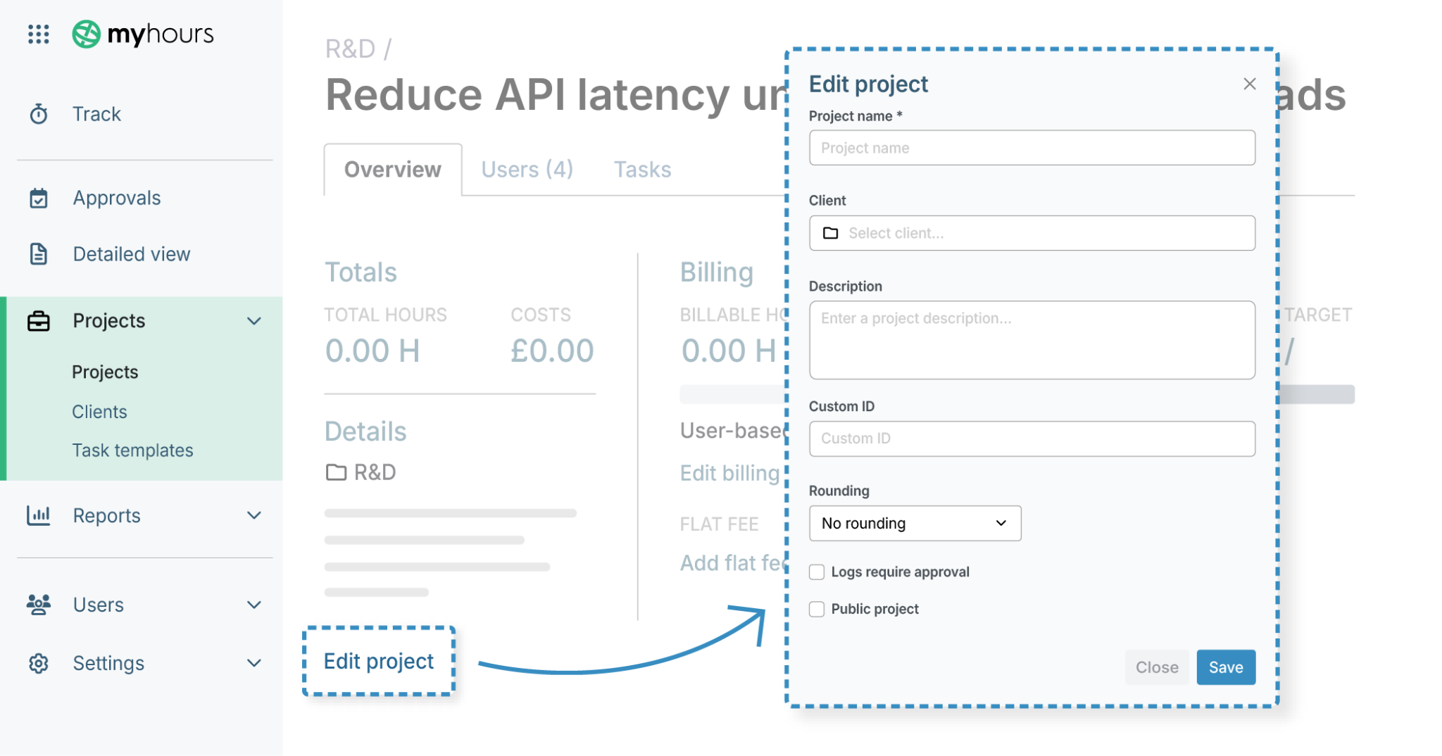

Next, you can structure tasks within each project:

- Head to Projects and click on the relevant project name
- Click the Tasks tab
- Click + Add task
- Enter the task name and any other details (like budget, custom ID, etc.), and assign the users who will be working on the task.
- When complete, click Add this task.

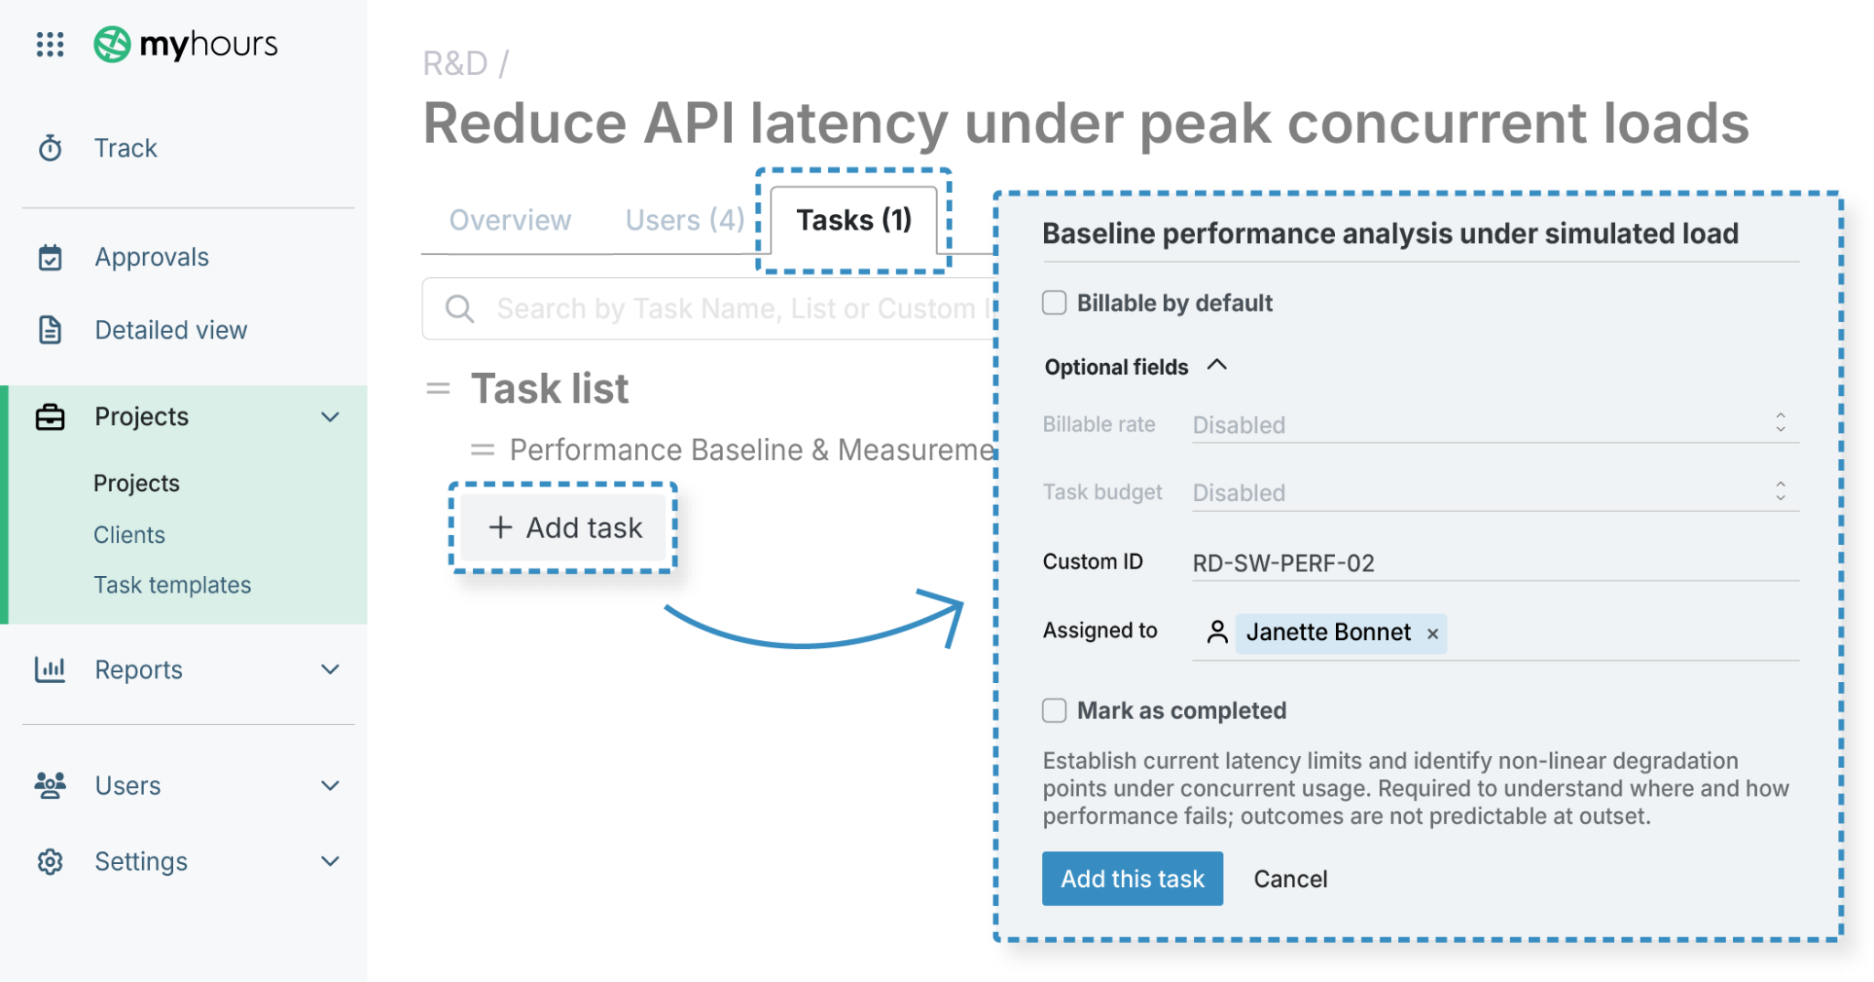

Here are some tips for creating tasks that align with CapEx/OpEx classification:

- Create tasks that describe specific work outcomes, not generic activities like Admin, Support, or Misc (for example, Design warehouse layout instead of Design work).
- Separate capitalizable build or improvement tasks from operational support or maintenance so labor type can be identified and classified appropriately.
- Use consistent task naming across departments to make reporting and audit review easier.
- When a project contains both CapEx and OpEx activity, create distinct tasks for each type rather than mixing them in one bucket.

Step 3: Activate timesheet validation
Timesheet validation provides a layer of protection and ensures that timesheets are checked before they reach finance.

When reviewing timesheets, managers can quickly see if the right tags have been applied and whether any adjustments need to be made.

How to set up time sheet validation in My Hours:

- Head to Settings > Account settings
- Click on the Approvals tab
- Choose between manual timesheet submission (Submit for approval) or Automatic submission, and click Save
- Now, click the Users tab
- For each team manager, click into their profile and ensure that the Approve time logs box is checked

Once a timesheet is submitted, managers will receive an email to say it is awaiting their attention. Entire timesheets or individual time entries can be approved or rejected.

If an entry is rejected, it goes back to the user for correction. Once the timesheet has been approved, it gets locked, preventing any further editing.

If you prefer, you can also set up automatic locking, which prevents edits before approval.

To set up automatic timesheet locking:

- Head to Settings > Account settings
- Click on the Advanced tab
- Select a time period for when timesheets get locked (daily, weekly, or monthly)

