MASP PRESENTS SOL CALERO’S PAVILION AT THE MUSEUM'S FREE SPAN

Casa María Lionza, the first work by the Venezuelan artist to be presented in Brazil, was created specifically for the space beneath the Lina Bo Bardi building

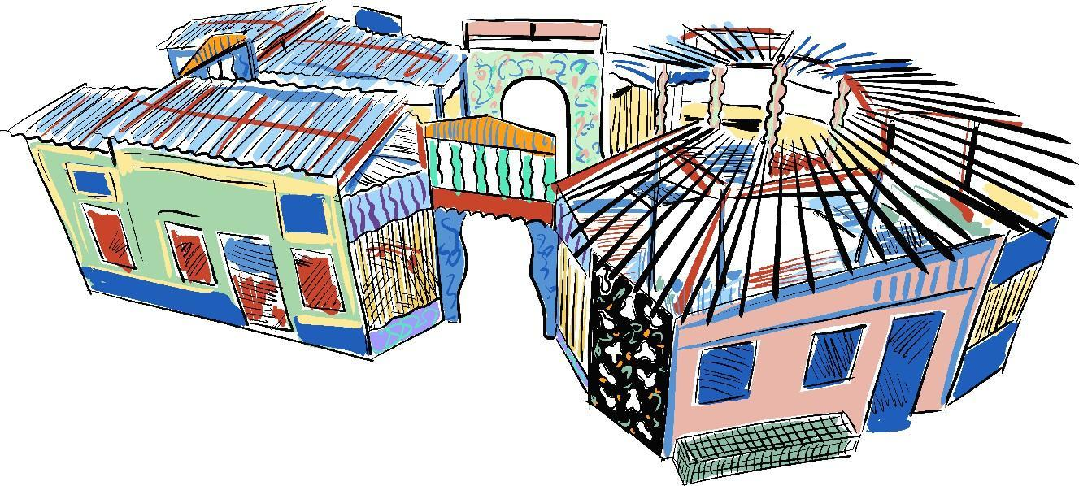

Sol Calero, Casa María Lionza, 2026

Opening July 3rd, 2026

On July 3, MASP — Museu de Arte de São Paulo Assis Chateaubriand will open Casa María Lionza to the public, the first work by artist Sol Calero (Caracas, Venezuela, 1982) to be presented in Brazil. Created specifically to occupy the Museum’s Free Span, the installation invites the public to enter a space of welcome and gathering, where facades, benches, windows, doors, murals, mosaics, and furniture become a canvas for the work of the Venezuelan artist.

Curated by Adriano Pedrosa, artistic director at MASP, and Laura Cosendey, assistant curator at MASP, Sol Calero’s pavilion is also intended to be a dynamic space that forms an integral part of the cultural program for the Free Span. The first event to be held at the pavilion will take place on Sunday, July 5, when the artist will lead a free workshop on creating mosaics that will be incorporated into the building’s exterior façade.
Calero creates works that combine elements of vernacular architecture with a vibrant visual style, reflecting on themes such as identity, belonging, and the processes of exoticization of Latin American culture. The architecture of Lina Bo Bardi (1914–1992), who designed MASP, was one of the inspirations for the installation conceived by Sol Calero for the Vão Livre. Elements such as the circular floor plan of the Igreja do Espírito Santo do Cerrado in Uberlândia and the organically shaped window cutouts of Sesc Pompeia in São Paulo—both designed by Lina—appear in Casa María Lionza, creating a dialogue with the history of the building that houses the installation. Also serving as references are the photographs of facades by artist Anna Mariani (1935–2022), which explore the relationship between geometry, color, and the built environment in the urban landscape.

The artist conceives her pavilions as three-dimensional paintings, welcoming spaces inspired by the atmosphere of domestic environments traditionally managed by women. The titles of her installations often refer to iconic female figures celebrated in salsa songs. The installation for Vão Livre continues this tradition, as María Lionza is a deity in Venezuelan spirituality, embodying the syncretism of Catholic, Indigenous, and African beliefs. Associated with nature and creation, María Lionza has also inspired popular music: Willie Colón and Rubén Blades have dedicated songs to her.

“Sol Calero reflects on the imagery of Latin identity, blending elements from diverse cultures and drawing on various aesthetic references. Her work is not merely meant to be viewed; it is not a space isolated from the world: her art finds its meaning as a place of encounter and coexistence,” says Laura Cosendey.
Sol Calero: Casa María Lionza is part of MASP’s annual program dedicated to Latin American Histories. This year’s program also includes exhibitions by Santiago Yahuarcani, Claudia Alarcón & Silät, La Chola Poblete, Sandra Gamarra Heshiki, Colectivo Acciones de Arte, Damián Ortega, Carolina Caycedo, Pablo Delano, Rosa Elena Curruchich, Manuel Herreros, Mateo Manaure, Jesús Soto, and an international group exhibition.

ABOUT THE ARTIST
Sol Calero was born in 1982 in Caracas, Venezuela, and lives in Berlin. Her practice combines painting, installations, and projects for public spaces, through which she explores notions of identity and processes of cultural exoticization. Calero has been building an international career, with projects at institutions and biennials in Europe and other continents. She presented Pabellón Criollo at the 60th Venice Biennale (2024), proposing an alternative meeting space in the Giardini della Biennale. The installation was named after a typical Venezuelan dish that combines ingredients from Indigenous, African, and European cultures.

PRODUCED BY
Sol Calero: Casa María Lionza is produced under the Federal Culture Incentive Law and is supported by Tintas Coral.

SERVICE

Sol Calero: Casa María Lionza
Curated by: Adriano Pedrosa, Artistic Director, MASP, and Laura Cosendey, Assistant Curator, MASP

Free Span, Lina Bo Bardi Building
Opening July 3, 2026
Daily from 10 a.m. to 10 p.m.
Free admission

Workshop with Sol Calero
Date: July 5, 2026 (Sunday), from 10 a.m. to 12 p.m. Registration will open soon on MASP’s website Location: Free Span, Lina Bo Bardi Building

MASP — São Paulo Museum of Art Assis Chateaubriand, 1578
Paulista Avenue – Bela Vista, São Paulo, SP 01310-200
Phone: (11) 3149-5959
Hours: Free admission on Tuesdays, 10 a.m. to 8 p.m. (last admission at 7 p.m.); Wednesdays and Thursdays, 10 a.m. to 6 p.m. (last admission at 5 p.m.); Fridays, 10 a.m. to 9 p.m. (free admission from 6 p.m. to 8:30 p.m.); Saturday and Sunday, 10 a.m. to 6 p.m. (last admission at 5 p.m.); closed on Mondays.
Online booking required via the link masp.org.br/ingressos
Tickets: R$ 85 (full price); R$ 42 (Seniors and Students with ID)

Website Facebook
X(ex-Twitter) Instagram

PRESS OFFICE
imprensa@masp.org.br

