BILL ELMS ASSOCIATES | PRESS RELEASE
WEDNESDAY 17 SEPTEMBER 2025 | FOR IMMEDIATE RELEASE

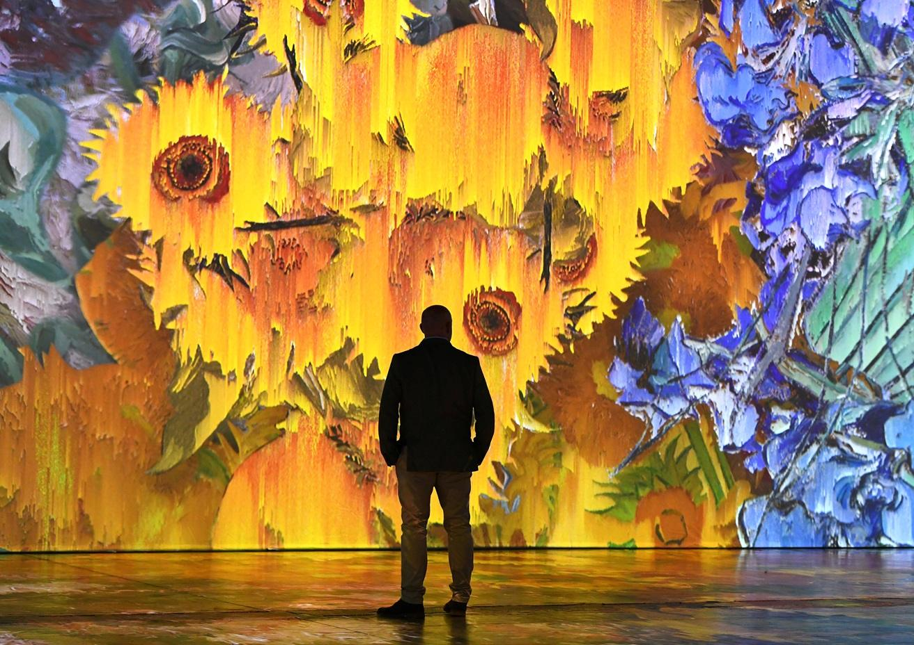
BEYOND VAN GOGH OPENS IN EXETER NEXT MONTH

Four-week countdown to the breathtaking immersive experience which comes to Westpoint Exeter this October

Enjoy yoga amid the wonderful world of Van Gogh
___________________________________________________________________________

There are just four weeks ago until the stunning Beyond Van Gogh: The Immersive Experience opens in Exeter.

The South West premiere of the exhilarating multimedia attraction is set to be staged at the Westpoint Arena, Exeter from 16th to 31st October 2025, making it the perfect half term activity for the whole family.

Timed entry tickets can be booked via the Beyond Van Gogh UK website www.beyondvangogh.co.uk/exeter-on-sale-now

And with a strictly limited two-week run, the attraction is expected to be in high demand.

Produced by Annerin Productions and Paquin Entertainment Group, Beyond Van Gogh: The Immersive Experience blends more than 300 of the post-Impressionist icon’s paintings with cutting-edge technology and a specially curated musical soundtrack to tell the story of one of history’s most influential artists, with people able to wander through iconic works - including The Starry Night, Sunflowers and Terrace of a Café at Night - as they came alive around them.

Beginning in the Introduction Hall, visitors connect with Vincent van Gogh through personal letters he wrote to his brother, and greatest supporter, Theo. They then move into the heart of the exhibition – the Immersive Room – where Van Gogh’s paintings are freed from their frames to dominate the space and fully immerse the audience in the incredible detail of his work, awakening their imagination in a playful and dreamlike way as they are enveloped in colourful flowers, cafés and stunning landscapes, shifting and swirling across the projection-swathed walls and floor.

The immersive experience has already been seen by more than seven million people across the United States, Canada and South America. It made its UK debut in Liverpool last summer, where it attracted more than 60,000 visitors, and was also staged to acclaim in Glasgow and Birmingham. During 2025, in addition to Exeter it has returned to Liverpool as well as visiting Aberdeen for the first time.

Meanwhile Exeter visitors are also being invited to immerse themselves in Van Gogh’s visionary world by taking part in bespoke yoga sessions inside the exhibition itself.

The Saturday morning classes, conducted by a yoga specialist, take place at 9am on 18th and 25th October and are suitable for participants with all levels of expertise.

The cost is £38.59 including fees and gives admittance to the entire experience. Those taking part are also welcome to take photographs and video throughout their visit.

Westpoint Exeter is the South West’s largest and most versatile arena and showground, providing the ultimate destination for a wide range of exhibitions, concerts, shows and other events including the flagship annual Devon County Show.

The venue, which offers free parking, is situated in 150 acres of rolling green fields close to Junction 30 of the M5, making it easily accessible for visitors across the West Country and beyond. It is also just a 10-minute journey from Exeter International Airport and 15 minutes from Exeter St David’s railway station.

As part of its two-week Exeter residency, is also the chance to purchase VIP Experience tickets which will include selected Beyond Van Gogh merchandise along with flexible arrival times and fast track entry.

In addition, there are various discounted tickets available including parent and child and family ticket options. Merchandise will also be available in the Beyond Van Gogh store on site.

Anna Parry, UK Business Development at Annerin Productions, said today: “There’s just four weeks to go now until Beyond Van Gogh arrives at Westpoint Exeter, and I can’t wait for our first visitors to step through the doors and immerse themselves in Vincent’s mesmerising and visionary universe.

“The team at Westpoint Exeter has been a joy to work with, and the exhibition space is perfect. I can guarantee everyone who comes to Beyond Van Gogh will be transported as his stunning artworks shimmer and move around them.

“I’m also delighted we’re able to offer special yoga sessions in the heart of Beyond Van Gogh. They add a wonderful and inspirational extra dimension to the whole experience.”

LISTINGS INFORMATION

BEYOND VAN GOGH
VENUE: Westpoint Exeter, Clyst St Mary, Exeter EX5 1DJ
DATE: Thursday, 16th October - Friday, 31st October 2025
TIME: Starting from 10am.
PRICES: Adult tickets from £24.30 (Concessions available)
Family Ticket, Parent and Child and VIP Experience tickets available
Three and under go Free
Yoga sessions: £38.59
All prices include booking fees. | Flexible entry ticket type, or available as an add-on from £3.30

Entry is by timed ticket. No change of date or time is permitted unless you have purchased flexible ticket add on. Please arrive 15 minutes before your entrance time.

VIP Experience includes flexibility to arrive at any point on your selected date, fast track entry and 2 pieces of Beyond Van Gogh merchandise.

Tickets can be booked via and www.beyondvangogh.co.uk/exeter-on-sale-now

For more information
Website – www.beyondvangogh.co.uk
Facebook – Beyond Van Gogh UK
Instagram – @beyondvangoghuk
TikTok – @beyondvangoghuk

ENDS

_________________________________________________________________________________

For further information, images and interviews please contact Bill Elms at bill@billelms.com

EDITORS NOTES

Press night for Beyond Van Gogh: The Immersive Experience will be Wednesday 15th October 2025.

For more information visit www.beyondvangogh.co.uk

Event Images - Photo credits are added to each individual Jpeg image

About Annerin Productions:
With more than 40 years in the industry, Annerin Productions recognises the demand for elevated entertainment and immersive experiences and is well positioned to deliver them. We constantly explore new entertainment avenues and push the boundaries of what is possible. With offices in Canada, the United States and London, Jeff Parry Promotions and Annerin Productions have expanded but remain true to their core aim: to provide global audiences with extraordinary entertainment.

About Vincent van Gogh:
Dutch Post-Impressionist painter Vincent van Gogh was born to a Protestant minister and his wife in Zundert, in the Netherlands, in 1853 and started his career as an art dealer, working in London and Paris.

He also worked as a schoolteacher in Ramsgate and London, a bookseller, and a lay preacher in a Belgian mining community, before in 1880 his younger brother Theo suggested he concentrate on art.

Van Gogh quickly became prolific, creating more than 2,000 artworks over the course of a single decade including 860 paintings – among them landscapes, still lives, portraits and self-portraits. Many of them were painted in the final two years of his life, when he lived in Provence, and include some of his most famous works, among them The Starry Night, Irises, Café Terrace at Night, Bedroom in Arles and Almond Blossoms.
But dogged by mental health problems, in 1889 he cut off his left ear, and the following year – aged 37 - he took his own life.

