BILL ELMS ASSOCIATES | PRESS RELEASE
MONDAY 16 JUNE 2025 | FOR IMMEDIATE RELEASE

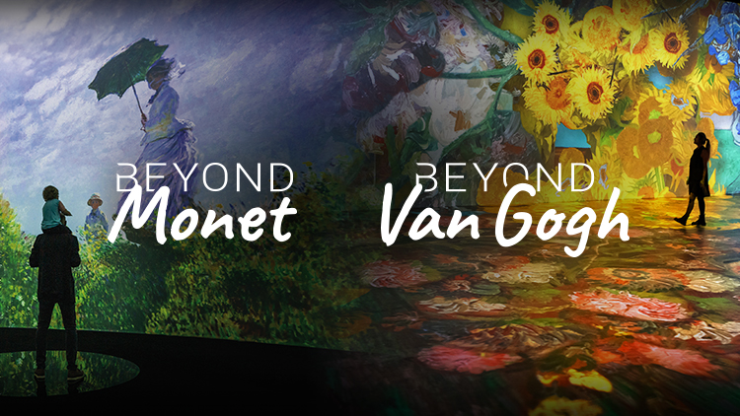
BEYOND MONET AND BEYOND VAN GOGH COMING TO EDINBURGH THIS CHRISTMAS

Scottish premiere of immersive experience which brings Monet’s impressionist masterpieces thrillingly to life

Spectacular seasonal treat for art lovers in the Scottish capital
___________________________________________________________________________

Edinburgh art lovers are being given the opportunity to enjoy not one but two stunning multimedia experiences this Christmas.

Beyond Monet and Beyond Van Gogh come to the Scottish capital from Saturday, 29 November 2025 to Friday, 2 January 2026 – with Edinburgh hosting the Scottish premiere of the experience which brings the works of ‘Father of Impressionism’ Claude Monet to life in thrilling fashion.

The immersive spectaculars will be staged on different days throughout the five-week run at the Royal Highland Centre,

Tickets for both go on pre-sale at 9am today. People are being encouraged to sign up for the chance to be the first to secure tickets on www.beyondvangogh.co.uk/edinburgh

General sale opens on Wednesday, 18 June at 10am.

And there are a range of entry ticket options including special family tickets and ‘parent and child’ tickets which offer great savings on individual prices.

The Royal Highland Centre is Scotland’s biggest indoor and outdoor venue. Located at Ingliston to the west of Edinburgh city centre, it welcomes more than one million visitors a year and delivers some of the biggest events in Scotland.

It makes it the perfect location for Beyond Monet and Beyond Van Gogh, with both multimedia extravaganzas featuring an immersive room which is 10,000sq ft in size.

The centre is also perfectly positioned with good transport links including the A8, the motorway network and Edinburgh Airport.

Produced by Annerin Productions and Paquin Entertainment Group, Beyond Monet: The Immersive Experience celebrates the groundbreaking work of the ‘Father of Impressionism’ in mesmerising and colourful fashion.

In the immersive impressionist extravaganza, cutting-edge technology breathes new life into more than 400 of the legendary French painter’s canvases, taking visitors on a spectacular and unforgettable audio-visual journey through his captivating and colourful world.

Beyond Monet brings together some of the artist’s most famous paintings – including Poppies, Impression: Sunrise and his exquisite Water Lilies series – with lesser-known works which all swirl around the space, offering a fresh and exciting new look at much-loved masterpieces and a deeper connection with Monet, his subjects and his innovative technique.

Taking inspiration from Musée de l’Orangerie in Paris, the designated home of Monet’s works, visitors can freely roam the Infinity Room where they are transported inside the paintings themselves to the accompaniment of a moving original score.

Meanwhile, Beyond Van Gogh: The Immersive Experience brings together more than 300 of the post-Impressionist icon’s paintings blended with cutting-edge technology and a specially curated musical soundtrack to tell the story of one of history’s most influential artists, with people able to wander through iconic works - including The Starry Night, Sunflowers and Terrace of a Café at Night - as they came alive around them.

This is Annerin Productions’ third visit to Scotland following Beyond Van Gogh at Glasgow’s SEC in 2024 – where it won critical acclaim and was seen by 50,000 visitors, and the same experience’s residency at the P&J Live in Aberdeen this summer.

It is the first time the entertainment company has staged anything in Edinburgh.

Anna Parry, UK Business Development at Annerin Productions, said today: “I’m absolutely delighted we’re bringing Beyond Van Gogh to Edinburgh this Christmas, particularly after the very warm welcome Scottish art lovers have already given the experience in Glasgow and the demand for tickets for this summer’s Aberdeen run.

“I’m also excited to be able to present a very special Scottish premiere – Beyond Monet: The Immersive Experience – in the city. Edinburgh was at the heart of the Scottish Enlightenment and art has always played a hugely important role in its cultural landscape.

“Beyond Monet is a stunning show packed with many of his most important and most powerful artworks, immersing art lovers in his revolutionary impressionist world and accompanied by a wonderfully evocative soundtrack.

“With both experiences running throughout December and into the New Year, they’re an ideal festive gift for the art lover in your life, as well as being a great day out for families looking to do something together in the run up to and over the Christmas holidays.

“The Royal Highland Centre is the perfect venue for both Beyond Van Gogh and Beyond Monet and I’m excited to work with the team there who have been incredibly supportive and enthusiastic about our vision.”

Mark Currie, Director of Venue at Royal Highland Centre, said: “Being able to host such unique and immersive events like Beyond Van Gogh and Beyond Monet at the Royal Highland Centre is testament to the truly unique space we have here at Ingliston.

“As Scotland’s largest indoor and outdoor venue, we have an extremely versatile space, and we can’t wait to see these art masterpieces come to life in such an exceptional way for those across the city and beyond to enjoy!”

FOR MORE INFORMATION
Website – www.beyondvangogh.co.uk
Facebook – Beyond Van Gogh UK | Beyond Monet UK
Instagram – @beyondvangoghuk | @beyondmonetuk

LISTINGS INFORMATION

BEYOND MONET/ BEYOND VAN GOGH
VENUE: Royal Highland Centre, Ingliston, Newbridge, EH28 8NB.
DATE: Saturday 29 – Friday 2 January 2026 (closed Christmas Eve and Christmas Day)
TIME: Starting from 10am
PRICE: From £23.94 for adults (Concessions are available). VIP entrance from £41.47
(Booking fees not included). | Flexible entry ticket types available

Entry is by timed ticket. No change of date or time is permitted unless you have purchased flexible ticket add on. Please arrive 15 minutes before your entrance time.

VIP Experience includes flexibility to arrive at any point until 4pm on your selected date, fast track entry and choice of selected merchandise package.

Sign-up now for pre-sale and book from Monday, 16 June 9am.
Link: www.beyondvangogh.co.uk/edinburgh

General sale from 18 June at 10am.
Tickets can be booked via www.beyondvangogh.co.uk/edinburgh

ENDS

For further Press information, images and interviews please contact Bill Elms at Bill Elms Associates on bill@billelms.com

DIARY DATE: Press and VIP night will be Friday, 28 November. (Invites to follow)

Images for both Beyond Monet and Beyond Van Gogh can be found on the link: https://we.tl/t-bxY2ByHHuZ (Photos are individually credited)

Trailers for both Beyond Monet and Beyond Van Gogh can be found on the link below https://drive.google.com/drive/folders/1Om6p1ACYkqnp4alMgzWaWdGoZ8pOQyg0

EDITORS NOTES

About Annerin Productions:
With more than 40 years in the industry, Annerin Productions recognises the demand for elevated entertainment and immersive experiences and is well positioned to deliver them. We constantly explore new entertainment avenues and push the boundaries of what is possible. With offices in Canada, the United States and London, Jeff Parry Promotions and Annerin Productions have expanded but remain true to their core aim: to provide global audiences with extraordinary entertainment.
About Vincent van Gogh:
Dutch Post-Impressionist painter Vincent van Gogh was born to a Protestant minister and his wife in Zundert, in the Netherlands, in 1853 and started his career as an art dealer, working in London and Paris
He also worked as a schoolteacher in Ramsgate and London, a bookseller, and a lay preacher in a Belgian mining community, before in 1880 his younger brother Theo suggested he concentrate on art.
Van Gogh quickly became prolific, creating more than 2,000 artworks over the course of a single decade including 860 paintings – among them landscapes, still lives, portraits and self-portraits. Many of them were painted in the final two years of his life, when he lived in Provence, and include some of his most famous works, among them The Starry Night, Irises, Café Terrace at Night, Bedroom in Arles and Almond Blossoms.
But dogged by mental health problems, in 1889 he cut off his left ear, and the following year – aged 37 - he took his own life.
About Claude Monet
Born in Paris in 1840, Claude Monet was a schoolboy in Le Havre when he started taking drawing classes and later studied the art of the landscape with artists Eugene Boudin and Johan Jongkind. His early paintings were Realist in style.
In his early 20s, Monet spent time sketching in the Louvre, where he met fellow future impressionist Eduard Manet while, following a year in military service in Algeria, he shared studio space in the French capital with Renoir and Sisley among others.
After marrying his first wife Camille in 1870, the couple spent time living in London and the Netherlands. He would later return to London and paint it in the early 20th Century.
It was Monet’s 1872 work Impression: Sunrise which was inadvertently responsible for the term Impressionism – an art critic coined the term in a scathing judgement of the work of Monet and fellow painters including Cezanne, Pissarro, Renoir, Sisley and Degas.
As an artist, Monet was fascinated by the way the same landscape seemed to change over the course of a day and painted many scenes repeatedly to try and capture this.
Among his most famous works are Woman with a Parasol – Madame Monet and her Son, Rouen Cathedral, Houses of Parliament, Saint-Lazare Station, The Poppy Field near Argenteuil and his series of giant Water Lilies canvases painted at his home at Giverny, where he died in 1926.

