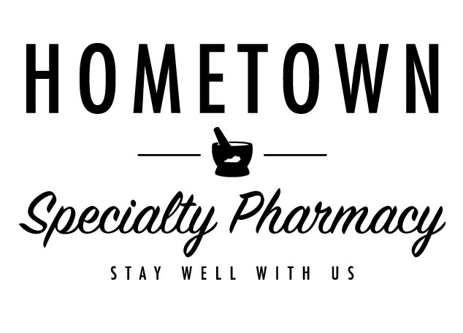

**3200 New Columbia Road, Campbellsville, KY 42718**Phone: 270-937-9008 | Fax: 270-937-9009  
www.hometownspecialtypharmacy.com

**WELCOME TO HOMETOWN PHARMACY SPECIALTY SERVICES!**Dear Patient and/or Caregiver,  
  
We are pleased to welcome you to Hometown Pharmacy Specialty Services, your trusted local partner in advanced pharmacy care. Our team is dedicated to providing the highest level of service and support to help you manage your health with confidence and convenience.  
  
At Hometown Pharmacy Specialty Services, we strive to deliver superior pharmaceutical care that focuses on the unique needs of each patient. Our mission is to help prevent and manage chronic health conditions, improve overall wellness, and collaborate closely with healthcare providers to ensure you receive the best possible outcomes.  
  
With a commitment to innovation and compassionate care, we offer a high-touch pharmacy experience tailored to you.  
  
SPECIALTY CARE SERVICES  
  
We provide access to specialty medications and clinical support for individuals receiving treatment for a variety of complex conditions, including but not limited to:  
- Hepatitis  
- Skin disorders  
- Autoimmune disorders  
- Multiple sclerosis  
- Osteoporosis  
- Rheumatoid arthritis  
- Cancer  
- Hemophilia  
- Behavioral health conditions  
- Addiction management  
  
Our team offers personalized support throughout your treatment journey, including:  
- Condition-specific education and guidance  
- Medication administration training  
- Insurance benefit verification and coordination of prior authorizations  
- Co-pay card enrollment and manufacturer assistance programs to reduce out-of-pocket costs  
  
We aim to make managing your medication as convenient as possible by serving as your single point of contact for all your pharmaceutical needs. We work directly with your local healthcare providers and specialist physicians to streamline communication and ensure continuity of care.  
  
Our entire staff is committed to making your experience with Hometown Pharmacy Specialty Services exceptional. We truly care about your health, and we encourage you to call or visit us at any time if you have questions about your treatment or our services.  
  
Please remember to sign and return the PATIENT AUTHORIZATION and PATIENT SATISFACTION SURVEY in the enclosed envelope, so we can begin supporting you right away.  
  
Sincerely,  
  
Your Hometown Specialty Pharmacy Team  
Hometown Pharmacy Specialty Services