When you access the website you can see the following.
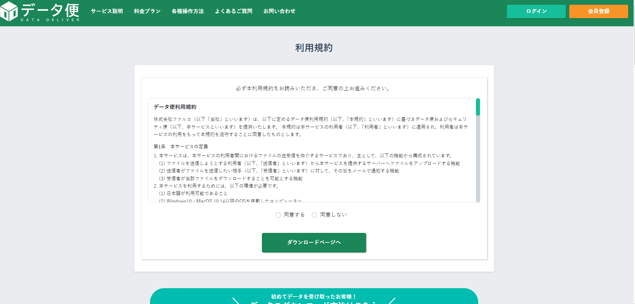
This page is for agreement to use.
Please push on the left side 〇 then push “download page” here

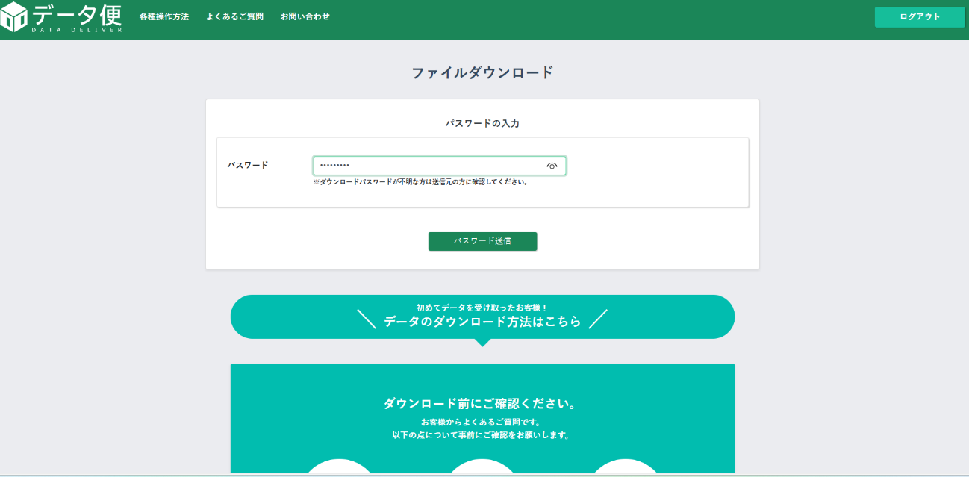
Enter the password that I send by E-mail before here. Then push “send” here.
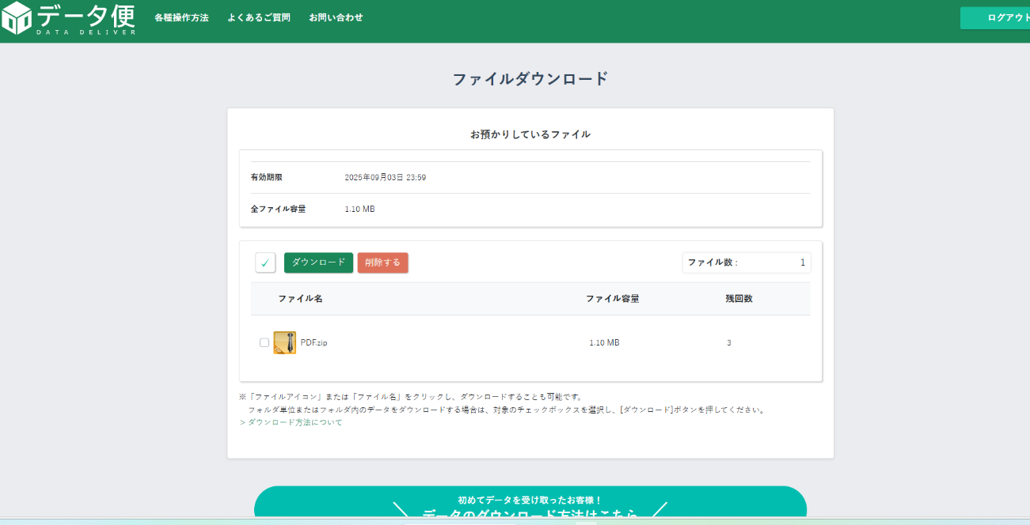
Push the box here.
Then push the “download” here.
Then finally you can get the documets.

