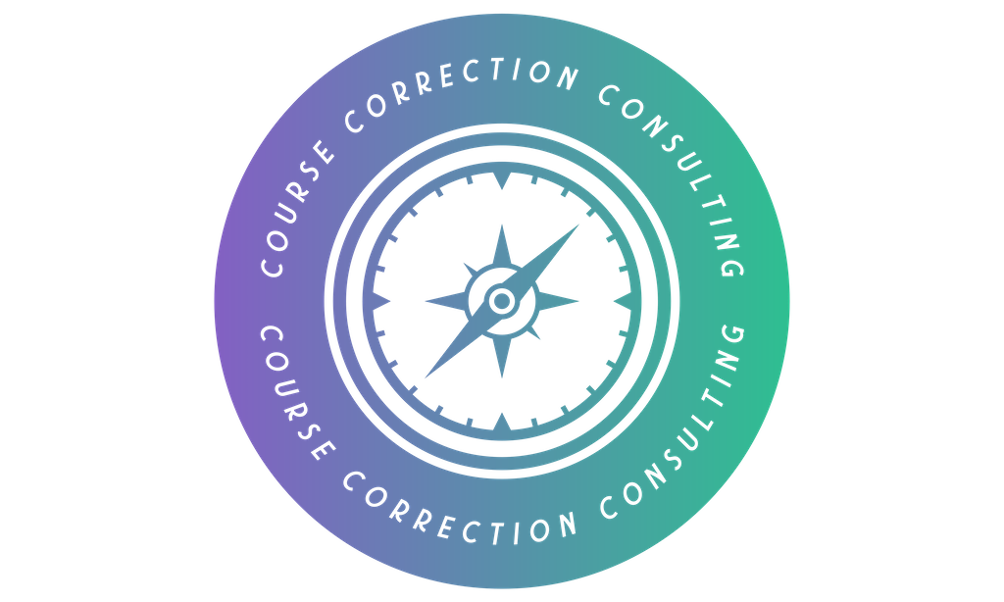
MANAGER-EMPLOYEE WORKING FORM
Simple Role Clarity and Performance Agreement
For well-defined operational roles | Complete together in 30 minutes
Purpose. Complete this together. Agree the job's purpose, standards, decision limits and support.
Employee | Role | Manager | Date
[Type here] | [Type here] | [Type here] | [Type here]

1. Purpose
In one sentence, what is this role here to achieve?
Describe the useful result, not a list of tasks.
[Type here]
2. Main responsibilities and standards
Main responsibility | What good work looks like
[Type here] | [Type here]
[Type here] | [Type here]
[Type here] | [Type here]
[Type here] | [Type here]
3. Decisions and help
Decision level | Simple meaning | Examples for this role
Decide and act | Work within the agreed method and limits. | [Type here]
Decide, then tell | Act, then keep the named person informed. | [Type here]
Ask first | Get help when the issue is outside your authority or competence. | [Type here]
Ask for help immediately when...
Name any safety, customer, quality, cost or unusual situations that should not wait.
[Type here]

4. How performance will be recognised
Choose three useful signals only. If a measure will not change a conversation, decision or action, leave it out.
What we will review | Expected standard | Evidence or source
Result | [Type here] | [Type here]
Quality / reliability | [Type here] | [Type here]
Teamwork / work habit | [Type here] | [Type here]
5. Support and development
The manager will provide...
Include information, time, equipment, access, feedback, training or cover.
[Type here]
One skill or area of confidence to develop
[Type here]
6. Immediate priority
What is the one improvement or priority for the next 30 days?
[Type here]
7. Review
Check-in rhythm | Review date | Change this agreement when...
Weekly / fortnightly / monthly | [Date] | The work, standard or support changes
Important. This is a practical working agreement, not a substitute for an employment contract or a disciplinary process. Review it when the job or operating conditions change.

