Laser Cut Tetris
Shared by: Jamie Chelel, MIT K-12 Maker Lab team
Specialized tools and materials used: | Experience level required:
GlowForge laser cutter (or similar) | Beginner
Graphics processing tools | Beginner
Acrylic sheets | Beginner
Grade Level and Subject (of this example): HS US History 1
Topic/Content Standards (for this example): MA US History 1 [USI.T1] - How did events of the Revolutionary period inform the ideas in the Constitution?
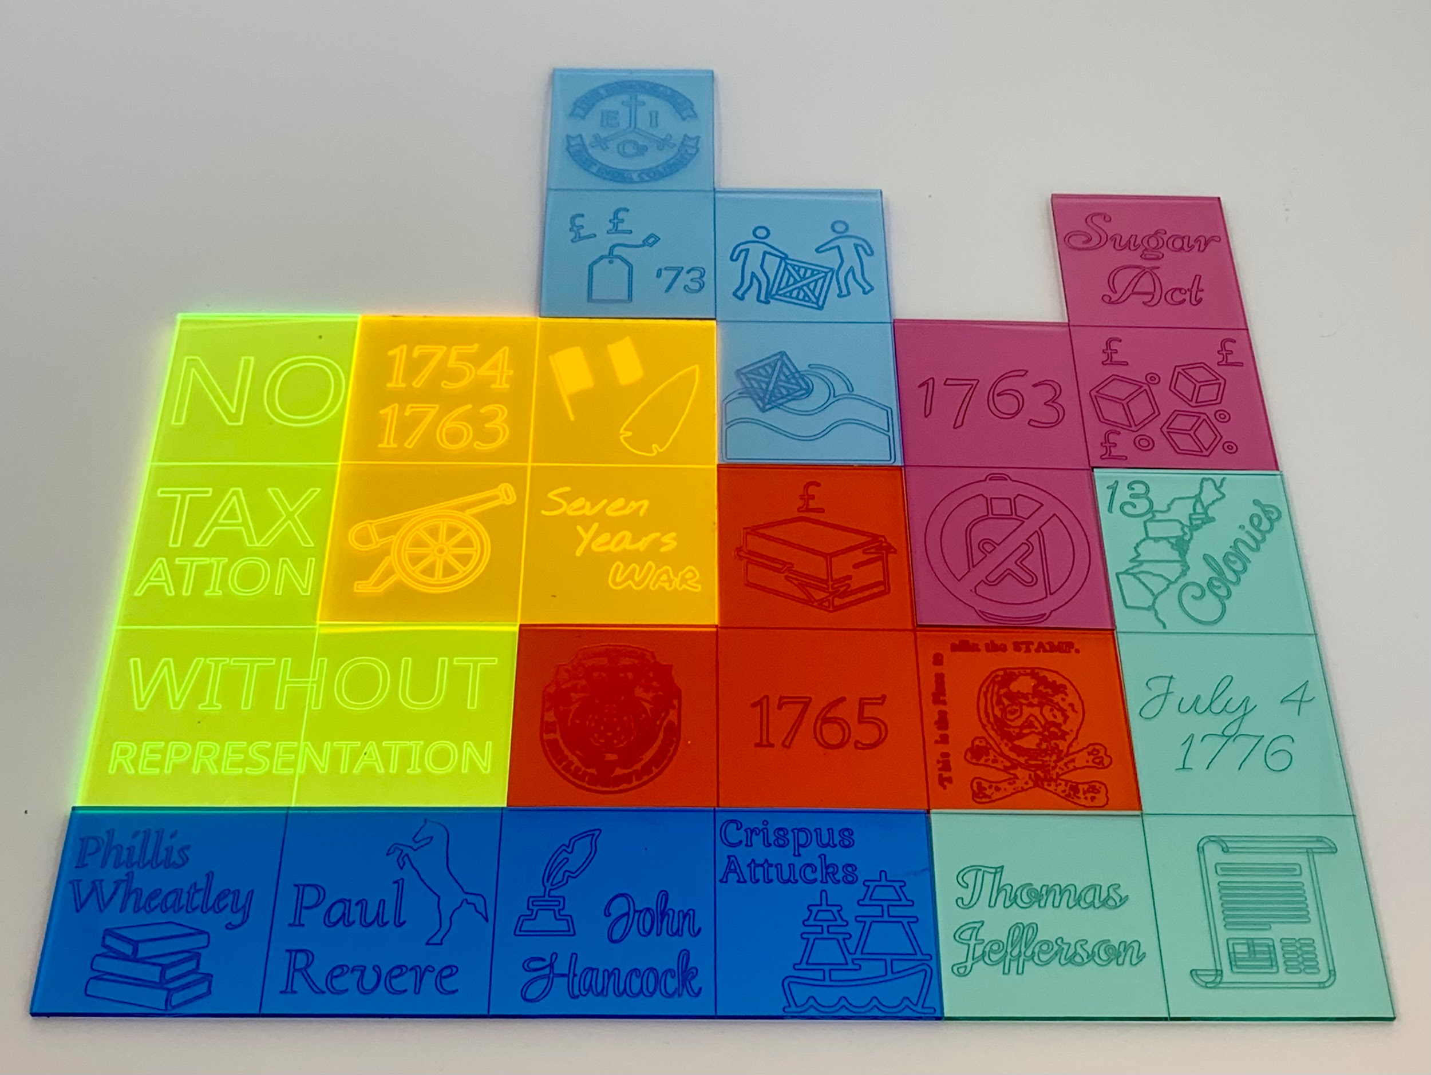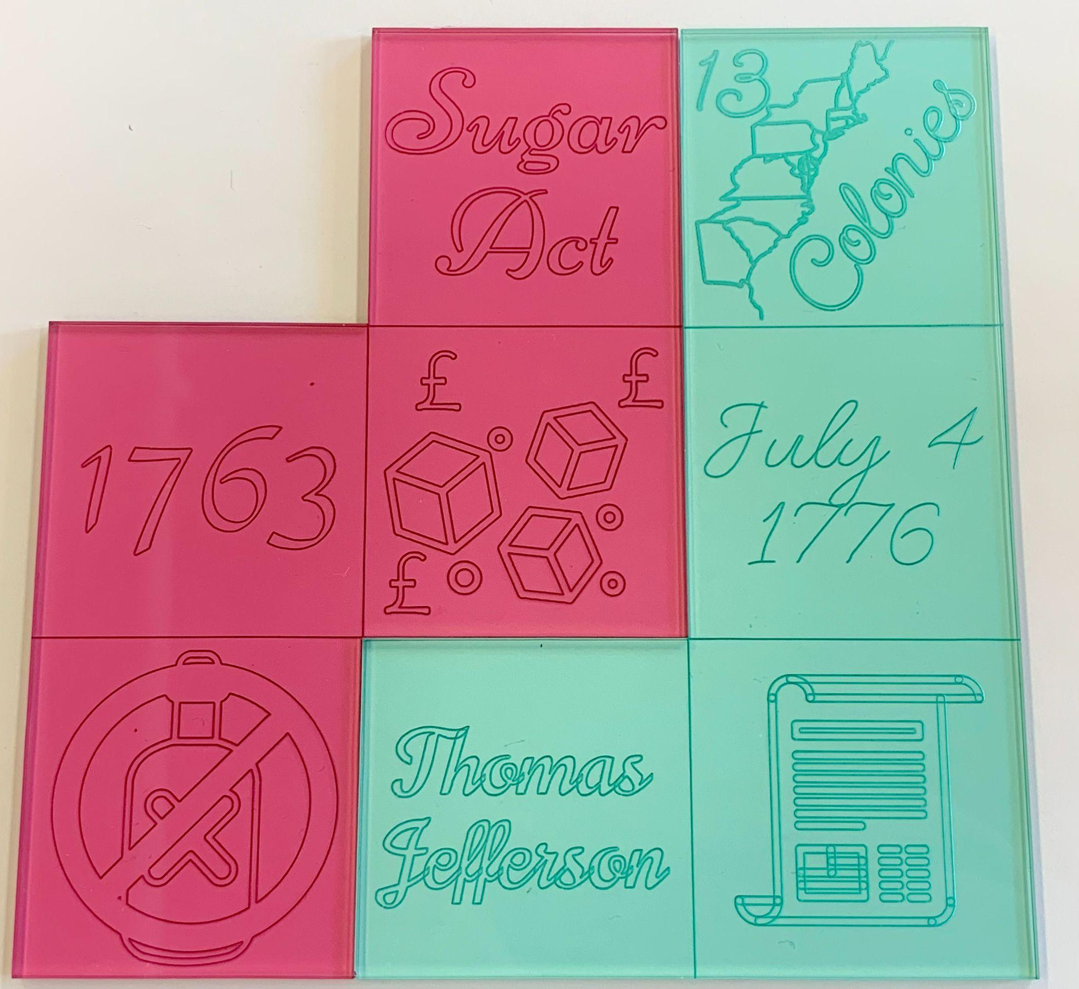
Summary of Project:
To demonstrate understanding of the movement behind the Declaration of Independence and American Revolution, students created a set of custom laser cut Tetris pieces. Each student created one Tetris piece representing contributing factors, important events, or people related to the cause. They chose four significant pieces of information, and put one on each of the four squares on each Tetris piece. At the end of the project, the class had a set of Tetris pieces about the American Revolutionary movement which could be used in a game or other activity.
Students utilized graphics in SVG format downloaded from online royalty-free resources, as well as shapes and text tools native to the design program that they used. In this case, the colors are not related to the pieces’ meaning, but that is a possible extension in other applications.
Start with Tetris piece templates, or ask students to draw their own. Either way, the lineweight of the outline and designs should be appropriate for cutting and scoring on a laser cutter.
Opaque or transparent acrylic can be used. When using transparent acrylic, there is the option to engrave into the back of acrylic for a smoother piece. To achieve that effect, mirror the designs before laser cutting.
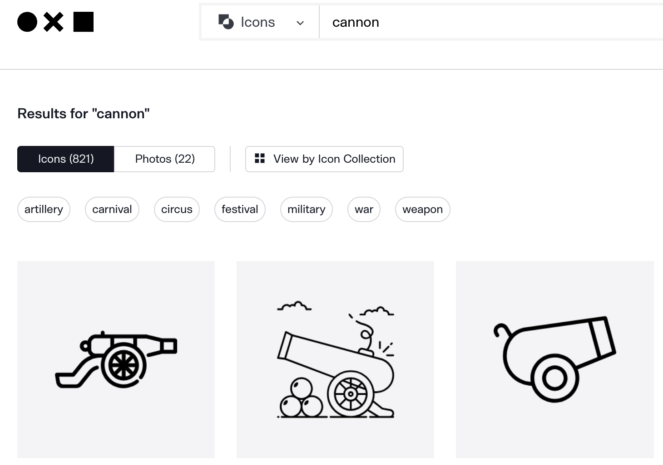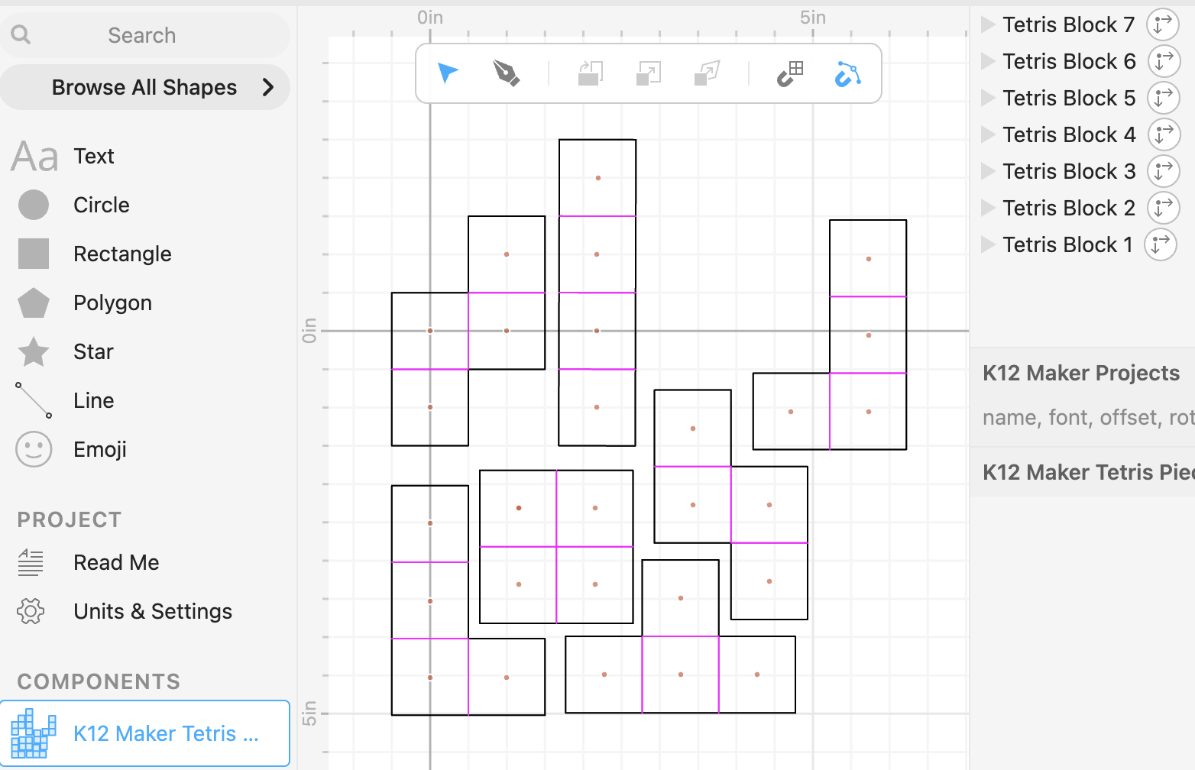
thenounproject.com
Blank Tetris piece templates in Cuttle.xyz
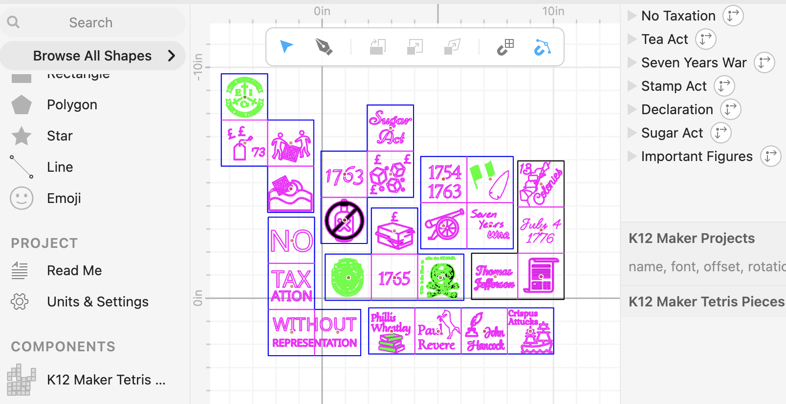
Tetris pieces with SVG icons and text
Suggested resources
- For royalty-free images: The Noun Project (thenounproject.com)
- For removing backgrounds of images: RemoveBG.com or similar tool
- To convert images from JPG and PNG to SVG: PicSVG.com
- Graphic editors: Cuttle.xyz, Vectr.com or similar
Possible Content explorations [example MA Content Standards]
- STEM - Ecosystems [5-LS2-1], Ecosystems [HS-LS2]
- ELA - Vocabulary and parts of speech [6-L-4]
- History & Social Science - Societal and political movements [​​USII.T2 - How did the United States respond to new ideas about society? WHI.T4.8 - Protestant Reformation and Catholic Counter-Reformation]

