Monthly Clay Days

Hosted by Carrie Sant in the Creative Cabin

Dates: Tuesday 8th September, Tuesday 13th October, Tuesday 10th November
Location: Quiet Waters Christian House, Flixton Road, Bungay NR35 1PD
What to expect: Practice hand building and throwing clay with expert guidance. No prior artistic experience is needed,
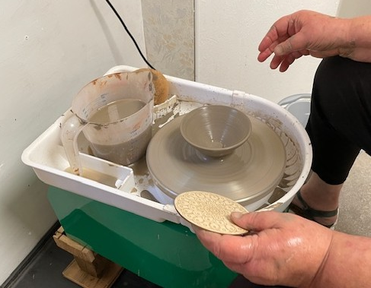


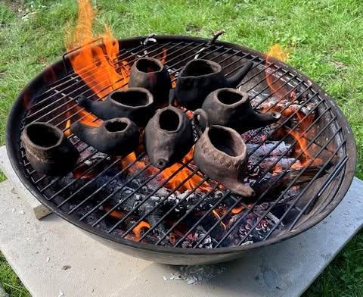

Cost: £20.00 (booking is required) and there is a small additional cost for firing and materials used) 10:15-3:30pm Please bring a packed lunch
To book: contact the QW office at mail@quietwaters.org.uk or 01986 893201
Monthly Clay Days

Hosted by Carrie Sant in the Creative Cabin

Dates: Tuesday 8th September, Tuesday 13th October, Tuesday 10th November
Location: Quiet Waters Christian House, Flixton Road, Bungay NR35 1PD
What to expect: Practice hand building and throwing clay with expert guidance. No prior artistic experience is needed,

Cost: £20.00 (booking is required) and there is a small additional cost for firing and materials used) 10:15-3:30pm Please bring a packed lunch
To book: contact the QW office at mail@quietwaters.org.uk or 01986 893201

