
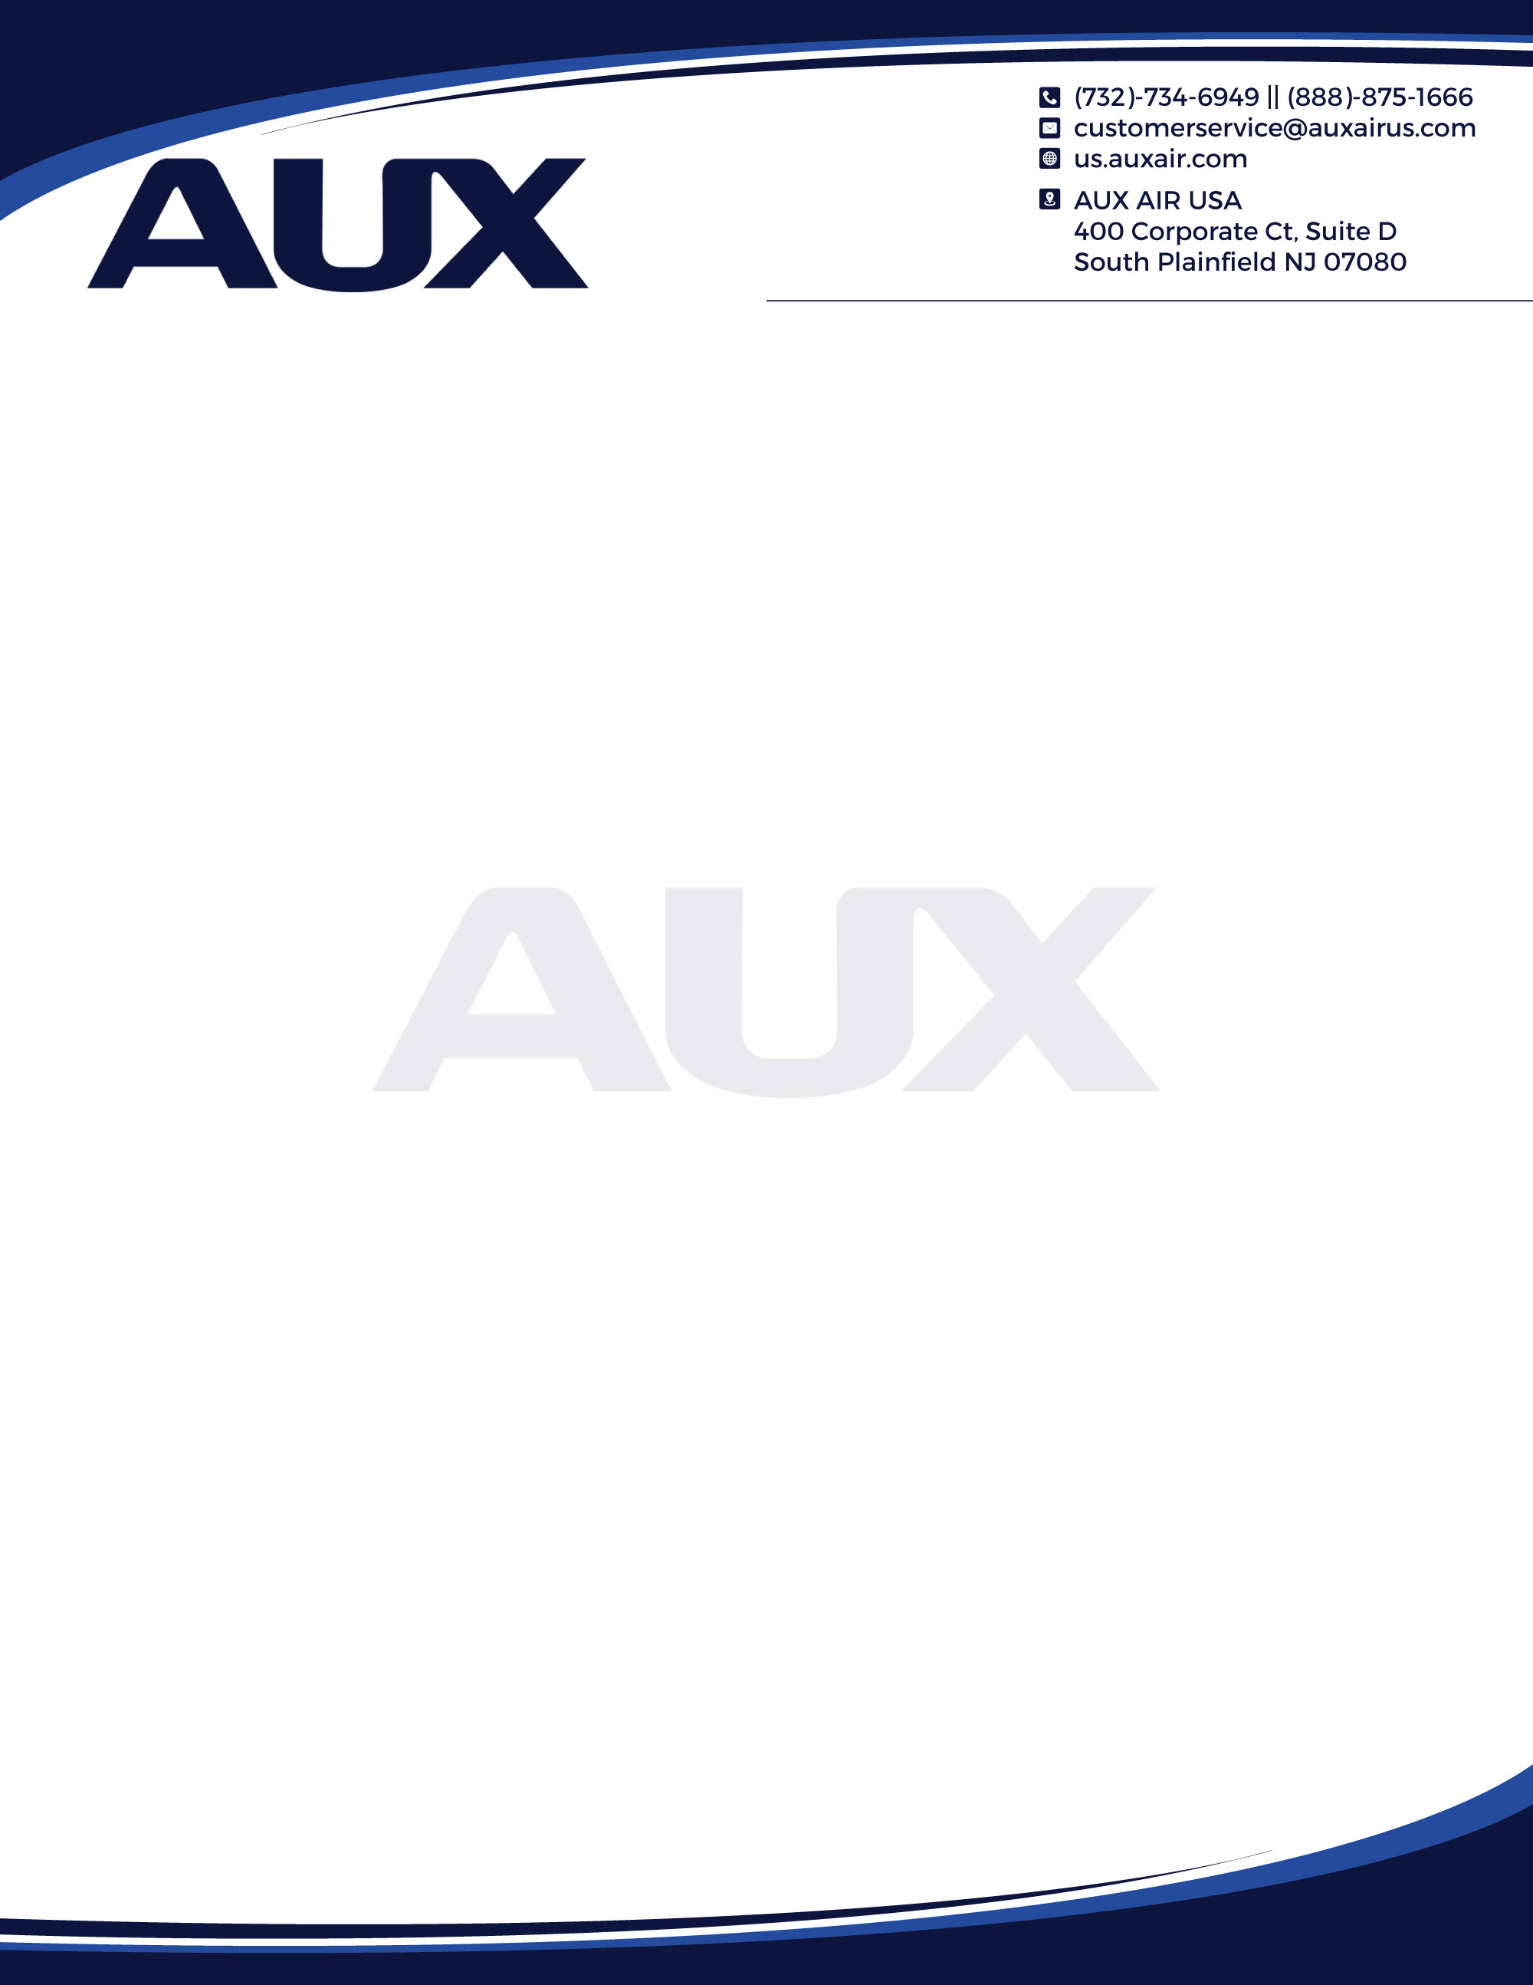




AUX Equipment Warranty Claim Form
Application must be submitted within 90 days of equipment failure. Submit application via email to customerservice@auxairus.com. If claim is rejected, you will be notified via phone/email within 2 business days from submission. For questions regarding submission please contact us at 888-875-1666.

Company Information:
Company Name: |  | Distributor Name:
Business Phone: | Business Email: | Distributor Phone: | Distributor Email:
Business Address: |  | Distributor Ship-to: Product will be shipped to this address
City, State, Zip: |  | City, State, Zip:

Equipment Info:
Unit Model | Unit Serial | Purchase Date

Service Details:
Installation Date: | Failure Date: | Unit Replacement (Select One) | Credit (Select One)

Equipment Warranty Request Reason:
Primary Reason for Service Call: | Service Performed/Troubleshooting:

Submitter Information:
Submitter Full Name: | Submitter Email: | Submitter Phone Number:

AUX INTERNAL USE ONLY:
Approved By: | Denied By: | AUX Ticket #:

400 Corporate Ct, Suite D, South Plainfield NJ 07080
us.auxair.com

Please note that our Warranty may be updated periodically due to product upgrades. If you have any questions or are unable to access our current warranty policy, please visit our website at: www.auxair.com/us for the most up-to-date information. AUX reserves the right to charge for warranty equipment that is not returned within 14 days of AUX’s request.

