
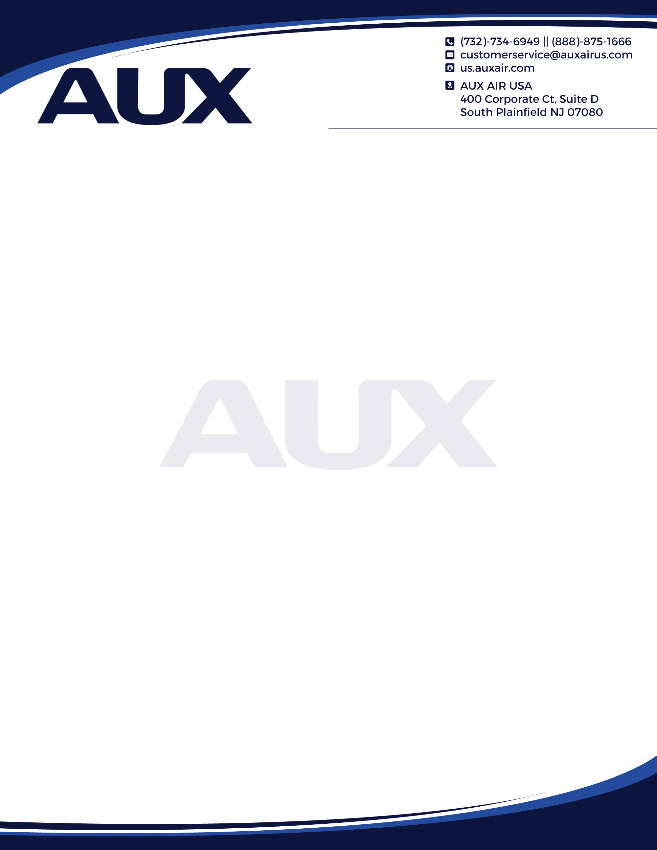




Return Materials Authorization Forms (RMA)

1. RMA Request: All returns, and warranty claims must have an RMA number. To obtain an RMA number the customer must complete and submit the RMA Form to customerservice@auxairus.com.

2. Condition of Merchandise being Returned:

  - IF MERCHANDISE IS BEING RETURNED UNDER AUX WARRANTY:
    - Product must be returned in original packaging or packaged securely to avoid damage in shipping.
    - Product must be returned with all accessories.

  - IF MERCHANDISE IS BEING RETURNED FOR CREDIT:
    - Product must have been purchased (date of invoice) within 14 days of requesting this RMA.
    - Product must be returned to the original packaging with all literature.
    - Product must be returned with all accessories.
    - The product itself must be in perfect condition (i.e.: no scratches, no signs of wear and tear etc.).
    - All Returns are subject to 15% re-stoking fee
    - Special Order and Final Sales and Obsolete products are non-refundable and not eligible for return.

3. RMA Review: The RMA Administrator will review the request and, before proceeding, may request additional information, or suggest additional diagnostic steps to ensure that the hardware is not returned unnecessarily.

4. RMA Charges for Defective Products: Products covered under warranty will be replaced at no cost. Products no longer covered under warranty will incur a charge.

5. RMA Issued: When the RMA is approved and all other requirements have been satisfied, an RMA number will be sent, which may include packaging and shipping instructions.

6. RMA Expiration: Once the RMA # has been issued, the product must be received by AUX within 14 days of the date of issue of the RMA#.

7. Returns to AUX: For returned sellable products, AUX is not responsible for shipping charges. Customers are required to contact AUX when returns are shipped and to provide shipment tracking details. Approved RMA form must be included in the return shipment. Any damage of the product related to inappropriate packaging could result in the product being refused by AUX.

8. Shipping of Non-Warranty Products from AUX: Shipping of all Non-Warranty Products from AUX is at customer expense.

9. Expedited Replacement of Warranty Products: AUX may expedite shipment for a failed product on a case-by-case basis. Only Warranty covered products will be considered for Expedited Replacement at AUX’s discretion.

SHIP PRODUCT ALONG WITH RMA AND PROOF OF PURCHASE TO:
Returns
Aux Cloud Commerce USA Inc.
400 Corporate Ct, Suite D, South Plainfield New Jersey 07080

400 Corporate Ct, Suite D, South Plainfield NJ 07080
us.auxair.com

Return Materials Authorization Forms (RMA)

To submit a Return Merchandise Authorization (RMA) request, complete the following form. You will be notified with an RMA number if your return request has been approved with instruction for the next steps. For any questions concerning completion of the form please contact AUX Customer Support by email at Customerservice@auxairus.com or by telephone at 888-875-1666

General Information:
First Name: | Last Name:
Email:
Company Name:
Telephone: | Extension:
Contact Name (for Technical Questions)

Shipping Information
Address: | City: | State:
Country: | Zip Code:

Product Information:
Product Name: | Model #: |  |  |  |  | Invoice #:
Serial #: | Purchase Date:
Installer Name: | Installer Phone:
Description of Problem / Issue: |  |  | Quantity Returned:
Additional Comments:

Date: |  | Categories: |  | Equipment |  |  | Un-Used |  | Used
Printed Name: |  | RMA #:

Shipping Information:
Address: 400 Corporate Boulevard, Suite D | City: South Plainfield | State: New Jersey
Zip Code: 07080 | Attention: Warranty Dept

400 Corporate Ct, Suite D, South Plainfield NJ 07080
us.auxair.com

