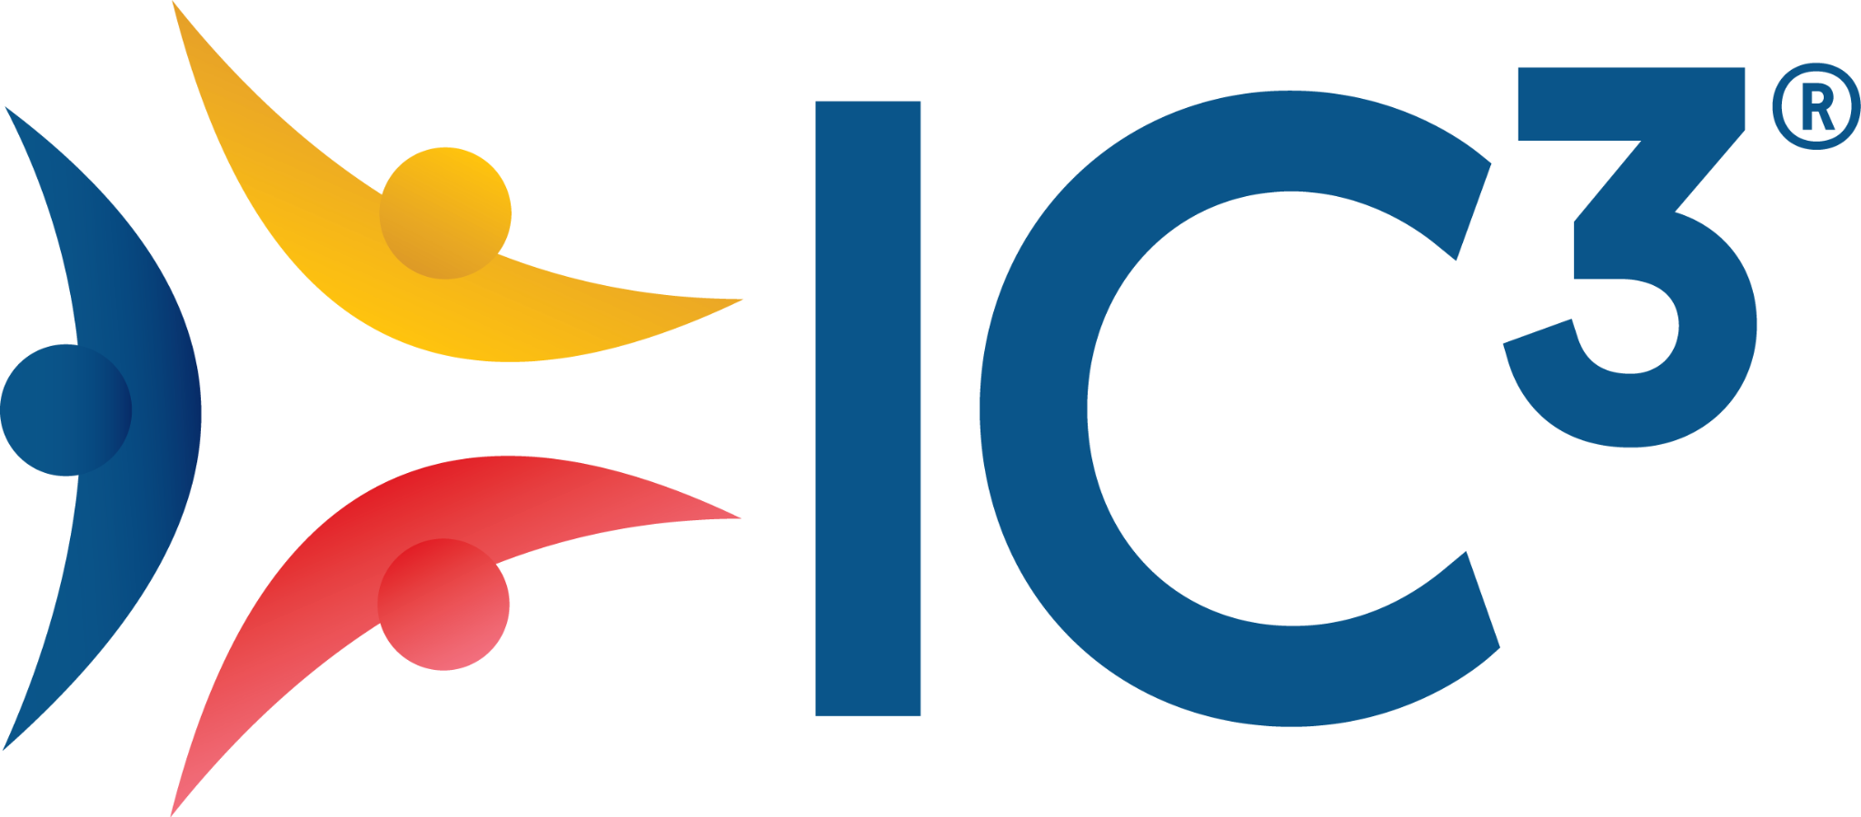

Dear [Recipient's Name],
I trust this email finds you well. My name is [Your Name], and I am glad to reach out to you on behalf of a volunteer-led, volunteer-driven organization called the IC3 Movement. Our mission is to bring counseling to every school, and as a volunteer and advocate, I invite you to be part of a transformative experience at the 10th Annual IC3 Conference & Expo
The IC3 Movement is committed to making career and college counseling accessible in every school, helping students find purpose and direction. Through initiatives such as the Annual IC3 Conference & Expo, we bring together high school and university communities to engage in meaningful discussions and collaboration toward this shared vision. The conference will feature inspiring keynote addresses, curated sessions addressing global community issues, and other exciting events.
Your participation at the conference presents an invaluable opportunity to:
- Advocate for the importance of career and college counseling
- Gain insights into the challenges faced by educators, counselors, and students alike and seek solutions together
- Expand your network by connecting with education leaders from across the globe
This year, the conference is scheduled to take place in-person at Jio World Convention Centre, in Mumbai, India, on 19 and 20 August 2026. I encourage you to visit the links below to learn more about the IC3 Movement and its initiatives and feel free to reach out to me if you have follow-up thoughts or queries.
Registrations: Start your conference registration
Call for Proposals: Be a thought leader and submit an intriguing session proposal around this year’s inspiring theme, Looking Deeply – From Information to Insight
Scholarships: We have scholarships available to create access to attend the conference
IC3 Expo: If you are a university/approved organization, then this is the place to be
The Molly Teacher video sums up the essence and vision of the IC3 Movement

I eagerly anticipate the opportunity to meet you in August and engage in enriching discussions that will shape the future of career and college counseling.
Thank you for considering this invitation.
Warm regards,

