
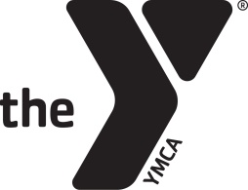
34th Annual

YMCA/Memering Motorplex

Scholarship Golf Outing

A Charity Golf Event - Wednesday, June 17, 2026

Sponsor Packages (Circle sponsor commitment.)
Tax ID # 35-0868218

Gold Sponsor Package $1000
- Listing as a major sponsor on signage at outing
- Full page ad in tournament brochure
- Hole sponsor sign
- Golf outing entry fee for team of four

Silver Sponsor Package $500
- Listing as a lunch sponsor on signage at outing
- ½ page ad in tournament brochure
- Hole sponsor sign

Corporate Sponsor Package $400
- Sponsorship of a special hole contest
- $100 to winner, $250 to the charity
(closest to the pin, longest drive, etc.)
- ¼ page brochure ad
- Hole sponsor sign

Hole Sponsor $250
- ⅛ page brochure ad
- Hole sponsor sign

*Donations for door prizes are also needed and greatly appreciated.*

Sponsor: _____________________________________________________________________________Phone:__________________________________________________

Address: _________ ________________________________________________________________

Contact:___________ ___________ Signature: _ _________

E-mail: _____________________________________________________________________________________________________

For information contact the Y at 812-895-9622
Mail or email completed form to Bill Davis at: marketing@vincennesymca.org. Check or credit/debit cards are available for payment.

YMCA OF VINCENNES
2010 College Avenue, Vincennes, IN 47591 P 812 895 9622 F 812 882 3947 W vincennesymca.org

