SUBMITTAL DATA SHEET
AUX R32 - The Free Match Inverter Series - ASUM18HPMULO
Job Name | Location Date
Purchaser | Engineer
Submitted to | For □Reference □Approval □Construction
Unit Designation | Schedule #

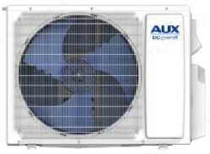
ASUM18HPMULO
- AHRI No: 214291428
- One Person Installation
- 3 Ways to Control (Voice, Wi-Fi & Remote)
- Highly Performance
- Outdoor Unit PCB Coating
- Easy Service Control Board
- Golden Fin
- Wide Voltage Operation

Submittal Data Sheet - ASUM18HPMULO
Specifications
DC INVERTER | Model |  |  | ASUM18HPMULO
System Format |  |  |  | 1 drive 2
Capacity | Cooling |  | Btu/h | 18000(4800-25000)
Capacity | Heating |  | Btu/h | 21000(5000-26000)
Cooling | Capacity | Rated | Btu/h | 18000
Cooling | Capacity Range | Min-Max | Btu/h | 4800-25000
Cooling | Power Input | Rated | W | 1440
Cooling | Moisture Removal |  | Kg/h | 3
Heating | Capacity at 47℉ | Rated | Btu/h | 21000
Heating | Capacity Range | Min-Max | Btu/h | 5000-26000
Heating | Power Input at 47℉ | Rated | W | 1620
Heating | Capacity at 17℉ | Rated | Btu/h | 18100
Heating | Capacity at 5℉ | Max | Btu/h | 21800
Heating | Capacity at -5℉ | Max | Btu/h | 14700
Electric Data | Power Supply |  | V~,Hz,Ph | 208~230,60,1
Electric Data | Cooling Power Input |  | W | 1440
Electric Data | Heating Power Input |  | W | 1620
Electric Data | Rated Current (cooling & heating) |  | A | 6.40/7.18
Electric Data | Max current |  | A | 18
Electric Data | MCA |  | A | 20
Electric Data | MOCP |  | A | 30
Electric Data | Max power |  | KW | 3.8
Efficiency | SEER |  | W/W | 23.3
Efficiency | HSPF |  | W/W | 11
Efficiency | EER/COP |  | W/W | 3.66/3.80
Air Flow Volume |  |  | CFM | 2235
Noise Level | Sound Pressure Noise Level |  | dB(A) | 58
Noise Level | Sound Power Noise Level |  | dB(A) | 68
Dimension | Net Dimension (W*D*H) |  | inch | 38.58×15.28×27.56

 | Packing Dimension (W*D*H) | inch | 39.96×16.73×30.00
Weight | Net/Gross | lbs | 104.7/111.3
Refrigerant | Type | - | R32
 | Charged Volume | Oz/kg | 49.4/1.4
 | Additional charge | (oz/ft)/(g/m) | 0.16/15
Piping | Liquid Side | inch(mm) | 1/4(6.35)x2
Piping | Gas Side | inch(mm) | 3/8(9.52)x2
Piping | Max. length for all rooms (m) | Ft/m | 131/40
Piping | Max. length for one IDU (m) | Ft/m | 82/25
Piping | Max. height difference between IDU and OU (m) | Ft/m | 49/15
Piping | Max. height difference between IDUs (m) | Ft/m | 33/10
Piping | Adapter | - | NO
Ambient Temp (Cooling/Heating) |  | ℉ | -13~125℉/-22~75℉
Submittal Data Sheet - ASUM18HPMULO
Remarks:
1.All specifications are subject to change by the manufacturer without prior notice.
2.All units are being tested and comply to ISO5151.
3.Sound pressure levels are measured in anechoic chamber.
During actual operation, sound pressure level will be higher as a result of room specification condition.
4.Data from AUX lab,05/03/24, Data may change according to test surroundings, AUX reserves right of explanation on data.

Submittal Data Sheet - ASUM18HPMULO
Model # | Capacity (Btu/H) | Max Combination Ratio | Number of Ports
ASUM18HPMULO | 18K | 133% | 2
Suggested Combination | 1 Drive 2
Suggested Combination | Two Units | 9+9 | 9+12 | 12+12

Applicable IDU models
09K  AFEB09HP230V1CH | 12K  AFEB12HP230V1CH
Note：
1. All above indoor units can be freely matched and combined, but must be installed strictly according to the above table or the cooling capacity and stability would be decreased.
2. You may substitute the 9K unit with a 7k High Wall unit.


Dimensions
Outdoor Unit
ASUM18HPMULO
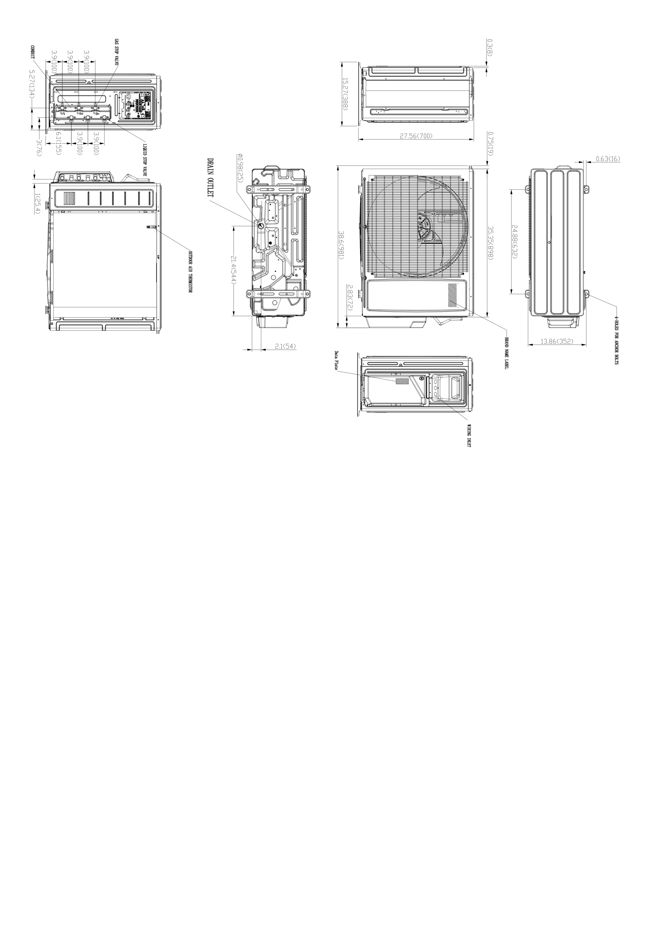

Clearances
Outdoor Unit
ASUM18HPMULO
