
SUBMITTAL DATA SHEET
AUX R32 - Inverter Ducted system Series - AHU36HPV1BI
Job Name | Location Date
Purchaser | Engineer
Submitted to | For □Reference □Approval □Construction
Unit Designation | Schedule #

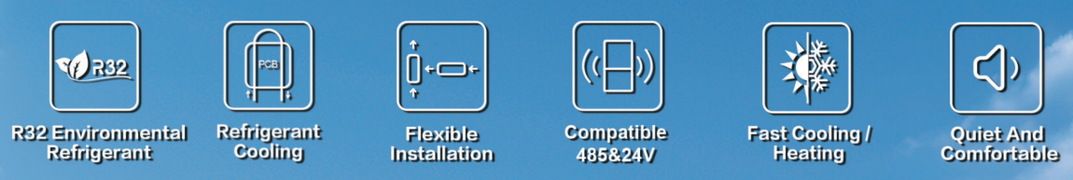
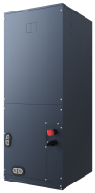
AHRI No: 216032395
AHU36HPV1BI

Specifications
Model | Indoor unit |  |  | AHU36HPV1BI
Model | Outdoor unit |  |  | AHU36HPV1BO
Cooling | Capacity | Rated | Btu/h | 36000
Cooling | Capacity Range | Min-Max | Btu/h | 8500-39500
Cooling | Power Input | Rated | W | 3600
Heating | Capacity at 47℉ | Rated | Btu/h | 38000
Heating | Capacity Range | Min-Max | Btu/h | 7600-39500
Heating | Power Input at 47℉ | Rated | W | 3375
Electric Data | Power Supply |  | V~,Hz,Ph | 208/230,60,1
Electric Data | Rated Cooling Current |  | A | 15.97
Electric Data | Rated Heating Current |  | A | 14.97
Electric Data | MCA | Indoor unit | A | 5.7
Electric Data | MAX.Fuse | Indoor unit | A | 10
Efficiency | SEER2 |  | (Btu/h)/W | 18.20
Efficiency | HSPF2(Region IV) |  | (Btu/h)/W | 10.00
Efficiency | EER2 |  | (Btu/h)/W | 10.00
Efficiency | COP |  | W/W | 3.30
Indoor Unit | Indoor Air Flow | Hi/Mi/Lo | CFM | 1200/950/790
Indoor Unit | Noise Level | Hi/Mi/Lo | dB(A) | 53/51/49
Indoor Unit | External Static Pressure |  | in.w.g | 0.5(0~1)
Indoor Unit | Net Dimension | H | In.[mm] | 49[1245]
Indoor Unit | Net Dimension | W | In.[mm] | 21[534]
Indoor Unit | Net Dimension | D | In.[mm] | 21[534]
Indoor Unit | Packing Dimension | H | In.[mm] | 55-1/2[1410]
Indoor Unit | Packing Dimension | W | In.[mm] | 24-5/8[625]
Indoor Unit | Packing Dimension | D | In.[mm] | 27-3/4[705]
Indoor Unit | Weight | Net/Gross | lbs | 132.9/152.1
Pipe | Liquid(O.D.) |  | In.[mm] | 3/8[Ф9.52]
Pipe | Gas(O.D.) |  | In.[mm] | 5/8[Ф15.88]
Pipe | Max. Length |  | ft[m] | 164[50]
Pipe | Max. Height |  | ft[m] | 98[30]

Submittal Data Sheet - AHU36HPV1BI

Operation Temperature Range |  | ℉（℃） | 61~90(16~32)
Ambient Temp Range | Cooling | ℉（℃） | 5~125(-15~52)
Ambient Temp Range | Heating | ℉（℃） | -22~75(-30~24)
Connection Wiring  Remarks:  1.All specifications are subject to change by the manufacturer without prior notice.  2.All units are being tested and comply to AHRI210/240.  3.Sound pressure levels are measured in anechoic chamber.  During actual operation, sound pressure level will be higher as a result of room specification condition.  4.Data from AUX lab,30/09/24, Data may change according to test surroundings, AUX reserves right of explanation on data. | Power Wiring（Indoor） | AWG | 18
 | Signal Wiring | AWG | 22




Dimensions
Indoor Unit
AHU36HPV1BI
